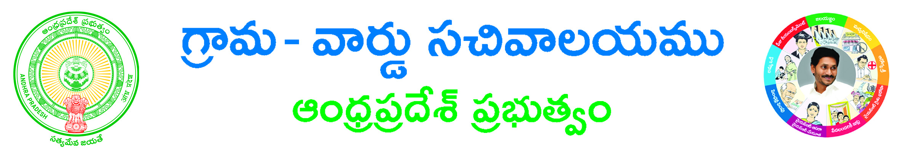
FORM OF APPLICATION CLAIMING FAMILY BENEFIT (FB)
UNDER NSAP
PART-1
(To be filled in by the Head of the Surviving family)
District_______________ Mandal____________

1. Name of the applicant Sri/Smt.:
2. Full address:
3. Name of the deceased primary bread winner:
4. Relationship of the deceased with the applicant:
5. Date of death of primary bread winner:
6. I solemnly affirm that:
(a) I do not have any family income of Rs.5,000/- per month or more.
(b) I am the surviving head of the family of the deceased Primary bread winner.
(c) The Primary bread winner died at the age of ____________ (Proof like Death Certificate to be attached)
(d) The deceased was resident of District Where he had been residing for last 3 years immediately preceding
The death.
(e) I declare that the information furnished in the application is true and correct to the best of my knowledge and
belief.

Place:
Date: Signature of Applicant

PART-II
(To be filled by the Local Enquiry Team)
We certify after due enquiry as follows that:
1. The deceased was the Primary bread winner of the house hold
2. The deceased had been residing in the district for three years before death.
3. The applicant is the surviving head of the family
4. The age of the primary bread winner at the time of death is ____________years.
5. We recommend/do not recommend for sanction of family benefit.
6. This claim is received on_______________ and is being forwarded to Medical Officer/P.O. ICDs.
Place:
Date: Signature of Enquiry Officer with Designation

