SUPRIYA
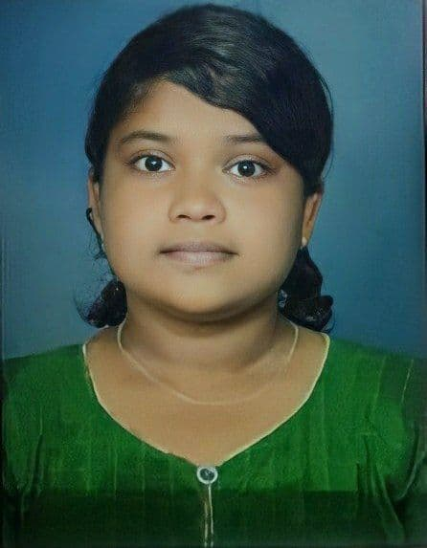

Address: Aradhana Nittur, Udupi
Phone Number: +91 9513297162
Email ID: supriyaamin386@gmail.com

CAREER OBJECTIVE
To be able to work under an encouraging and stable guide who will assist me in developing and improving myself. I am looking forward to challenging my potential and being worthy of management and trust.

Qualification | Institution | University/Board | Passing Year | Percentage
SSLC | Milagres English Medium School | Karnataka Board | 2016 | 80
PUC | Govt P.U College for Girls | Karnataka Board | 2018 | 86
B.COM | Dr. G. Shankar govt Women’s First Grade College | Mangalore University | 2021 | 73
ACADEMIC QUALIFICATION

WORK EXPERIENCE
I have worked in the field of Digital Marketing for four months and have practically worked on building websites and running paid advertisements.

PERSONAL PROFILE
Father Name - Soorya
Date of Birth - 1/12/2000
Gender - Female
Languages Known - English, Hindi, Kannada, Tulu

DECLARATION
I hereby declare that the details above are correct and true to the best of my knowledge.
Place: Udupi Signature
Date: 11-09-2022 Supriya

