1. **Introduction**

The World Around Is Constantly Changing. Interactive Computing, With Wirelessly Connected Device That Are Being Used In Various Day To Day Activities, Are Changing And Improving The Standard Of The Quality Life. Based On This Interactive Computing And Communication Technologies, Many Devices/ Products Are Now Emerging And With This Multimedia Intelligence It Is Providing Comfortable, Secure And Convenient Personal Services And Making A Lot Of Users Comfortable. We Have Smart Cities, Smartphones, Smart Cars, And More. This Fast Way Of Life Requires. The Developments Of Home Automation Projects. The Smart Homes Which Will Automatically Close Or Open Windows Based On Weather Conditions Outsides.

**Application**

In Industries.

In Home Automation.

In Hospitals.

**Advantages of a Smart Mirror**

A great advantage of building your own smart mirror is the modules and software other people have already built. There are literally hundreds of different modules other people have built you can use for your smart mirror.

You can fully customize your smart mirror by picking and choosing the modules you want to include.

Imagine while you go through your morning routine you can look at your mirror and see a traffic report, weather forecast for the day, and your day’s schedule.

**Disadvantages of a Smart Mirror**

One of the **drawbacks of Magic Mirror** technology is the lack of human interaction. Of course, consumers today have spent so much time online that they can become used to shopping in solitude.

**Summary**

The “**Smart Mirror**” consists of an electronic display along with a one-way **mirror** for the informational display. It uses a camera to track movement and provide facial recognition with the use of an embedded computer. Users can create their customized display through a smartphone interface.

**Methodology review**

A smart mirror is a two-way mirror with an electronic display behind the glass. The display can show the viewer different kinds of information in the form of widgets, such as weather, time, date, and news updates. This product would be useful for busy individuals that want to multitask and stay informed while on the go. Instead of constantly pulling out a device, one could get informed while finishing daily grooming tasks. I designed and built my own prototype and delved into the world of do-it-yourself smart mirrors.

***Functional Working Process***  
The basic design of a smart mirror starts with the glass that is to be used. Two-way glass is the recommended type as it lets the graphics on the display come through clearer. Vanity Vision glass was used as it is an optimal choice for building smart mirrors. I used an Android tablet as a display to be mounted on the back of the mirror. The rest of the glass around the display was blacked out by use of black cardboard to ensure that there was a good reflection. Upon uploading the code to the device from Android Studio, the widgets of time, date, real-time weather and news updates were visible through the front of the glass while reflecting the user’s image on the mirror.

**Electrical design**

The electrical component of this project was a simple Android tablet device mounted to the back of the glass. I used the smart mirror code on GitHub and connected the device to my laptop. I then uploaded the code to the Android device which booted up the display for the smart mirror app. The code has built-in features for modification of design of the application. The device must be connected to Wi-Fi in order to gather the correct data. The device must also be plugged in to a power source. Originally, I wanted to incorporate an Arduino Uno to add sensor features like the Ad fruit PIR motion sensor so that when movement was detected, it would turn the mirror on and off when someone walked in front of it, thus saving power. The data is collected by the code installed on the device, which is transmitted by Wi-Fi signal, and presented on the screen of the device which is displayed through the glass to the user.

Complete the timeline and gantt chart.

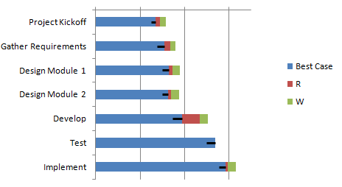

Use case and ERD

