PRACTICAL-03
Develop a C program using fork() that creates a parent and child process. Display the Process ID (PID), Parent Process ID (PPID), and process states at different stages of execution.Design an experiment to observe process state transitions (Ready, Running, Waiting, Terminated) using Linux monitoring tools such as ps, top, and /proc. Document the observations.
CODE:-
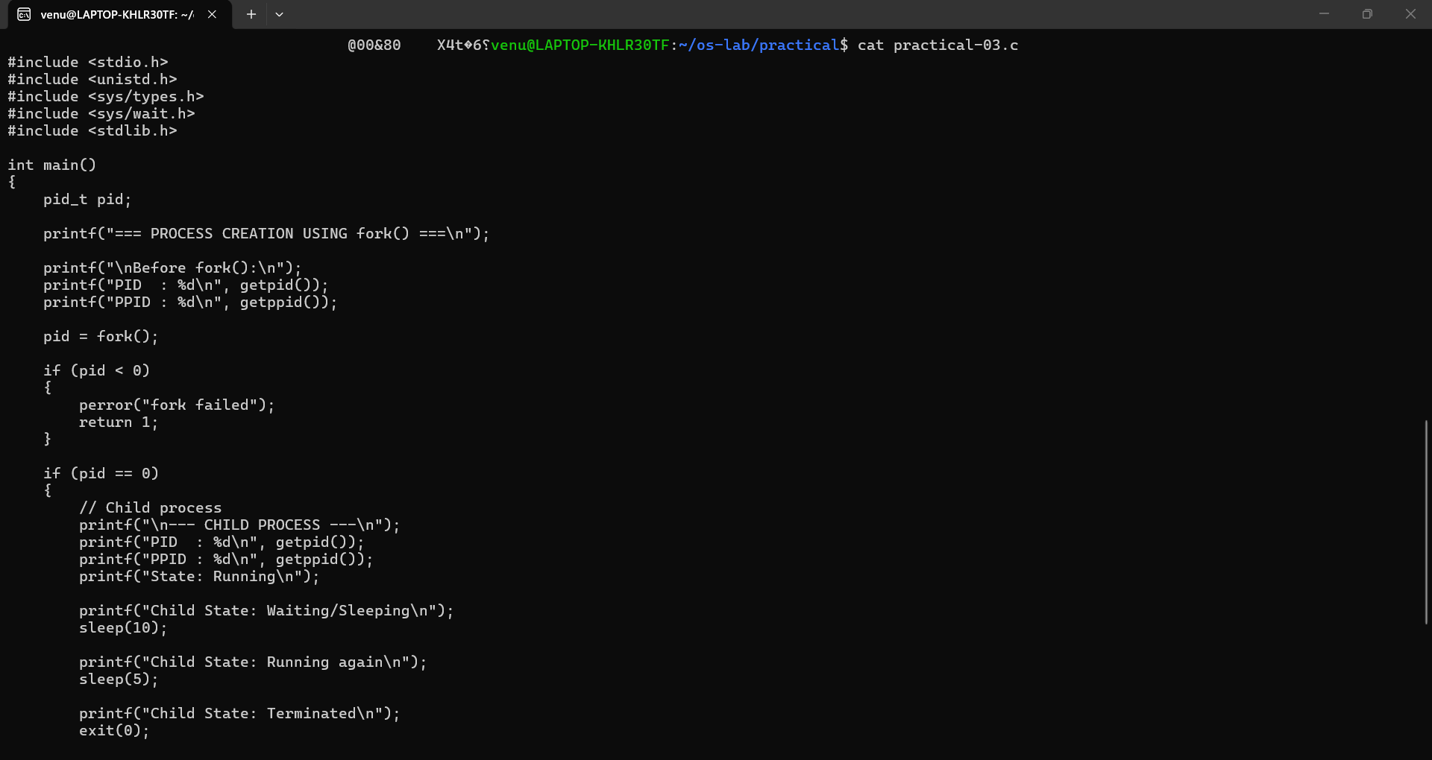
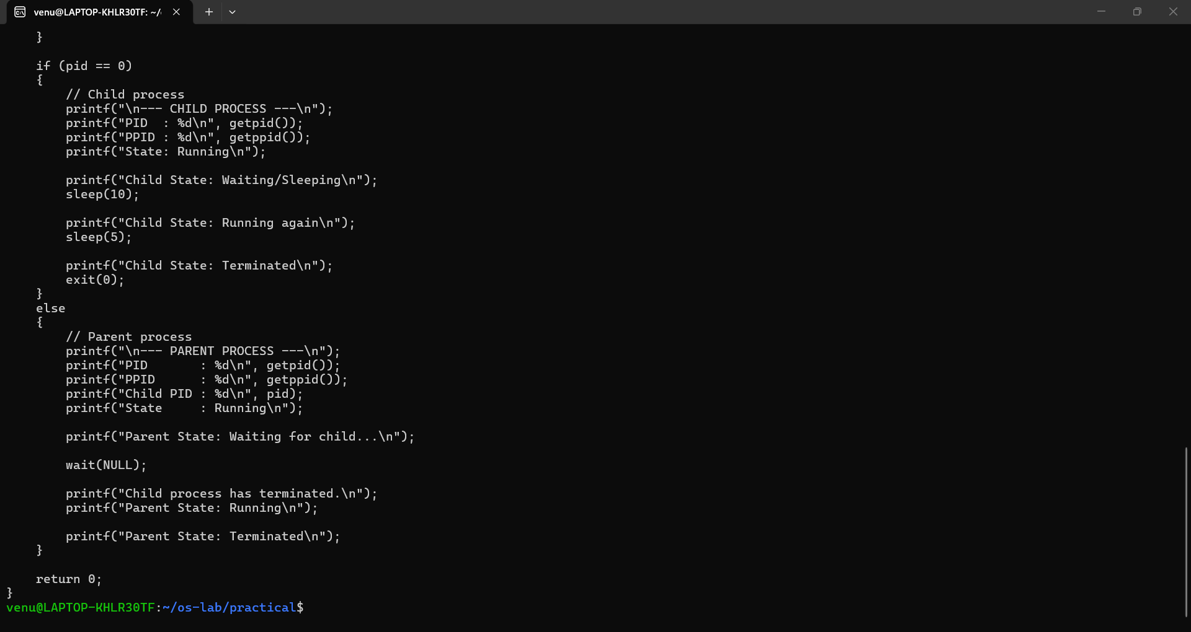

OUTPUT:-
