Data-Driven Precision: Machine Learning's Impact on Thyroid Disease Diagnosis and Prediction
Jannam Sadana¹, Mirjumla Sumalatha², and Shaik Jaheda³
^{1 &3}Department of Information Technology
²Department of Computer Engineering
^{1, 2, &3}CVR College of Engineering, Hyderabad, India
¹jannamsadhana548@gmail.com
²sumagopagalla91@gmail.com
³sony.jaheda@gmail.com

Abstract. The unification of stratification-based machine learning acts an important role in different medical services. In the medical healthcare sector, the principal and challenging task is to determine patient’s health circumstances and to come up with a proper care and meditation of the disease at early stage. The customary and conventional approaches of thyroid diagnosis include thorough extensive perusal and an assort of blood tests. The major aim is to identify the disease at the preliminary stages with exactitude. Machine learning algorithms and data mining techniques are essential for managing and scrutinizing the vast amount of healthcare data associated with thyroid diseases. A hybrid model, incorporating a comprehensive knowledge base, can be utilized for prediction and also for medical evaluation, continually modifying their understanding as novel data is acquired. The motivation of this research is to predict the thyroid disease using Logistic Regression, SVM, Gradient Boosting, MLP, Decision Tree, Voting Classifier and Random Forest, can be utilized to develop accurate classification models and predict the likelihood of thyroid conditions. By leveraging machine learning capabilities, we can improve diagnostic accuracy and offer tailored recommendations based on hospital datasets for effective management of thyroid disorders.
Keywords: Metabolism, Precautions, Diagnostic accuracy, puffy, bradycardia.
Introduction
The thyroid gland exhibits a butterfly-like shape, in the petite situated in the front of the neck, just below Adam’s apple [2]. Regardless of its small size, the thyroid gland assumes a pivotal role in maintaining a multitude of bodily functions and coordinating, harmonizing, or organizing through the meticulous release and production of thyroid hormones. The thyroid gland is composed of two lobes connected by a small tissue bridge called the isthmus. internal part of gland, follicles which is a tiny sacs that means the space inner is occupied by material gel-like called colloid which can provide a specific composition and texture with in sacs. There are two key hormones in the thyroid gland which is acting as a role: triiodothyronine (T3) and thyroxine (T4) [6]. These hormones play a major role in governing various bodily functions such as growth, regulating metabolism, and the overall progression of the body. T3 is active and has a more potent effect on the body's cells, while T4 represents the hormone in its inactive state. The release and production of thyroid hormones controlled by a feedback system that encompasses pituitary gland and hypothalamus. To secure thyroid-stimulating hormone (TSH) [1] it signals to pituitary gland, thyrotropin-releasing hormone (TRH) a hormone like hypothalamus is released. TSH, in turn, triggers the thyroid gland to release and produce thyroid hormones. When the amount of thyroid hormones increases in the bloodstream, they will send a signals back to pituitary gland and hypothalamus in order to reduce TSH and TRH, in order to maintain a balance in hormone production.

Due to imbalance of hormones, Thyroid disorders occur when the thyroid gland is produced which will lead to health issues. Two primary types of thyroid disorders are:

Hyperthyroidism: Hyperthyroidism arises when the thyroid gland is heightened activity and produces excessive amounts of thyroid hormones [15]. This will result in an accelerated metabolism, which leads to symptoms such as irritability, tremors, weight loss, rapid heartbeat, and excessive sweating. Graves' disease is an autoimmune disease that affects the thyroid gland.

Hypothyroidism: When the thyroid gland is underactive, leads to insufficient release of thyroid hormones. It can cause a indolent metabolism, resulting in symptoms like sensitivity to cold, weight gain, dry skin, constipation, fatigue, and difficulties with concentration. One of the most common causes of hypothyroidism is an Immunological disorder called Hashimoto's thyroiditis.

Thyroid ailments, a subset of endocrinology, endure as one of the most misconstrued and underdiagnosed medical conditions. Within the realm of endocrine disorders, thyroid gland diseases hold a prominent position globally, ranking second only to diabetes as per the WHO (World Health Organization) [1]. It is estimated that more than 200 million individuals worldwide suffer from some variation of thyroid disease, with this figure steadily escalating each year. Most of these instance’s stem from thyroid dysfunction, resulting in conditions such as hypothyroidism (insufficient thyroid function) and hyperthyroidism (excessive thyroid activity) [3]. Prompt identification and treatment are pivotal in averting long-term complications and promoting overall well-being.
Implementation
2.1 Exploring its Role and Diagnostic Techniques
The thyroid, a gland resembling a butterfly and present in the neck, has the important role of producing hormones which play a crucial role in regulating the body's metabolic rate. These hormones, known as triiodothyronine (T3) and thyroxine (T4), body temperature, control energy levels, and heart rate [4]. The pituitary gland produces thyroid-stimulating hormone (TSH), which acts on the thyroid gland, governs the synthesis and secretion of T3 and T4. Imbalances in T3 and T4 prompt the pituitary gland to release more TSH, stimulating the thyroid to generate additional hormones.
Thyroid detection involves identifying any irregularities within the thyroid gland [16]. Thyroid diseases can cause conditions such as underactive thyroid (hypothyroidism), or an overactive thyroid (hyperthyroidism), both of which can have significant impacts on the body if left untreated. Various methods are employed for thyroid detection, including physical examinations, blood tests, and imaging procedures. During a physical exam, doctors may palpate the neck to check for unusual swelling or nodules that may indicate thyroid problems [5]. Blood tests assess hormone and TSH levels in the bloodstream, providing valuable insights into thyroid gland function. Imaging tests, such as ultrasound or radioactive iodine uptake scans, generate detailed images of the thyroid gland, allowing the identification of abnormal growths or other indications of thyroid disease.
2.2 Unveiling the Power of Classification and Regression
A Decision Tree is a one of famous method for making decisions in a decision tree and used for both Regression problems and classification but likely it is used mainly in order to solve a problem based on Classification [10]. A tree-structured classifier is a model that employs a hierarchical tree-like structure in order to classify the data. By employing a sequence of binary decisions at every internal node, based on the specific features, it directs the data towards the leaf nodes, which signify the final classifications or predictions. Based on the dataset given, the performances and decisions were performed. On specific conditions, all the possible solutions to a decision problem can be represented in a graphical way. This segments into categories, for each value of the attribute, it corresponds to one. The recursive tree process is implemented to each cluster by considering only the cases that reach that particular distinct branch [13]. Once the node gets the same classification in all the cases then the progress of tree can be stopped. Typically, classification error or entropy both are used in order to define the ideal tree partition.

Fig. 1. Decision Tree Principle

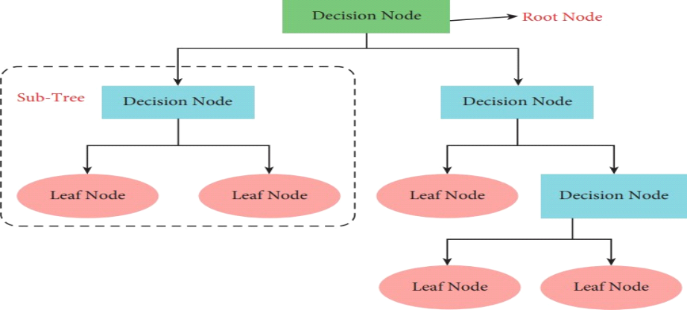

H(Y)=-∑(p(i)* logk(p(i))) (1)

Where,
Y is the set of class labels.
p(i) is the proportion (probability) of instances that belong to class i in the dataset.
k is the number of classes.

Fig. 2. Decision Tree Confusion Matrix

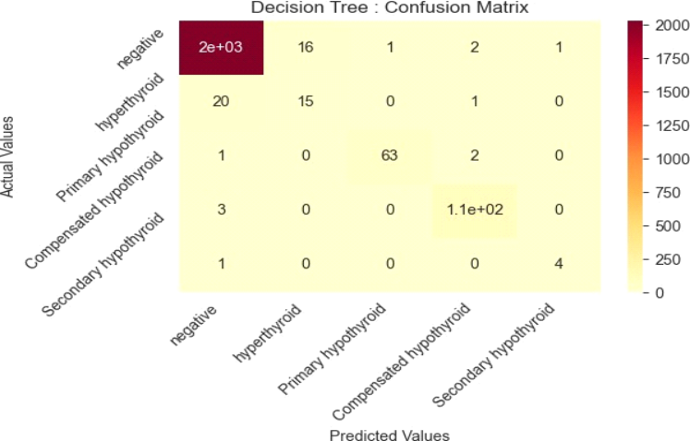
2.3 Unraveling Multinomial Logistic Regression: Considerations, Applications, and Interpretation:
The method of logistic regression serves as a data analysis technique purpose, mainly for modeling and analyzing the data, that employs mathematical formulas to identify and understand relationships between two data factors. It leverages these relationships to predict the value of one factor based on the other. Multinomial logistic regression is a statistical approach specifically designed for analyzing the association of a response variable or an outcome that will take one distinct level or a category in simple known as categorical dependent variable [22]. It expands upon the concept of binary logistic regression, which is applicable to dependent variables with only two categories. In the context of multiclass classification using logistic regression, there are two primary methods commonly used to tackle problems involving more than two classes: the one-vs-all (OVA) approach and the simultaneous approach.
one-vs-all (OVA) approach:
In this approach, the problem involves a nominal dependent variable with multiple classes, such as classes A, B, and C. To address this, we create individual logistic regression models for each class. For instance, when building the initial method like Class A, the dependent variable is 1 if and only if belongs to Class A, else it is 0 otherwise. For Class B Model, the dependent variable is 1 if the observation belongs to it, if not it is assumed as 0. Similarly, for Class C Model, the dependent variable will be 1 if the obtained in Class C, otherwise it is 0. In the next level, combination of Class A and C vs. Class B, we assign a value of 1 to Class B and 0 to Classes A and C. Similarly, in the last phase it is a comparison between Class A and B vs. Class C, we assign a value of 1 to Class C and 0 to Classes A and B. By building separate models for each class, we can independently examine the relationship between the predictor variables and each individual class, providing insights into the distinctive characteristics of each class.
Now, we the probability of A, B and C are found using formulas:
1
Logistic p(X) = (2)
1 + e^(-z)
In this formula, p(X) indicates the estimated probability of a particular event taking place with the predictor variables X.
e is base of the natural logarithm; its appropriate values is 2.71828.
z is the linear combination of coefficients in logistic regression model and predicator variables, it is also implemented as

z = â0 + â1X1 + â2X2 + ... + âkXk (3)

Where â0, â1, â2, ..., âk represent the coefficients estimates with a reference of logistic regression.
Fig. 3. One vs All Approach in Multinomial Logistic Regression

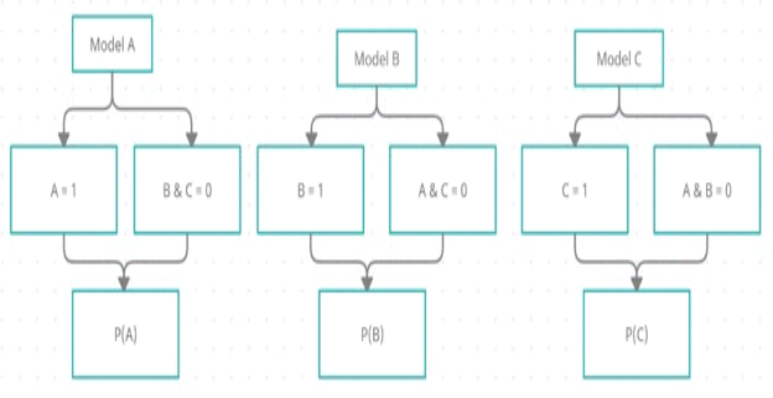

For a record, probability of event A (P(A)) is greater than the probability of event C (P(C)) and the probability of event A is also greater than the probability of event B (P(B)), then the target dependent class will be Class A.

Simultaneous Approach
When dealing with K classes or potential outcomes, we employ a methodology where we build K-1 distinct binary regression models. Each model is designed to analyze a specific outcome/class in relation to a chosen "reference" or "pivot" class. For instance, if we have three classes (Class A, B, and C) as the possible outcomes in our dependent variable, we will create two logistic regression models [18]. Let's assume we select Class C as the reference or pivot class. The first model would be developed to examine Class A in relation to the reference class (C). This model would employ a probability equation specifically designed for this purpose.

(p(A)/ p(C)) = a1 + b1x1 + … + bnxn (4)

p(A)/p(C) = exp (a1 + b1x1 + … bnxn) (5)

p(A) = p(C) * exp (a1 + b1x1 + … + bnxn (6)

In order to develop the next logistic regression method for a class B with reference of class C, the equation can be defined as follows:

In (p(B)/ p(C)) = a2 + b1x1 + … + bnxn (7)

p(B)/p(C) = exp (a2 + b1x1 + … bnxn) (8)

p(B) = p(C) * exp(a2 + b1x1 + … + bnxn) (9)

Since P(A)+P(B)+P(C) = 1 , then (10)

P(C) * exp (a1 + b1x1 + … + bnxn) + p(C) * exp exp (a2 + b1x1 + … bnxn) + p(C) = 1 (11)

P(C) = 1/ 1+ exp (a1 + b1x1 + … bnxn) + exp exp (a2 + b1x1 + … bnxn) (12)

Fig. 4. Understanding the fundamentals of Multinomial Logistic Regression

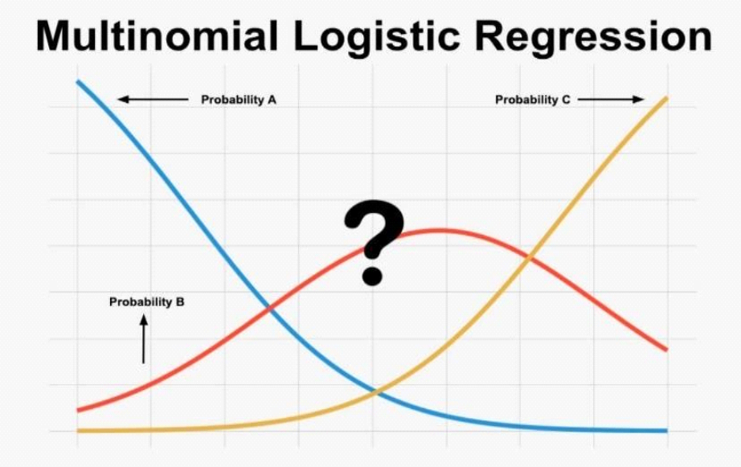

After computing the probability of class C, we can proceed to calculate the probabilities of class A & B using the formulas mentioned earlier. In this approach, it is extended to K classes, in which there is a development of K-1 logistic regression. Finally, the highest probability with a class is assigned to the new data point based on these calculated probabilities [17].

Fig. 5. Multinomial Logistic Regression Confusion Matrix

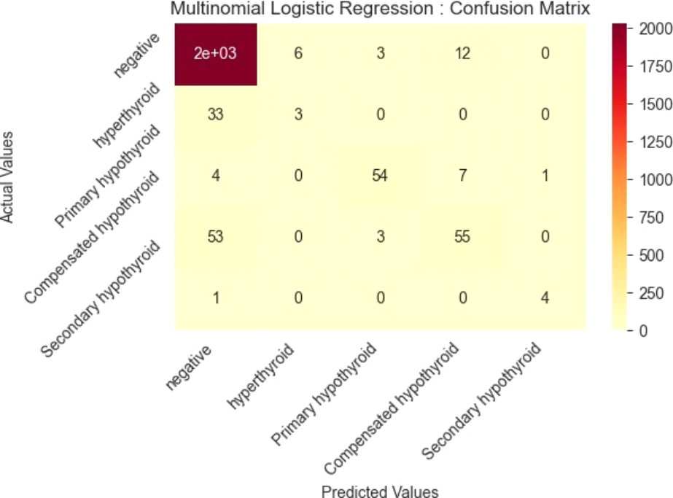

Fig. 6. ROC Curve for Multinomial Logistic Regression

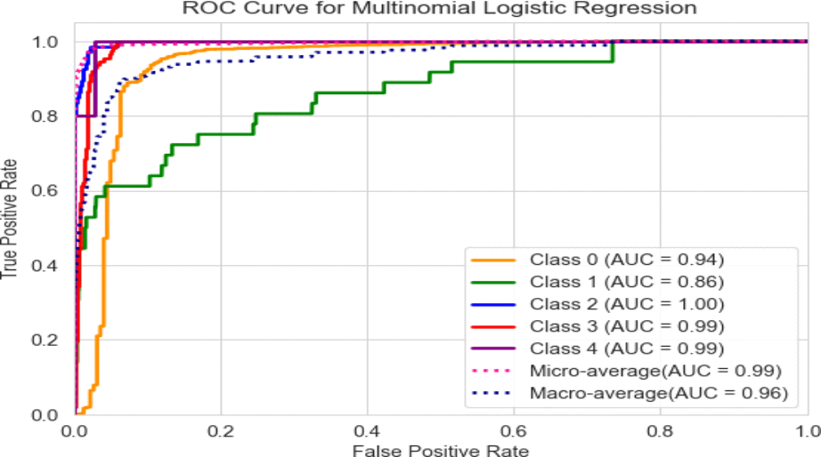
Support Vector Machine (SVM) Variants and Extensions
Exploring Advanced Techniques: One of the most popular Supervised learning algorithms is known as Support Vector Machine or SVM [7], in which it is used for classification and regression problems. It is potential in solving linearly separable and non-linearly separable tasks by changing the input data into n-dimensional space or higher-dimensional space. To create the decision boundary or best line that can separate n-dimensional space into classes which makes data to be placed in a correct category. Hyperplane is one of the best decision boundaries.
The main purpose of SVM is to identify an optimal hyperplane that will then discrete the data points of each class. The points nearer to the hyperplane are known as support vectors, and they take part a crucial role in defining the determination boundary. With the help of kernel functions, SVM can manage both linear and nonlinear classification problems. Kernel functions empower the algorithm to completely map all the input values data into a scatter graphs (higher dimensional feature space), where linear separation can become feasible. Few commonly used kernel functions include polynomial, linear, sigmoid, and Gaussian (Radial Basis Function). For solving a optimization problems, SVM can involve finding the optimal hyperplane values. This algorithm will optimize the classification errors while maximizing the margin. Quadratic programming is mainly used for optimization problems to solve optimization techniques.
To Create a hyperplane, SVM chooses an extreme points/vector [6]. These extreme cases are also known as Support vectors, and consequently algorithm is denominate as Support Vector Machine. With the help of available training data, SVM creates an ideal hyperplane remote from support vectors. Hyperplane is a line that will divide a plane into two classes in two-dimensional space. The regularization, epsilon, and kernel parameters are the SVM classifier turn-off parameters [41].

Fig. 7. Principles of Support vector machine

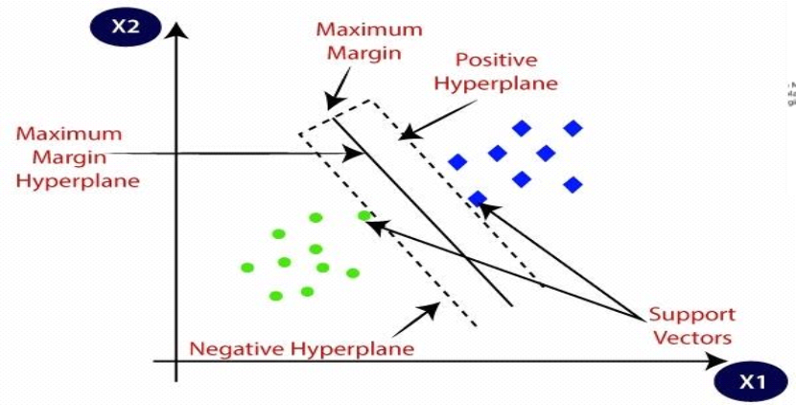

In multiclass classification, the same method is used after breaking down the multi grouped problems into multiple binary classifications problems. The two main methods to handle the problems are: one-vs-one (OVO) and one-vs-all (OVA) approaches.

One vs One: In this approach, the multi-class classification problems can be handled. In OVO, the problems are divided into many binary problems which includes all the possible collaborations between pairs of classes. So that any classifier can learn to separate each pair, and the outcomes of these base classifiers are merged to get the outcomes class. For instance, let us consider A, B, C are the three classes, then OVO will train these three binary classifiers like A vs B, B vs C, C vs A and the end class forecast will be based on the highest vote of the three binary classifiers. This classifier uses m(m-1)/2 SVM’s.

Fig. 8. One vs One approach in Support vector machine

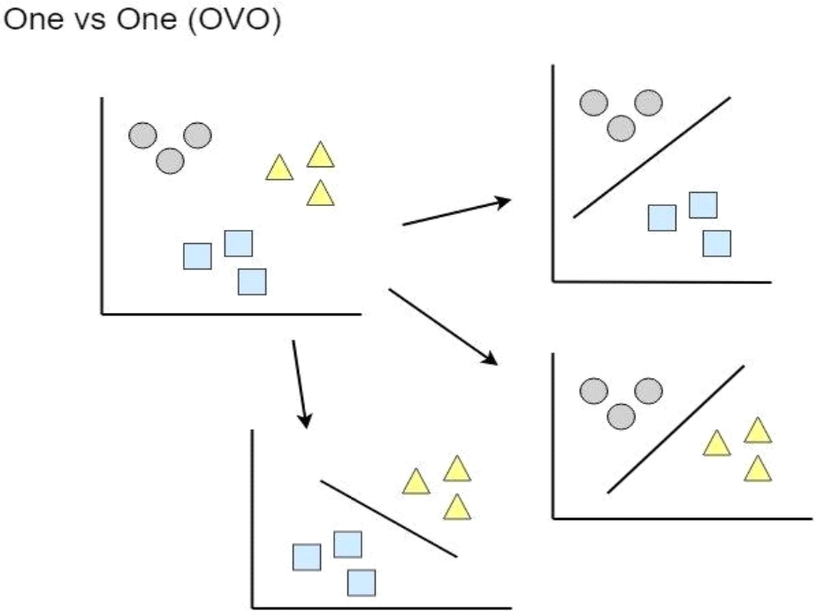

One vs All (One vs Rest): Here the multi-class classification issue is transformed into multiple binary classification sub issues. Each of these sub issues is then trained to discriminate between one class and the rest of the classes.

In order achieve this approach, Training Phase will train all N classes per N binary classifiers. For class, one binary classifier is trained to differentiate instance of that class from all other remaining classes [19]. Predication Phase will predicate for a new instance, all the binary classifiers will be used. Every classifier will identify whether it belongs to a positive or negative class.

Fig. 9. One vs All approach in Support vector machine
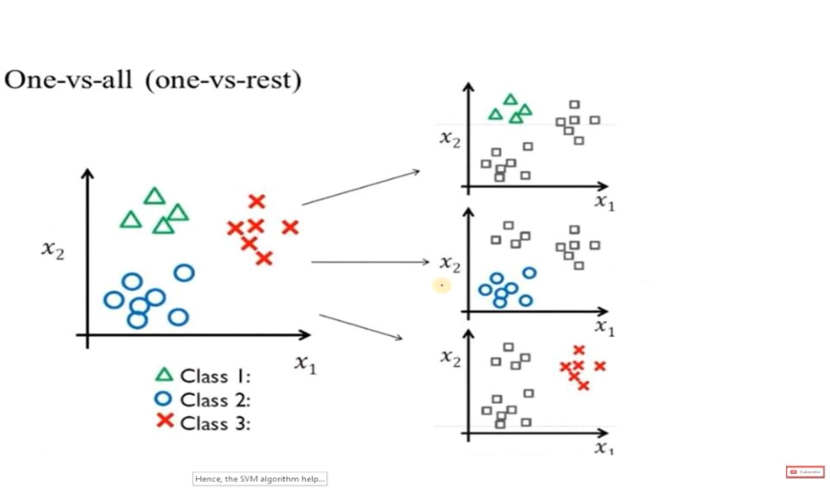

Fig. 10. Support vector machine Confusion Matrix

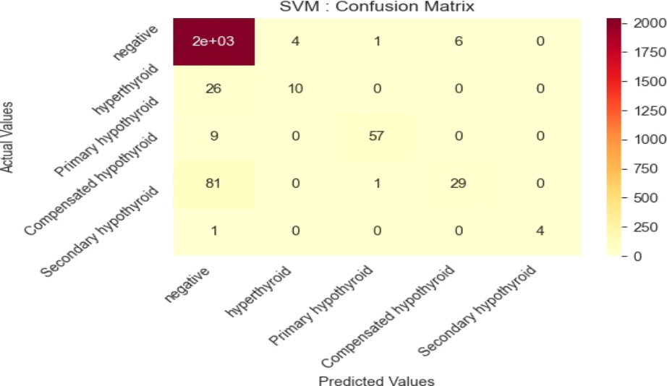
Gradient Boosting

To create accurate prediction values, we use multiple weak predictive models like decision trees. This technique mainly aims for predicting any archived values or any categorical variable with many possible values [28]. The main aim of this technique is to build a new model in order to improve the errors of the previous model. The models are constructed in a Consecutive manner, with each subsequent model centering on fixing the oversights of the preceding prototypes. It can be accomplished by using a gradient descent algorithm for updating the prototypes values. The common steps involved in this technique are:

Fit an initial model: At the outset, a rudimentary model is employed for making predictions for the target variables by taking into consideration either a singular attribute or a minor subset of features [31].
Calculate the residuals: Quantifying the deviation between the forecasted values produced by the actual values and factual values of the target values is discrepancy.
Fit a new model: A novel developed model is trained using the residuals calculated in step 2, shaped to address the discrepancies present in the model that come before it.
Update the predictions: The prognostications generated from the models that came earlier models and the new model, iteratively predictive outcomes are updates and improved.
Repeat steps 2-4: Until the stopping criterion is met, repeat the calculating residuals, fitting into a new model, and updating the predictions.

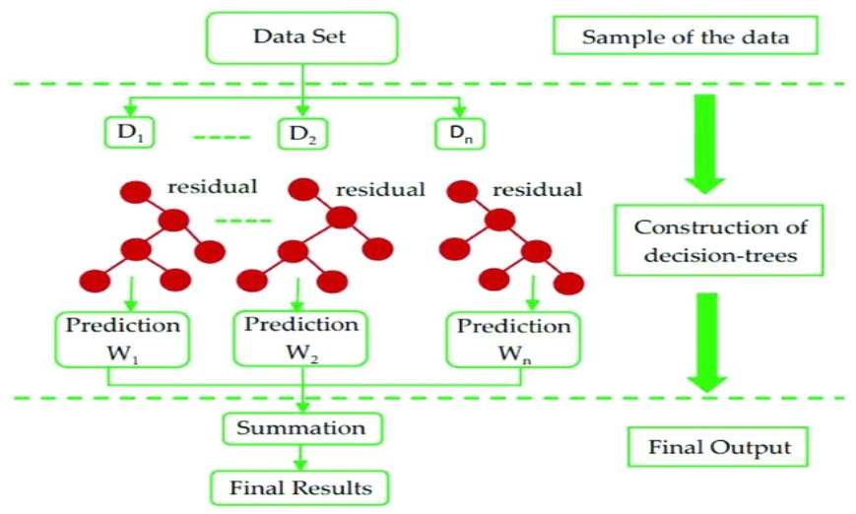Fig. 11. Gradient Boosting Principle
Conclusion and Future work
In this investigation, thyroid disorders have a crucial effect on metabolism and require appropriate diagnosis and prediction in healthcare. Data mining techniques and Machine learning algorithms will act an impact role in particularly managing and examine the vast amount of healthcare data associated with thyroid diseases. This study presents a hybrid model that blends a comprehensive knowledge base with different machine learning techniques such as SVM, Decision Tree, Logistic Regression, Voting Classifier, and Random Forest. By applying these techniques, accurate classification model can be designed to predict the probability of thyroid conditions. The elaborate technique could estimate the likelihood of developing thyroid-related problems and provide personalized suggestions to everyone at risk. With support of machine learning capabilities and access of datasets from hospital, the system acts to improve diagnostic reliability and offer customize recommendations for powerful management of thyroid disorders. Altogether, this research donates to the advancement of thyroid disease predication systems and illustrates the values of machine learning in healthcare, finishes the way to enhance diagnosis, customized care, and cured management of thyroid disorders.
In the forthcoming responsibilities, to improve explicit our asset it is better to elaborate the data set and the attributes which are included in. With reference to additional data the discipline process can give extra effective classifiers also by doing so, an additional accurate estimation of the present performance becomes achievable. Certainly, alternative facet that merits examined is the existence of any other thyroid disease related to the patient, to recognize if there is a specific supplementary thyroid disease that can take hold. In fact, the simultaneous incidence of more than one thyroid disease is commonly seen in patients.

References
Sonuç, E. (2021, July). Thyroid disease classification using machine learning algorithms. In Journal of Physics: Conference Series (Vol. 1963, No. 1, p. 012140). IOP Publishing.
Rao, A. R., & Renuka, B. S. (2020, November). A machine learning approach to predict thyroid disease at early stages of diagnosis. In 2020 IEEE international conference for innovation in technology (INOCON) (pp. 1-4). IEEE.
Chaganti, R., Rustam, F., De La Torre Díez, I., Mazón, J. L. V., Rodríguez, C. L., & Ashraf, I. (2022). Thyroid disease prediction using selective features and machine learning techniques. Cancers, 14(16), 3914.
Mir, Y. I., & Mittal, S. (2020). Thyroid disease prediction using hybrid machine learning techniques: An effective framework. International Journal of Scientific & Technology Research, 9(2), 2868-2874.
Chandan R, Chetan Vasan, and Devika Rani H S(2021) .“THYROID DETECTION USING MACHINE LEARNING” published on ResearchGate.
Razia, S., Siva Kumar, P., & Rao, A. S. (2020). Machine learning techniques for thyroid disease diagnosis: a systematic review. Modern Approaches in Machine Learning and Cognitive Science: A Walkthrough: Latest Trends in AI, 203-212.
Isa IS, Saad Z, Omar S, Osman MK, Ahmad KA, Sakim H. Suitable MLP network activation functions for breast cancer and thyroid disease detection. 2010 Second International Conference on Computational Intelligence, Modelling and Simulation (CIMSiM); 2010. p. 39–44.
Akbas A, Turhal U, Babur S, Avci C (2013) Performance improvement with combining multiple approaches to diagnosis of thyroid cancer. Sci Res. doi:10.4236/eng.2013.510B055
Ankita Tyagi and Ritika Mehra. (2018).“Interactive Thyroid Disease Prediction System using Machine Learning Techniques” published on ResearchGate.
Das, R.; Saraswat, S.; Chandel, D.; Karan, S.; Kiran, J.S. An AI Driven Approach for Multiclass Hypothyroidism Classification. In Proceedings of the International Conference on Advanced Network Technologies and Intelligent Computing, Varanasi, India, 17–18 December 2021; pp. 319–327
Al-Dhabyani, W., & Elshafie, A. (2019). Thyroid disease classification using machine learning techniques. International Journal of Advanced Computer Science and Applications, 10(8), 50-55.
S. Razia, P. Swathi Prathyusha, N. Krishna, and N. Sumana. A comparative study of machine learning algorithms on thyroid disease prediction. International journal of engineering and technology, 7:315, 2018.
Gupta, S., & Manchanda, P. (2020). Detection and classification of thyroid disease using machine learning techniques. International Journal of Advanced Research in Computer Science and Software Engineering, 10(4), 15-21.
Singh, R. K., & Kumar, R. (2018). A comparative study of MLP and SVM in thyroid disease diagnosis. International Journal of Computer Applications, 181(43), 14-19.
Li M, Zhou Z-H (2006) Improve computer-aided diagnosis with machine learning techniques using undiagnosed samples. IEEE 5:1–12
A. Tyagi, R. Mehra and A. Saxena, "Interactive Thyroid Disease Prediction System Using Machine Learning Technique," 2018 Fifth International Conference on Parallel, Distributed and Grid Computing (PDGC), Solan, India, 2018, pp. 689-693, doi: 10.1109/PDGC.2018.8745910.
Abbad Ur Rehman, H., Lin, CY., Mushtaq, Z. et al. Performance Analysis of Machine Learning Algorithms for Thyroid Disease. Arab J Sci Eng 46, 9437–9449 (2021). https://doi.org/10.1007/s13369-020-05206-x
Lee, K. S., & Park, H. (2022). Machine learning on thyroid disease: a review. Frontiers in Bioscience-Landmark, 27(3), 101.
Razia, S., & Rao, M. N. (2016). Machine learning techniques for thyroid disease diagnosis-a review. Indian J Sci Technol, 9(28), 1-9.
Tyagi, A., Mehra, R., & Saxena, A. (2018, December). Interactive thyroid disease prediction system using machine learning technique. In 2018 Fifth international conference on parallel, distributed and grid computing (PDGC) (pp. 689-693). IEEE.
Prasad, V., Rao, T. S., & Babu, M. S. P. (2016). Thyroid disease diagnosis via hybrid architecture composing rough data sets theory and machine learning algorithms. Soft Computing, 20, 1179-1189.
Aversano, L., Bernardi, M. L., Cimitile, M., Iammarino, M., Macchia, P. E., Nettore, I. C., & Verdone, C. (2021). Thyroid disease treatment prediction with machine learning approaches. Procedia Computer Science, 192, 1031-1040.
D.C. Yadav and S Pal, "Prediction of thyroid disease using decision tree ensemble method", Hum.-Intell. Syst. Integr, vol. 2, pp. 89-95, 2020.
Jha, R., Bhattacharjee, V., & Mustafi, A. (2022). Increasing the prediction accuracy for thyroid disease: a step towards better health for society. Wireless Personal Communications, 122(2), 1921-1938.
G. Chaubey, D. Bisen, S Arjaria et al., "Thyroid Disease Prediction Using Machine Learning Approaches", Natl. Acad. Sci. Lett., vol. 44, pp. 233-238, 2021.
R. Jha, V. Bhattacharjee and A Mustafi, "Increasing the Prediction Accuracy for Thyroid Disease: A Step Towards Better Health for Society", Wireless Pers Commun, vol. 122, pp. 1921-1938, 2022.
H. Abbad Ur Rehman, CY. Lin, Z Mushtaq et al., "Performance Analysis of Machine Learning Algorithms for Thyroid Disease", Arab J Sci Eng, vol. 46, pp. 9437-9449, 2021.
L. Aversano, M. L. Bernardi, M. Cimitile, M. Iammarino, P. E. Macchia, I. C. Nettore, et al., "Thyroid Disease Treatment prediction with machine learning approaches", Procedia Computer Science, vol. 192, pp. 1031-1040, 2021.
D.C. Yadav and S Pal, "Prediction of thyroid disease using decision tree ensemble method", Hum.-Intell. Syst. Integr, vol. 2, pp. 89-95, 2020.
Alex Stagnaro-Green, Allan Dong and Mary D. Stephenson, "Universal screening for thyroid disease during pregnancy should be performed", Best Practice Research Clinical Endocrinology Metabolism, pp. 101320, 2019.
Chandani Patel Chavez, Maria del Mar Morales Hernandez, Jesse Kresak and Whitney W. Woodmansee, "Evaluation of multi nodular goitre and primary hyperparathyroidism leads to a diagnosis of AL amyloidosis Division of Endocrinology", Diabetes and Metabolism.
Bashar Bazkke, Joli Osman, Mohammad Shahrour, Mohammad Ziadeh, Aya Haji Mohamad, Mohamed Imad Eddin Mouhandes, et al., A pregnant women with history of hashimoto’s thyroiditis diagnosed with Kikuchi-Fujimoto disease: the first case report.
Khalid Salman et al., "Thyroid Disease Classification using Machine Learning Algorithm hm", J. Phys.: Conf. Ser, vol. 1963, pp. 012140, 2021.
Chandel Kushboo et al., "A comparative study on thyroid disease detection using K-nearest neighbour and classification techniques", CSI transactions on ICT ICT, vol. 4, no. 2-4, pp. 313-319, 2016.
G. Rasita Banu et al., "A Role of decision Tree classification data Mining Technique in Diagnosing Thyroid disease", International Journal of Computer Sciences and Engineering, vol. 4, no. 11, pp. 64-70, 2016.
Umar Sidiq et al., "Diagnosis of various thyroid ailments using data mining classification technique", Int Journal SCI RES Coput SCI Inf Tecnol, vol. 5, pp. 131-6, 2019.
Göksu AKGÜL et al., "Hipotiroidi Hastalığı Teşhisinde Sınıflandırma Algoritmalarının Kullanımı", Bilişim Teknolojileri Dergisi, vol. 13, no. 3, pp. 255-268, 2020.
K Vijiya Kumar et al., "Random Forest Algorithm for the Prediction of Diabetes", 2019 IEEE International Conference on System Computation Automation and Networking (ICSCAN), 2019.
Vikas Chaurasia, Saurabh Pal and B. B. Tiwari, "Prediction of benign and malignant breast cancer using data mining techniques", Journal of Algorithms & Computational Technology, vol. 12, no. 2, pp. 119-126, 2018.
Amina Begum and A. Parkavi, "Prediction of thyroid disease using data mining techniques", 2019 5th International Conference on Advanced Computing & Communication Systems (ICACCS), 2019.
Jha, Ritesh, Vandana Bhattacharjee, and Abhijit Mustafi. "Increasing the prediction accuracy for thyroid disease: a step towards better health for society." Wireless Personal Communications 122, no. 2 (2022): 1921-1938.

