**FRAGMENT BASED DRUG DESIGH**

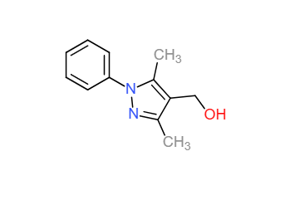

|  |  |
| --- | --- |
| IUPAC Name | (3,5-dimethyl-1-phenylpyrazol-4-yl)methanol |
| SMILES | CC1=C(C(=NN1C2=CC=CC=C2)C)CO |
| Pubchem ID | CID 2526674 |
| LogP | 1.97 |
| HBond_Donor | 2 |
| HBond_Acceptor | 1 |
| Molecular Weight | 202.25 |
| Bioavailability Score | 0.55 |
| Lipinski violations | 0 |
| Best Matching | Z46486555 |
| Matching Percentage | 31.81818182 |

**2N0A**

Misfolded α-synuclein amyloid fibrils are the principal components of Lewy bodies and neurites, hallmarks of Parkinson's disease (PD). Over 200 unique long-range distance restraints define a consensus structure with common amyloid features including parallel in-register β-sheets and hydrophobic core residues.

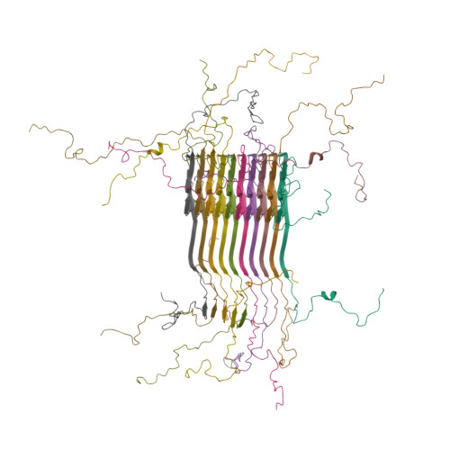

Fig: Structure of alpha-synuclein fibrils (2N0A)

**5CAW**

E3 ubiquitin ligase parkin in complex with Ser65-phosphorylated ubiquitin.

The model comprises the RBR-type parkin core—including a Ubl domain, RING0, RING1, IBR, and RING2 zinc-finger domains—bound to phospho-ubiquitin.

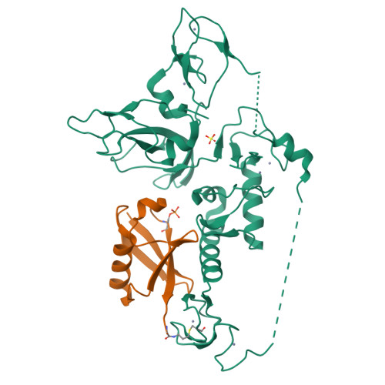

Fig: Structure of Pediculus humanus Parkin bound to phospho-ubiquitin (5CAW)

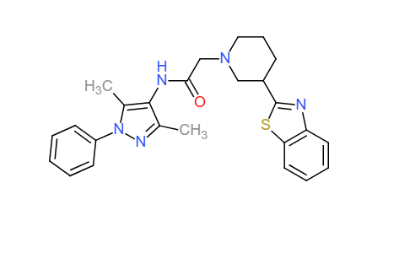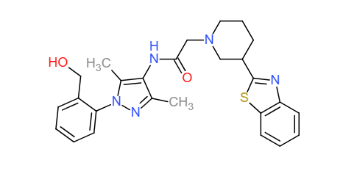

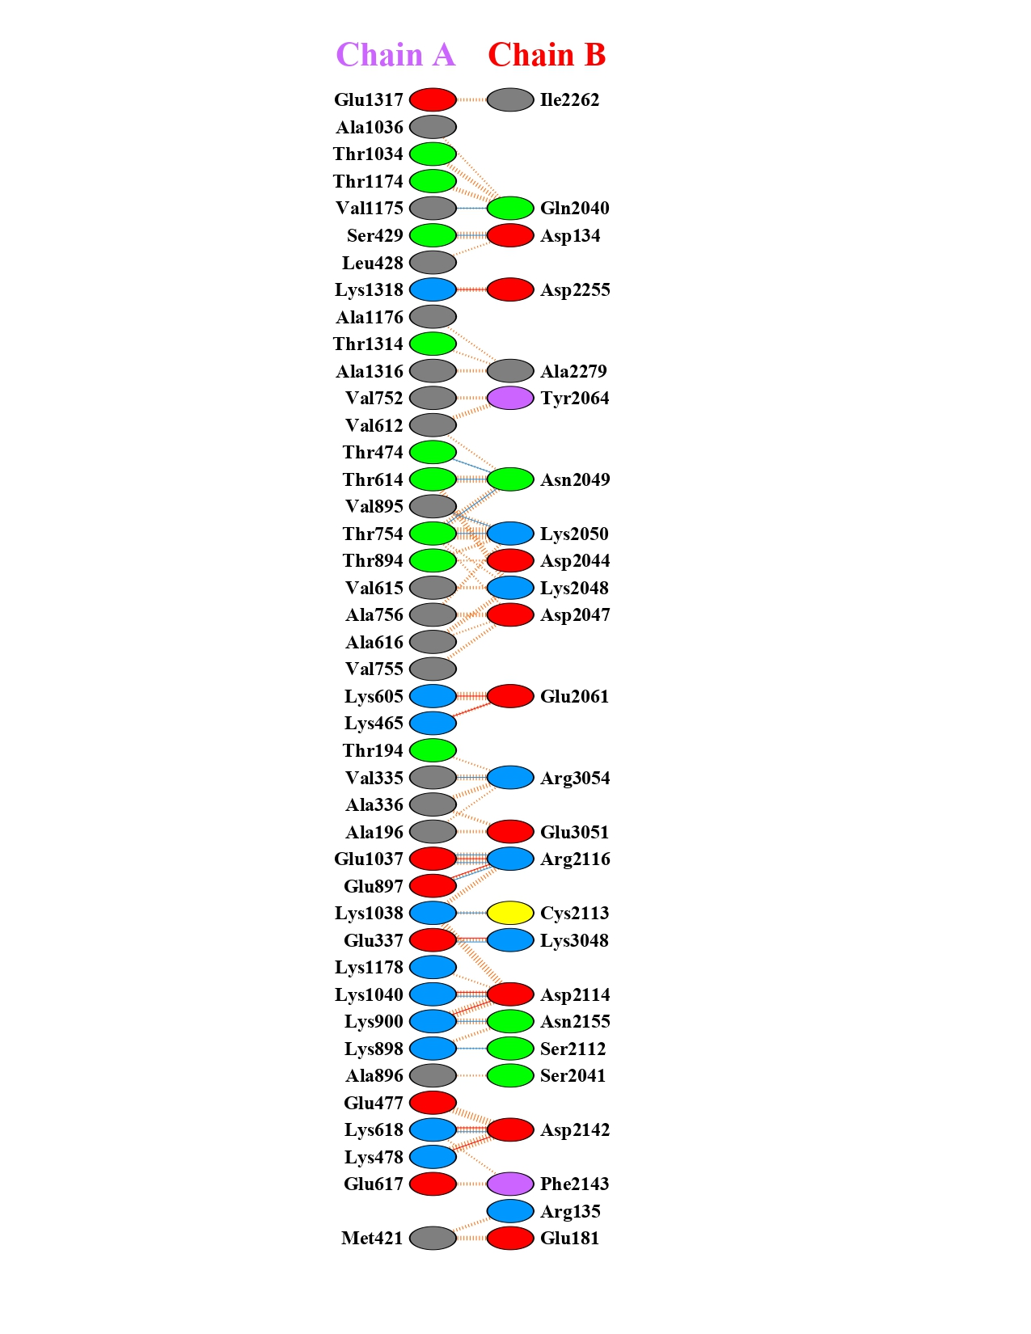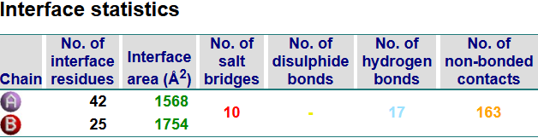

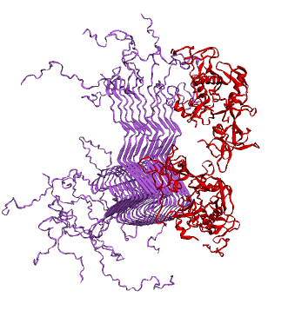

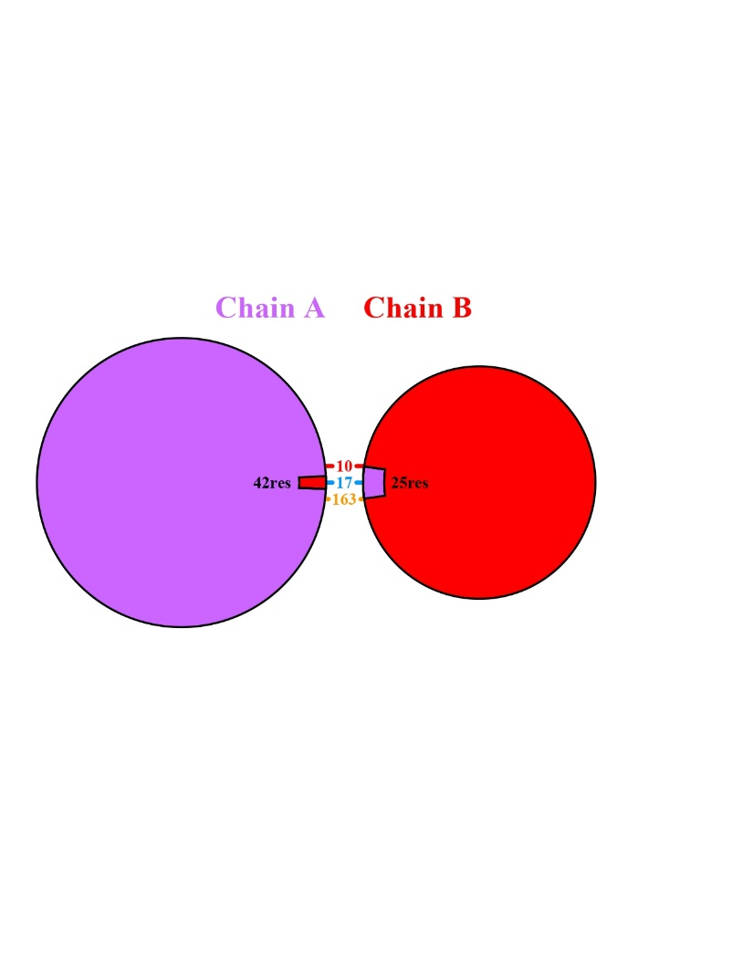

|  |  |  |  |
| --- | --- | --- | --- |
|  | WARHEAD | LINKER | BINDER |
| IUPAC Name | 2-[3-(1,3-benzothiazol-2-yl)piperidin-1-yl]-N-(3,5-dimethyl-1-phenylpyrazol-4-yl)acetamide | N-heptyl-2-hydroxyacetamide | methyl 2-[(1R,2S,4R,6R,9R,10S,11R,15R,18R)-6-(furan-3-yl)-7,9,11,15-tetramethyl-12,16-dioxo-3,17-dioxapentacyclo[9.6.1.02,9.04,8.015,18]octadeca-7,13-dien-10-yl]acetate |
| SMILES | CC1=C(C(=NN1C2=CC=CC=C2)C)NC(=O)CN3CCCC(C3)C4=NC5=CC=CC=C5S4 | CCCCCCCNC(=O)CO | CC1=C2[C@@H](C[C@H]1C3=COC=C3)O[C@H]4[C@@]2([C@@H]([C@@]5([C@H]6[C@H]4OC(=O)[C@@]6(C=CC5=O)C)C)CC(=O)OC)C |
| Pubchem ID | CID [16358423](https://pubchem.ncbi.nlm.nih.gov/compound/16358423) | CID [135304905](https://pubchem.ncbi.nlm.nih.gov/compound/135304905) | CID [12313376](https://pubchem.ncbi.nlm.nih.gov/compound/12313376) |
| LogP | 4.7 | 1.48 | 2.2 |
| HBond_Donor | 1 | 2 | 0 |
| HBond_Acceptor | 5 | 2 | 7 |
| Molecular Weight | 445.6 | 173.25 | 455.6 |
| Bioavailability Score | 0.55 | 0.55 | 0.55 |
| Lipinski violations | 0 | 0 | 0 |
| Structure |  |  |  |

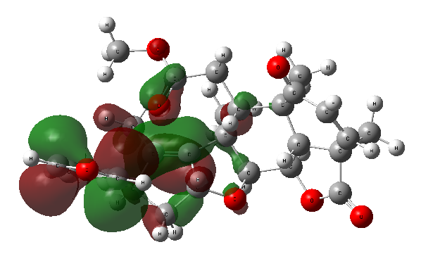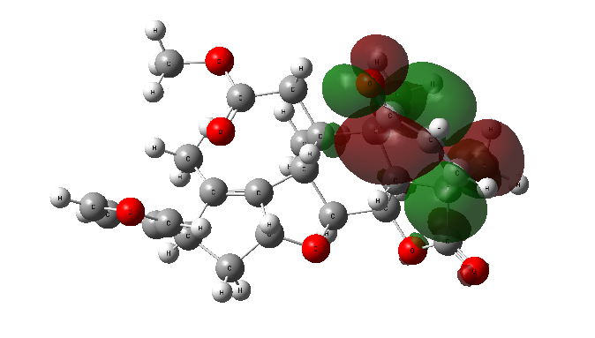

Fig: HOMO-LUMO Structure of Binder (CID 12313376)

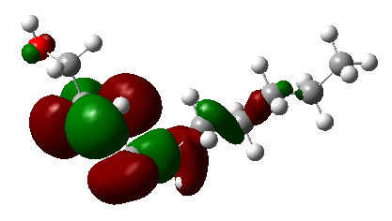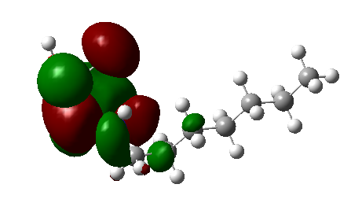

Fig: HOMO-LUMO Structure of Linker (CID 135304905)

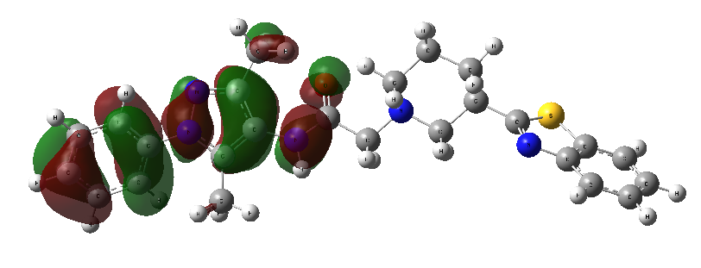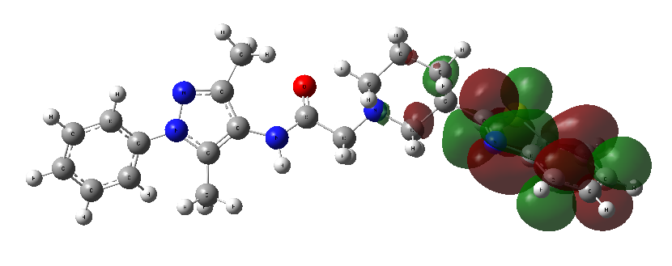

Fig: HOMO-LUMO Structure of Warhead (CID 16358423)

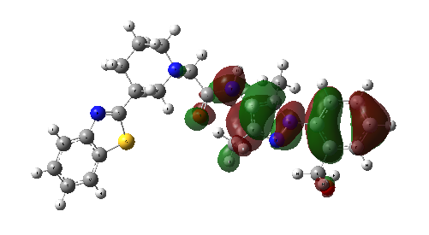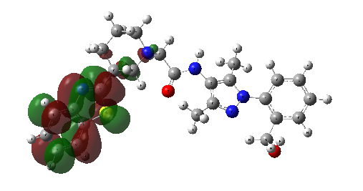

Fig: HOMO-LUMO Structure of FBDD Generated Warhead

**PROTAC 1-protein complex**

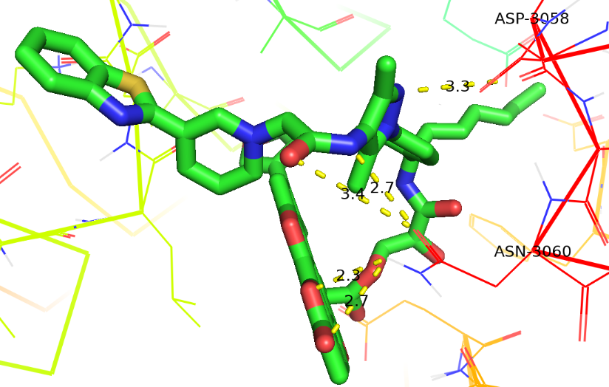

Fig: 3D Interaction between PROTAC 1 and **Protein–Protein Complex**

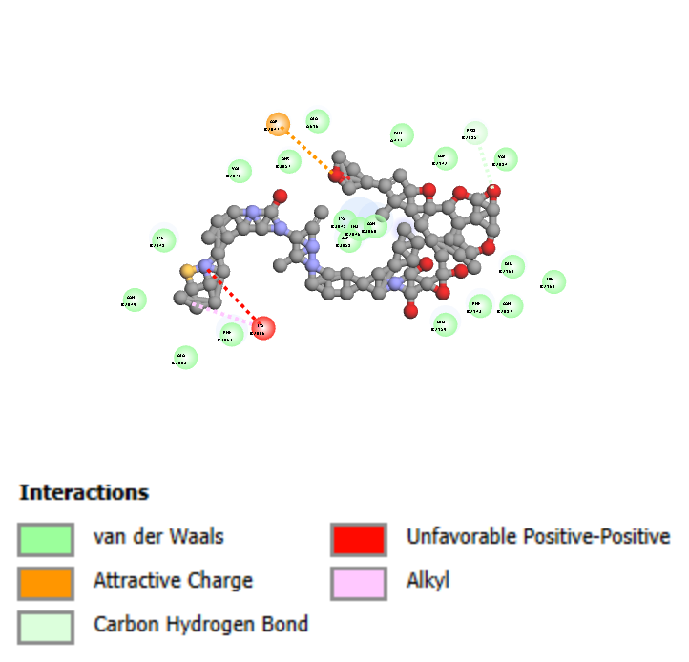

Fig: 2D Interaction between PROTAC 1 and **Protein–Protein Complex**

**PROTAC 2-protein complex**

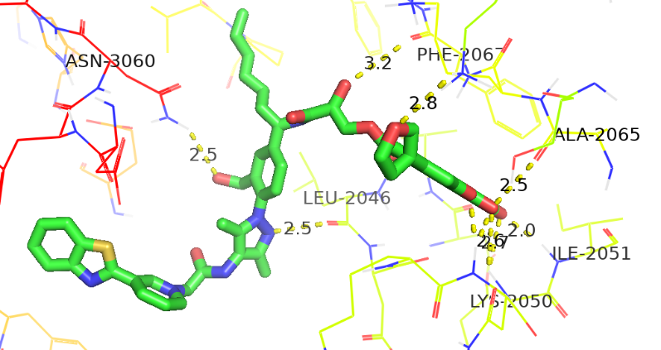

Fig: 3D Interaction between PROTAC 2 and **Protein–Protein Complex**

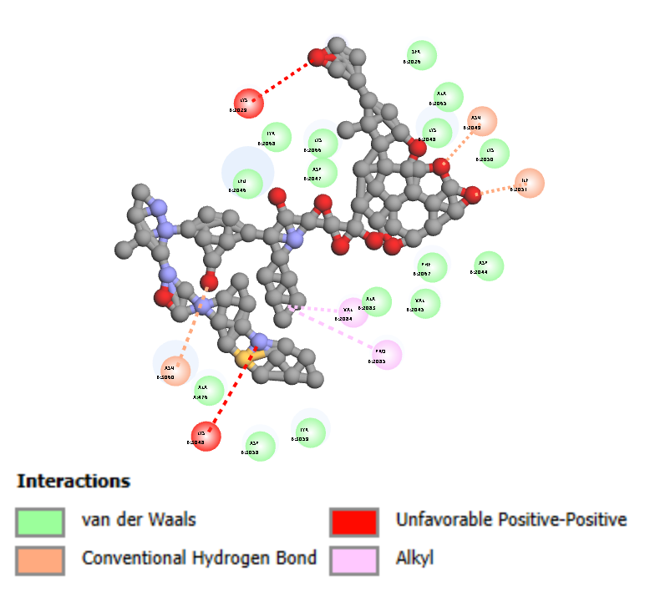

Fig: 2D Interaction between PROTAC 2 and **Protein–Protein Complex**

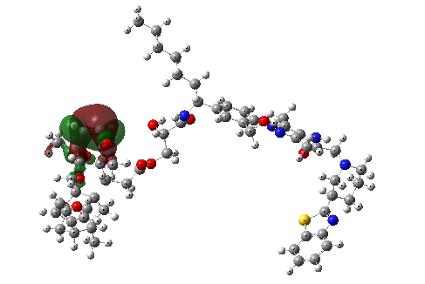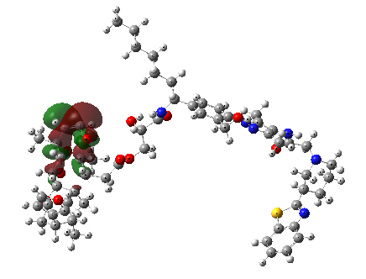

Fig: HOMO -LUMO Structure of PROTAC 1

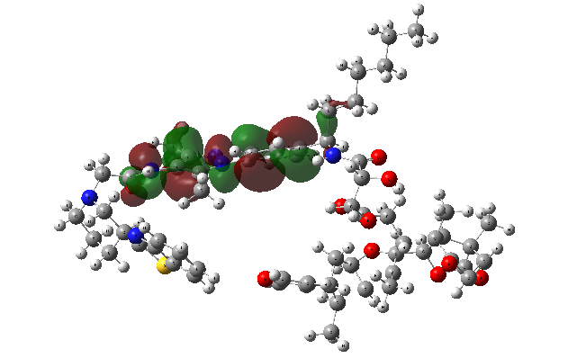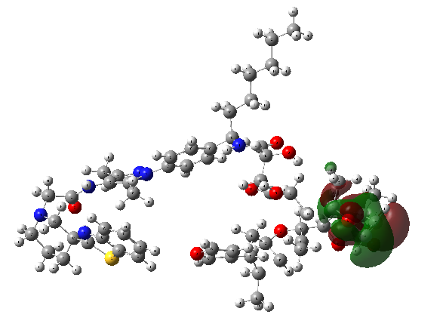

Fig: HOMO -LUMO Structure of PROTAC 2