**Java Collection Framework**

**Objective**

This document demonstrates the implementation and usage of key Java Collection Framework interfaces. It provides working examples for each interface along with explanations, performance considerations, and real-world use cases.

**1. Collection Interface**

The Collection interface is the root of the Java Collection Framework. It provides basic operations such as adding, removing, clearing elements, and checking the size.

**Example:**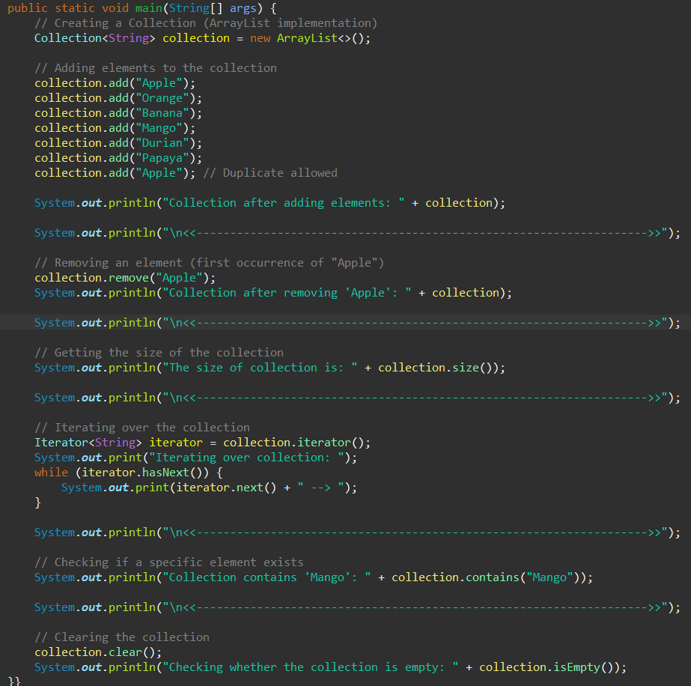

**Performance Considerations:**

* ArrayList provides **fast read access** but **slow insert/remove operations**.
* LinkedList is better for **frequent insertions/removals**.

**2. List Interface**

A List is an ordered collection that allows duplicate elements. Common implementations:

* **ArrayList** (Dynamic array, fast random access)
* **LinkedList** (Doubly linked list, fast insertion/removal)
* **Vector** (Synchronized, thread-safe)

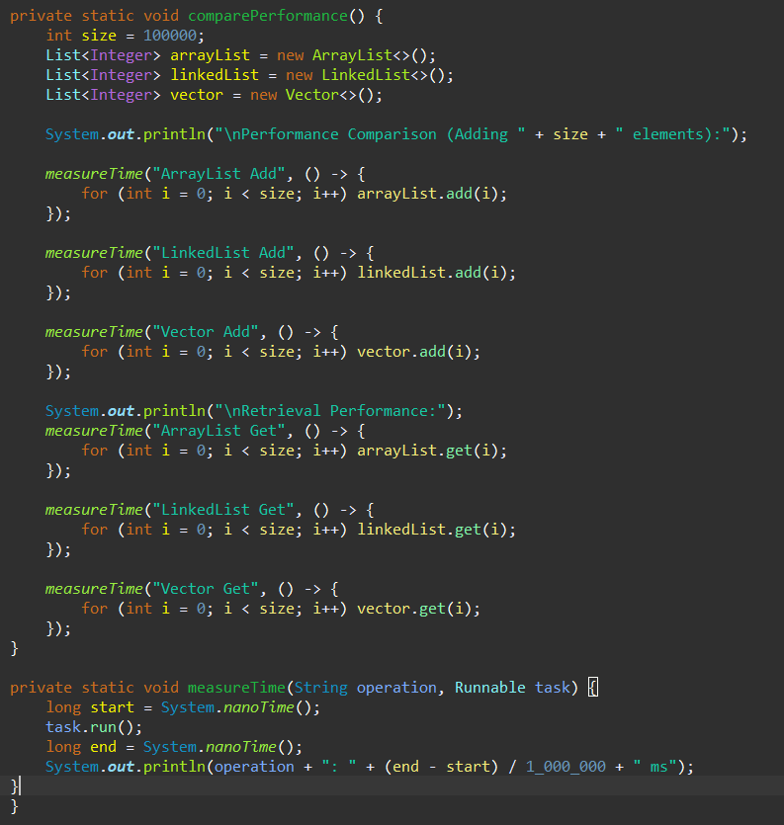**Performance Considerations:**

* ArrayList is better for **frequent reads**.
* LinkedList is better for **frequent insertions/removals**.
* Vector is **thread-safe**, but ArrayList is preferred in single-threaded environments.

**3. Set Interface**

A Set does not allow duplicate elements. Common implementations:

* **HashSet** (Unordered, best performance for basic operations)
* **LinkedHashSet** (Maintains insertion order)
* **TreeSet** (Sorted order)

**Example:**

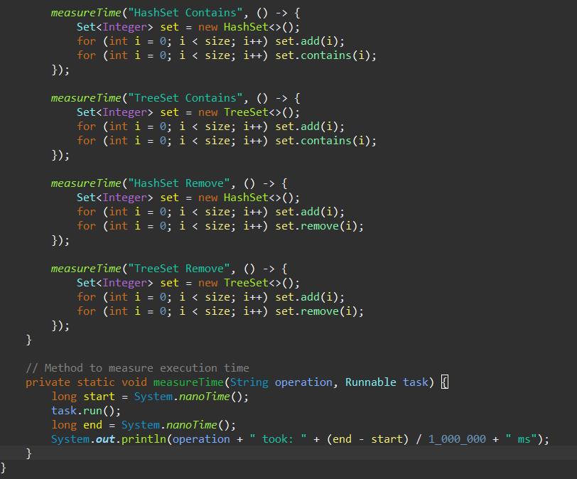**Performance Considerations:**

* HashSet is best for **fast lookups**.
* LinkedHashSet maintains **insertion order**.
* TreeSet is **sorted** but slower due to balancing operations.

**4. Queue Interface**

A Queue follows **FIFO (First-In-First-Out)**. Common implementations:

* **LinkedList** (FIFO behavior)
* **PriorityQueue** (Elements are ordered based on priority)

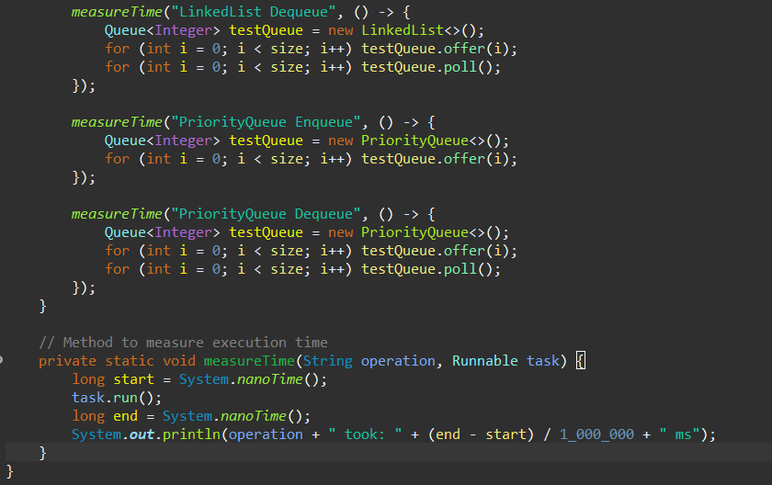

**Performance Considerations:**

* LinkedList is used for simple **FIFO queues**.
* PriorityQueue maintains **priority order** but has **logarithmic time complexity**.

**5. Deque Interface**

A Deque (Double-ended Queue) allows insertions/removals from both ends. ArrayDeque is a common implementation.

**

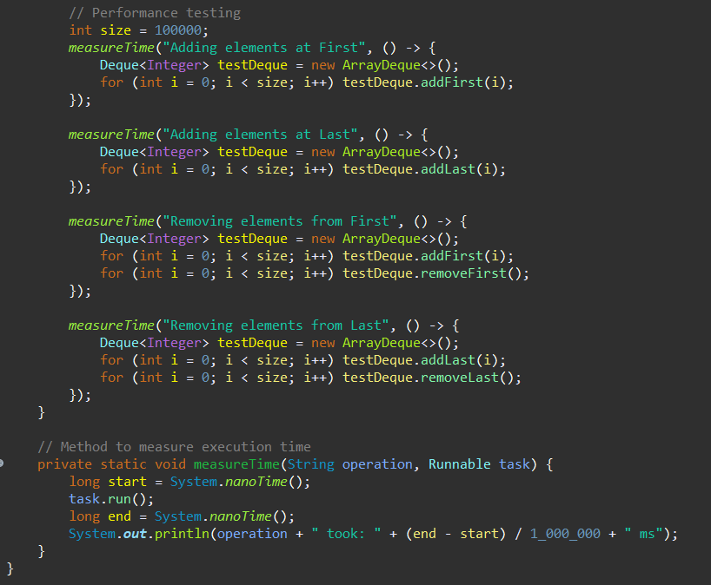**Performance Considerations:**

* ArrayDeque is **faster than LinkedList** for both stack and queue operations.

**6. Map Interface**

A Map stores key-value pairs. Common implementations:

* **HashMap** (Unordered, fast lookup)
* **LinkedHashMap** (Maintains insertion order)
* **TreeMap** (Sorted keys)

**Example:**

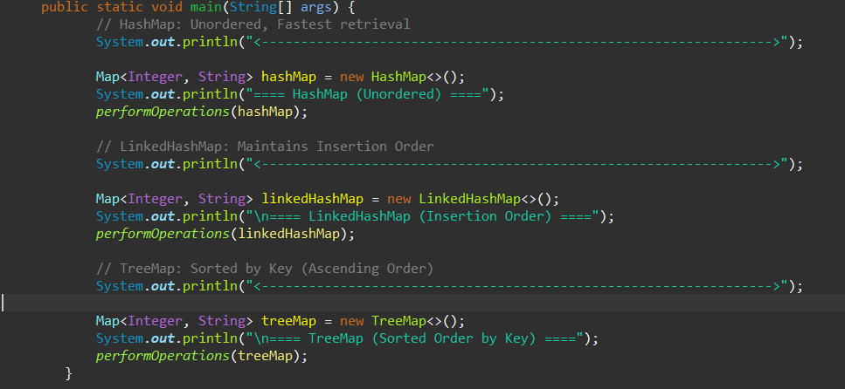

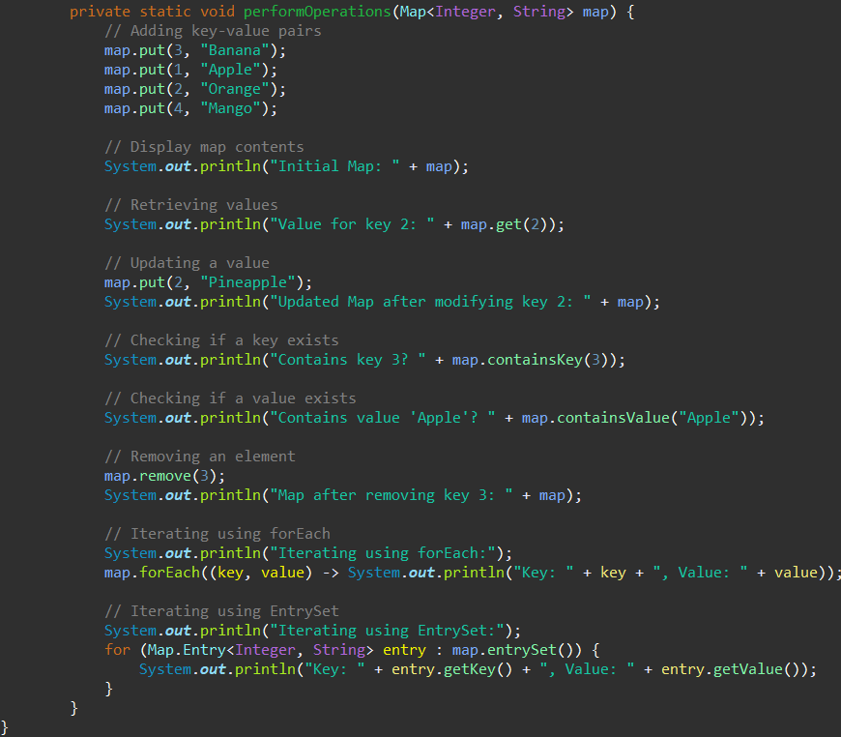

**Performance Considerations:**

* HashMap is best for **fast lookups**.
* LinkedHashMap is useful for **ordered access**.
* TreeMap provides **sorted keys**, but is slower than HashMap.

**Conclusion**

This document provides a comprehensive **Proof of Concept (PoC)** for the Java Collection Framework, covering key interfaces (Collection, List, Set, Queue, Deque, and Map). Each section includes:

* **Example Code**
* **Performance Considerations**
* **Real-World Use Cases**