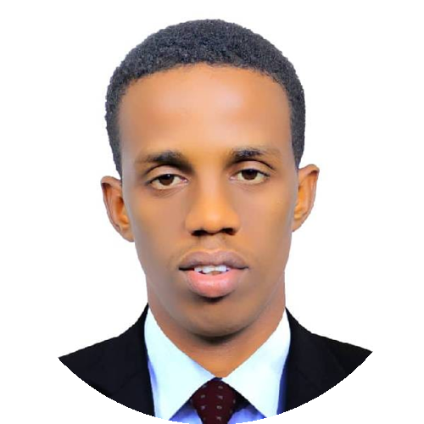  SADAK HASSAN  AHMED  FULL-STACK  SOFTWERE  DEVELOPER  CONTACT  +252 613 170 796  Sadaqsamor99@gmail.com  github.com/sadaqhassan  sadak-hasan.vercel.app  Mogadishu, Somalia  TECHNICAL SKILLS  Languages  • JavaScript  • Python  Frontend  • React.js  • HTML/ CSS /TailwindCss  • Reactjs  • Nextjs  Backend  • Node.js  • Express.js  Mobile  • React Native  Databases  • MongoDB  • PostgreSQL  Tools & Practices  • Git & GitHub  • REST API Development  • DevOps Fundamentals  LANGUAGES  Somali — Excellent  English — Very Good  Arabic — Good | PROFESSIONAL SUMMARY  Motivated and detail-oriented Full-Stack Web Developer with a Bachelor's degree in Computer Science and Information Technology. Experienced in designing and developing responsive web and mobile applications using modern technologies, with a focus on e-commerce and dropshipping store development. Skilled across the frontend and backend, database management, version control, and software development best practices. Passionate about building scalable solutions, learning emerging technologies, and contributing to innovative software development teams.  PROJECTS  School Management System — A complete web application for managing students, teachers, attendance, courses, and academic records.  Bus Booking App — An online transportation booking platform that allows users to search, reserve, and manage bus tickets efficiently.  Students Hub — A student community platform where users can share educational content, upload learning materials, and interact with other students.  Meal Planner App — A smart meal planning application that helps users organize daily meals, manage nutrition plans, and schedule recipes.  Nice Shore — A smart project combines a refined visual identity inspired by ocean and shoreline tones with a server that handles authentication, user management, and beach-related data.  EDUCATION  Bachelor of Computer Science and Information Technology  Somali International University (SIU) | 2022 – 2026  Training in MERN Stack Web Development  SIU Innovation Center | 2024 – 2025  Training in Internet of Things (IoT)  SIU Innovation Center  Secondary School Certificate  Jaabir Binu Hayaan Secondary School | 2018 – 2022  Primary Education  Care School & Jaabir Binu Hayaan Nasteexo | 2010 – 2018  CERTIFICATIONS  • Bachelor of Computer Science and Information Technology  • Secondary School Certificate  • MERN Stack Web Development Training Certificate  • Internet of Things (IoT) Training Certificate  REFERENCES  Dr. Rahma Hassan Ahmed  +252 617 597 356  RahmaHassanr99@gmail.com
  Dr. Aden Hassan Ahmed  +252 610 818 103  Adanwalihassan@gmail.com | Major Ismail Hassan Ahmed  SNA Officer  +252 615 442 531  xujo114@gmail.com

