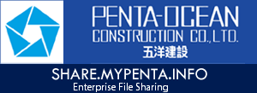

About SHARE.MYPENTA.INFO

Welcome to Penta-Ocean Enterprise file sharing platform, your self-hosted file sync and share solution.
Share.Mypenta.Info is the open source file sync and share software bases on Nextcloud for everyone from individuals to large enterprises and service providers. Nextcloud provides a safe, secure and compliant file sync and share solution on servers you control.
With Share.Mypenta.Info you can share one or more folders on your PC, and sync them with your Nextcloud server. Place files in your local shared directories, and those files are immediately synced to the server, and then to other PCs via the desktop client. Not near a desktop client? No problem, simply log in with the web client and manage your files there. The Android and iOS mobile apps allow you to browse, download and upload photos and videos.
Whether using a mobile device, a workstation, or a web client, Share.Mypenta.Info provides the ability to put the right files in the right hands at the right time on any device in one simple-to-use, secure, private and controlled solution.

All example pictures & music are licensed under Creative Commons Attribution.

