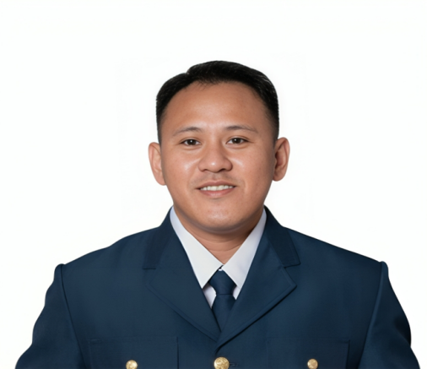
Bon Jovi F. Sadaya
Nationality: Filipino
Date of Birth: 01/02/2026
Height: 165cm Weight: 72Kg
Passport Number: Expiry:
09562972094
sadayabonjovi@gmail.com
Babag II, Lapu-Lapu City, Cebu, Philippines

🎯 Objective
Dedicated maritime professional with 6 years of service in the Philippine Coast Guard, seeking a Security Staff position aboard a cruise ship. Skilled in safety enforcement, emergency response, and maintaining order in high-pressure environments. Committed to ensuring passenger and crew security at sea.

🎓 Work Experience
Philippine Coast Guard Enlisted Personnel - May 01 2019 to Feb 14 2026

- Conducted port and vessel security inspections
- Supervised access control, screening, and surveillance operations
- Responded to emergencies including search and rescue, fire drills, and medical evacuations
- Trained junior personnel in maritime safety and security protocols
- Coordinated with local law enforcement and port authorities for joint operations

🛠️ Education
- Bachelor of Science in Aircraft Maintenance Technology
Philippine State College of Aeronautics, MBEAB Campus, Philippines
2014 Year Graduated

- Coast Guard Information System Technician Specialization Course
Coast Guard Weapons, Communications, Electronics, and Information System Command Training Institute
Headquarters Coast Guard District Central Visayas, Pier 3, Cebu City
Graduated as top 1 in class out of 55 students

🛠️ Skills/Training
- Pre-Departure Inspection Training
- Basic Marpol Inspection Training
- Basic Life Support Training
- Water Safety, Rescue and Survival Technique Training
- Computer System Servicing Tesda Certificate NCII
- Vessel Safety Enforcement Inspection Training
- Coast Guard Information System Technician Specialization Course graduated as top 1 in class out of 55 students
- Knowledge of ISPS Code and STCW standards
- Team leadership and discipline
- Maritime Security and Surveillance
- Crowd Control and Conflict Resolution
- Conducts Emergency Readiness Evaluation

🧪 Documents
- Valid Passport
- Seaman’s Book
- Medical Certficate
- STCW Basic Safety Training

🧍 References
LTJG ZANDRO P PINZON PCG, Commanding Officer of Coast Guard Station Camotes - 63969 302 0511

