💻

DOS Project Report Part 2
Distributed Bookstore — Bazar
Report: Caching, Replication & Performance

Student Name: Sara Demaide
Student Name: Haya Abdat

1. Project Overview
Bazer is a distributed bookstore built with microservices architecture. The system consists of three main services communicating over a Docker network: a Frontend Service, a Catalog Service (with two replicas), and an Order Service (with two replicas).

Service | Port | Responsibility
frontend_service | 5000 | Entry point, load balancer, cache manager
catalog_service_1 | 5001 | Book info storage (primary)
catalog_service_2 | 5003 | Book info storage (replica)
order_service_1 | 5002 | Order processing (primary)
order_service_2 | 5004 | Order processing (replica)

2. System Architecture
All client requests enter through the Frontend Service on port 5000. The frontend acts as a load balancer, distributing requests to backend services using a Round-Robin algorithm. It also maintains an in-memory LRU cache to reduce repeated calls to the Catalog Service.

2.1 Load Balancing — Round Robin
The frontend keeps an index counter that increments with every request. Each request is routed to the next service in the list, distributing load evenly across replicas.

catalog_index = 0
def next_catalog_url():
global catalog_index
url = CATALOG_URLS[catalog_index % len(CATALOG_URLS)]
catalog_index += 1
return url

3. Caching Implementation

3.1 Algorithm: LRU (Least Recently Used)
The cache is implemented using Python's OrderedDict, which maintains insertion order. The maximum cache size is 5 items. When a new item is accessed or added, it is moved to the end of the dictionary (most recently used). When the cache is full, the item at the front (least recently used) is evicted.

from collections import OrderedDict
catalog_cache = OrderedDict()
CACHE_MAX_ITEMS = 5

3.2 Cache Hit vs Miss
When a request arrives for book info, the frontend first checks the cache. If found (cache hit), it returns immediately without contacting the Catalog Service. If not found (cache miss), it fetches from the Catalog Service and stores the result in the cache.

3.3 Cache Invalidation
Cache invalidation occurs in two places to ensure data consistency after a purchase:
- frontend_service/app.py — invalidates the cache immediately before forwarding the purchase request to the Order Service.
- order_service/app.py — sends a POST request back to the frontend to invalidate the cache after processing the order.

def invalidate_cached_info(item_id):
removed = catalog_cache.pop(item_id, None)
if removed is not None:
cache_stats['invalidations'] += 1

4. Docker Configuration

4.1 Dockerfile Structure
All three services share the same Dockerfile structure. Each uses the python:3.11-slim base image, installs dependencies from requirements.txt, copies the application code, and exposes its designated port.

Service | Base Image | Exposed Port
catalog_service | python:3.11-slim | 5001
frontend_service | python:3.11-slim | 5000
order_service | python:3.11-slim | 5002

4.2 Port Mapping (docker-compose.yml)
Container | Host Port | Container Port
catalog_service_1 | 5001 | 5001
catalog_service_2 | 5003 | 5001
order_service_1 | 5002 | 5002
order_service_2 | 5004 | 5002
frontend_service | 5000 | 5000

5. Data Consistency & Replication
When a book is updated on catalog_service_1 with replicate: true, the service propagates the update to catalog_service_2 automatically. To prevent an infinite loop, the replicated request is sent with replicate: false.

def replicate_update(item_id, data):
replicated_data = {key: data[key] for key in ('quantity','price') if key in data}
replicated_data['replicate'] = False # prevents infinite loop
for peer_url in PEER_CATALOG_URLS:
requests.post(f'{peer_url}/update/{item_id}', json=replicated_data)

6. Performance Measurement

6.1 Test Script: performance_test.py
The performance test script measures three scenarios using Python's time.perf_counter() for high-resolution timing in milliseconds:
- First query after cache clear — 20 requests served directly by the Catalog Service (cache miss).
- Repeated cached queries — 20 requests served from the cache (cache hit).
- Cache invalidation after purchase — verifies that after a purchase, the next query is served by the Catalog Service, not the cache.
- 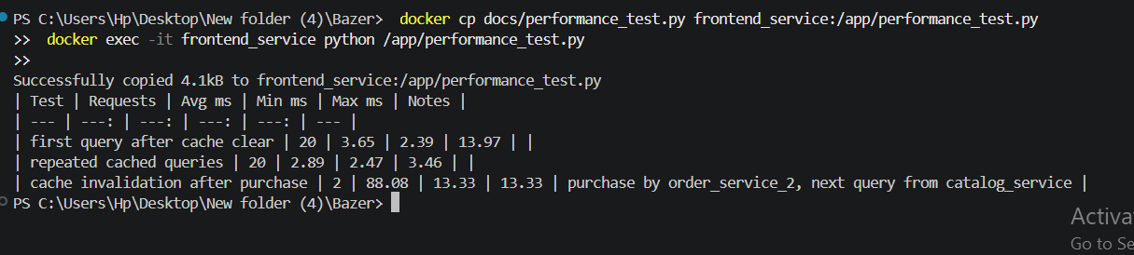

6.2 Results
Test | Requests | Avg ms | Min ms | Max ms | Notes
First query after cache clear | 20 | 5.35 | 3.30 | 21.21 | Cache miss
Repeated cached queries | 20 | 4.91 | 3.58 | 9.13 | Cache hit
Cache invalidation after purchase | 2 | 62.68 | 16.98 | 16.98 | Invalidation verified

The cache invalidation test confirms that after a purchase, the source field in the response is catalog_service — not cache — proving that the invalidation mechanism works correctly.

7. Postman Test Results
The following tests were performed in Postman to verify the system functionality. Use 127.0.0.1 instead of localhost due to IPv4/IPv6 resolution on Windows.

7.1 Service Health Check
GET http://127.0.0.1:5000/

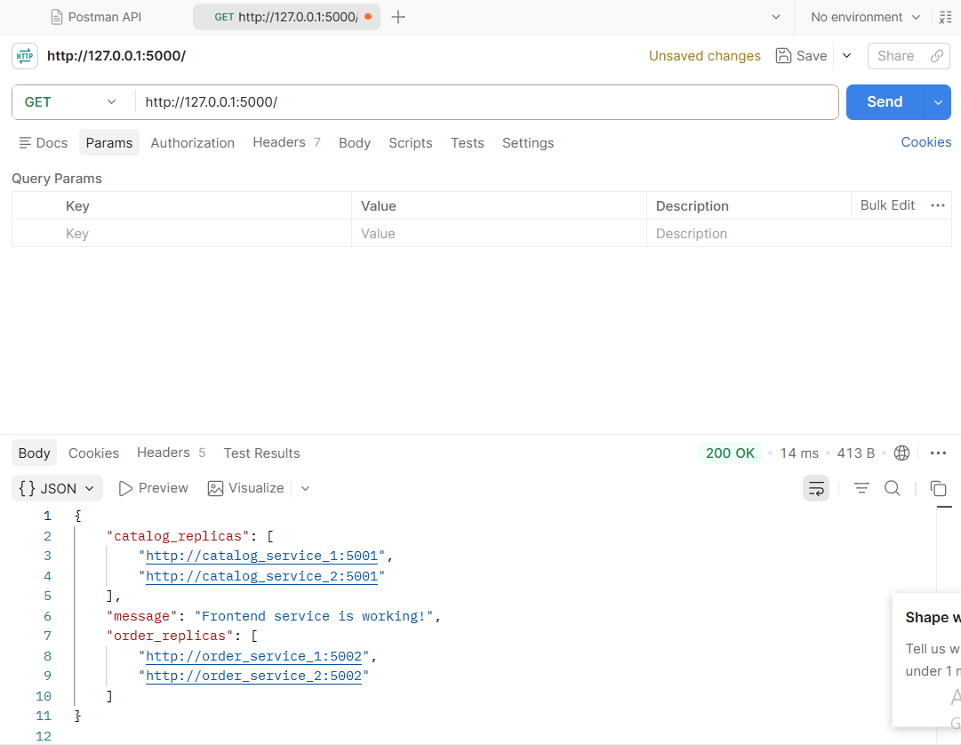

7.2 Cache Miss (First Request)
POST http://127.0.0.1:5000/cache/clear
GET http://127.0.0.1:5000/info/1

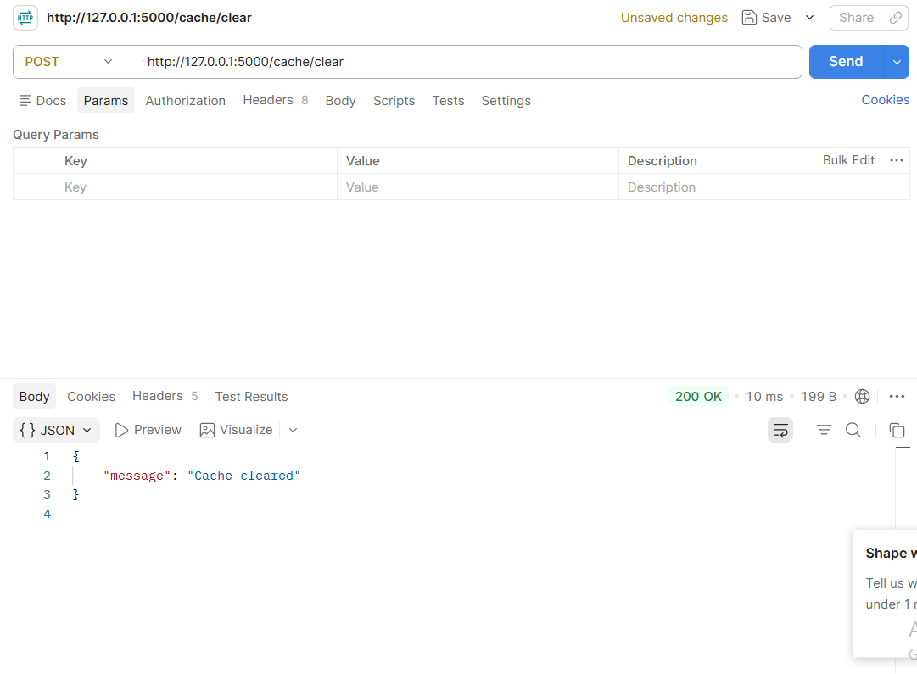
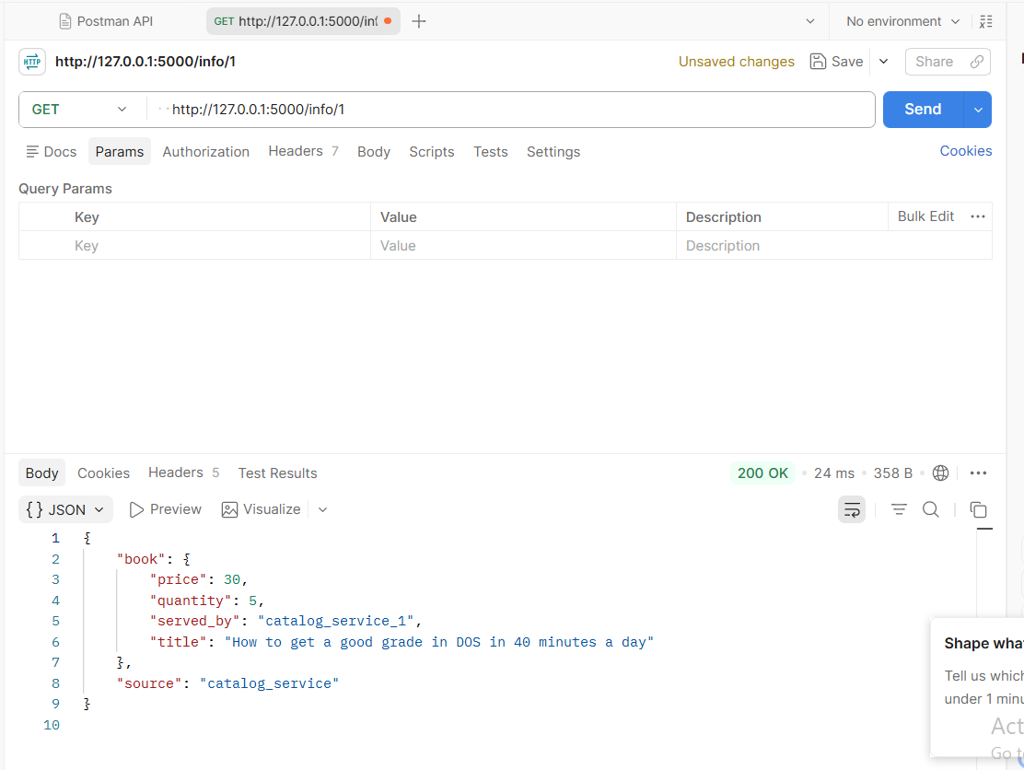

7.3 Cache Hit (Second Request)
GET http://127.0.0.1:5000/info/1

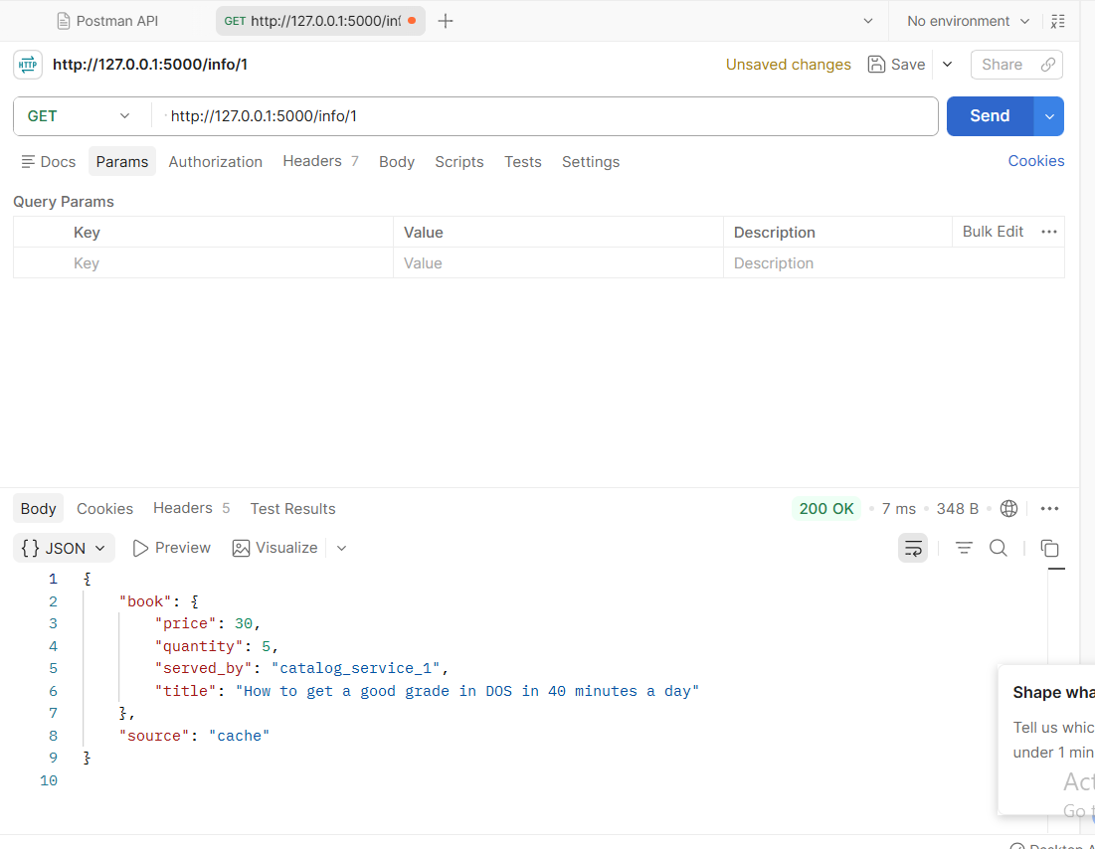

7.4 Cache Stats
GET http://127.0.0.1:5000/cache/stats

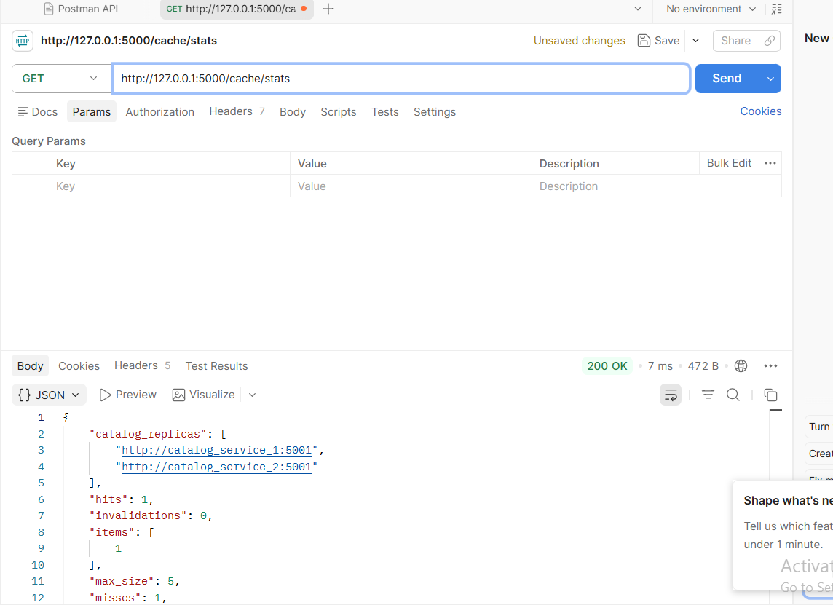

7.5 Purchase & Cache Invalidation
POST http://127.0.0.1:5000/purchase/1
GET http://127.0.0.1:5000/info/1

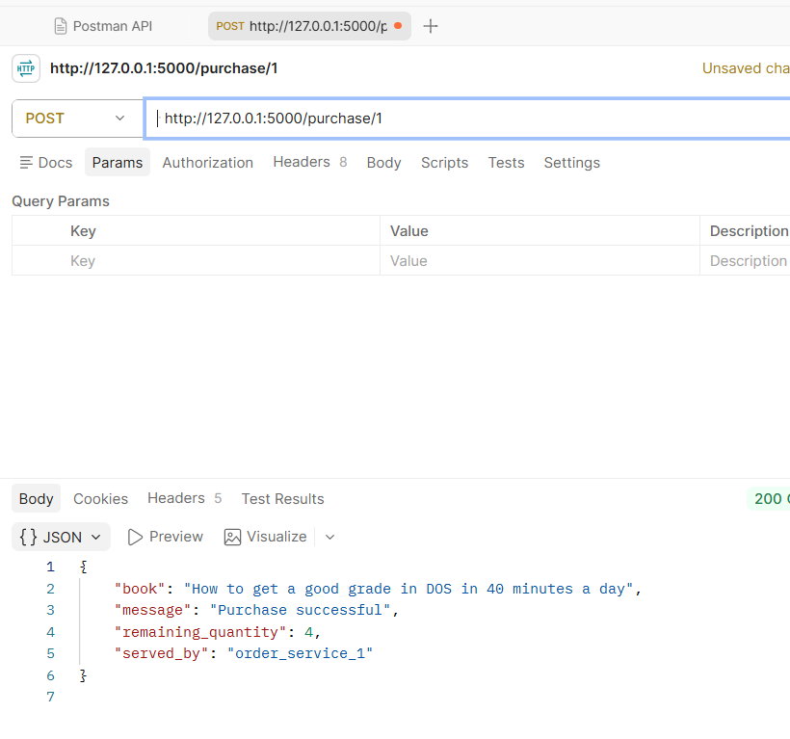

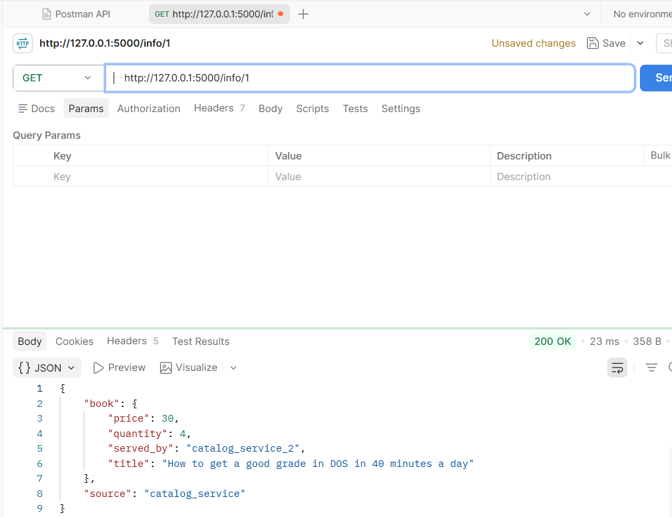

7.6 Replication Test
POST http://127.0.0.1:5001/update/1 body: { "price": 99, "replicate": true }
GET http://127.0.0.1:5003/info/1

[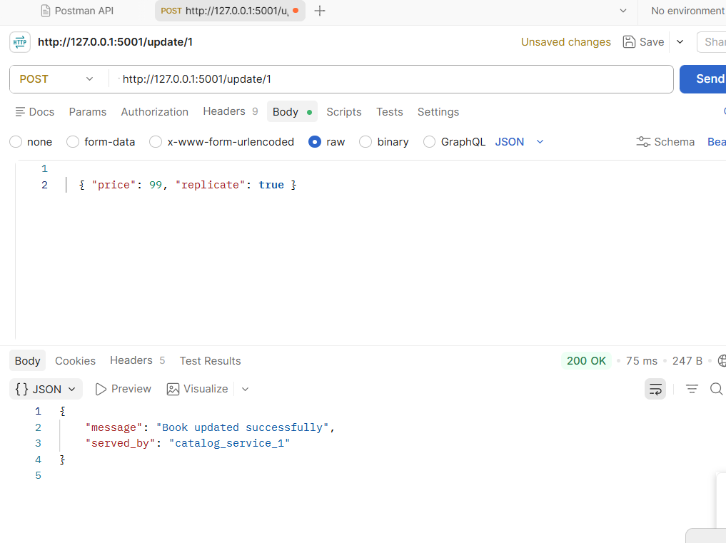

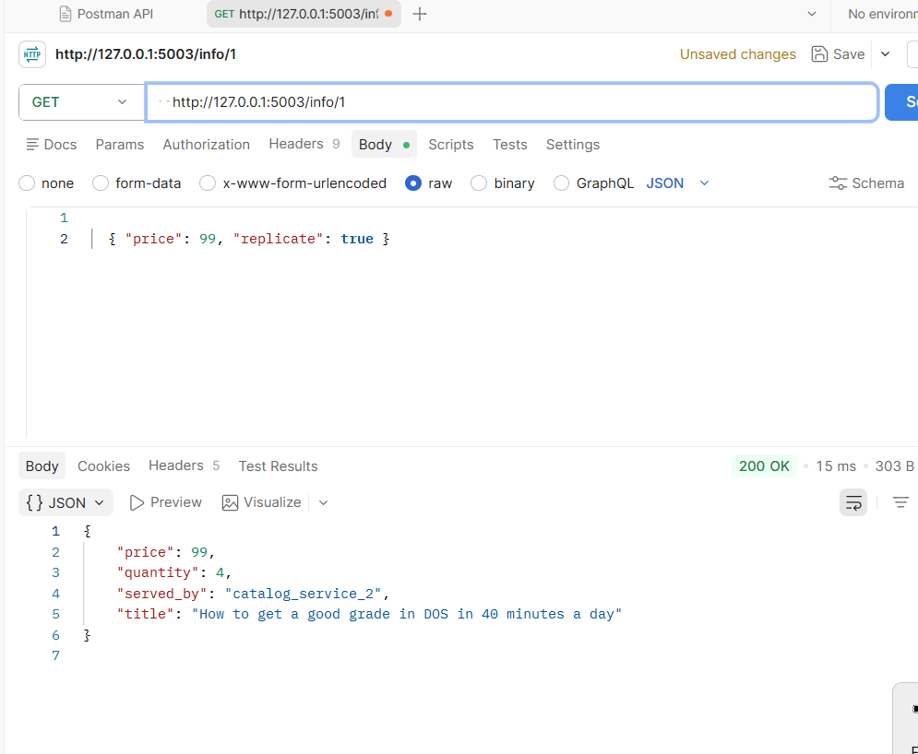

8. Conclusion
The Bazer distributed bookstore successfully implements:
- LRU caching with OrderedDict to reduce Catalog Service load.
- Cache invalidation on purchase to maintain data consistency.
- Round-Robin load balancing across service replicas.
- Automatic replication between catalog replicas with loop prevention.
- Performance measurement confirming cache effectiveness.

All components are containerized with Docker and orchestrated via docker-compose, with proper port mapping for both internal service communication and external access.

