Software Design Document - Notes Sharing Backend
Prepared by: Sara Demaide (sadd33667) | Team backend
Stack: Spring Boot 4.1.1, Java 25, Maven, Spring Data JPA, Spring Security, H2 now / MySQL later
Repo: https://github.com/sadd33667/notes-sharing (branches: main, development, feature/*)

1. Purpose and Scope
This document describes the backend design of the Notes Sharing app: layers, database, APIs, security, and workflow. In scope: auth, notes CRUD, sharing with view/edit, friends, calendar/reminders, notifications, profile/settings. Out of scope for now: 2FA codes table, public-link sharing expiry, rich-text editor.

2. System Overview
REST API backend. Clients call /api/** with JSON. Request flows top-down only: Controller -> Service -> Repository -> Entity -> Database. H2 in-memory for development, MySQL profile ready for later.

3. Architecture
Layered architecture. Each layer has one job:
- Controller: HTTP only, validate input, call service, return response. Never business logic, never repository.
- DTO: request/response shapes. Never expose Entity or PasswordHash.
- Service: all business rules (ownership, sharing permission, friendship status).
- Repository: 6 Spring Data JPA interfaces, no raw SQL in code.
- Entity: 6 JPA classes matching the ERD tables.
- Mapper: Entity<->DTO in one place. Exception: one error shape {error}. Config/Security: outside business.
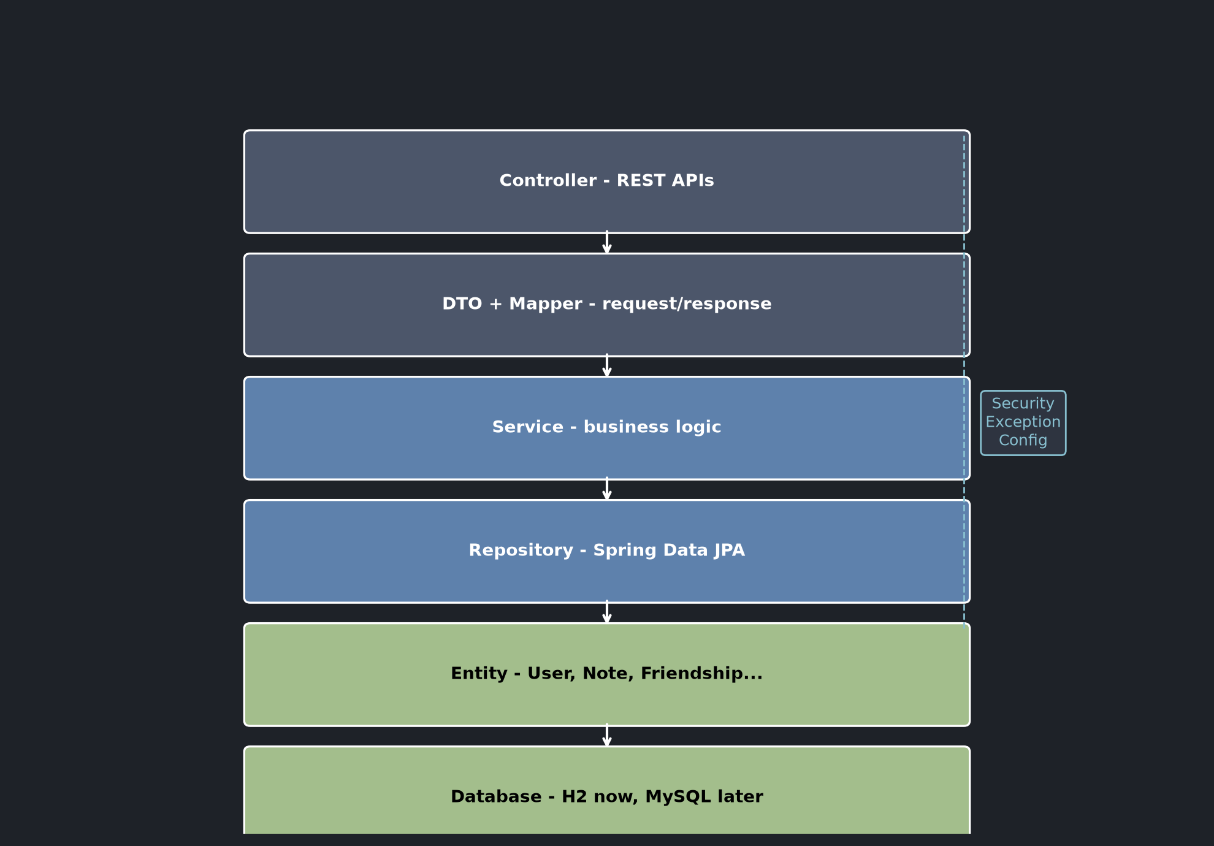

4. Database Design
6 tables. User is the center. 1-1 User-UserSettings. 1-N User-Notes (OwnerID), User-Friendships (FUserID/SUserID), User-Sharings. NoteSharing breaks the User-Note ManyToMany. Notification collects share/friend/reminder events. Email unique. Dates auto. Full column details: see Student_ERD_Explanation.docx.
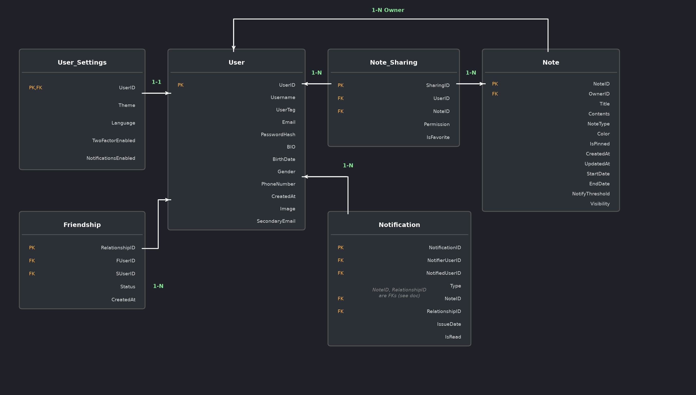

5. API Design
Base: /api. First live endpoint (tested, returns 201):
- POST /api/notes {ownerId, title, contents, noteType?, color?, visibility?} -> 201 {noteID, title, ...} | 404 {error} if user missing.
- Planned next: POST /api/auth/register, POST /api/auth/login, GET /api/notes?ownerId=, PUT /api/notes/{id}, DELETE /api/notes/{id}, POST /api/notes/{id}/share {userId, permission}, GET /api/friends, POST /api/friends/request.
- Conventions: POST=201, GET/PUT=200, errors always {error}. Validation via jakarta.validation.

6. Security
Passwords stored as hashes, never returned in DTOs. /api/** open temporarily for development; JWT login comes next. H2 console disabled in prod. 2FA flag exists in settings; codes table later if needed.

7. Git Workflow
main = stable, development = work. Every feature: branch feature/<name> from development -> commit (commit-msg skill style) -> push -> PR to development -> code-review skill -> merge. No direct merges. First PR: feature/create-note (Create Note API + CreateNoteTest).

8. Testing (TDD)
RED-GREEN-REFACTOR. Proof: CreateNoteTest saves a user, posts a note via service, asserts noteID/title/owner. Run: ./mvnw test -Dtest=CreateNoteTest. Verified live POST returns 201 with noteID 1.

9. Configuration and Deployment
Default profile: H2 mem (notesdb, ddl-auto=update, data.sql seeds demo user). MySQL profile ready: application-mysql.properties + mysql-init.sql; run with -Dspring-boot.run.profiles=mysql after creating notesdb. Build: ./mvnw compile; run: ./mvnw spring-boot:run (Java 25, JAVA_HOME set).

10. Open Decisions for Trainer
- Confirm: link-sharing with expiry needed? 2FA codes table or flag enough? Rich editor or plain text first? Calendar reminders via threshold only?

End of SDD v1. Prepared before trainer vacation week; backend work starts from it.

