Custom-built MCP Servers
A suite of MCP (Model Context Protocol) servers built for Quality Engineering and SDLC workflows, enabling AI assistants to capture network traffic, generate test plans, and produce API specifications — all through natural language.
MCP Servers:
All servers run on a remote machine and communicate with the AI assistant via HTTP transport. Prompts are defined as /.github/prompts/*.prompt.md files (not @mcp.prompt() decorators).
Server | Port | Public Tools | Description
DevTools to HAR | 8001 | 10 | Captures live network traffic from Chrome/Edge via CDP; returns HAR 1.2 JSON content
JMeter | 8002 | 7 | Creates JMeter 5.4.3 / OpenJDK 11 test plans (.jmx) from HAR content or OpenAPI 3.0.3 specs; returns JMX strings
OpenAPI | 8003 | 6 | Generates OpenAPI 3.0.3 specs from Spring Boot source code or HAR traffic; merges and validates specs
Rest Assured | 8004 | 5 | Generates Java API functional test frameworks (Cucumber + Rest Assured + TestNG) from OpenAPI specs or HAR traffic
WireMock | 8006 | 5 | Converts HAR traffic into WireMock 3.9.1 stub mapping files (.json) with response body files
Postman | 8007 | 9 | Generates Postman Collection v2.1 JSON, environments, and Newman CI/CD configs from HAR or OpenAPI
Playwright | 8008 | 6 | Generates Playwright + TypeScript test projects with page objects from HAR or OpenAPI
Contract Testing | 8009 | 6 | Generates Pact v4 contracts and Spring Cloud Contract Groovy DSL from OpenAPI or HAR

Note: Each server includes a health-check tool (included in the counts above) that returns server name, version, status, and uptime.

Quick Start:
Automated Setup (recommended)
# Clone the repository
git clone <repository-url>
cd qe-mcp-servers
# One-time setup (venv + dependencies + firewall rules)
.\scripts\setup.ps1
# Start all servers (background jobs, bind to 0.0.0.0 for remote access)
.\scripts\start-servers.ps1
# Stop all servers
.\scripts\stop-servers.ps1
Manual Setup
# Create virtual environment
python -m venv .venv
.venv\Scripts\Activate.ps1
pip install -r requirements.txt
# Start individual servers (default: localhost only)
$env:MCP_BIND_HOST = "0.0.0.0" # Set to bind on all interfaces for remote access
python devtools_to_har_mcp.py # DevTools → http://0.0.0.0:8001/mcp
python jmeter_mcp.py # JMeter → http://0.0.0.0:8002/mcp
python openapi_mcp.py # OpenAPI → http://0.0.0.0:8003/mcp
python restassured_mcp.py # Rest Assured → http://0.0.0.0:8004/mcp
python wiremock_mcp.py # WireMock → http://0.0.0.0:8006/mcp
python postman_mcp.py # Postman → http://0.0.0.0:8007/mcp
python playwright_mcp.py # Playwright → http://0.0.0.0:8008/mcp
python contract_test_mcp.py # Contract Testing→ http://0.0.0.0:8009/mcp

Architecture (Remote-Server Model):
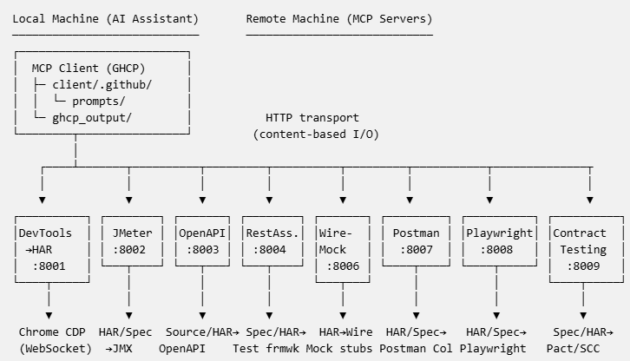

Content-based I/O: Tools accept content strings as input and return content/results as strings. HAR-processing tools also accept a har_file_path parameter for same-machine scenarios, avoiding large inline payloads. For very large HAR files in remote deployments, use client/send_har.py to call tools directly from the terminal. The AI assistant handles all local file reads/writes.
Cross-Server Workflows:
The servers are designed to work together. JMeter, OpenAPI, Rest Assured, WireMock, Postman, Playwright, and Contract Testing are downstream consumers of .har file artifacts produced by the DevTools to HAR server — they depend on .har files but have no dependency on the DevTools to HAR server at runtime. Several servers can additionally consume OpenAPI specs produced by the OpenAPI server:
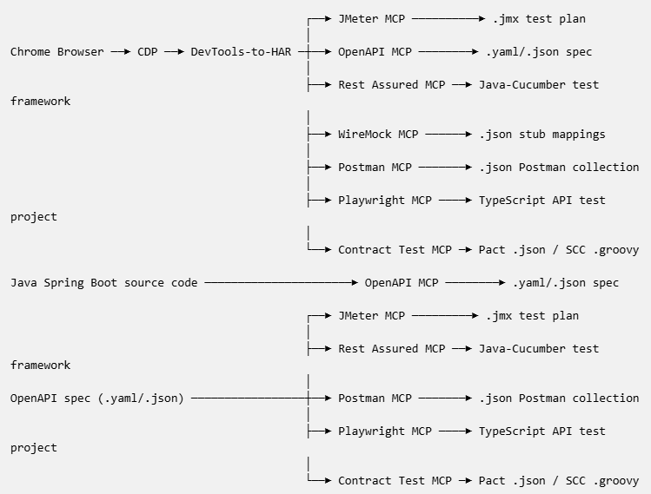

Note: JMeter, OpenAPI, Rest Assured, WireMock, Postman, Playwright, and Contract Testing can all consume .har files exported manually from the Chrome DevTools Network tab. The OpenAPI server can additionally generate specs directly from Java Spring Boot source code (no .har required). JMeter, Rest Assured, Postman, Playwright, and Contract Testing servers can also consume OpenAPI specs generated by the OpenAPI MCP Server.
Exclusion Configuration:
All traffic-processing servers (DevTools to HAR, JMeter, OpenAPI, WireMock, Postman, Playwright, Contract Testing) share a common set of exclusion rules via lib/config_loader.py. In the remote-server model, exclusion rules are defined in /.github/copilot-instructions.md and passed to tools via the exclude_config_json parameter. When omitted, built-in defaults are used.
Filter Category | Purpose
Non-HTTP schemes | Requests using blob:, data:, chrome-extension: schemes are always rejected (code-level)
excluded_domains | Hostnames always excluded from capture/conversion
excluded_path_patterns | URL path substrings always excluded (case-insensitive)
excluded_http_methods | HTTP methods always excluded (e.g. OPTIONS)
excluded_urls | Full URLs always excluded (exact match)
excluded_extensions | Static resource file extensions excluded
excluded_content_types | Static resource MIME types excluded

See /.github/copilot-instructions.md for the full exclusion config JSON that the AI assistant passes to tools.
Typical end-to-end workflows”
- Capture network traffic with the DevTools to HAR server, or export manually from Chrome DevTools (F12 → Network → Export HAR — useful in restricted Virtual Desktop without admin privileges)
- Create a JMeter test plan from the .har file or from an OpenAPI spec
- Generate an OpenAPI spec from the .har file or from Spring Boot source code
- Merge OpenAPI specs from multiple sources (source code + HAR) for a complete API contract
- Validate the generated OpenAPI spec for structural correctness
- Generate WireMock stub mappings from the .har file for mock server testing
- Create a Postman collection and Newman CI/CD config from the .har file or OpenAPI spec
- Generate Playwright + TypeScript test projects from the .har file or OpenAPI spec
- Generate Pact v4 contract tests or Spring Cloud Contract DSL from the OpenAPI spec or HAR traffic

Example Prompts:
Server | Try This
DevTools to HAR | "Capture traffic from https://example.com for 10 seconds"
JMeter | "Create a JMeter test from the HAR file in ghcp_output/"
JMeter | "Create a JMeter test from the OpenAPI spec at ghcp_output/my-api.yaml"
OpenAPI | "Generate an OpenAPI spec from the Spring Boot controllers in src/main/java/"
OpenAPI | "Create an OpenAPI spec from the HAR file at ghcp_output/my-app.har"
Rest Assured | "Generate Rest Assured API tests from the OpenAPI spec using Maven"
Rest Assured | "Create API functional tests from the HAR file with Gradle"
WireMock | "Convert the HAR file to WireMock mappings"
WireMock | "Analyze my-app.har and create WireMock stubs for example-app.com APIs"
Postman | "Create a Postman collection from the HAR file in ghcp_output/"
Postman | "Generate a Postman collection from the OpenAPI spec with Newman CI config"
Playwright | "Generate Playwright tests from the HAR file"
Playwright | "Create Playwright API tests from the OpenAPI spec"
Contract Testing | "Generate Pact contracts from the OpenAPI spec"
Contract Testing | "Create Spring Cloud Contract DSL from the OpenAPI spec"

Understanding Tools vs Prompts:
 | Tools | Prompts
What they do | Execute a single action and return data | Provide a multi-step workflow template for the AI
Where they live | Defined in *_mcp.py with @mcp.tool() | /.github/prompts/*.prompt.md files
How to use | Ask naturally; the AI picks the right tool | Select from the prompt picker (type /) or ask by name
Example | "List all open Chrome tabs" | "Use the capture_har_from_chrome prompt"
Output | Structured data (JSON) | AI-generated document (Markdown, JMX, etc.)

Documentation:
Local Setup Guide
New to the project? Start here: Local Setup Guide — step-by-step instructions for configuring your local VS Code + GitHub Copilot to connect to the remote MCP servers, customize exclusion filters, and run prompts.
User Guides (for End Users)
Server | Guide | What It Does
DevTools to HAR | User Guide | Capture live network traffic from Chrome/Edge via CDP; export, analyze, validate, and compare HAR files
JMeter | User Guide | Create JMeter 5.4.3 / OpenJDK 11 test plans (.jmx) from HAR files or OpenAPI specs; customize and validate JMeter test configurations
OpenAPI | User Guide | Generate OpenAPI 3.0.3 specs from Spring Boot source code or HAR traffic; merge and validate specs
Rest Assured | User Guide | Generate Java API functional test frameworks (Cucumber + Rest Assured + TestNG) from OpenAPI specs or HAR traffic
WireMock | User Guide | Convert HAR traffic into WireMock 3.9.1 stub mapping files with response body files
Postman | User Guide | Generate Postman Collection v2.1 JSON, environments, and Newman CI/CD configs from HAR or OpenAPI
Playwright | User Guide | Generate Playwright + TypeScript test projects with page objects from HAR or OpenAPI
Contract Testing | User Guide | Generate Pact v4 contracts and Spring Cloud Contract Groovy DSL from OpenAPI or HAR

Developer Guides (for contributors)
Server | Guide | Port | Key Topics
DevTools to HAR | Developer Guide | 8001 | CDP WebSocket client, HAR 1.2 builder, thread-pool body fetching
JMeter | Developer Guide | 8002 | JMeter test plan generation from HAR or OpenAPI, JMeter XML generation, schema-based sample body generation
OpenAPI | Developer Guide | 8003 | Spring Boot annotation parsing, HAR-to-OpenAPI inference, spec merging and validation
Rest Assured | Developer Guide | 8004 | OpenAPI/HAR parsing, Java code generation (Cucumber + Rest Assured + TestNG), Maven/Gradle support
WireMock | Developer Guide | 8006 | HAR filtering, WireMock stub mapping JSON generation, response body file creation
Postman | Developer Guide | 8007 | HAR/OpenAPI parsing, Postman Collection v2.1 generation, Newman CI/CD config
Playwright | Developer Guide | 8008 | HAR flow analysis, Page Object Model generation, TypeScript project scaffolding
Contract Testing | Developer Guide | 8009 | Pact v4 JSON builder, Spring Cloud Contract Groovy DSL, provider verification tests

Guardrails & Security:
All servers include built-in guardrails for production readiness:
Feature | Description
Rate Limiting | Token-bucket rate limiter (default 60 req/min per server)
Payload Size Validation | Rejects oversized payloads (default 50 MB)
Path Traversal Protection | File paths validated against allowed directories
Structured Logging | JSON-formatted logs with per-request correlation IDs
Standardized Responses | Consistent {"status": "success/error", ...} envelope format
Error Sanitization | Internal file paths stripped from error messages
Health Check | Every server exposes a health_check tool (server name, version, status, uptime)
Graceful Shutdown | SIGINT/SIGTERM handlers with cleanup logging
Localhost Binding | Default bind host is 127.0.0.1 (configurable via MCP_BIND_HOST)

Environment Variables:
Variable | Default | Purpose
MCP_LOG_LEVEL | INFO | Logging verbosity (DEBUG, INFO, WARNING, ERROR)
MCP_LOG_FORMAT | json | Log output format (json or text)
MCP_MAX_PAYLOAD_MB | 50 | Maximum payload size in MB
MCP_ALLOWED_FILE_DIRS | (cwd) | Comma-separated list of allowed file directories
MCP_RATE_LIMIT | 60 | Maximum requests per minute per server
MCP_BIND_HOST | 127.0.0.1 | Network interface to bind to (0.0.0.0 for remote access)

Note: The start-servers.ps1 script automatically sets MCP_BIND_HOST=0.0.0.0 so remote clients can connect. When starting servers manually for remote access, set $env:MCP_BIND_HOST = "0.0.0.0" before launching.
Running Tests:
python -m pytest tests/test_guardrails.py -v # 28 guardrail unit tests

Project Structure:
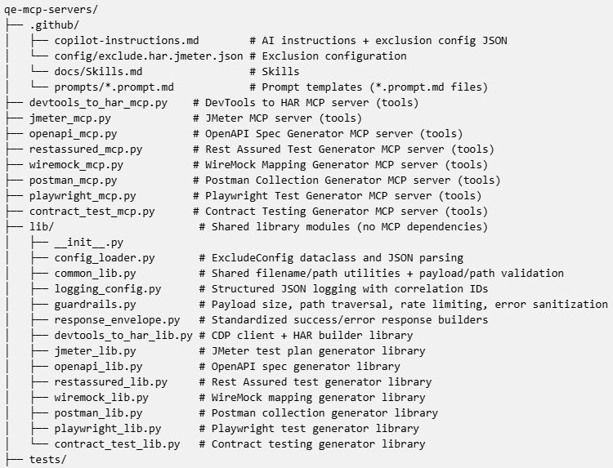
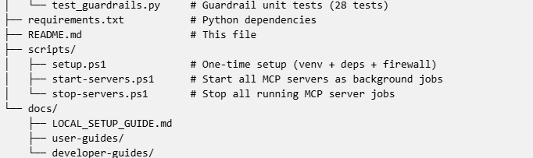

Requirements:
- Python 3.10+
- Chrome/Chromium/Edge with --remote-debugging-port=9222 --remote-debugging-address=0.0.0.0 (launched locally on the client machine; MCP server connects over the intranet)
- See requirements.txt for Python packages (fastmcp, requests, urllib3, PyYAML)

Further Reading:
Topic | Resource
MCP Specification | modelcontextprotocol.io
FastMCP Framework | FastMCP GitHub
Chrome DevTools Protocol | chromedevtools.github.io
HAR 1.2 Spec | softwareishard.com/blog/har-12-spec
OpenAPI 3.0.3 Spec | swagger.io/specification/v3
Rest Assured | rest-assured.io
Cucumber | cucumber.io/docs
TestNG | testng.org
WireMock | wiremock.org
Postman / Newman | learning.postman.com
Playwright | playwright.dev
Pact | docs.pact.io
Spring Cloud Contract | spring.io

