**Pods:**

Command : kubectl get pods

Result:

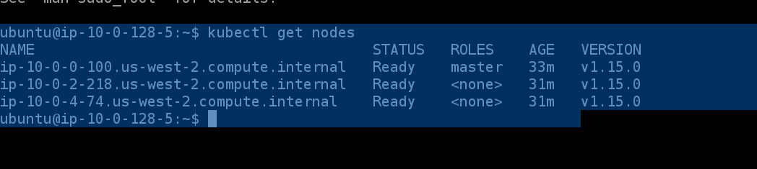

Command :cd src

Files you can find in below git hub:

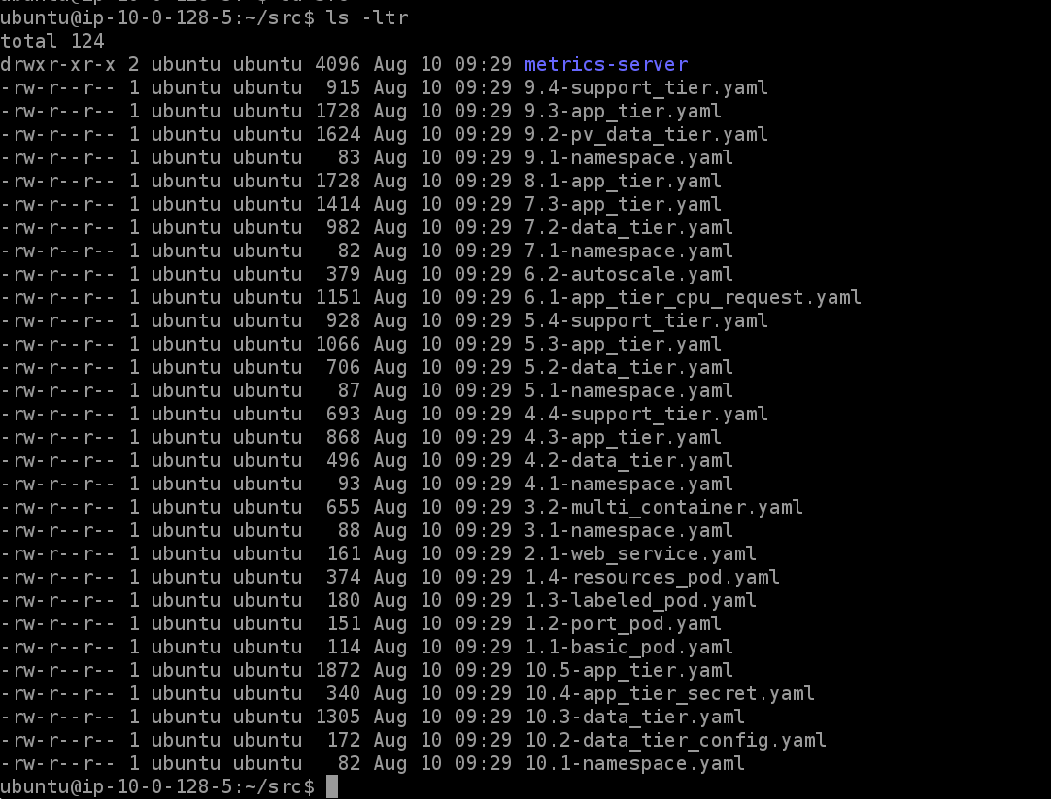

kubectl create -f 1.1-basic_pod.yaml

kubectl get pods

kubectl describe pod mypod | more

kubectl delete pod mypod

kubectl create -f 1.2-port_pod.yaml

kubectl describe pod mypod | more

curl 192.168.###.###:80 (Replace ###.### with the IP address octets from the describe output)

kubectl describe pod mypod | more

kubectl delete pod mypod

kubectl create -f 1.4-resources_pod.yaml

kubectl describe pod mypod | more

Note: kubectl will accept the singular or plural form of resource kinds. For example kubectl get pods and kubectl get pod are equivalent.

**Services:**

kubectl create -f 2.1-web_service.yaml

kubectl get services

kubectl describe service webserver

kubectl describe nodes | grep -i address -A 1

curl 10.0.0.100:3#### (replace #### with the actual port digits)

**Multi-Container Pods:**

kubectl create -f 3.1-namespace.yaml

kubectl create -f 3.2-multi_container.yaml -n microservice

kubectl get -n microservice pod app

kubectl describe -n microservice pod app

kubectl logs -n microservice app counter --tail 10

kubectl logs -n microservice app poller -f

**Service Discovery:**

kubectl create -f 4.1-namespace.yaml

kubectl create -f 4.2-data_tier.yaml -n service-discovery

kubectl get pod -n service-discovery

kubectl describe service -n service-discovery data-tier

kubectl create -f 4.3-app_tier.yaml -n service-discovery

kubectl create -f 4.4-support_tier.yaml -n service-discovery

kubectl get pods -n service-discovery

kubectl logs -n service-discovery support-tier poller -f

**Deployments:**

kubectl create -f 5.1-namespace.yaml

kubectl create -n deployments -f 5.2-data_tier.yaml -f 5.3-app_tier.yaml -f 5.4-support_tier.yaml

kubectl get -n deployments deployments

kubectl -n deployments get pods

kubectl scale -n deployments deployment support-tier --replicas=5

kubectl -n deployments get pods

kubectl delete -n deployments pods support-tier-... support-tier-... --wait=false (You can use tab completion to display the possible values to replace ... with)

watch -n 1 kubectl -n deployments get pods

kubectl scale -n deployments deployment app-tier --replicas=5

kubectl -n deployments get pods

kubectl describe -n deployments service app-tier

**Autoscaling:**

kubectl create -f metrics-server/

watch kubectl top pods -n deployments

kubectl create -f 6.1-app_tier_cpu_request.yaml -n deployments

kubectl apply -f 6.1-app_tier_cpu_request.yaml -n deployments

kubectl get -n deployments deployments app-tier

kubectl create -f 6.2-autoscale.yaml -n deployments

watch -n 1 kubectl get -n deployments deployments app-tier

kubectl api-resources

kubectl describe -n deployments hpa

kubectl get -n deployments hpa

kubectl edit -n deployments hpa

watch -n 1 kubectl get -n deployments deployments app-tier

**Rolling Updates and Rollbacks:**

kubectl delete -n deployments hpa app-tier

kubectl edit -n deployments deployment app-tier

watch -n 1 kubectl get -n deployments deployments app-tier

kubectl edit -n deployments deployment app-tier

kubectl rollout -n deployments status deployment app-tier

tmux

kubectl edit -n deployments deployments app-tier (left terminal)

kubectl rollout -n deployments status deployment app-tier (right terminal)

kubectl rollout -n deployments pause deployment app-tier (left terminal)

kubectl get deployments -n deployments app-tier (left terminal)

kubectl rollout -n deployments resume deployment app-tier (left terminal)

kubectl rollout -n deployments undo deployment app-tier

kubectl scale -n deployments deployment app-tier --replicas=1

**Probes:**

kubectl create -f 7.1-namespace.yaml

kubectl create -f 7.2-data_tier.yaml -n probes

kubectl get deployments -n probes -w

kubectl create -f 7.3-app_tier.yaml -n probes

kubectl get -n probes deployments app-tier -w

kubectl get -n probes pods

kubectl logs -n probes app-tier-... | cut -d' ' -f5,8-11 (You can use tab completion to display the possible values to replace ... with)

**Init Containers:**

kubectl apply -f 8.1-app_tier.yaml -n probes

kubectl describe pod -n probes app-tier... (You can use tab completion to display the possible values to replace ... with)

kubectl logs -n probes app-tier-... await-redis (You can use tab completion to display the possible values to replace ... with)

**Volumes:**

kubectl -n deployments logs support-tier-... poller --tail 1 (You can use tab completion to display the possible values to replace ... with)

kubectl exec -n deployments data-tier-... -it /bin/bash (You can use tab completion to display the possible values to replace ... with)

kill 1

kubectl -n deployments get pods

kubectl -n deployments logs support-tier-... poller --tail 1 (You can use tab completion to display the possible values to replace ... with)

Note: It takes around a couple of minutes for the effects of the restart to settle. The poller will stop updating and report the last value before restarting until it can reach the new data tier value. Try again after a minute if you don't see a relatively small value)

kubectl create -f 9.1-namespace.yaml

aws ec2 describe-volumes --region=us-west-2 --filters="Name=tag:Type,Values=PV" --query="Volumes[0].VolumeId" --output=text

vol_id=$(aws ec2 describe-volumes --region=us-west-2 --filters="Name=tag:Type,Values=PV" --query="Volumes[0].VolumeId" --output=text)

sed -i "s/INSERT_VOLUME_ID/$vol_id/" 9.2-pv_data_tier.yaml

kubectl create -n volumes -f 9.2-pv_data_tier.yaml -f 9.3-app_tier.yaml -f 9.4-support_tier.yaml

kubectl describe -n volumes pvc

kubectl describe -n volumes pod data-tier-... (You can use tab completion to display the possible values to replace ... with)

kubectl logs -n volumes support-tier-... poller --tail 1 (You can use tab completion to display the possible values to replace ... with)

Note: It takes a few minutes for all of the readiness checks to pass and for the counter to start incrementing. If you don't see a counter value output then try again after a minute or two.

kubectl delete -n volumes deployments data-tier

kubectl get -n volumes pods

kubectl create -f 9.2-pv_data_tier.yaml

kubectl logs -n volumes support-tier-... poller --tail 1 (You can use tab completion to display the possible values to replace ... with)

**ConfigMaps and Secrets:**

kubectl create -f 10.1-namespace.yaml

kubectl create -n config -f 10.2-data_tier_config.yaml -f 10.3-data_tier.yaml

kubectl exec -n config data-tier-... -it /bin/bash (You can use tab completion to display the possible values to replace ... with)

cat /etc/redis/redis.conf

redis-cli CONFIG GET tcp-keepalive

exit

kubectl edit -n config configmaps redis-config

kubectl exec -n config data-tier-... redis-cli CONFIG GET tcp-keepalive (You can use tab completion to display the possible values to replace ... with)

kubectl rollout -n config restart deployment data-tier

kubectl exec -n config data-tier-... redis-cli CONFIG GET tcp-keepalive (You can use tab completion to display the possible values to replace ... with)

kubectl create -f 10.4-app_tier_secret.yaml -n config

kubectl describe -n config secret app-tier-secret

kubectl edit -n config secrets data-tier-secret

kubectl create -f 10.5-app_tier.yaml -n config

kubectl exec -n config app-tier-... env (You can use tab completion to display the possible values to replace ... with)