Code You Never Write
Four Real-World AI Coding Projects
Panaversity AI-101 · Lecture 7

Student: Saddam Hussain
Email: saddamchandio@gmail.com
AI Tool: Claude (Sonnet) via Claude Code
Date: 6 July 2026

Approach — Client, Not Coder
This assignment applies the "Code You Never Write" method. In each project the role taken is that of the client, not the programmer: the problem is described precisely to an AI tool, the code is generated by the AI, and every result is verified against a fact already known to be true before it is trusted. The governing rule across all four projects is: never trust output that cannot be checked. Where a result did not match a known figure, the code was treated as wrong — not the known fact.
AI tool used for all four projects: Claude (Sonnet) via Claude Code. All input data is synthetic and Pakistan-centric; no real financial, academic, or personal data is included.
# | Project | Verified Against | Headline Result
1 | Money Detective | Known monthly totals (Apr 44,965 / May 44,646) | PKR 7,088/mo forgotten subscriptions + PKR 4,398 duplicate charges
2 | What's My Grade, Really | Hand-computed quiz category = 85.00% | Standing A- (80.15%); need 83.17% on final for an A
3 | The Books Don't Match | Hand-counted PKR 15,000 confirmed | Two members owe PKR 3,000; one unexplained PKR 1,500 deposit
4 | Organize the Mess | Planted 3 duplicate pairs + 1 large file | Found exactly those; zero originals modified

Project 1 — Money Detective
Problem It Solves
Ordinary budgeting apps track spending going forward. This project instead hunts the leak already hidden in past transaction history: forgotten subscriptions and duplicate (double) charges. The definition of a "leak" is personal, so no off-the-shelf app can find it.
AI Tool
Claude (Sonnet) via Claude Code generated the script. A synthetic Pakistani bank/wallet statement (50 transactions, PKR, March–May 2026) was used, with local merchants: K-Electric, SSGC, PTCL, PSO, Foodpanda, Careem, Daraz, Imtiaz, Naheed, Jazz, plus streaming and gym subscriptions.
Prompts
Initial prompt
I have a CSV of my bank transactions (date, description, amount_pkr) over three months. Find the money leaking from my history: recurring charges (same merchant + amount in 2+ months), likely forgotten subscriptions, and duplicate charges billed twice. Print my total spend per month so I can check it against my statement. One re-runnable file.
Improved prompts
1. Add a summary totalling forgotten subscriptions per month AND annualised (x12), plus how much is recoverable from duplicates — one clear "here is your leak" number.
2. Make the forgotten-subscription keywords an editable list at the top of the file.
3. Explain each detection in plain English as comments before I trust it.
Verification (against a known fact)
Two monthly totals already known from the statement footer were used as the anchor:
Figure | Known baseline | Script output | Match
April 2026 total | PKR 44,965.00 | PKR 44,965.00 | Yes
May 2026 total | PKR 44,646.00 | PKR 44,646.00 | Yes
Subscription total (by hand) | PKR 7,088.00 | PKR 7,088.00 | Yes

Because the totals already known matched exactly, the recurring and duplicate findings — which could not be computed by hand — were trusted.
What Worked / What Did Not
- Worked: (description, amount) grouping across months cleanly separated true subscriptions from one-off spending.
- Worked: exact (date, description, amount) matching caught both double charges without false positives.
- Did not: an early version keyed recurring detection on description alone, so a fuel top-up of a different amount was mis-grouped. Adding the amount to the key fixed it.
Final Result
Forgotten subscriptions bleed PKR 7,088/month (PKR 85,056/year) — the largest being a PKR 4,500 gym membership no longer used. Two duplicate charges (Foodpanda PKR 1,899; Daraz PKR 2,499) are PKR 4,398 recoverable. Concrete action: cancel the gym and Daraz VIP subscriptions and dispute the two double charges.
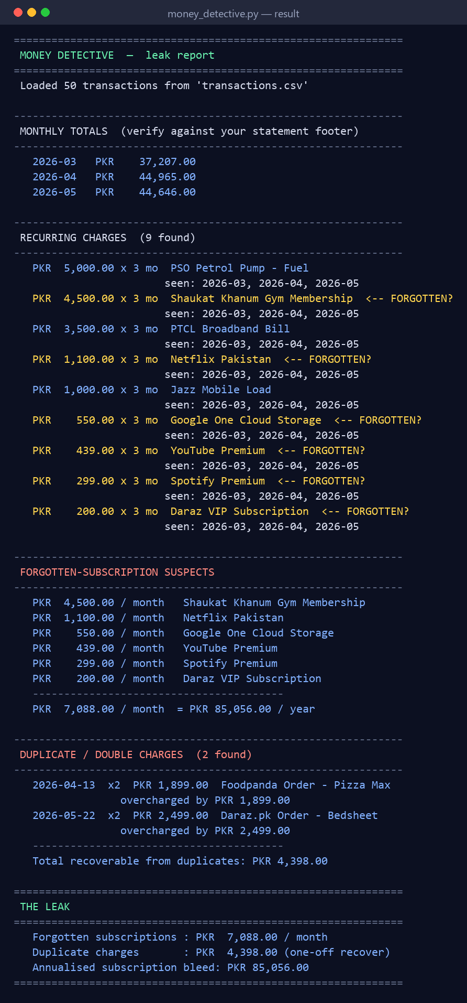
Screenshot — verified working result

Project 2 — What's My Grade, Really
Problem It Solves
The university portal shows raw marks but does not encode the teacher's real rules: drop the lowest quiz, weighted categories, and a conditional replacement in which the final exam replaces the midterm if it is higher. This script encodes those exact rules to compute true current standing and the precise final-exam score required for a target grade.
AI Tool
Claude (Sonnet) via Claude Code. The teacher's policy and the scores were provided as plain text and stored in an editable JSON file. Course: CS-201 Data Structures (synthetic, FAST-NUCES Karachi).
Prompts
Initial prompt
Here is my teacher's policy: Quizzes 15% (5 quizzes/10, drop lowest); Assignments 10%; Midterm 25%; Project 15%; Final 35%. Special rule: if my final % beats my midterm %, the midterm's 25% moves onto the final. My scores: quizzes 7,9,5,8,10; assignments 88,92,79,95; midterm 68; project 90; final not taken. Compute my current grade on completed work.
Improved prompts
1. Also compute the exact final-exam % needed for an A (85%), correctly applying the replacement rule when the required final beats the midterm.
2. When the rule applies, also print what I would have needed without it.
3. Keep policy + scores in JSON so I can update marks through the term.
Verification (against a known fact)
The quiz category was re-computed by hand: best 4 of (7,9,5,8,10) = 34/40 = 85.00%.
Figure | Hand calculation | Script output | Match
Quiz category | 34/40 = 85.00% | 85.00% | Yes
Current standing | 80.15% | 80.15% | Yes
Final needed (no rule) | 94.00% | 94.00% | Yes

What Worked / What Did Not
- Worked: encoding the replacement rule revealed the required final drops from 94% to 83.17% — the single most useful output.
- Did not: the first version applied the replacement unconditionally, understating the requirement; it was corrected to apply only when the resulting final actually exceeds the midterm (self-consistency check).
Final Result
Current standing is A- (80.15%) on the 65% of the course graded so far. Reaching an A requires 83.17% on the final — achievable — because the replacement rule shifts the midterm weight to the final. Without that rule, 94% would have been required.
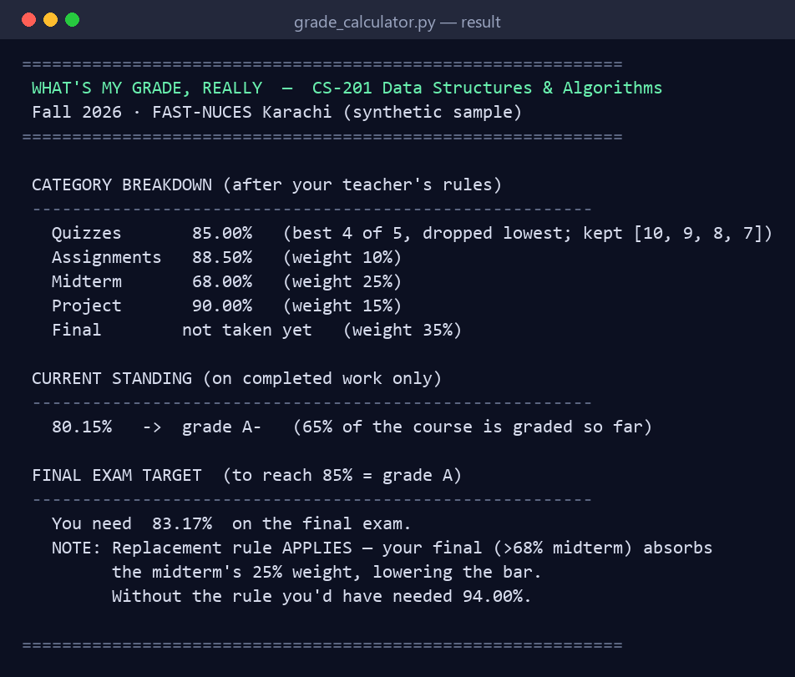
Screenshot — verified working result

Project 3 — The Books Don't Match
Problem It Solves
Monthly cricket-club dues are collected digitally. The expected total is known, but the JazzCash/Easypaisa record is messy — nicknames, blank memos, a split payment, an overpayment, and a deposit from an unrecognised number. This script applies personal interpretation rules, reconciles against the known total, and names who must be followed up.
AI Tool
Claude (Sonnet) via Claude Code. The target total was stated up front; the records were provided uncleaned; the interpretation rules were supplied as an editable JSON config. Data is synthetic.
Prompts
Initial prompt
12 members owe PKR 1,500 each, so I should have collected PKR 18,000. Here is a messy JazzCash/Easypaisa CSV (date, sender_raw, memo, amount). Do not clean it. Reconcile against 18,000 and find the gap.
Improved prompts
1. My interpretation rules (in editable JSON): "Chintu"=Bilal, "Guddu"=Faizan, any number with 4471=Usman (no memo), Kashif's "Eid Mubarak"=his dues, first-name matches to roster.
2. Add split installments (800+700) to 1,500; list unmatchable payments separately.
3. Output who still owes, overpayments to refund, and unexplained deposits; end with a check that matched + owed = 18,000.
Verification (against a known fact)
Ten members were personally confirmed as paid by hand = PKR 15,000. The script reproduced this independently, and the books balanced back to the expected total.
Figure | Known baseline | Script output | Match
Matched to roster | PKR 15,000 | PKR 15,000 | Yes
Reconciliation check (matched + owed) | PKR 18,000 | PKR 18,000 | Yes

What Worked / What Did Not
- Worked: nickname/number rules resolved every ambiguous entry; the split payment aggregated correctly to 1,500.
- Did not: an early first-name matcher wrongly matched an unrelated deposit; tightening the match (exact first name / roster membership) left the true mystery deposit correctly unmatched.
Final Result
Follow-up required with Waqar Younis and Naveed Akhtar (PKR 1,500 each = PKR 3,000 unpaid). One unexplained PKR 1,500 deposit from an unknown number needs confirmation before crediting. Saad Nadeem overpaid by PKR 500 (refund or carry forward).
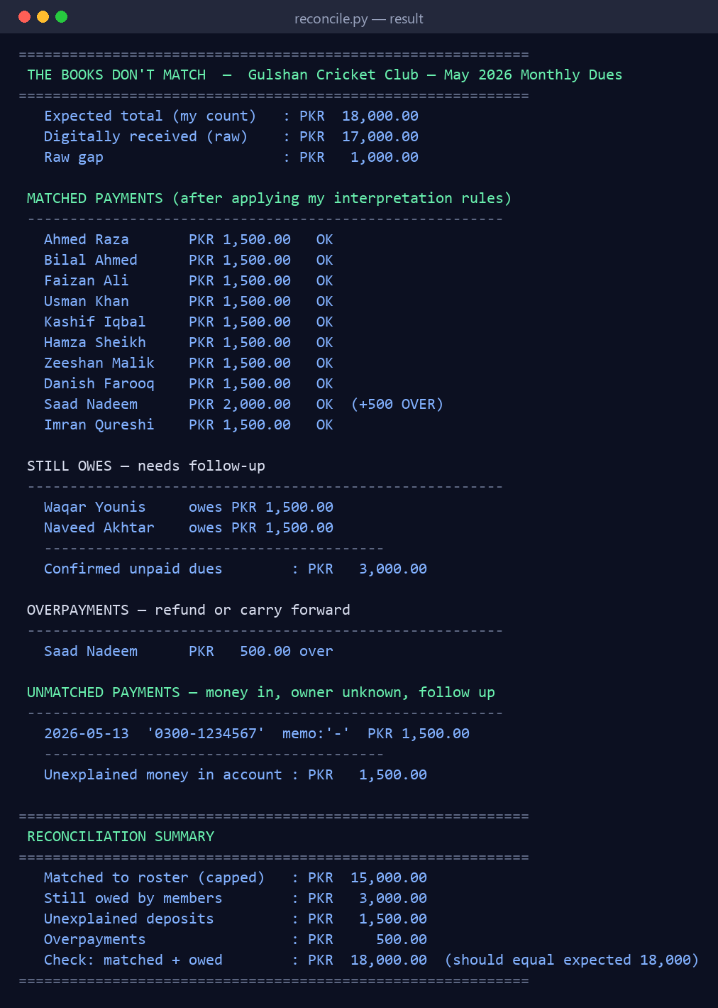
Screenshot — verified working result

Project 4 — Organize the Mess
Problem It Solves
A cluttered folder accumulates duplicates, forgotten downloads, and large files. This project reveals what is actually present and can tidy it — but, because it is the only project touching real files, it is built so that a careless run can never delete or overwrite anything.
AI Tool & Safety Design
Claude (Sonnet) via Claude Code. The prompts explicitly demanded the safe order taught in the lecture, which the script enforces:
- Dry run by default — running with no flag shows the full plan and touches nothing.
- Copy, never move or delete — --execute copies into a new organized_output/ folder; originals are untouched.
- Duplicates are proven by SHA-256 and only reported; the human decides what to delete.
Prompts
Initial prompt
Write a script that tells me what is in a messy folder: find true duplicates (same contents), flag very large files, and group everything by type.
Improved prompts
1. This touches real files, so be safe: show the FULL plan first and do NOT move/rename/delete anything unless I pass --execute.
2. On --execute, COPY into a new organized_output/ folder; never overwrite or delete originals; only REPORT duplicates.
3. Detect duplicates by SHA-256 of contents, not filename; show reclaimable space.
Verification (against a known fact)
The sample folder was seeded with exactly three duplicate pairs and one large file. Safety was confirmed by counting originals before and after execution.
Check | Expected | Actual | Match
Originals after --execute | 19 (untouched) | 19 | Yes
Files copied to output | 19 | 19 | Yes
Duplicate groups (SHA-256) | 3 | 3 | Yes
Large files > 100 KB | 1 | 1 | Yes

What Worked / What Did Not
- Worked: dry-run-by-default and copy-only behaviour meant the originals were provably untouched (19 before, 19 after).
- Worked: content hashing caught the "(1)" duplicate and the "_v2"/"- Copy" duplicates that a filename check would miss.
- Consideration: the type map and large-file threshold are constants at the top of the file, easy to tune per folder.
Final Result
Three duplicate groups and one 156 KB installer were identified for cleanup; all files were grouped into Documents, Images, Audio, Archives, Code, Installers, and Other. On execution, 19 copies were written to organized_output/ while the original folder retained all 19 files.
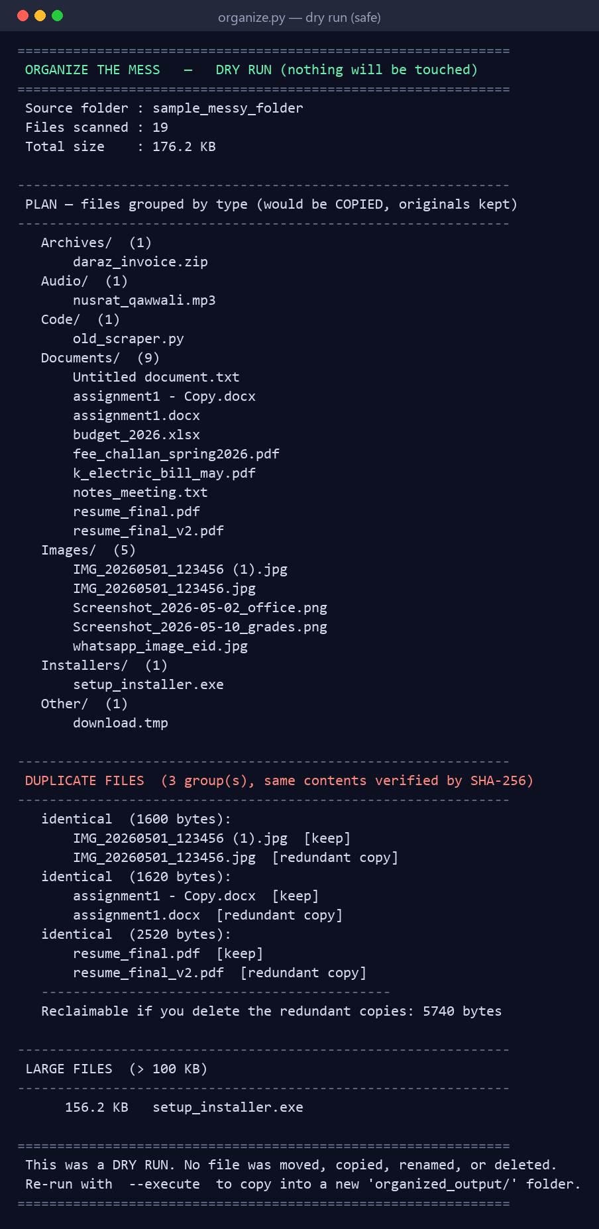
Screenshot — verified working result

What I Learned
The skill demonstrated across these four projects is not programming; it is being a good client for code. Three habits mattered most:
- Describe the problem and the personal rules precisely — the rules only I know (what counts as a leak, my teacher's replacement rule, who "Chintu" is, what "clean" means) are exactly what no off-the-shelf app can encode.
- Iterate in small, targeted prompts — each improved prompt fixed one observed shortcoming rather than rewriting everything.
- Verify before trusting — in every project a figure already known (a monthly total, a hand-computed category, a hand-counted sum, a planted file count) was the thing that turned "the AI said so" into "I checked, and it is correct."
The verification step was decisive every time. In Projects 2 and 3 it caught real logic errors in the first draft (an over-eager replacement rule and an over-eager name matcher). Had the output been trusted blindly, both would have produced confident, wrong answers.

