1. **Task 1**
2. **Creating username using: command: useradd “username”**

1. **Giving sudo access to techie user**

**Command: nano / path of the sudoers folder**



**Task 2 ) Here I have given all the privileges of root to techie user**

**Task 3**

**Navigating to the home directory**

**Command: cd ~**

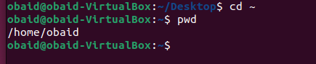

**Task 4**

**Creating a new directory**

**command: mkdir “directory name”**

**Task 5**

1. **List the content of the directory**

**Command: ls “directory name”**

**Task 6**

1. **Change the current directory**

**Command: cd “directory name”**

**Task 7**

1. **Creating a new empty file**

**Command: touch “filename”**



**Task 8**

1. **View the content of the file**

**Command: cat “filename”**

**Task 9**

1. **cp “filename” “path where you want to copy”**



**Task 10**

1. **move a file to another location**

**command: mv “file name” “path”**

**Task 11**

1. **Rename a file**

**command: mv “file name “ “new name”**

**Task 12**

1. **rm “ filename”**

**Task 13**

**Grant or revoke permissions on a file or directory**



**Task 14**

**View current date and time.**

**Command: date**



**Task 15**

**Checking system uptime**

**Command: uptime**



**Task 16**

**Checking running process**

**Command: u**

**Task 17**

**View the running process.**

**Command: ps -ef**

**Task 18**

**Kill running process**

**Command: kill name**

**Task 19**

**install a package**

**command: apt install “package name”**

**Task 20**

**Update the system package**

**Command: apt update**

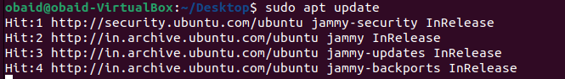

**Task 21**

**Create symbolic link.**

**Task 22**

**Find the file.**

**Command: find /-name “file name”**

**23) Compress and decompress files using tar.**

**Command: tar cvf “newfilename”.tar “name of file to bundle”**

**24) Monitor system resources with top or htop.**

**25) Create and manage user groups.**

**Here I am adding techie to sudo group access to user techie**

**26) Monitor log files using tail or grep.**

**27) Set up a web server (e.g., Apache or Nginx).**

**a) installing nginx**

**b) starting nginx**

**28) Configure and secure a MySQL Database.**

**29 Set up Application Server (e.g.,Apache Tomcat)**

**a) installing apache**

**b) to start apache we need to stop nginx server so stopping nginx**

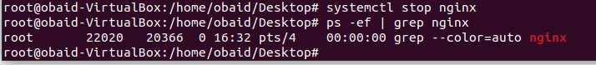

**c) starting apache2 server**

**30) Print specific columns from a delimited file.**

**31) Filter and print lines based on a specific pattern or condition.**

**a) here I am printing row no 3 to 6 and column no 3**

**34) Count the occurrences of a specific pattern in a file.**



**35) Sort lines based on a specific field or column.**

**36) Merge multiple files based on a common field or column.**



**37) Substitute text in a file using search and replace.**

**38) Delete specific lines based on a pattern or line number.**

**39) Append or insert text before or after a specific pattern or line.**

**40) Print only specific lines from a file.**

**41) Delete leading or trailing whitespace from lines.**

**42) Edit files in-place, making changes directly to the file.**

**43) Join multiple lines into a single line or split a line into multiple lines.**

**Here I am splitting line into multiples lines after every space**

**44) Copy file from linux to windows machine**