1. Random from SHOP_NAME

1. Random from **SHOP_NAME, PRODUCT_NAME, IMAGE_URL**,Max show 3 and I want can linked to shop-single

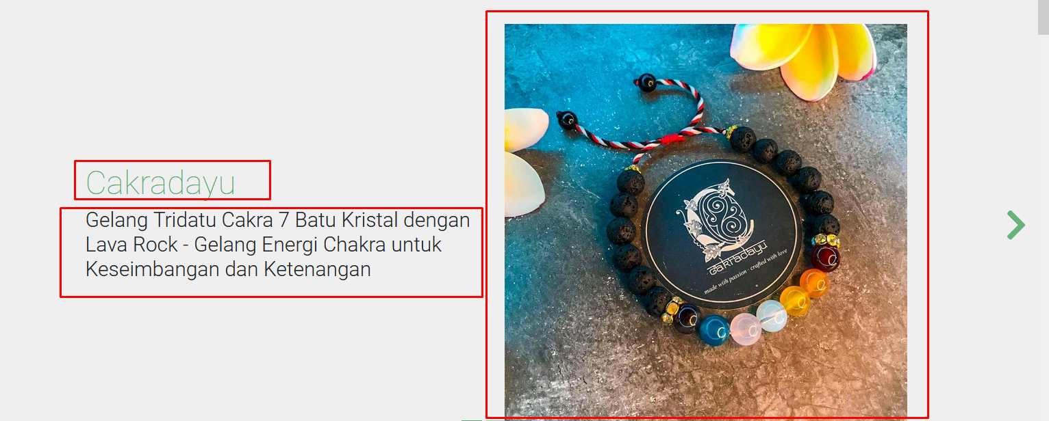

1. Random from **IMAGE_URL** ,Max show 3 and linked to shop-single

1. Random from **SHOP_NAME, PRODUCT_NAME, IMAGE_URL, PRICE**,Max show 3 and linked to shop-single

1. Random from **SHOP_NAME,** Max show 7 and linked to shop-single

