**Java String & StringBuilder**

Louis Botha louis.botha@tuni.fi

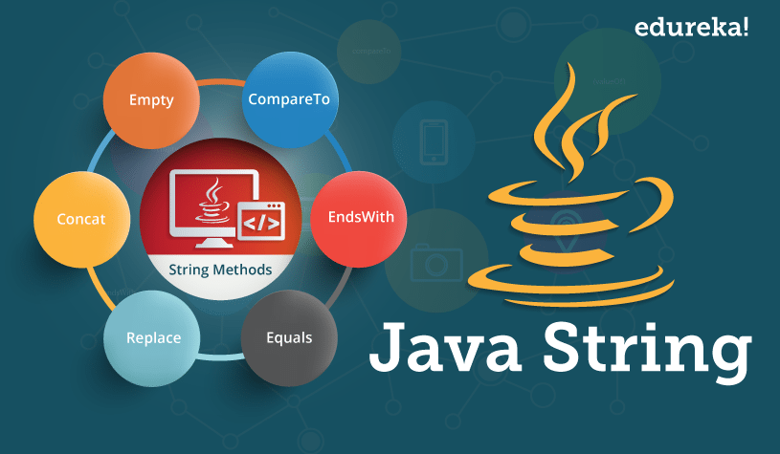

**Java String**

What is a Java String?  It’s a char array of course!

In Java, a string is an object that represents a sequence of characters or char values. For example, "hello" is a string containing a sequence of characters 'h', 'e', 'l', 'l', and 'o'.

The *java.lang.String* class is used to create a Java String object (not a primitive type).

There are two ways to create a String object:

1. **By string literal** : Java String literal is created by using double quotes.

String s = "Welcome";

* *attention Notice that the type is* ***S****tring (capital S)*

1. **By new keyword** : Java String is created by using a keyword “new”.

String s = new String("Welcome");

**Immutable String in Java**

* *attention Interview question*

An immutable object is an **object whose internal state remains constant after it has been entirely created**. This means that once the object has been assigned to a variable, we can neither update the reference nor mutate the internal state by any means.

A String is an unavoidable type of variable while writing any application program. String references are used to store various attributes like username, password, etc.

In Java, **String objects are immutable**. Once a String object is created its data or state can't be changed but a new String object is created.

**Why Strings are immutable in nature?**

Here are some more reasons for making String immutable in Java:

* The String pool cannot be possible if String is not immutable in Java. A lot of heap space is saved by JRE. The same string variable can be referred to by more than one string variable in the pool. More about the String pool later.
* If we don’t make the String immutable, it will pose a serious security threat to the application. For example, database usernames, passwords are passed as strings to receive database connections. The socket programming host and port descriptions are also passed as strings. The String is immutable, so its value cannot be changed. If the String doesn’t remain immutable, any hacker can cause a security issue in the application by changing the reference value.
* The String is safe for multithreading because of its immutableness. Different threads can access a single “String instance”. It removes the synchronization for thread safety because we make strings thread-safe implicitly.
* Immutability gives the security of loading the correct class by Classloader. For example, suppose we have an instance where we try to load the java.sql.Connection class but the changes in the referenced value points to the myhacked.Connection class that does unwanted things to our database.

spiral notepad**Small Side Note - mutable vs immutable**

In programming, an object or data type is said to be mutable if its state can be modified after it is created, while an object or data type is said to be immutable if its state cannot be modified after it is created.

Immutable objects or data types are often preferred in programming because they are simpler and more predictable. Since their state cannot be modified, they are inherently thread-safe and can be shared between multiple threads without the need for synchronization. Additionally, they are less prone to bugs caused by unintended side effects, since their state cannot be modified.

Some examples of immutable objects in Java include String, Integer, Boolean, and LocalDate. These objects cannot be modified after they are created, so any operations that appear to modify them actually create a **new** object with the modified state.

Mutable objects, on the other hand, can be modified after they are created, either by changing the values of their fields or by calling methods that modify their internal state. Examples of mutable objects in Java include StringBuilder, ArrayList, and HashMap.

Mutable objects can be useful in certain situations where performance is a concern or where it is necessary to modify the state of an object. However, they are generally more complex and require more careful handling to avoid unintended side effects. Additionally, mutable objects can be more difficult to use in concurrent environments, since their state can be modified by multiple threads at the same time, leading to race conditions and other synchronization issues.

**Java String Pool**

* *attention Interview question*

Java String pool refers to collection of Strings which are stored in heap memory. In this, whenever a new object is created, String pool first checks whether the object is already present in the pool or not. If it is present, then same reference is returned to the variable else new object will be created in the String pool and the respective reference will be returned.

Refer to the diagrammatic representation for better understanding:

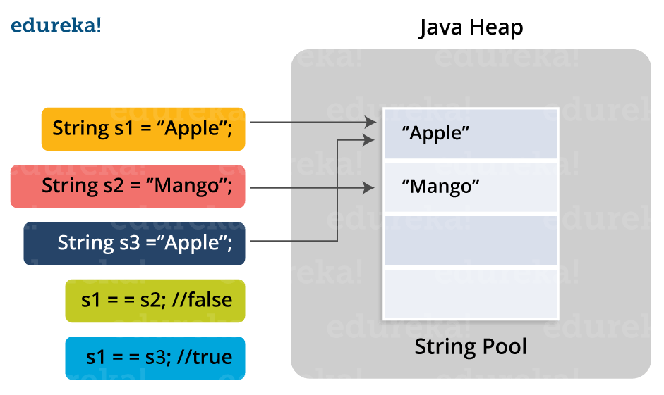String-pool - Edureka

In the above image, two Strings are created using literal i.e “Apple” and “Mango”. Now, when third String is created with the value “Apple”, instead of creating a new object, the already present object reference is returned.

Run the following code:

class Main {

    public static void main(String[] args) {

        String s1 = "apple";

        String s2 = "mango";

        String s3 = "apple";

        System.out.println(s1);

        System.out.println(s2);

        System.out.println(s3);

        System.out.println(Integer.toHexString(System.identityHashCode(s1)));

        System.out.println(Integer.toHexString(System.identityHashCode(s2)));

        System.out.println(Integer.toHexString(System.identityHashCode(s3)));

    }

}

// Output

apple

mango

apple

58b835a

62dc3c2

58b835a

Notice that the s1 and s3 are pointing to the same reference.

spiral notepad**Small Side Note**

light bulbWe can use the hashCode() method because we are not overriding the implementation.

* *The hashCode() method returns an integer value that is based on the contents of the object. Two objects that are equal according to the equals() method must return the same hash code value, but two objects that are not equal according to the equals() method can still return the same hash code value.*

light bulbWe are using the identityHashCode()

* *The identity hash code is a system-generated integer value that is unique for each object instance. It is based on the memory address where the object is stored in memory, and is not affected by the object's state or any of its properties.*

**Java String Methods**

The String class has a set of built-in methods that you can use with Strings.

For example here is an example of how retrieve the character at a specific position in a string. The method is called **charAt().** This method also needs you to supply an index (number), position of the character you are interested in.

String myStr = "Hello";

char result = myStr.charAt(1);

System.out.println(result);

//Output

e

Here is a table with some of the String methods. You don’t have to memorize all of the methods but it is good to have an idea what methods are available. These methods tend to make life much easier slightly smiling face.

|  |  |  |
| --- | --- | --- |
| **Method** | **Description** | **Return Type** |
| charAt() | Returns the character at the specified index (position) | char |
| compareTo() | Compares two strings lexicographically | int |
| compareToIgnoreCase() | Compares two strings lexicographically, ignoring case differences | int |
| concat() | Appends a string to the end of another string | String |
| contains() | Checks whether a string contains a sequence of characters | boolean |
| contentEquals() | Checks whether a string contains the exact same sequence of characters of the specified CharSequence or StringBuffer | boolean |
| endsWith() | Checks whether a string ends with the specified character(s) | boolean |
| equals() | Compares two strings. Returns true if the strings are equal, and false if not | boolean |
| equalsIgnoreCase() | Compares two strings, ignoring case considerations | boolean |
| hashCode() | Returns the hash code of a string | int |
| indexOf() | Returns the position of the first found occurrence of specified characters in a string | int |
| isEmpty() | Checks whether a string is empty or not | boolean |
| lastIndexOf() | Returns the position of the last found occurrence of specified characters in a string | int |
| length() | Returns the length of a specified string | int |
| replace() | Searches a string for a specified value, and returns a new string where the specified values are replaced | String |
| replaceFirst() | Replaces the first occurrence of a substring that matches the given regular expression with the given replacement | String |
| replaceAll() | Replaces each substring of this string that matches the given regular expression with the given replacement | String |
| split() | Splits a string into an array of substrings | String[] |
| startsWith() | Checks whether a string starts with specified characters | boolean |
| substring() | Returns a new string which is the substring of a specified string | String |
| toLowerCase() | Converts a string to lower case letters | String |
| toString() | Returns the value of a String object | String |
| toUpperCase() | Converts a string to upper case letters | String |
| trim() | Removes whitespace from both ends of a string | String |

**Java String Concatenation**

We can combine strings with **+**

public class Main {

  public static void main(String args[]) {

    String firstName = "John";

    String lastName = "Doe";

    System.out.println(firstName + " " + lastName);

  }

}

//Output

John Doe

* *attentionNote that we are explicitly adding the space between the 2 strings.*

We can also combine stings with the concat() method

public class Main {

  public static void main(String[] args) {

    String firstName = "John ";

    String lastName = "Doe";

    System.out.println(firstName.concat(lastName));

  }

}

//Output

John Doe

* *attentionNotice that we added the space at the end of the firstName string.*

Use System.out.println() to test the following concatenation examples.

1 + 2

"string1" + "string2"

"string1" + 2

"string1" + 3.3

3.3 + "string" + 3.3

2 + "string2"

"a" + "b"

"a" + 'b'

'a' + "b"

'a' + 'b'  //97 + 98

* *attention‘a’ + ‘b’ = 195, WTF?*

In Java, the char variable stores the ASCII value of a character (number between 0 and 127) rather than the character itself.

The ASCII value of lowercase alphabets are from 97 to 122. And, the ASCII value of uppercase alphabets are from 65 to 90. That is, alphabet a is stored as **97** and alphabet z is stored as **122**.

Similarly, alphabet A is stored as **65** and alphabet Z is stored as **90**.

Now, in that statement we are adding up the ASCII values of the letters, why we get the result of 195.

**String Escape Character**

The backslash **\** escape character turns special characters into string characters:

|  |  |  |
| --- | --- | --- |
| **Escape character** | **Result** | **Description** |
| \' | ' | Single quote |
| \" | " | Double quote |
| \\ | \ | Backslash |

Here we use the \ to display the double quotes around Vikings.

public class Main {

  public static void main(String[] args) {

    String txt = "We are the so-called \"Vikings\" from the north.";

    System.out.println(txt);

  }

}

//Output

We are the so-called "Vikings" from the north.

Some common escape sequences that are valid in Java are:

|  |  |
| --- | --- |
| **Code** | **Result** |
| \n | New Line |
| \r | Carriage Return |
| \t | Tab |
| \b | Backspace |
| \f | Form Feed |

The two that are most often used are **\n** and **\t**. Here we use the **\n** escape sequence to display the Doe on a new line:

public class Main {

  public static void main(String args[]) {

    String firstName = "John\n";

    String lastName = "Doe";

    System.out.println(firstName + " " + lastName);

  }

}

//Output

John

 Doe

Here we use the **\t** escape sequence to display John and Doe separated by one tab away

public class Main {

  public static void main(String args[]) {

    String firstName = "John\t";

    String lastName = "Doe";

    System.out.println(firstName + " " + lastName);

  }

}

//Output

John    Doe

**StringBuilder**

Java StringBuilder is a class in Java that represents a mutable sequence of characters. It is similar to the String class, but provides more flexibility and performance when it comes to manipulating strings.

The StringBuilderclass is part of the java.lang package and provides methods to append, insert, and delete characters in a string, as well as methods to reverse, replace, and substring a string. It also has a capacity, which is the number of characters that can be stored without requiring the StringBuilder object to allocate more memory. If more characters are added to the StringBuilder object than its current capacity, it automatically expands its capacity.

Unlike the String class, StringBuilder objects are mutable. This means that it allows you to modify the value of a string without creating a new object each time. This can be more efficient than using the String class, which creates a new object every time you modify the string. StringBuilder is especially useful when you need to concatenate multiple strings or modify a string repeatedly.

To use StringBuilder, you can create a new StringBuilder object and initialize it with an initial value, such as an empty string or an existing string. You can then use its methods to append, insert, or modify the characters in the StringBuilder object. Once you have finished modifying the string, you can convert the StringBuilder object to a String using the toString() method.

StringBuilder sb = new StringBuilder("Hello");

sb.append(", world!");   // Append ", world!" to the StringBuilder object

sb.insert(5, " there");  // Insert " there" at index 5

String result = sb.toString(); // Convert the StringBuilder object to a String

System.out.println(result);    // Output: "Hello there, world!"

Here's a more advanced example of how to use Java StringBuilder to generate a CSV (Comma Separated Values) file from a list of data:

import java.io.FileWriter;

import java.io.IOException;

import java.util.ArrayList;

import java.util.List;

public class CSVGenerator {

    public static void main(String[] args) {

        // Sample data

        List<String[]> data = new ArrayList<>();

        data.add(new String[]{"Name", "Age", "Gender"});

        data.add(new String[]{"John", "25", "Male"});

        data.add(new String[]{"Jane", "30", "Female"});

        data.add(new String[]{"Bob", "40", "Male"});

        // StringBuilder to generate CSV content

        StringBuilder sb = new StringBuilder();

        // Loop through each row of data

        for (String[] row : data) {

            // Loop through each column of the row

            for (int i = 0; i < row.length; i++) {

                // Append the value to the StringBuilder

                sb.append(row[i]);

                // If this is not the last column, append a comma

                if (i < row.length - 1) {

                    sb.append(",");

                }

            }

            // Append a new line character to separate rows

            sb.append("\n");

        }

        // Write the CSV content to a file

        try (FileWriter writer = new FileWriter("data.csv")) {

            writer.write(sb.toString());

            System.out.println("CSV file generated successfully.");

        } catch (IOException e) {

            System.err.println("Error generating CSV file: " + e.getMessage());

        }

    }

}

**StringBuilder Methods**

The StringBuilder in Java provides numerous methods to perform different operations on the string builder. The table depicted below enlists some primary methods from the StringBuilder class.

|  |  |
| --- | --- |
| **Method** | **Description** |
| StringBuilder append (String s) | This method appends the mentioned string with the existing string. You can also with arguments like boolean, char, int, double, float, etc. |
| StringBuilder insert (int offset, String s) | It will insert the mentioned string to the other string from the specified offset position. Like append, you can overload this method with arguments like (int, boolean), (int, int), (int, char), (int, double), (int, float), etc. |
| StringBuilder replace(int start, int end, String s) | It will replace the original string with the specified string from the start index till the end index. |
| StringBuilder delete(int start, int end) | This method will delete the string from the mentioned start index till the end index. |
| StringBuilder reverse() | It will reverse the string. |
| int capacity() | This will show the current StringBuilder capacity. |
| void ensureCapacity(int min) | This method ensures that the StringBuilder capacity is at least equal to the mentioned minimum. |
| char charAt(int index) | It will return the character at the specified index. |
| int length() | This method is used to return the length (total characters) of the string. |
| String substring(int start) | Starting from the specified index till the end, this method will return the substring. |
| String substring(int start, int end) | It will return the substring from the start index till the end index. |
| int indexOf(String str) | This method will return the index where the first instance of the specified string occurs. |
| int lastIndexOf(String str) | It will return the index where the specified string occurs the last. |
| Void trimToSize() | It will attempt to reduce the size of the StringBuilder. |

**Activity**

We are going to create a cheatsheet containing **runnable** examples of the String and StringBuilder methods. The examples are collected on [Mural](https://app.mural.co/t/tg5g00ev163001websovelluskeh4798/m/tg5g00ev163001websovelluskeh4798/1678532206368/126963bc53f55705e3527c953690e7e194847ef8?sender=u9bcbbed311777a14d9149309) as **screenshots**. The methods on the tables above are the most used but you can go have a look at the [String](https://docs.oracle.com/en/java/javase/17/docs/api/java.base/java/lang/String.html) and [StringBuilder](https://docs.oracle.com/en/java/javase/17/docs/api/java.base/java/lang/StringBuilder.html) documentation to find a method not listed.

An example of the code snippet to make and paste on Mural

public class Example {

    public static void main(String[] args) {

        String myStr = "Hello";

        char result = myStr.charAt(1);

        System.out.println(result);

    }

}

**Javadoc**

Louis Botha, louis.botha@tuni.fi



[Read more](https://www.baeldung.com/javadoc)

**Commenting in Java**

In Java there is 3 ways in which to comment source code:

// This is a single line comment

/*

 * This is a regular multi-line comment

 */

/**

 * This is a Javadoc

 */

Now that you are starting to code your own classes, it is time to add some documentation to the classes.

**What is Javadoc?**

Javadoc is a tool which comes with JDK and it is used for generating Java code documentation in HTML format from Java source code, which requires documentation in a predefined format.

Javadoc comments may be placed above any class, method, or field which we want to document. These comments are commonly made up of two sections:

1. The description of what we're commenting on
2. The standalone block tags (marked with the “*@*” symbol) which describe specific meta-data

*/\*\**

*\* The class Math contains methods for performing basic .. (short explanation)*

*\**

*\* Unlike some of the numeric methods of class StrictMath, all implementations*

*\* of the equivalent functions of class Math are not defined to return*

*\* the bit-for-bit same results... (long explanation)*

*\**

*\* @author Tina Smith*

*\*/*

public class Math {

*/\*\**

*\* Returns the absolute value of an int value.*

*\**

*\* If the argument is not negative, the*

*\* argument is returned. If the argument is negative, the negation of the argument*

*\* is returned.*

*\**

*\* @param a the argument whose absolute value is to be determined*

*\* @return the absolute value of the argument.*

*\*/*

    public static int abs(int a) {

        if (a < 0) {

            return a * -1;

        } else {

            return a;

        }

    }

}

To generate the documentation, try this on the command line:

javadoc -d doc Math.java

By default the author is not added to the generated documentation.

javadoc -author -d doc Math.java

This generates the documentation and place it in a directory called doc. It generates a lot of file so you want to nearly always make it generate into a specific directory.

Now browse to the directory and open the index.html file with an Internet browser.

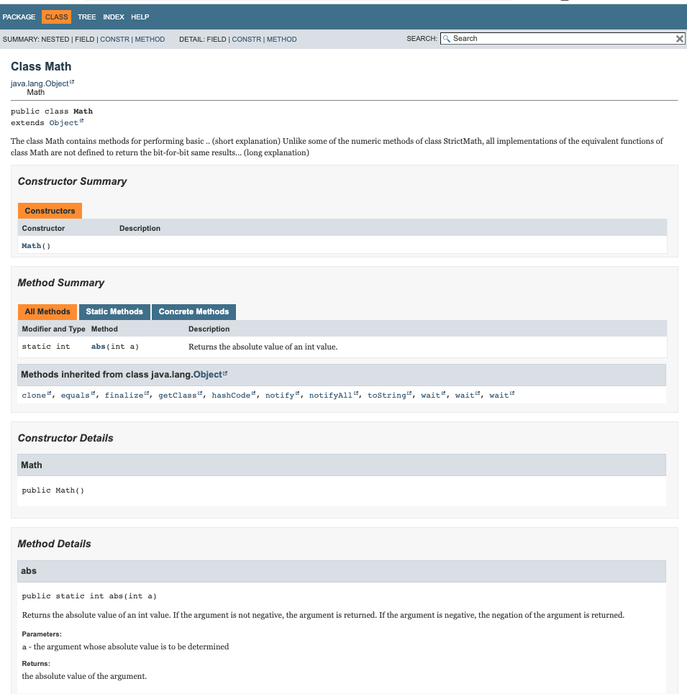

**What to document?**

Most important is the first short and long explanation of the class. Explain what this class knows and what it does. A author, version an may be added.

|  |  |  |
| --- | --- | --- |
| @author | Adds the author of a class. | @author name-text |
| @version | Adds a "Version" subheading with the specified version-text to the generated docs when the -version option is used. | @version version-text |

Above each of the methods in the class, explain what the method does, what parameters the method expects and what the method returns. If the method can throw an exception then it would be good to add that.

|  |  |  |
| --- | --- | --- |
| @param | Adds a parameter with the specified parameter-name followed by the specified description to the "Parameters" section. | @param parameter-name description |
| @return | Adds a "Returns" section with the description text. | @return description |
| @exception | Adds a **Throws** subheading to the generated documentation, with the classname and description text. | @exception class-name description |