Grocery Management System

**Software Development Project - I and Industrial Tour**

**Course Code: CSE2112**



**Supervisor**

Md. Mahfuz Reza  
 Assistant professor

**Submitted by**

Md. Saddam Hossen

ID: CE18046

**Department of Computer Science and Engineering,**

Mawlana Bhashani Science and Technology University, Santosh, Tangail- 1902

**Table of Contents**

Introduction **3.**

Analysis & Domain Modeling 3-5**.**

System Operation Contracts **5.**

Data Model and Persistent **6.**

Mathematical Model **6.**

Interaction Diagram **7.**

Algorithms and Data Structures **8.**

User Interface Design & Implementation **8.**

Design of Tests **9-10.**

Plan of Work **10.**

References **11.**

**Introduction:**

**“**Grocery Management System**”** is a simple c++ language based application. Main objective to create the application is to buying and selling product of a shop.

**1. Analysis and Domain Modeling**

**a. Analysis:**

* Display product: Customer can see all product with price, stock.
* Update: Shopkeeper can update any product price and stock if needed.
* Buy: Customer can buy different type of product. Finally have given a Memo.
* Nothing: if customer do not want to buy any product, then application will clos

**Domain Modeling:**

Buy?

Input

Input

Yess

No

Display Product

Input

Different product according to type

Rice/oil/Dal

Display

# 

Input

Input

CnNn

?

?

Buy

Input

?

cn

No

Yess

Display product

Input

Rice/oil/Dal

Input

?

Input

Display Product

Input

Yess

No

More?

Update

Input

Input

Cn

?

?

Product Buy

Update

Flow Chart

**b. System Operation Contracts**

**“**Grocery Management System**”** ” is an offline based application. User must know the following instruction to buy product. When the application is turn on and open a Welcome to Grocery Management System of the application.

First ask me what will to do. And give some option with indicator. According to our demand we take the indicator input and go forward. Such we can buy product, see product list & update product list.

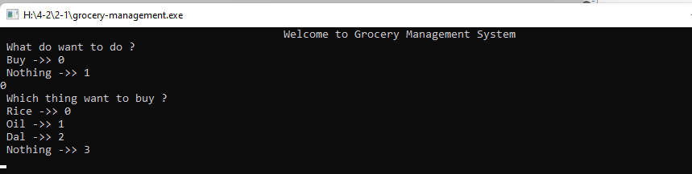

**c. Data Model and Persistent**

**Data Storage:** Using structure array.

**d. Mathematical Model**

No Mathematical model.

**2. Interaction Diagram**

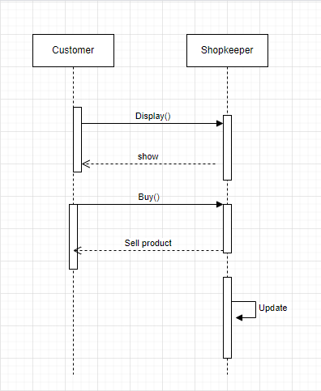

**3. Algorithms and Data Structures**

**a) Algorithm**

No algorithom.

**b) Data Structures**

Yes, in this system we use array, structure and switch case.

I used array to store structural data and Collection of primitive data types such as integer, char, etc. And also used Structure to store non-primitive data types.

**4. User Interface**

For Design and Implementation, I used code blocks for my project implementation. It works with C++.

**5.** Design of Tests:

Unit Testing:

In this part, we will test our every individual part of our project. Is our every page is working correctly or not? We will test in this part.

Welcome window shows

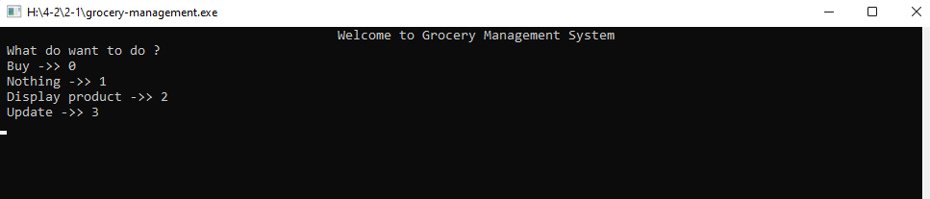

Buy:

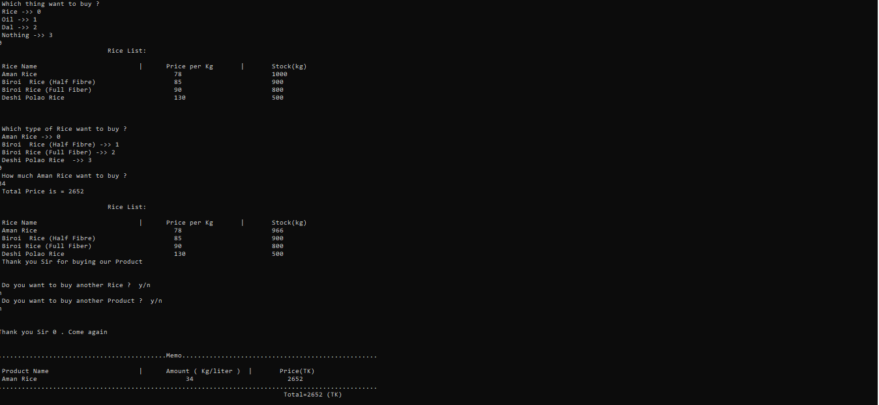

Display Product:

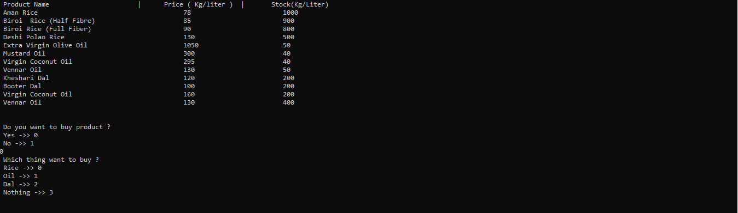

Update:

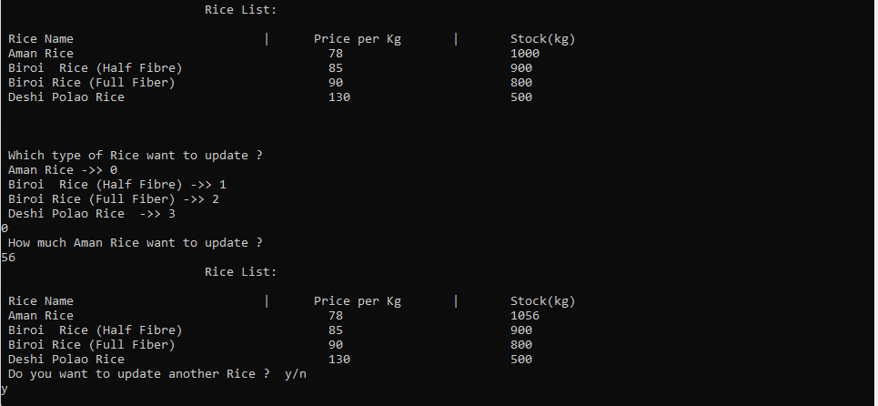

# Plan of Work:

Project Period – 2021

|  |  |  |  |  |  |  |  |  |  |  |
| --- | --- | --- | --- | --- | --- | --- | --- | --- | --- | --- |
| Activities | Jan | Feb | Mar | Apr | May | Jun | Jul | Aug | Sept | Oct |
| Topic Specification |  |  |  |  |  |  |  |  |  |  |
| Requirements Finding |  |  |  |  |  |  |  |  |  |  |
| Software Design |  |  |  |  |  |  |  |  |  |  |
| Methodology Development |  |  |  |  |  |  |  |  |  |  |
| Debugging, Testing & Updating |  |  |  |  |  |  |  |  |  |  |
| Writing & Editing Report |  |  |  |  |  |  |  |  |  |  |
| Project Submission |  |  |  |  |  |  |  |  |  |  |

1. **References**

[Data Structures - GeeksforGeeks](https://www.geeksforgeeks.org/data-structures/)

<https://www.w3schools.com/>

<https://www.tutorialspoint.com/index.htm>

<https://www.mathsisfun.com/>

<https://stackoverflow.com/>

**Conclusion:**

This “Grocery Management System” is a simple C language based application. This is a small attempt to represent my effort but give me enjoy.

-------------------------------- Date: 08/10/2022

Signature of Supervisor