LIBRARY MANAGEMENT STSTEM

PROOFS OF TEST CASES :
CASE – 1:
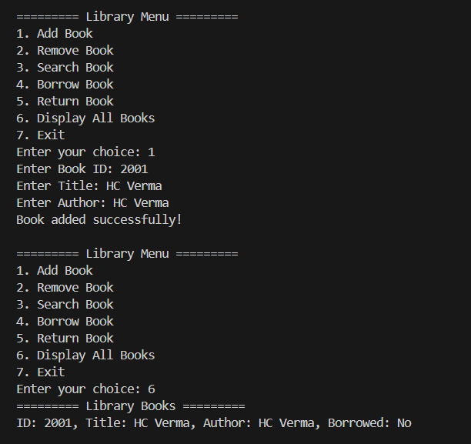

CASE --2:
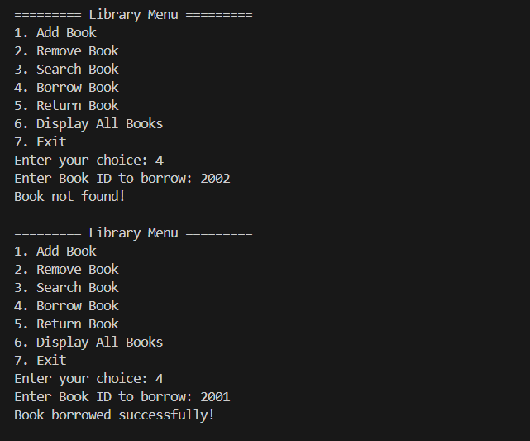

CASE --3:
