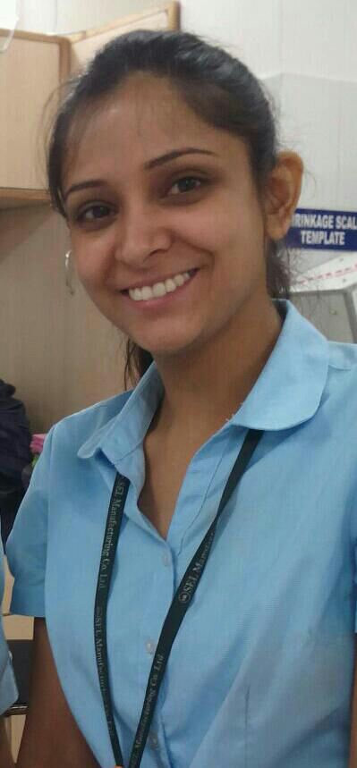  RIMPY SHARMA  Contact:  Mob: +91-9646645882,9805360448  E-mail:  rimpy.sharma6@gmail.com  Personal Information:  Father’s Name  Sh. Sunil Kumar Sharma  DOB: 28 March,1987  Gender: Female  Marital Status: Unmarried  Languages: English, Hindi,Russian,Punjabi  Permanent Address:  H.No:2587-A  Sector-20 C  Chandigarh  Pin Code: 160020 | CAREER OBJECTIVE  Seeking a challenging profile in textile sector that offers the opportunity to explore new avenues in public world by utilizing my domain knowledge.  WORK EXPERIENCE  2 Yrs work experience as a Quality Control Officer in SEL Manufacturing Co. Ltd.,(Physical Lab Incharge Unit -1 &2)/Auditing/Technical Trainings Cordination  ACADEMIC BACKGROUND  PROJECTS UNDERTAKEN  - 90 weeks Summer Training in Fabric Production and CPDC(Central Product Development Cell) Department in AURO WEAVING MILLS & M.S.M (TD) of VARDHMAN GROUP OF COMPANIES, Baddi ,  - PROJECT: Brand Study & Design Development  - 2 months Nedgraphics training with Textile Designer Shruti Salpona (NIFT) Ludhiana.  - MAJOR PROJECT IN FINAL YEAR: Print & Weave Development,Fabric Defects,Homefurnishing Products Development,Sari Project.  STRENGTHS  - Self-motivating and high level of determination.  - Adaptable and dedicated to work.  - Good leadership quality and also effective participation in team work.  - Keen to learn, result oriented, risk taking, practical approach.  - Hard working, never says no to work and reacts to a situation patiently.  PROFICIENCIES & SKILLS  Good command on Microsoft Word, Excel,Nedgraphics,Autocad,ERP & PowerPoint. Highly proficient in both written & verbal English and Hindi communication.  EXTRA-CURRICULAR ACHIEVEMENTS  - Received Best Student Award in 10TH Standard .  - Participated in various events of annual techno cultural fest held in School & College .  - Won Prize for developing the most innovative saree in College Annual Function  - Judged Mehndi Competition Organised by Company HR Department.  HOBBIES & OTHER INTERESTS  Dancing, Singing,Fashion Forecating, Painting,Sports(Swimming Badminton.),Travelling  DECLARATION  I hereby declare that all the details in the resume are true, complete and correct to the best of my  knowledge and belief.  RIMPY SHARMA
  Examination | University / board | Educational  Institute | Marks  %age
  B.Tech | Annamalai University | Internation Institute of Fashion Designing (INIFD),Chandigarh | 85.18%
  +2 CLASS | CBSE Board | Laurence Public School,Mohali. | 74%
  10th CLASS | CBSE Board | Govt.Model Senior Secondary School,Sector-19,Chandigarh | 80%

