RFID-Based Security System

**Lesson Description**

Before we get in to creating an RFID security system, first question we must ask is - What is an RFID tag? RFID tag is a small chip embedded in your access cards that contains encrypted information. The main components of an RFID system are a transmitter and a receiver. The transmitter is the RFID tag or your ID card. The receiver is the card reader or transceiver. This application can be used in home security and many other applications. RFID, short for radio-frequency identification uses the concept of electromagnetic fields to detect its unique identification number (UID). This is all done wirelessly!

**Prerequisite**

Arduino Knowledge

**Instruction Method**

**Schedule**

**Parts**

* Arduino UNO
* RFID Transmitter Key Card
* RFID Receiver
* LEDs
* Servo Motor
* Buzzer
* 220-ohm resistors
* I2C LCD
* Breadboard
* Jumper wires

**Procedure**

1. Connecting the RFID sensor to Arduino using jumper wires

|  |  |
| --- | --- |
| **Arduino Pin** | **RFID Reader** |
| 3V3 (Power) | 3.3 V (Power) |
| GND (Ground) | GND (Ground) |
| 5 | RESET |
| 10 | SDA (Serial-Data-Access) |
| 11 | MOSI (Master-Out-Slave-In) |
| 12 | MISO (Master-In-Slave-Out) |
| 13 | SCK (Serial-Clock) |

1. Connect the Arduino to I2C LCD Display
2. .

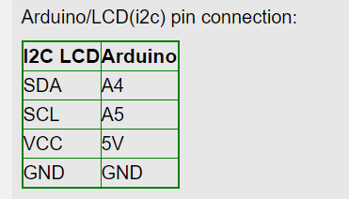

**Video**

**Links to learn more about the topic**

**References**

Parts Kit: <https://www.amazon.com/OSOYOO-Security-Mega2560-Learning-Components/dp/B01K6MO46C?ref_=fsclp_pl_dp_1&fbclid=IwAR0j_YPgi6IeFB7YwOc9eFM4jUcu175jbgzlksyqNV_q-HLL6bEnxLtL2WQ>