**Google Cloud platform project**

**Deploy Flash app on Google Cloud (App Engine)**

**By: Sadeem Khalid Alqarni**

**App Engine Settings:**

These are the steps of how to make your first application.

The application settings:

Choose the API access.

Click Next.

Cloud Shell:

After we create our first application

After we open the shell cmd: git clone <https://github.com/CJ-2/upload-app.get>

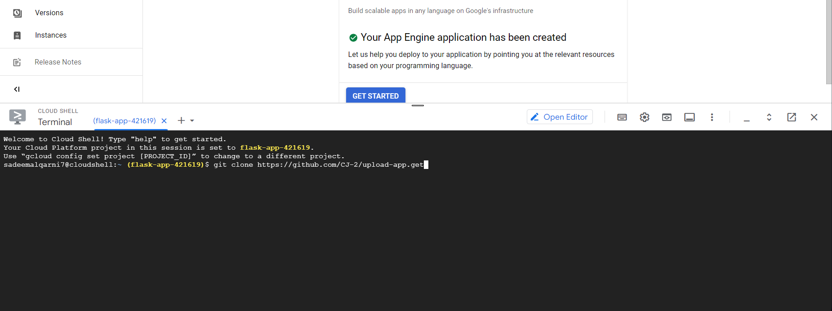

cmd: ls

cmd: cd upload-app



cmd: ls

cmd: cd storage



Cmd: ls



cmd: python main.py

Click on web preview and follow the steps:

Return to shell and cmd: CTRL+C

cmd: Clear

cmd: ls

cmd: gcloud app deploy

cmd: y

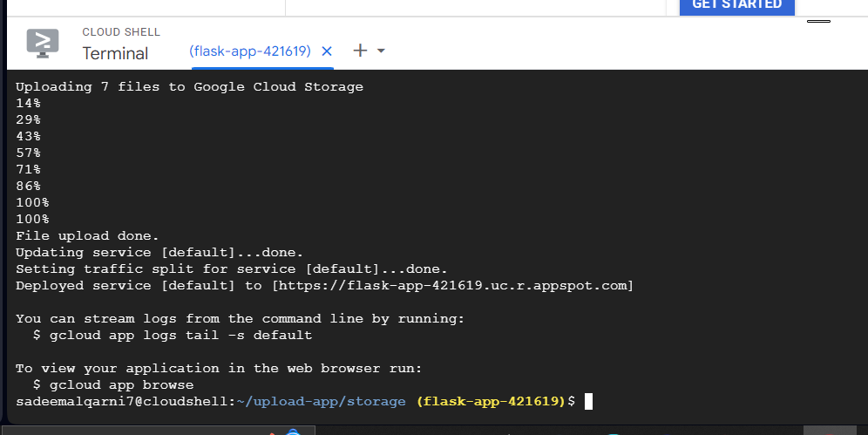

cmd: gcloud app browse

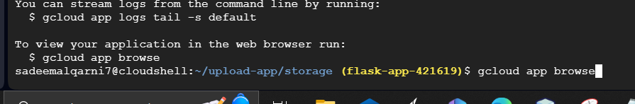

Click on the link

Now the app is deployed.

Go back to the dashboard and select Versions.

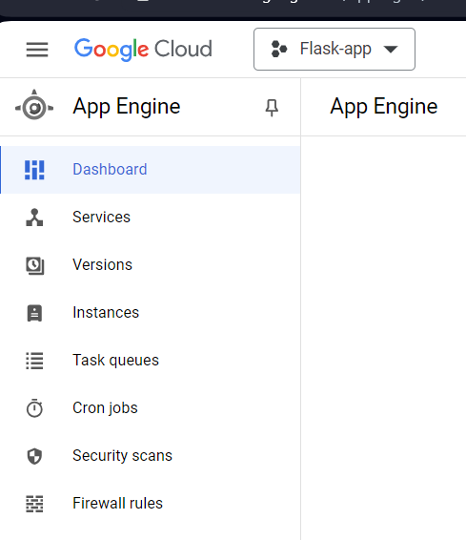

Here is the version

