|  |  |
| --- | --- |
| Name: Muhammad Sadeem Hannan | EE-272L Digital Systems Design |
| Reg. No.: 2023-EE-079 | Marks Obtained: ____________ |

**Lab Manual**

|  |  |  |  |  |  |
| --- | --- | --- | --- | --- | --- |
| **DSD Lab Manual Evaluation Rubrics** | | | | | |
|  |  |  |  |  |  |
| **Assessment** | **Total Marks** | **Marks Obtained** | **0-30%** | **30-60%** | **70-100%** |
| Code Organization (CLO1) | 3 |  | No Proper Indentation and descriptive naming, no code organization.  Zero to Some understanding but not working | Proper Indentation or descriptive naming or code organization.  Mild to Complete understanding but not working | Proper Indentation and descriptive naming, code organization.  Complete understanding, and proper working |
| Simulation (CLO2) | 5 |  | Simulation not done or incorrect, without any understanding of waveforms | Working simulation with errors, don't cares's(x) and high impedance(z), partial understanding of waveforms | Working simulation without any errors, etc and complete understanding of waveforms |
| FPGA (CLO2) | 2 |  | Not implemented on FPGA and questions related to synthesis and implementation not answered. | Correctly Implemented on FPGA or questions related to synthesis and implementation answered. | Correctly Implemented on FPGA and questions related to synthesis and implementation answered. |

## **Experiment 1**

**(a) Answers (Section-1)**

1. The voltage is 0V and LED doesn’t glow.
2. The voltage is 1.96V and LED glows
3. Input high to low and Output low to high: Propagation delay = 2.4µs

Output high to low and Input low to high: Propagation delay = 3.0µs

1. At f = 100kHz;

Input high to low and Output low to high: Propagation delay = 1.92µs

Output high to low and Input low to high: Propagation delay = 2.40µs

1. When frequency is increased, the propagation delay increases causing distorted waveforms

**(b) Input-Output Waveform**

At f = 1kHz,

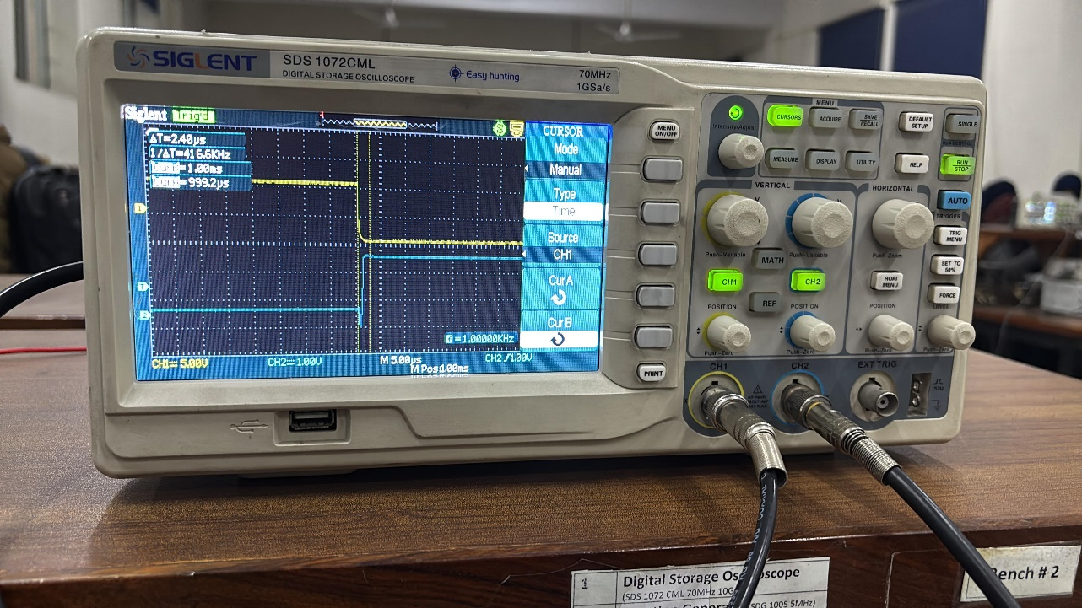Input high to low & Output low to high:

Output high to low and Input low to high:

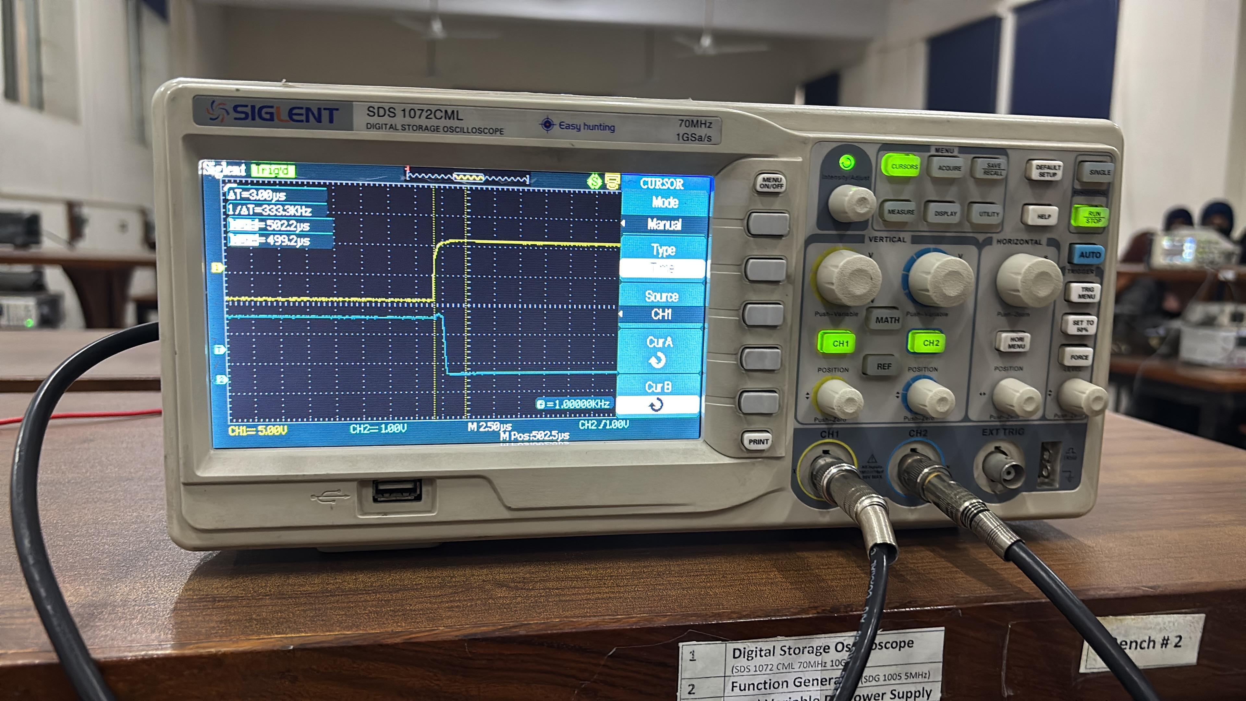

At f = 100kHz

Input high to low & Output low to high:

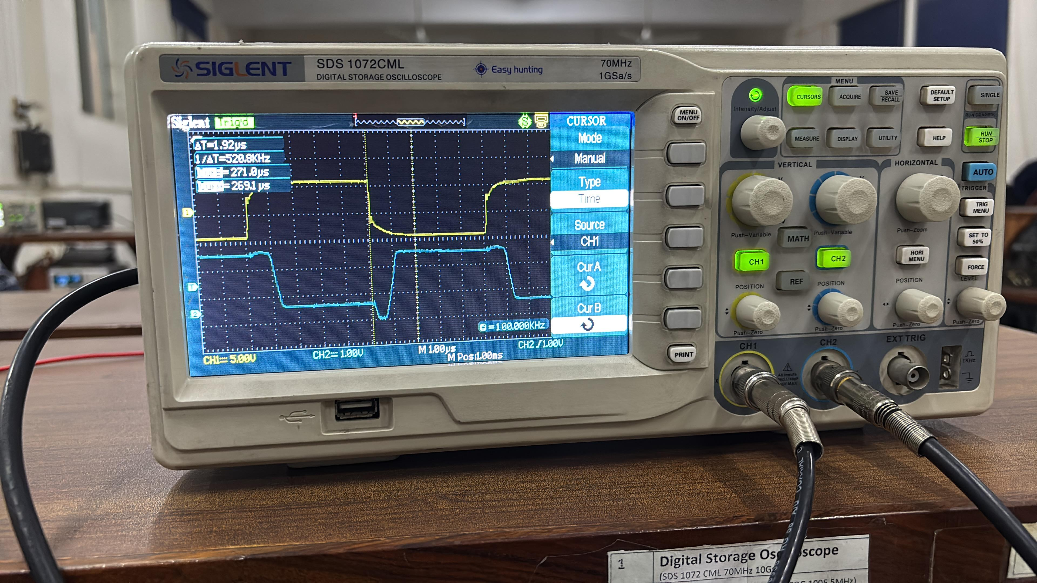

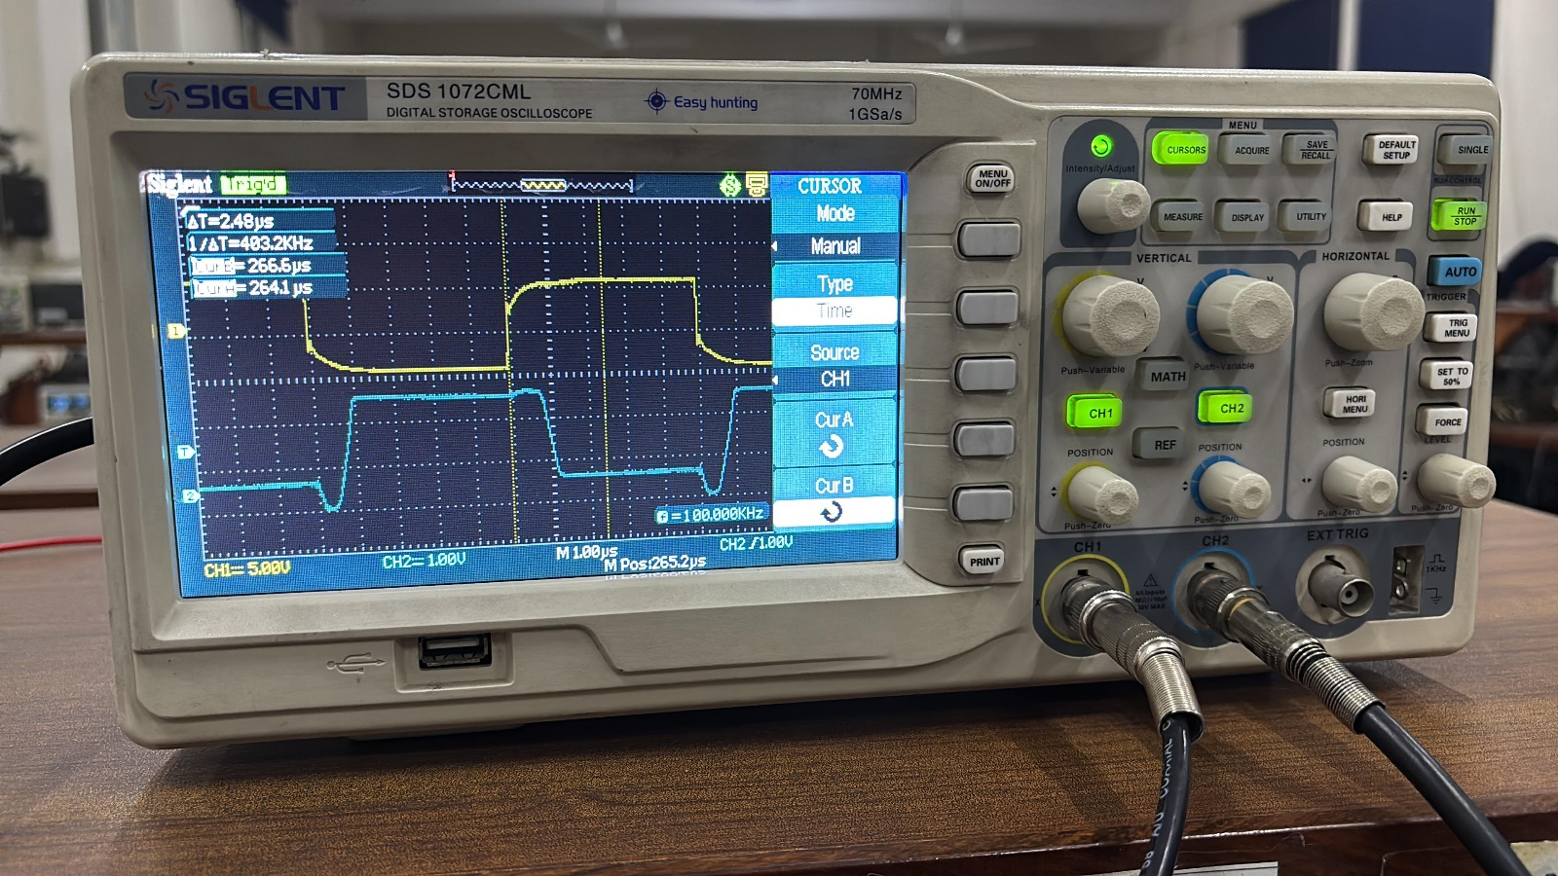Output high to low and Input low to high:

## **APPENDIX**

1. Breadboard Circuit

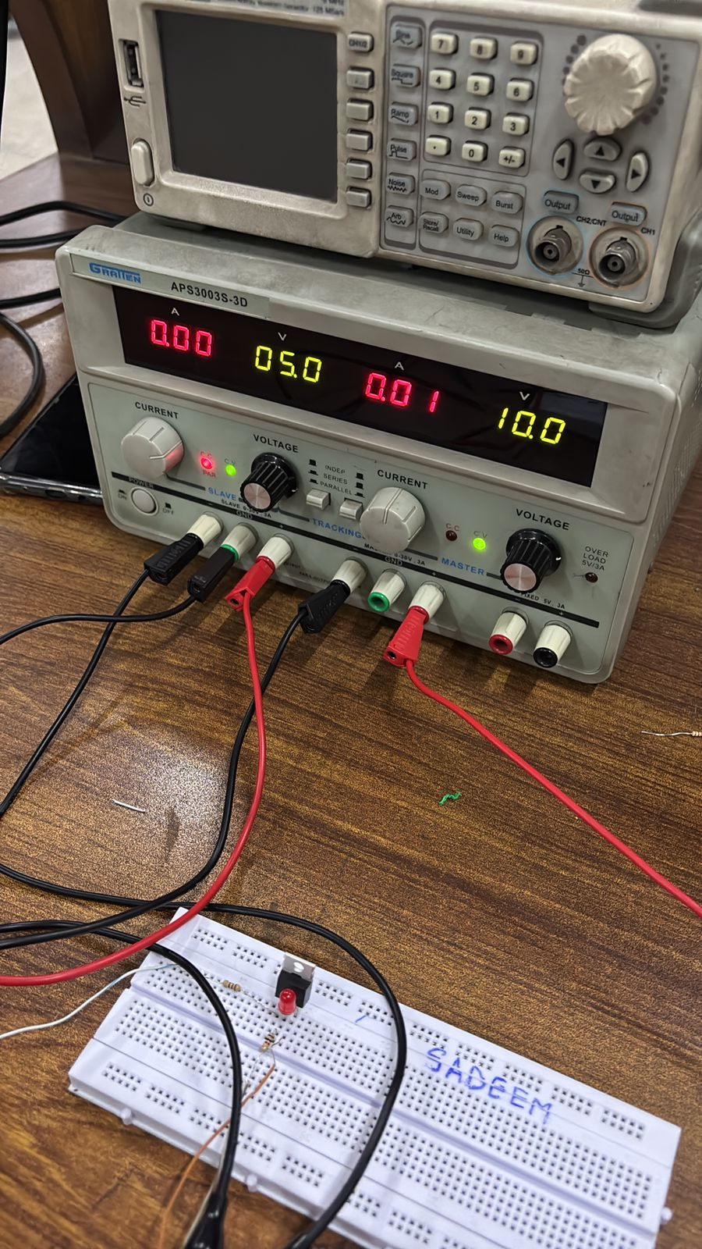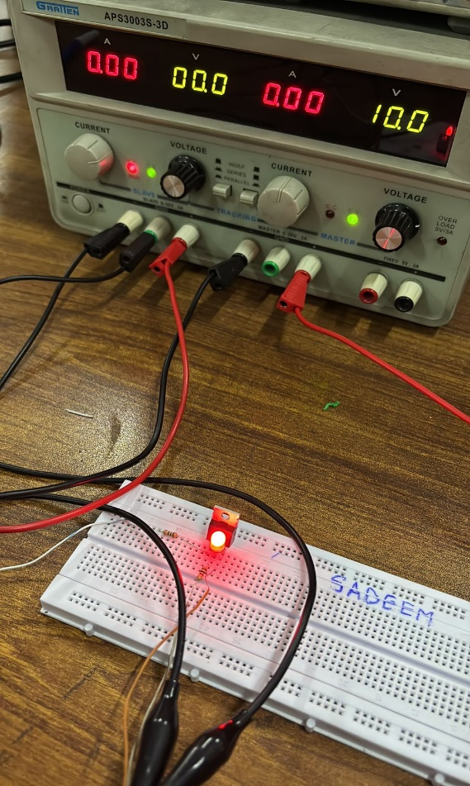2. Task 1 & 2

