Name ; Sadeem Rashid

Email ; [Sadeem909090@gmail.com](mailto:Sadeem909090@gmail.com)

Matric # ; 40402246

Answer 06 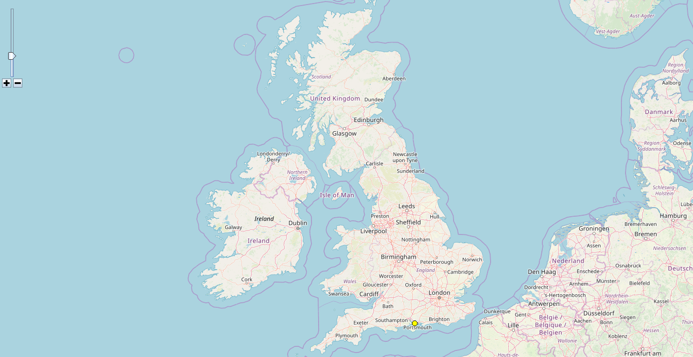

Answer 07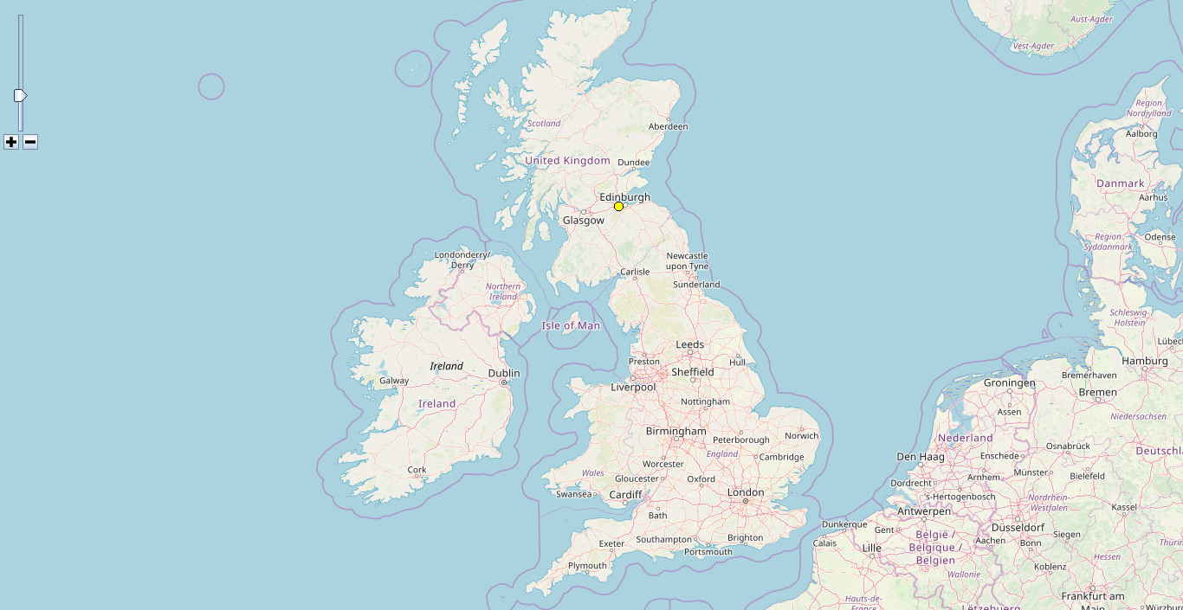

Answer 08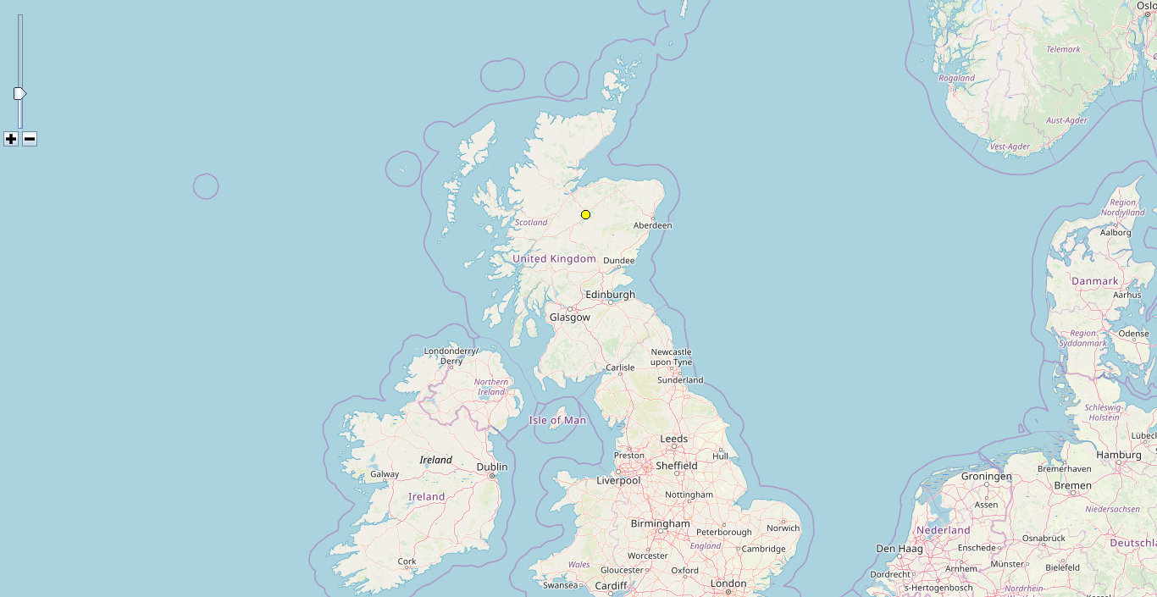Answer 09

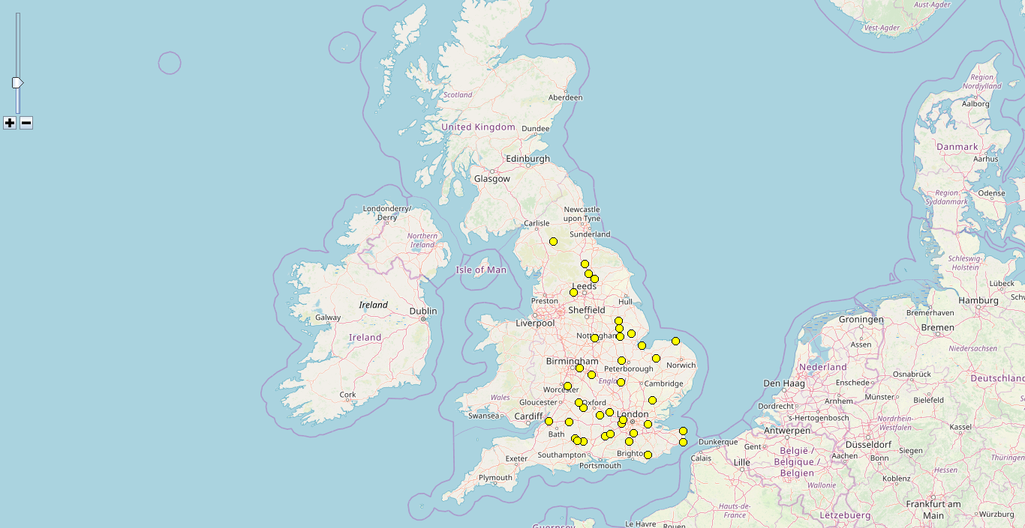

Answer 10

