

IT2030
Object Oriented Programming
2nd Year, 1st Semester

MID Assignment

Submitted to
Sri Lanka Institute of Information Technology

In partial fulfillment of the requirements for the
Bachelor of Science Special Honors Degree in Information Technology

Name : S D Kasthuriarachchi
ID NO : IT19082066
Group : 12.1(CSNE)

31/03/20
Declaration
I certify that this report does not incorporate without acknowledgement, any material previously submitted for a degree or diploma in any university, and to the best of my knowledge and belief it does not contain any material previously published or written by another person, except where due reference is made in text.

Registration Number : IT19082066
Name : S D Kasthuriarachchi

Console Output

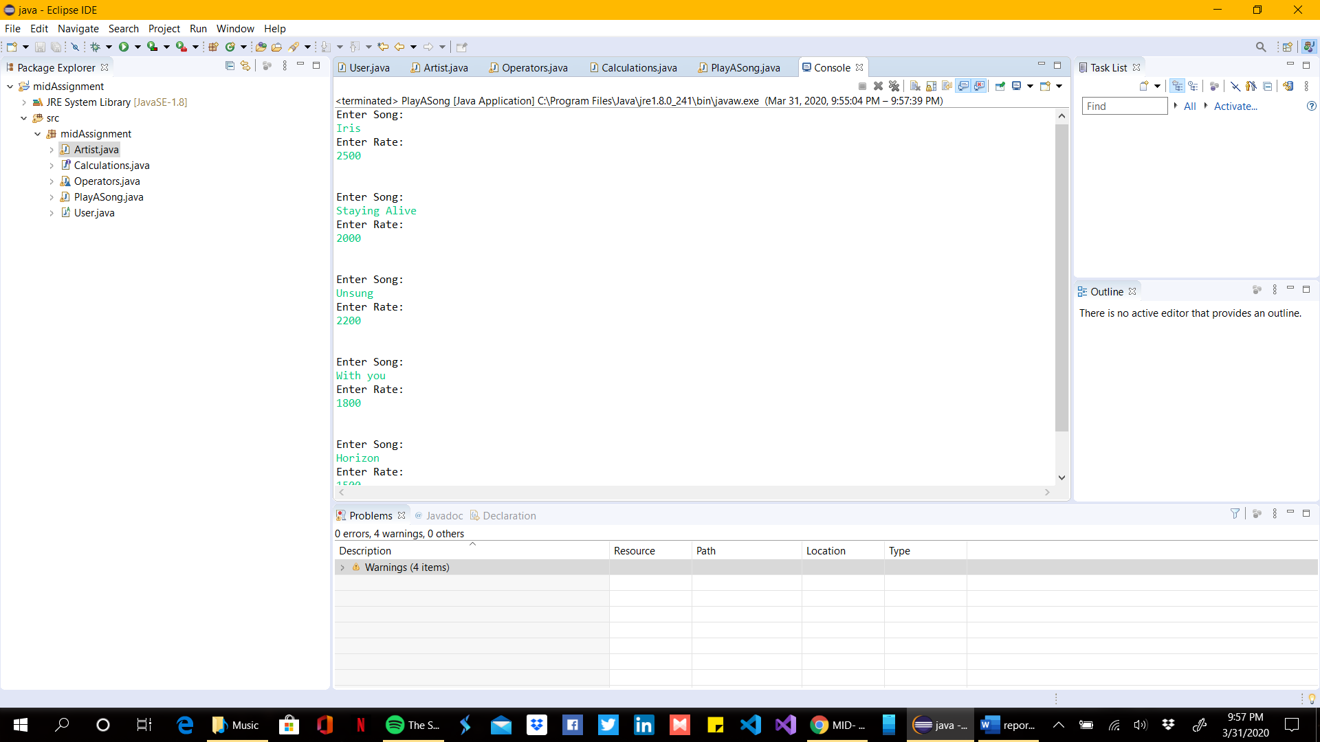

Figure 1.1
- The above figure shows the output of song_list_storage() Method.
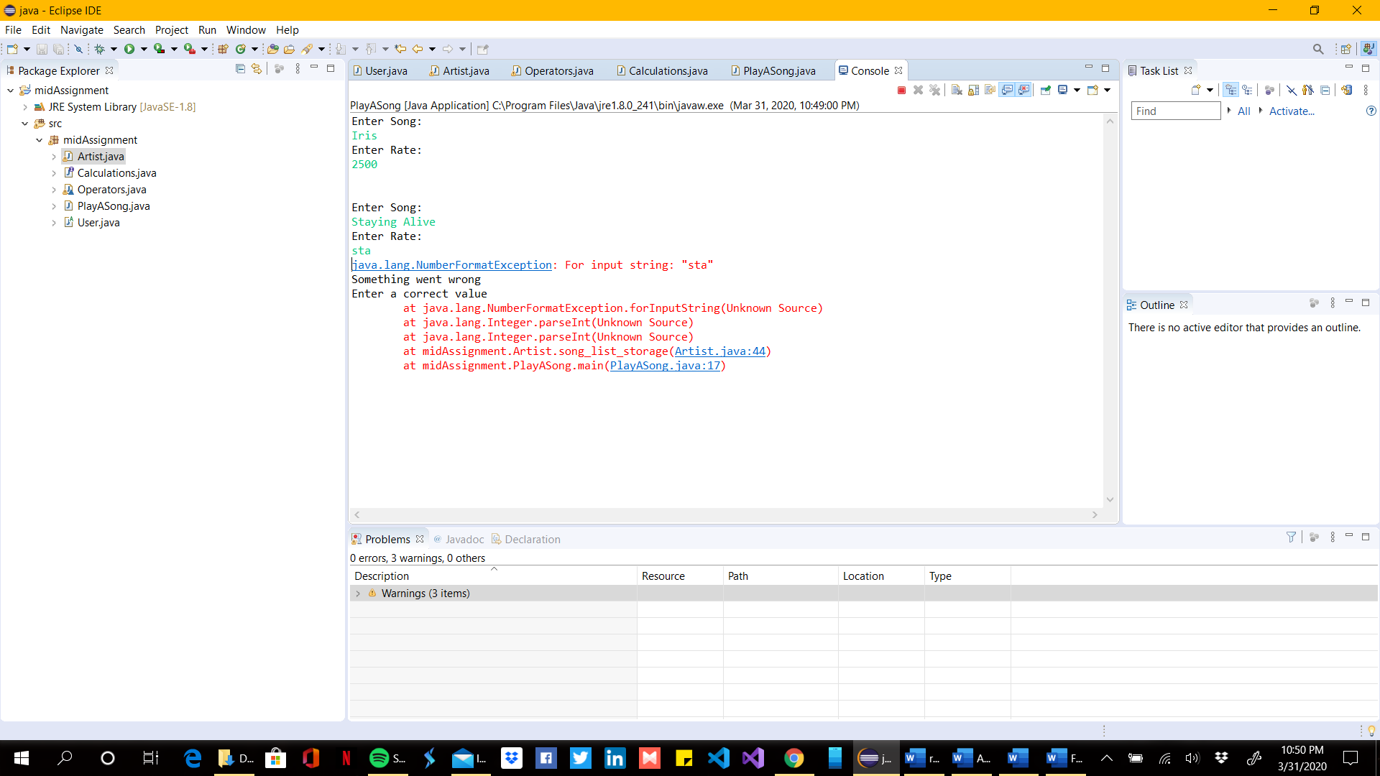

Figure 1.2
- The above figure shows a error message if entered a String value for the rate field.

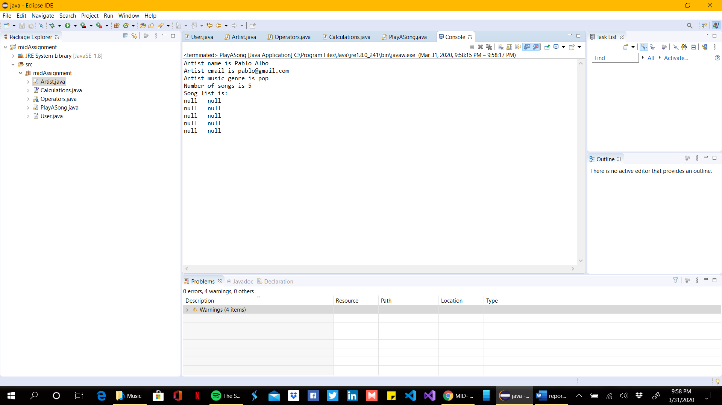Figure 2
- The above figure shows the output of printDetails() Method in Artist class.
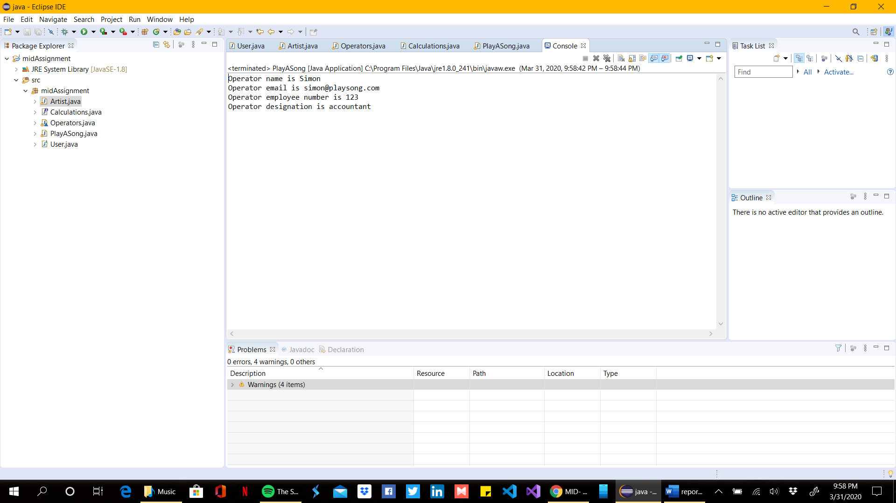
Figure 3
- The above figure shows the output of printDetails() Method in Operators class.

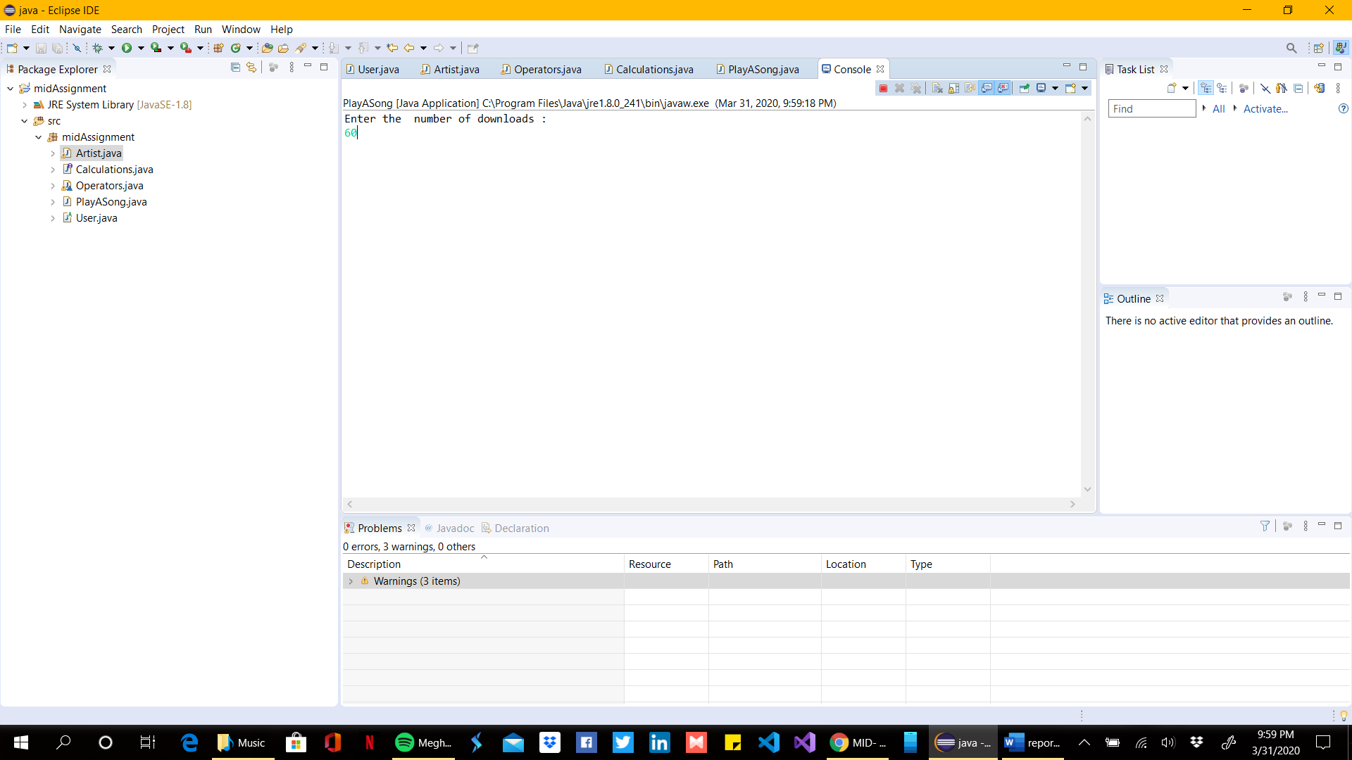
Figure 4
- The above figure shows the output of calculateRevenue(Artist Art1) Method.

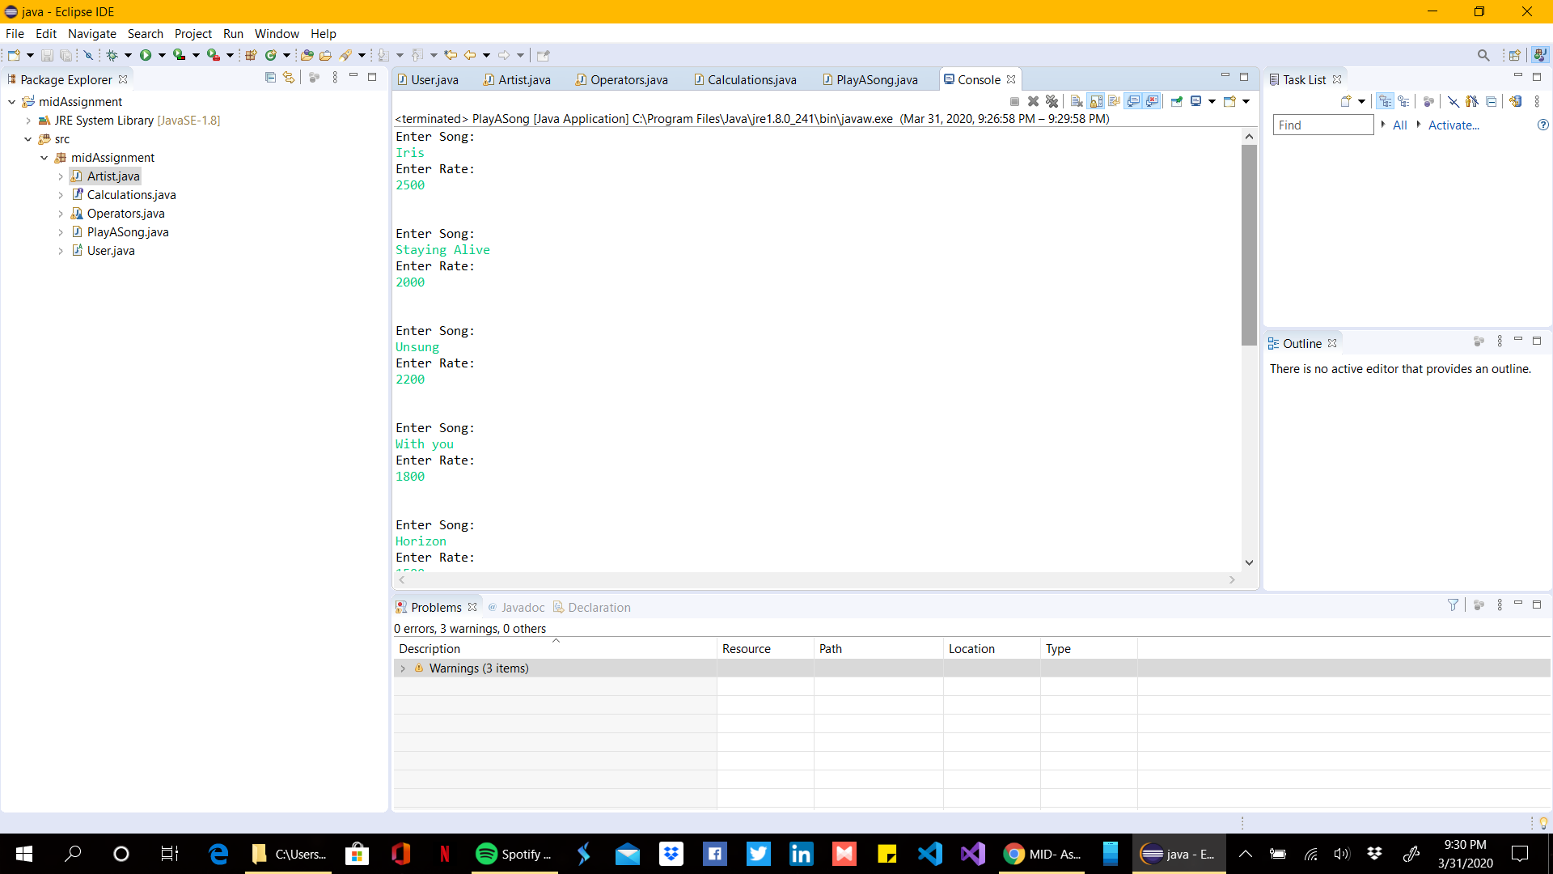
Figure 5.1
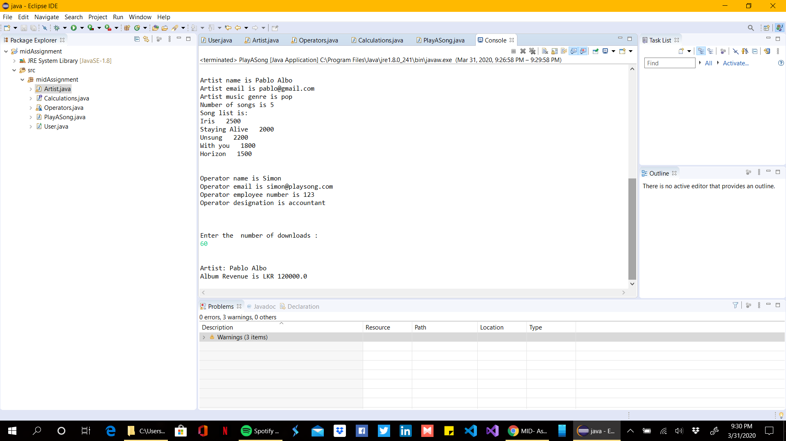
Figure 5.2
- The above 5.1 and 5.2 figures shows the last output of the all methods and functions.

