Lab worksheet 01

Q1.

Code

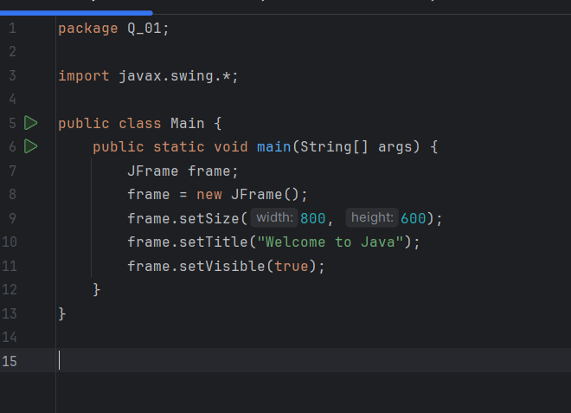

Output

Q2.

Code:

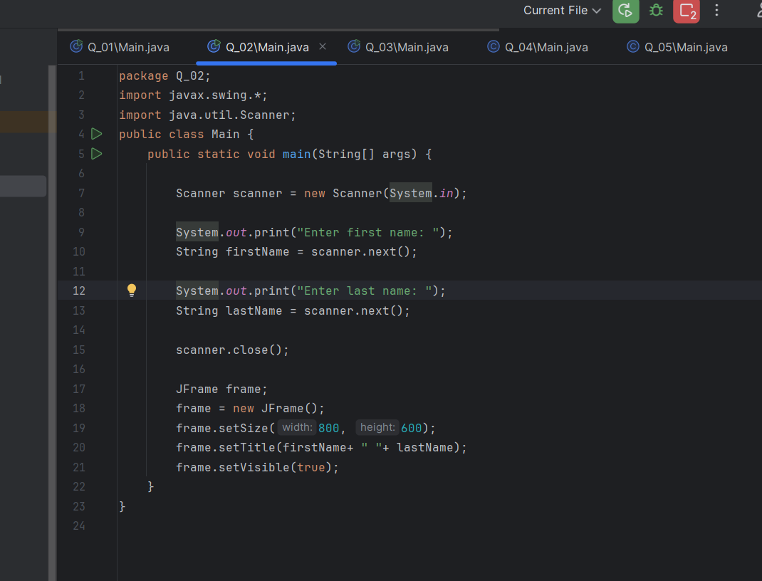

Output

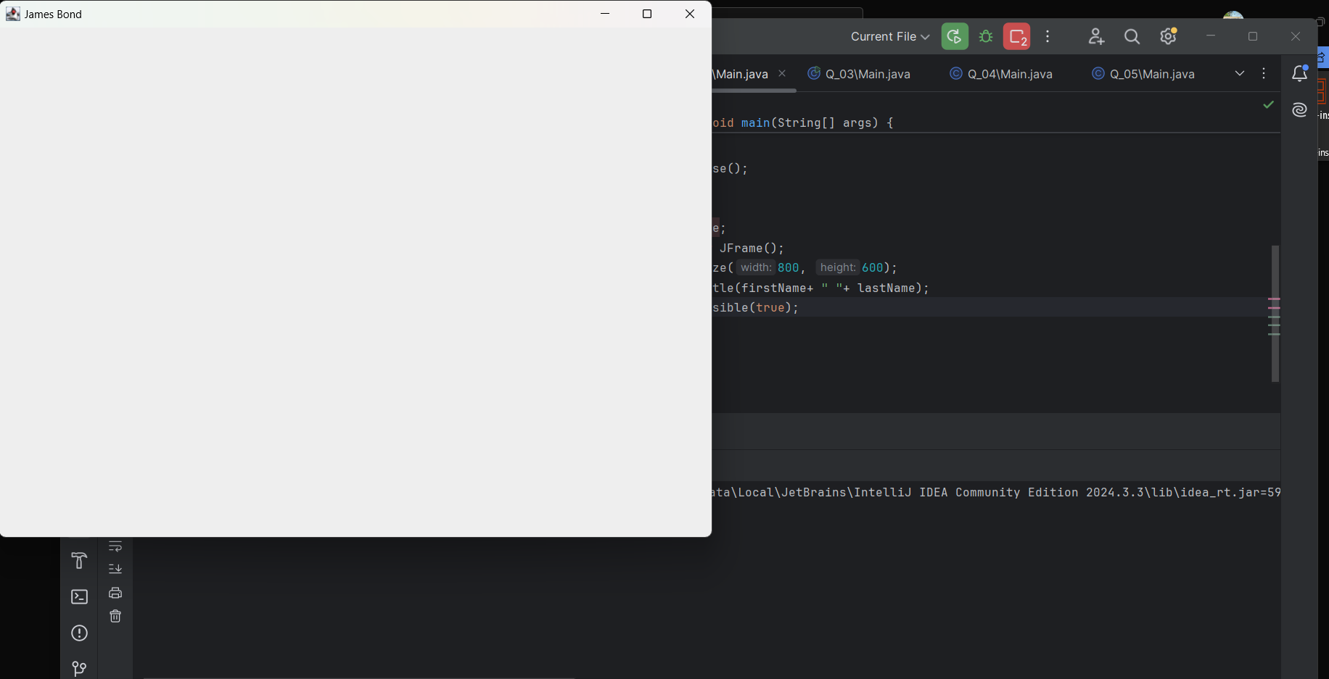

Q3.

Code

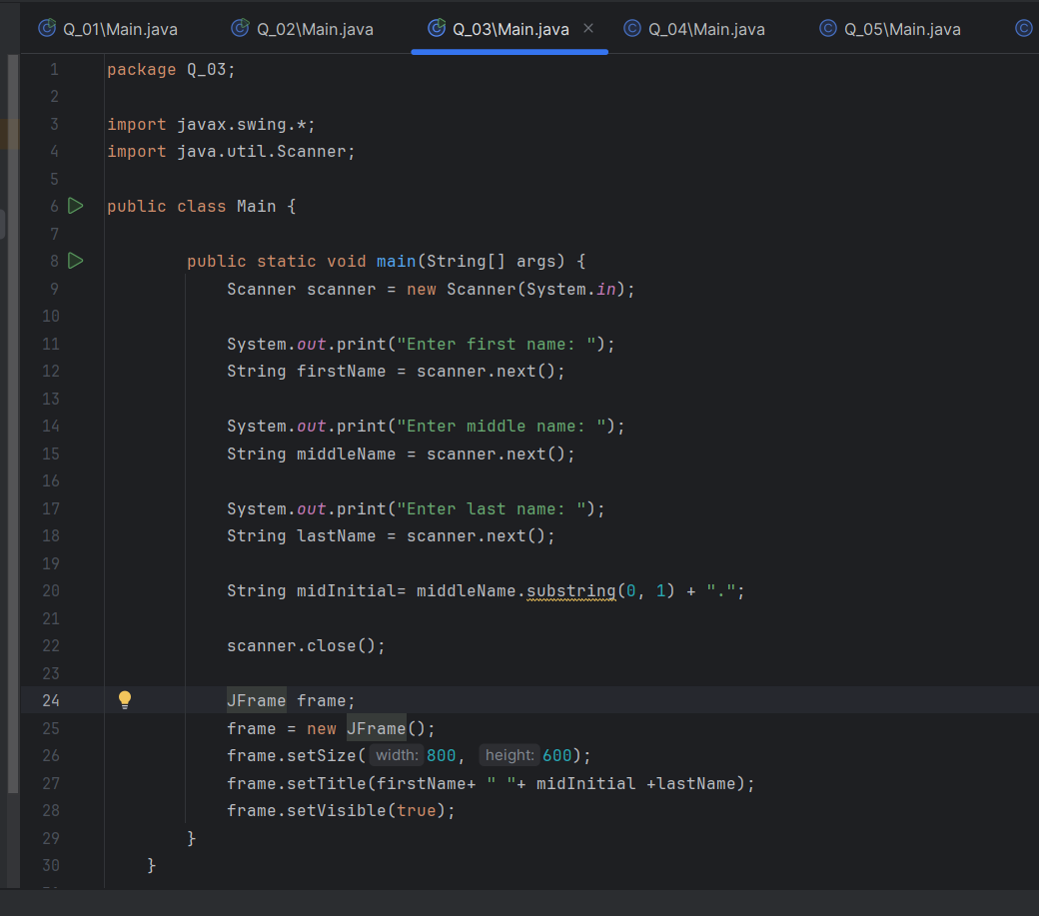

Q4.

Code

Output

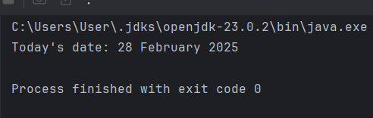

Q5.

Code

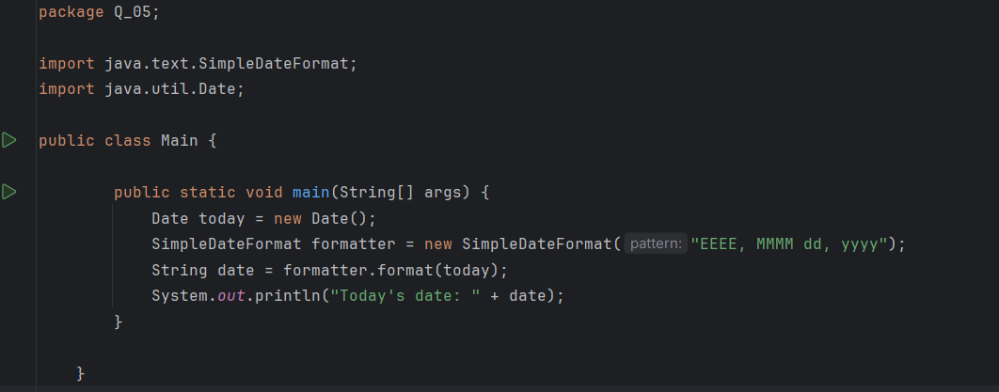

Output

Q6.

Code

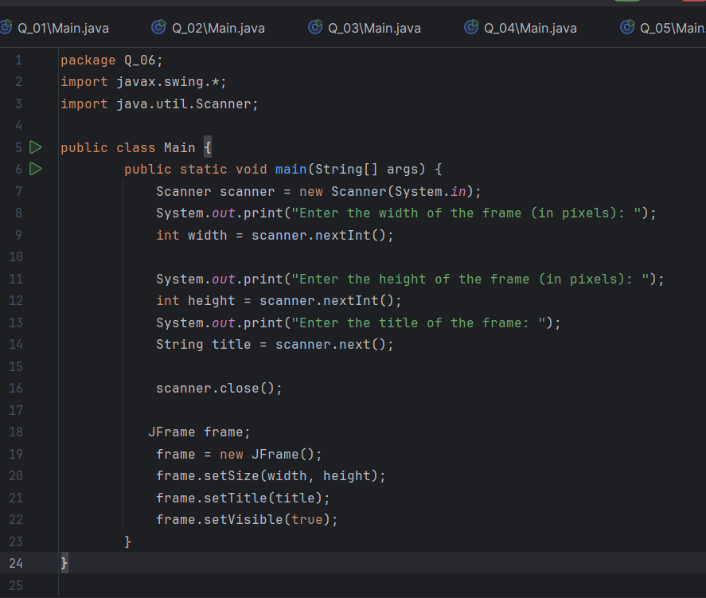

Output

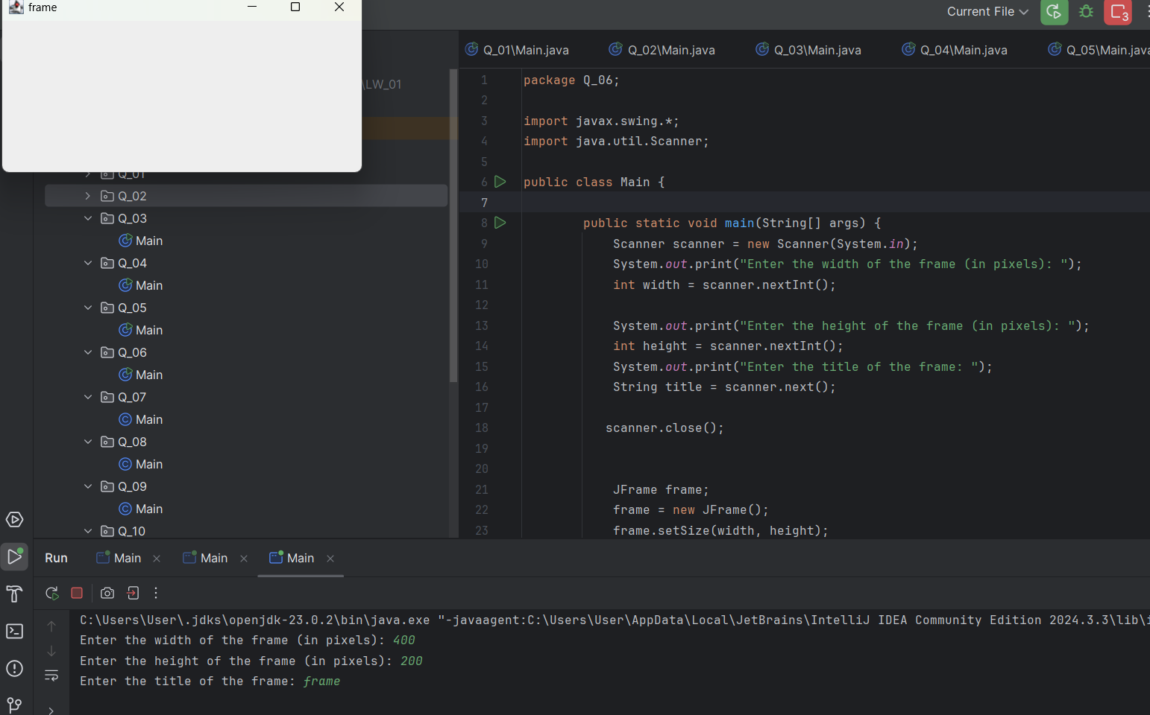

Q7.

Code

Output

Q8.

Code

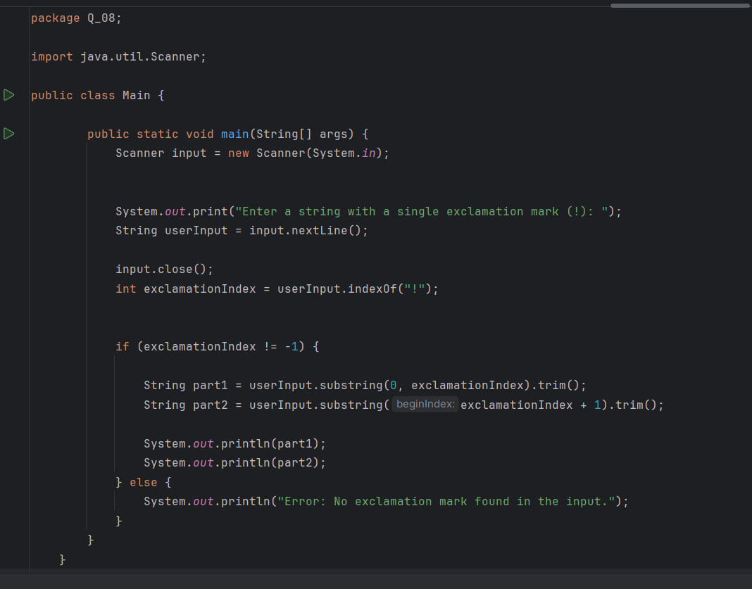

Output

Q9.

Code

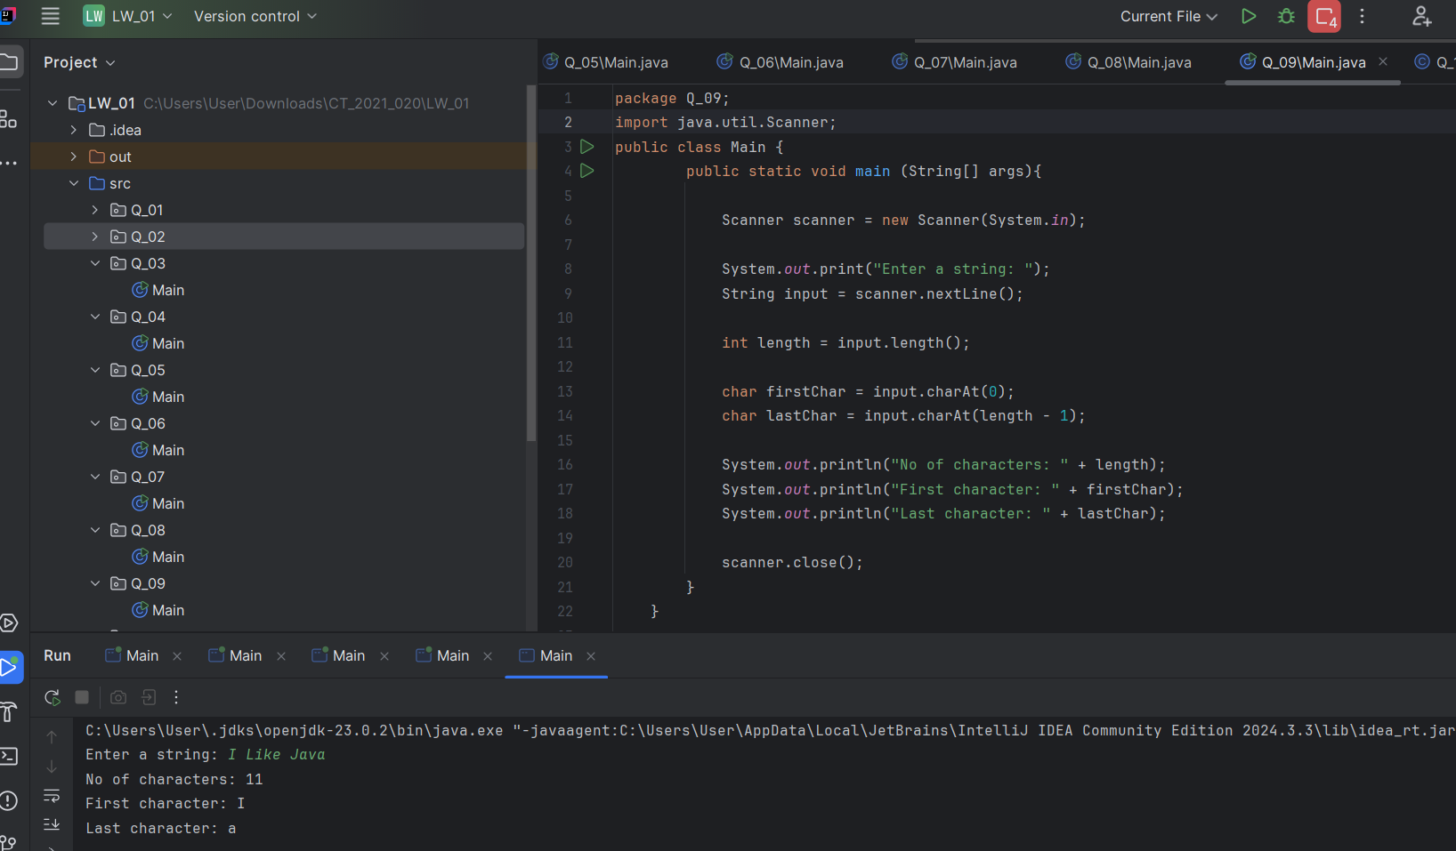

Output



Q10.

Code

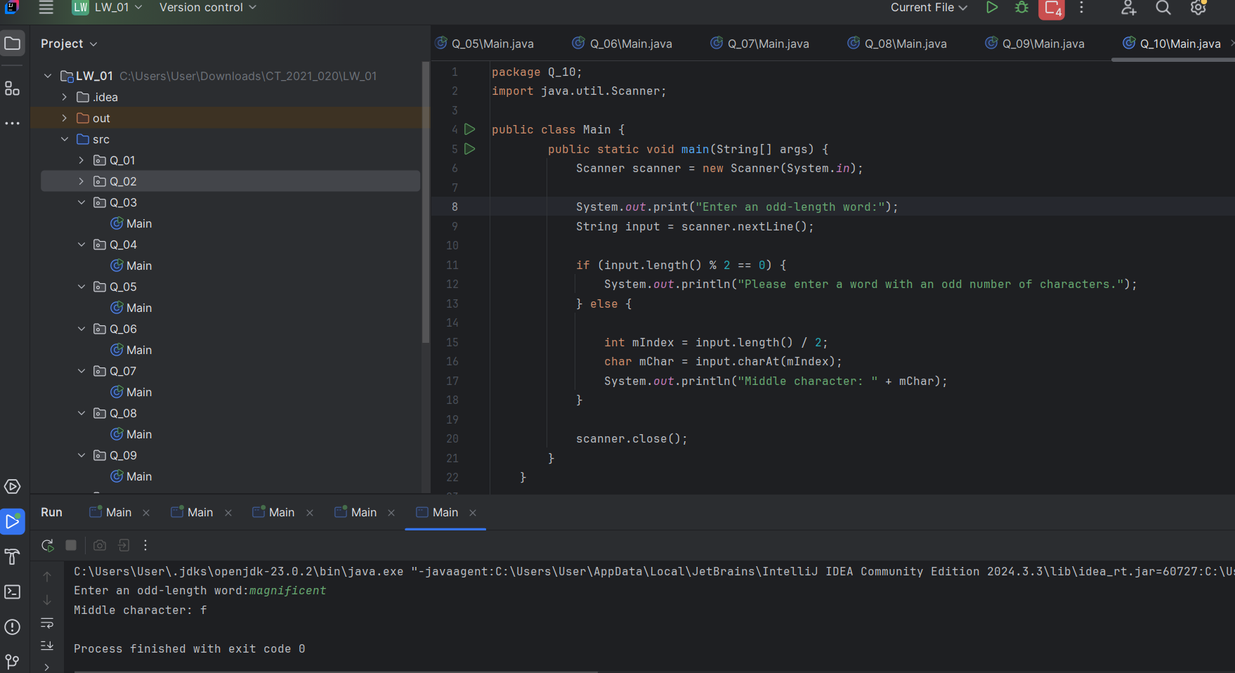

Output

Q11.

Code

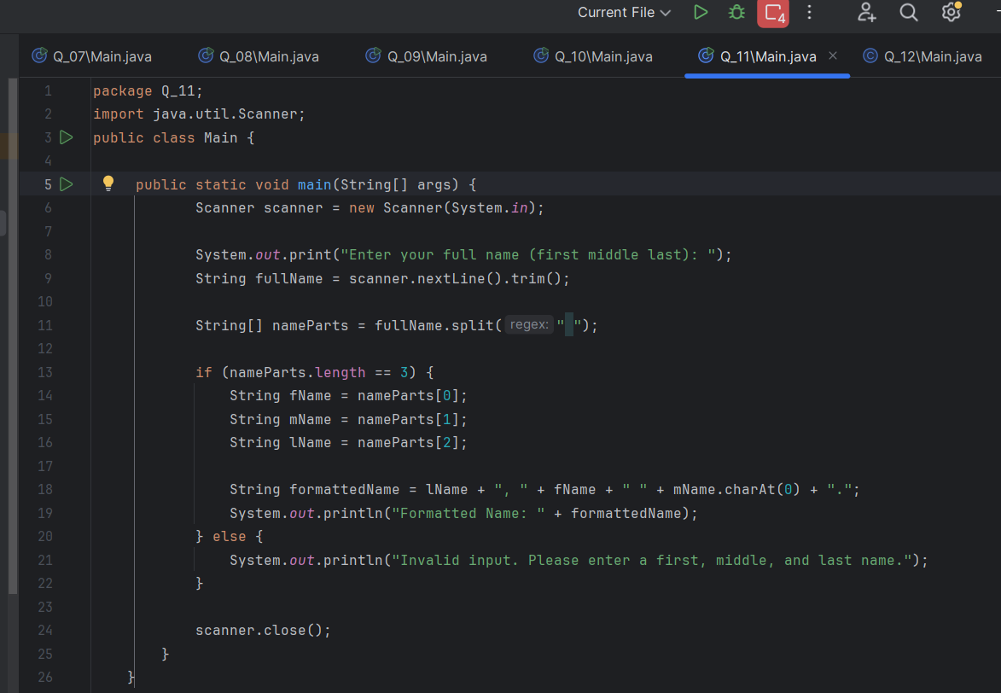

Output

Q12.

Code

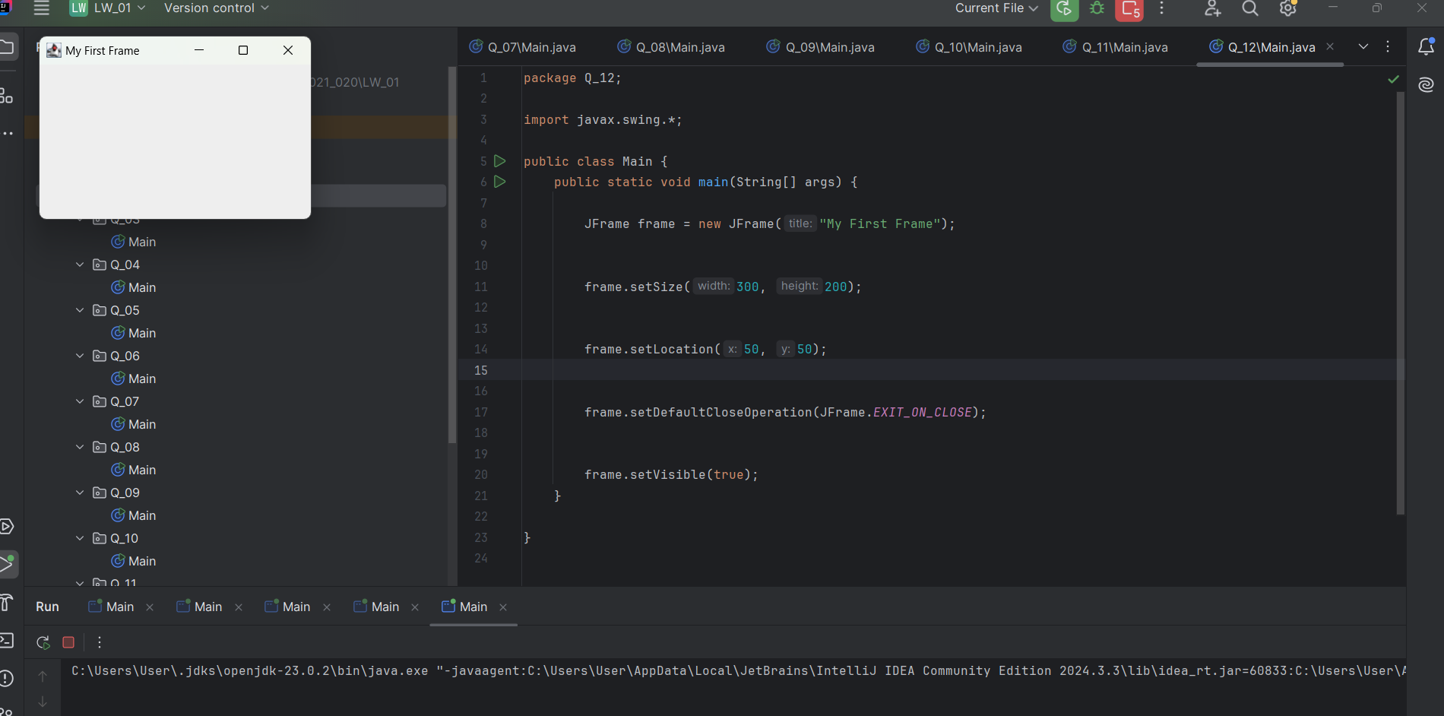

Output

