Lab worksheet 02

CT/2021/020

Q01.

A).

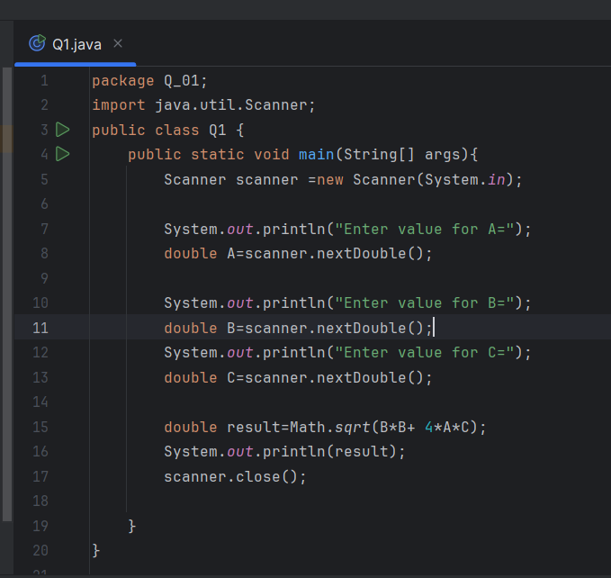

Output

B).

Output

C)

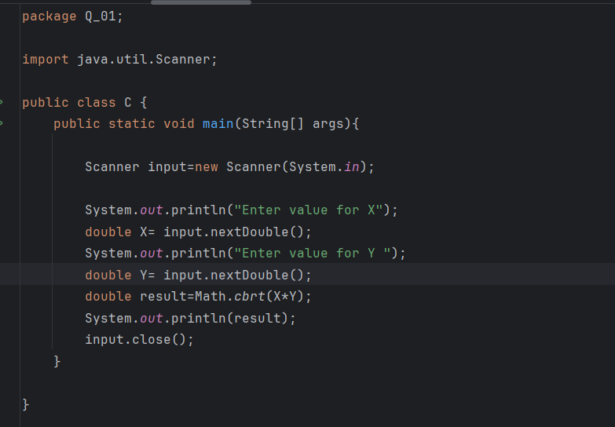

Output

D).

Output

Q02).

Output

Q03).

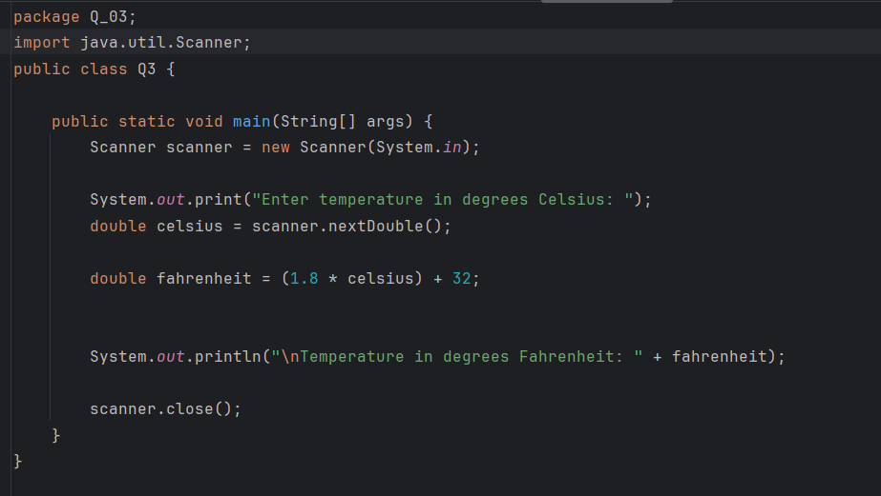

Output

Q04).

Output

Q05).

Output

Q06).

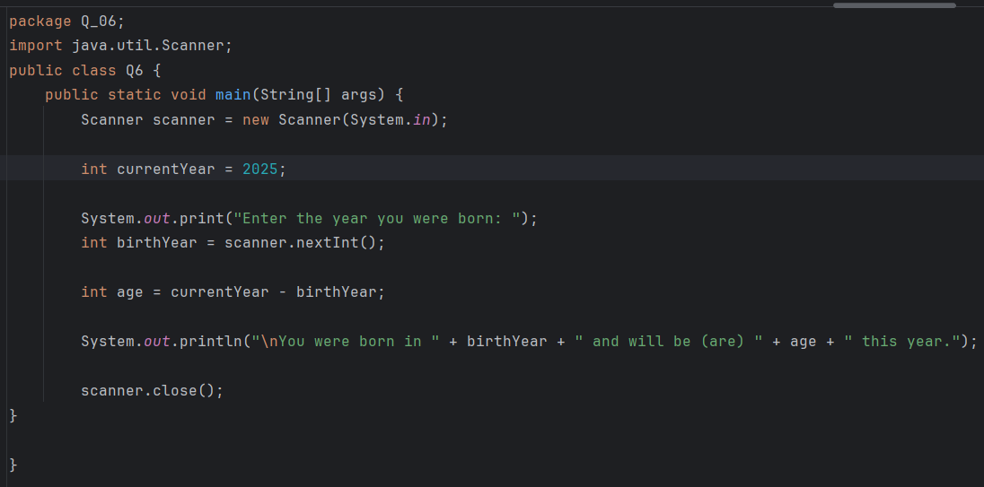

Output

Q07).

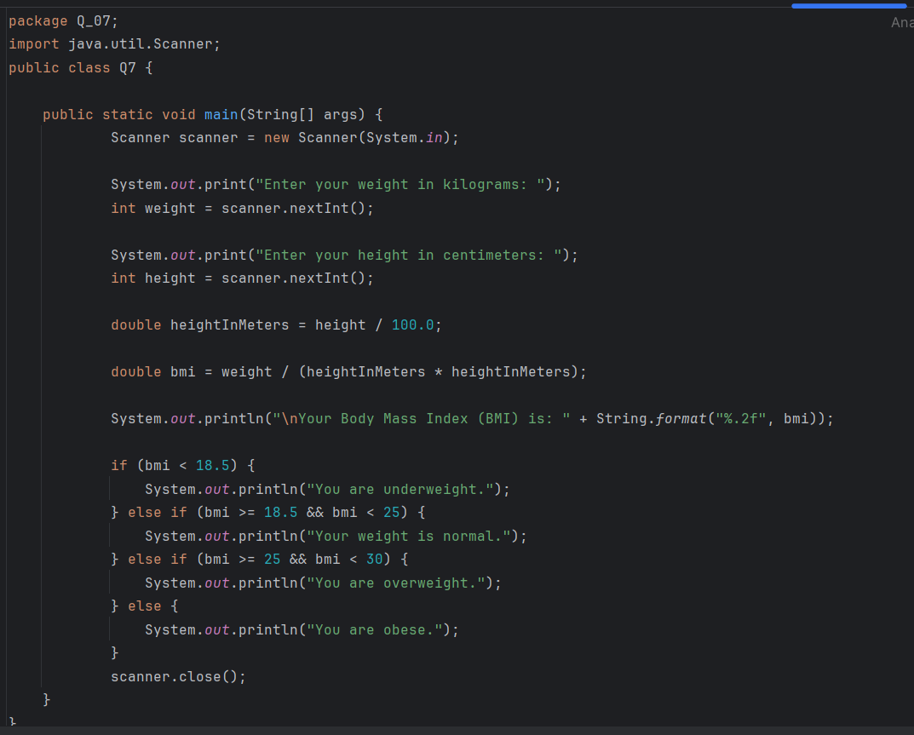

Output

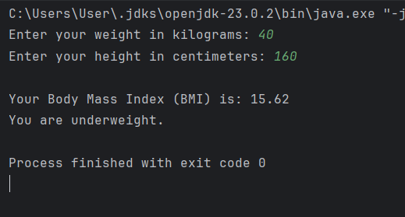

Q08).

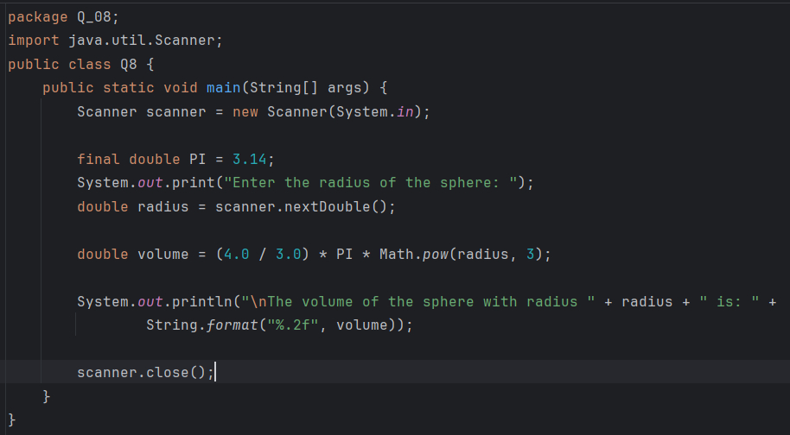

Output

Q09).

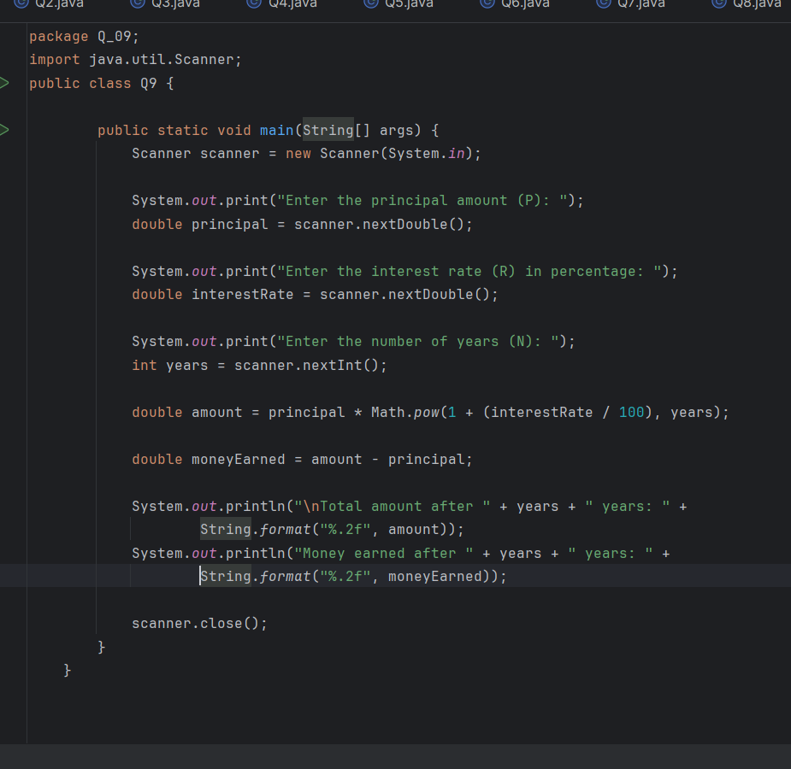

Output

Q10).

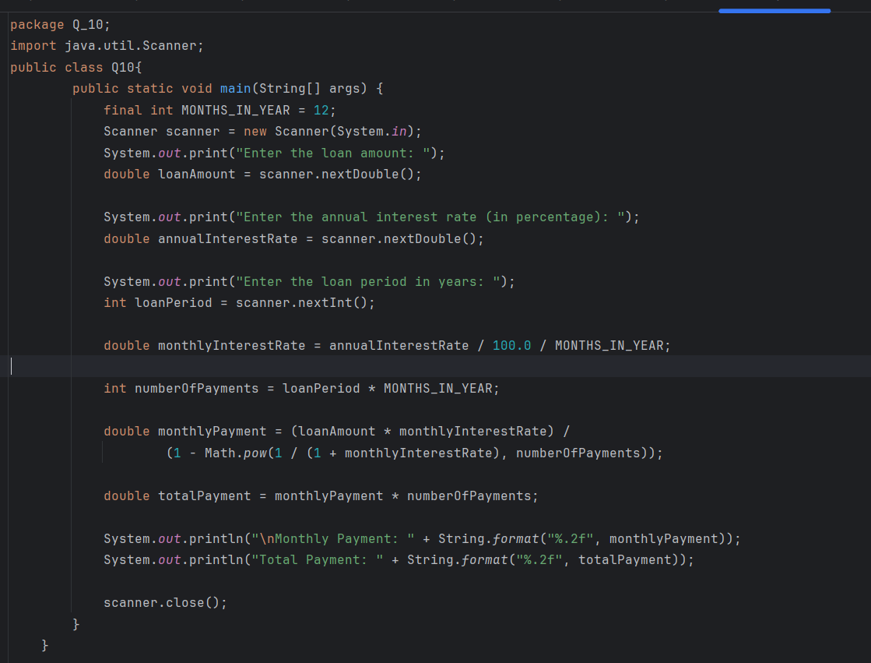

Output

