Lab worksheet 3

CT/2021/020

Amaranayaka.W.M.S.K.

Q01).

package Que01;  
  
import java.util.Scanner;  
  
class Temp {  
 private double celsius;  
  
 public Temp() {  
 this.celsius = 0.0;  
 }  
 public Temp(double celsius) {  
 this.celsius = celsius;  
 }  
 public double toFahrenheit() {  
 return (celsius \* 9 / 5) + 32;  
 }  
 public double toCelsius() {  
 return celsius;  
 }  
 public void setCelsius(double celsius) {  
 this.celsius = celsius;  
 }  
  
 public void setFahrenheit(double fahrenheit) {  
 this.celsius = (fahrenheit - 32) \* 5 / 9;  
 }  
}  
public class Temperature {  
 public static void main(String[] args) {  
 Scanner scanner = new Scanner(System.*in*);  
  
 System.*out*.print("Enter temperature in Celsius: ");  
 double celsiusInput = scanner.nextDouble();  
  
 Temp temp = new Temp(celsiusInput);  
 System.*out*.println("Equivalent Fahrenheit: " + temp.toFahrenheit());  
  
 scanner.close();  
 }  
}

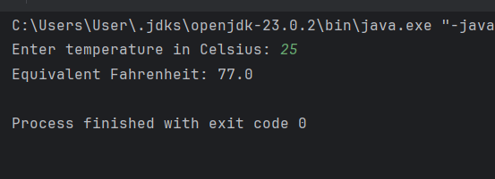

Q02).

package Que02;  
  
import java.util.Scanner;  
  
class Temp {  
 private double celsius;  
  
 public Temp() {  
 this.celsius = 0.0;  
 }  
  
 public Temp(double celsius) {  
 this.celsius = celsius;  
 }  
  
 public double toFahrenheit() {  
 return (celsius \* 9 / 5) + 32;  
 }  
  
 public double toCelsius() {  
 return celsius;  
 }  
  
 public void setCelsius(double celsius) {  
 this.celsius = celsius;  
 }  
  
 public void setFahrenheit(double fahrenheit) {  
 this.celsius = (fahrenheit - 32) \* 5 / 9;  
 }  
}  
  
public class Temperature {  
 public static void main(String[] args) {  
 Scanner scanner = new Scanner(System.*in*);  
  
 // Input temperature in Fahrenheit  
 System.*out*.print("Enter temperature in Fahrenheit: ");  
 double fahrenheitInput = scanner.nextDouble();  
  
 Temp temp = new Temp();  
 temp.setFahrenheit(fahrenheitInput);  
 System.*out*.println("Equivalent Celsius: " + temp.toCelsius());  
  
 scanner.close();  
 }  
}

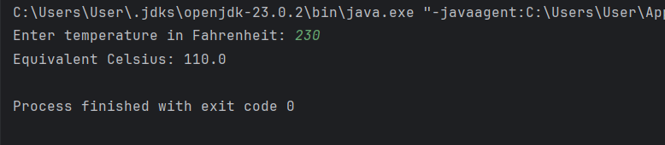

Q03).

package Que03;  
  
import java.util.Scanner;  
  
class Cir{  
 private double radius;  
  
 public Cir(double radius) {  
 this.radius = radius;  
 }  
 public void setRadius(double radius) {  
 this.radius = radius;  
 }  
 public double computeArea() {  
 return Math.*PI* \* radius \* radius;  
 }  
 public double computeCircumference() {  
 return 2 \* Math.*PI* \* radius;  
 }  
}  
  
public class Circle {  
 public static void main(String[] args) {  
 Scanner scanner = new Scanner(System.*in*);  
  
 System.*out*.print("Enter inner radius: ");  
 double innerRadius = scanner.nextDouble();  
  
 System.*out*.print("Enter outer radius: ");  
 double outerRadius = scanner.nextDouble();  
  
 Cir innerCircle = new Cir(innerRadius);  
 Cir outerCircle = new Cir(outerRadius);  
  
 double shadedArea = outerCircle.computeArea() - innerCircle.computeArea();  
 System.*out*.println("Shaded Area: " + shadedArea);  
  
 scanner.close();  
 }  
}

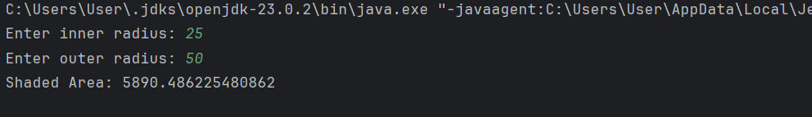

Q04).

package Que04;  
class Owner {  
 private String ownerName;  
 private String phoneNo;  
  
 public Owner(String ownerName, String phoneNo) {  
 this.ownerName = ownerName;  
 this.phoneNo = phoneNo;  
 }  
  
 public String getOwnerName() {  
 return ownerName;  
 }  
  
 public String getPhoneNo() {  
 return phoneNo;  
 }  
  
 public void setOwnerName(String ownerName) {  
 this.ownerName = ownerName;  
 }  
  
 public void setPhoneNo(String phoneNo) {  
 this.phoneNo = phoneNo;  
 }  
}  
  
class Bicycle1 {  
 private Owner owner;  
  
 public Bicycle1() {  
 this.owner = new Owner("Unknown", "0000000000");  
 }  
 public Bicycle1(String ownerName, String phoneNo) {  
 this.owner = new Owner(ownerName, phoneNo);  
 }  
  
 public String getOwnerName() {  
 return owner.getOwnerName();  
 }  
  
 public String getPhoneNo() {  
 return owner.getPhoneNo();  
 }  
  
 public void setOwner(String ownerName, String phoneNo) {  
 this.owner.setOwnerName(ownerName);  
 this.owner.setPhoneNo(phoneNo);  
 }  
}  
  
public class Bicycle {  
 public static void main(String[] args) {  
 Bicycle1 myBike = new Bicycle1("Nick John", "0774782323");  
 System.*out*.println("Owner Name: " + myBike.getOwnerName());  
 System.*out*.println("Phone Number: " + myBike.getPhoneNo());  
  
 myBike.setOwner("Britny Edward", "0765432111");  
 System.*out*.println("Updated Owner Name: " + myBike.getOwnerName());  
 System.*out*.println("Updated Phone Number: " + myBike.getPhoneNo());

}  
}

Q05).

package Que05;  
  
class Lecturer {  
 private String lecturerName;  
 private String courseTeaching;  
  
 public Lecturer(String lecturerName, String courseTeaching) {  
 this.lecturerName = lecturerName;  
 this.courseTeaching = courseTeaching;  
 }  
  
 public String getLecturerName() {  
 return lecturerName;  
 }  
 public String getCourseTeaching() {  
 return courseTeaching;  
 }  
  
 public void setLecturerName(String lecturerName) {  
 this.lecturerName = lecturerName;  
 }  
  
 public void setCourseTeaching(String courseTeaching) {  
 this.courseTeaching = courseTeaching;  
 }  
}  
  
class Course {  
 private String courseName;  
 private String courseCode;  
 private Lecturer lecturer;  
  
 public Course(String courseName, String courseCode, Lecturer lecturer) {  
 this.courseName = courseName;  
 this.courseCode = courseCode;  
 this.lecturer = lecturer;  
 }  
  
 public String getCourseName() {  
 return courseName;  
 }  
  
 public String getCourseCode() {  
 return courseCode;  
 }  
  
 public Lecturer getLecturer() {  
 return lecturer;  
 }  
  
 public void setCourseName(String courseName) {  
 this.courseName = courseName;  
 }  
  
 public void setCourseCode(String courseCode) {  
 this.courseCode = courseCode;  
 }  
  
 public void setLecturer(Lecturer lecturer) {  
 this.lecturer = lecturer;  
 }  
}  
  
class Student {  
 private String studentName;  
 private String degreeName;  
 private String courseFollowing;  
  
 public Student(String studentName, String degreeName, String courseFollowing) {  
 this.studentName = studentName;  
 this.degreeName = degreeName;  
 this.courseFollowing = courseFollowing;  
 }  
  
 public String getStudentName() {  
 return studentName;  
 }  
  
 public String getDegreeName() {  
 return degreeName;  
 }  
  
 public String getCourseFollowing() {  
 return courseFollowing;  
 }  
  
 public void setStudentName(String studentName) {  
 this.studentName = studentName;  
 }  
  
 public void setDegreeName(String degreeName) {  
 this.degreeName = degreeName;  
 }  
  
 public void setCourseFollowing(String courseFollowing) {  
 this.courseFollowing = courseFollowing;  
 }  
}  
  
  
public class Registration {  
 public static void main(String[] args) {  
 Lecturer lecturer = new Lecturer("Dr. Nickolose", "Network Lab");  
 Course course = new Course("Networking Systems", "CT2021061", lecturer);  
 Student student = new Student("Sadeepa kalhara", "Bachelor of ICT", "Networking Systems");  
  
 System.*out*.println("Course Name: " + course.getCourseName());  
 System.*out*.println("Course Code: " + course.getCourseCode());  
 System.*out*.println("Lecturer Name: " + course.getLecturer().getLecturerName());  
 System.*out*.println("Student Name: " + student.getStudentName());  
 System.*out*.println("Degree Name: " + student.getDegreeName());  
 System.*out*.println("Course Following: " + student.getCourseFollowing());  
 }  
}

