TID - Region A:

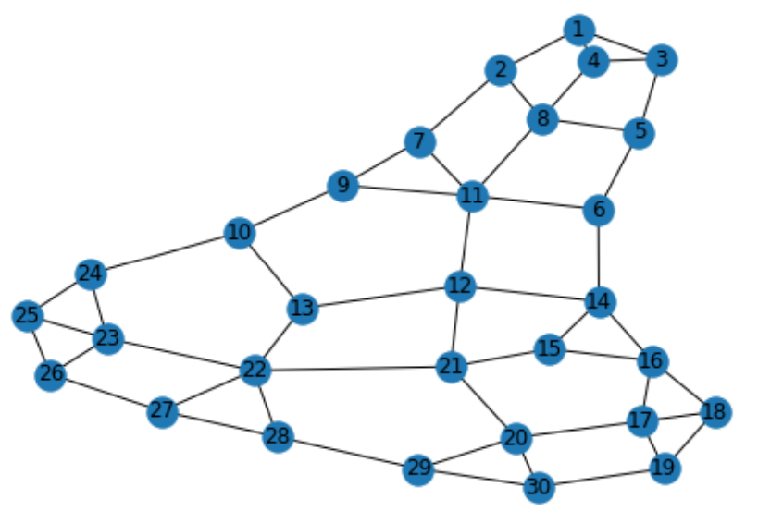c

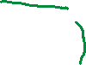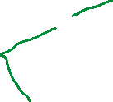

Hubs: node 8, node 22

Number of all paths between these two hubs: 64863

Number of all spanning trees between these two hubs: 86

Sorted Trees based on distance:

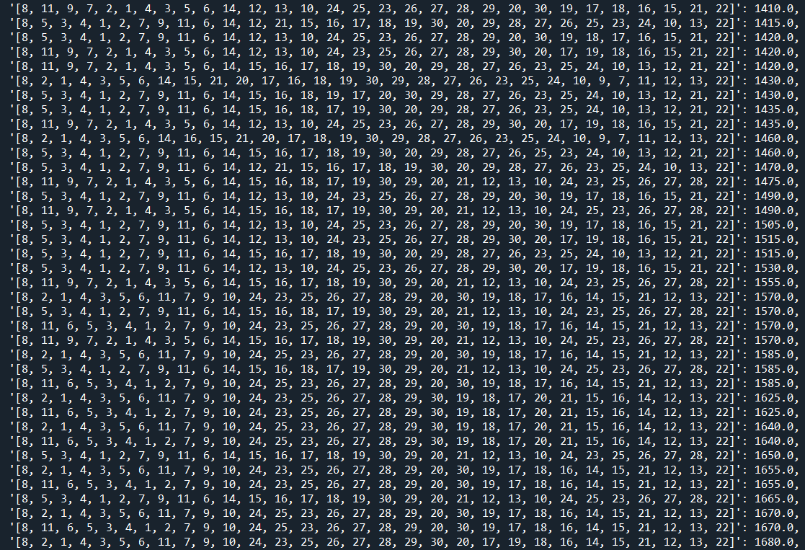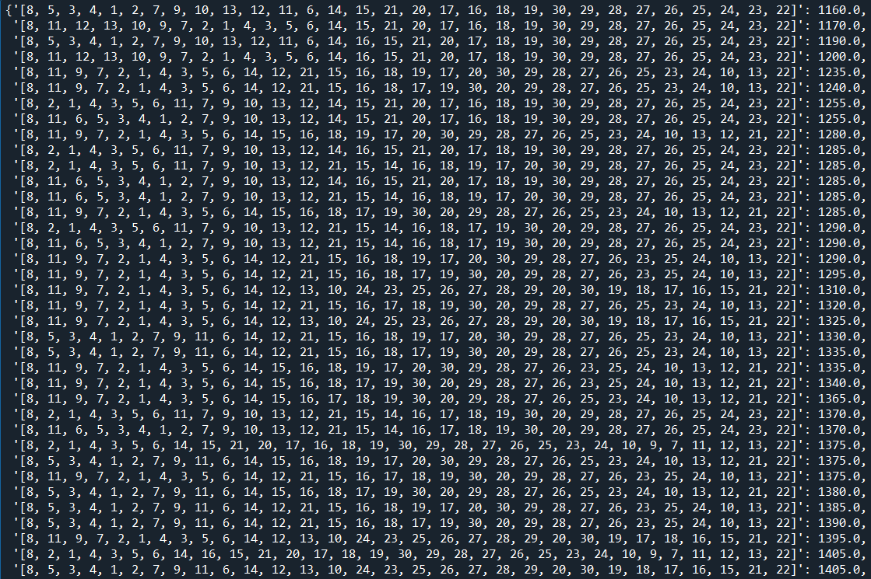

Sorted trees based on link attenuation:

