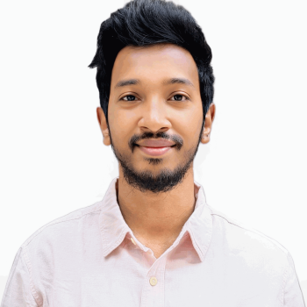**RESUME:**

**Abu Sadek Chowdhury (Sunny)**

729/29,road-10,adabor,Dhaka-1207

Mobile: **01799382934**

Email: [sadekchowdhury47@gmail.com](mailto:sadekchowdhury47@gmail.com)

Github: [sadek166621](https://github.com/sadek166621)

CAREER OBJECTIVE

To obtain a job within my choosen field that will challenge me and allow me to use my education, communication and interpersonal skills that is mutually beneficial to both myself allow for future growth and advancement.

**P R O F I L E S U M M A R Y**

* **(Sep 2023 - )** working **in Sky Dream IT** ([www.skydreamit.com](http://www.skydreamit.com)) as **a Junior Software Engineer (Php Laravel)**
* **6 month (Feb 2023 – Aug 2023)** working experience as Intern and junior Software engineer in Ai Software Solutions ( **Web design & Development )**

TECHNICAL SKILLS

**Php(Laravel), Javascript, Jquery, Css, html .**

PROJECTS (recent)

1. <https://www.dtmqa.org> (<https://github.com/sadek166621/DTMQA>)
2. **<https://travelengineer.xyz> (<https://github.com/sadek166621/travel_engineer>)**
3. **<https://ecom5.website-designer-pro.com/> (Single Vendor Ecommece) (<https://github.com/sadek166621/singlevendor_ecom>)**
4. **fxwwiits.com (<https://github.com/sadek166621/fx_wwiits>)**
5. **<https://medic.website-designer-pro.com/> (<https://github.com/sadek166621/medeasy>)**
6. **<https://smsprintingonline.com/> (<https://github.com/sadek166621/sms_printing>)**
7. **<https://nowabenkicollege.edu.bd/> (<https://github.com/sadek166621/nowabenki>)**
8. **<https://myteachersbd.com/>**
9. **<https://www.chokoriaprobashisociety.org/(https://github.com/sadek166621/Chokoria_probhashi)>**

Others Experience:

* Part time working experience as a web designer (2019-2020)
* Worked in a book fair (2019 -2021).
* Music event experience in chittagong (as a guitarist).
* Data entry, Lead generation, Web research, email searching.

EDUCATIONAL BACKGROUND

Graduation **Diploma in Engineering**

Institute of science and technology **(IST)**

Passing Year – 2021 **(CGPA 3.75 out of 4.00)**

Secondary Secondary School Certificate **(SSC)**

Mohammadpur model school and college

Passing Year – 2016 (1st Division)

**Competence & Ability:**

* Enjoy new challenges and team work.
* Strong communication and presentation skills.
* Ability to multitask jobs minimal supervision.

**Language Proficiency:**

* English- Thoroughly writing and talking English
* Bangla- Speaking, writing and skill Communicative level

**Interests:**

My leisure activities include Traveling in many place, Coding, listening music, Internet browsing and learning new activities.

**PERSONAL INFORMATION:**

* Name : Abu Sadek Chowdhury(Sunny)
* Father’s Name : (Late)Major.Enamul Haque Chowdhury
* Mother’s Name : Sabiha Chowdhury
* Date of Birth : 04 March 1999
* Place of Birth : Dist: Dhaka, Bangladesh.
* Blood Group : B +
* Present address : 726/29,road-10,adabor,mohammadpur, Dhaka
* Language : Bangla, English
* Hobby : Playing guitar, sketching & reading books.
* Others skills :Upwork, data entry, Lead generation,B2b,

Facebook marketing & Youtube marketing.

**Reference:**

(Engineer. Jahirul kader Rana)

Sr. Instructor   
Institute of science and technology

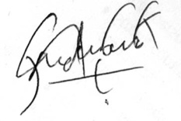

Signature & Date