Restaurant Industry Report

Name:

The city is interested in growing local business to increase its tax base. Since there has been a large increase in tourism in recent years, the city sees an opportunity to grow the restaurant market.

Currently, there are about 25 restaurants in the city making high economic profits. These restaurants offer different types of cuisine, different customer experiences, and a wide variety of price points. The city has a long-term goal of increasing the number of restaurants to 35.

Complete the sections below. Each answer should be 200–250 words in length.

Part 1: The Short Run

To begin, review the short-run equilibrium graph below.
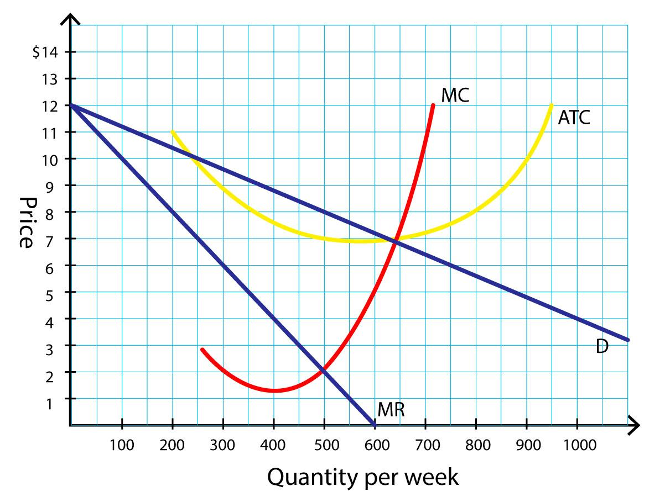

Use this graph to determine the quantity, price, and profit for an average restaurant in the short run. Answer the following questions:

- In the short run, what is the equilibrium quantity and price for an average restaurant, given the information on the graph?
- How much economic profit is made?

<Insert text here.>

Part 2: The Long Run

Explain how allowing more restaurants in the city would impact the restaurant market in the long run. Base your answer on what you found about price, quantity, and profit in the short run. Consider the following questions in your response:

- Overall, will there be entry or exit of restaurants in the market? Why?
- How will the economic profit change for restaurants?
- How will product choice and prices be affected?

<Insert text here.>

Part 3: Strategies
As part of the market structure analysis report, you will analyze the restaurant industry of the city. The city is interested in growing local business to increase its tax base and has a long-term goal of increasing the number of restaurants to 35. Currently, there are about 25 restaurants in the city making high economic profit.
Below is a list of current restaurants with the types of cuisine they offer and their price points. Price points are represented with $ symbols, where $ is a less expensive restaurant and $$$$ is a more expensive one.

Restaurant | Type of Cuisines | Price
1 | Italian | $
2 | Middle Eastern | $
3 | Thai | $
4 | Greek | $
5 | Chinese | $
6 | American Fast Food | $
7 | Mexican | $
8 | Italian | $
9 | Chinese | $
10 | Italian | $$
11 | Mexican | $$
12 | Asian Mix | $$
13 | Lebanese | $$
14 | Middle Eastern | $$
15 | Caribbean | $$
16 | Indian | $$
17 | Mediterranean | $$
18 | African | $$
19 | American | $$$
20 | Fusion | $$$
21 | Japanese | $$$
22 | Mediterranean | $$$
23 | Brazilian | $$$
24 | French | $$$$
25 | Eclectic | $$$$

After reviewing the list of restaurants, explain at least two strategies that current and new restaurants could use to be successful in this market. Be sure to include strategies related to product differentiation, price, and service.

- What could current restaurants do to defend their market share against new restaurants?
- What could new restaurants do to be successful in this market?

<Insert text here.>

