Hello ,

**1)** Updation for "Download Sample Format For Bulk upload" has been done successfully.

Project is successfully working now. All the designs and messages are displayed properly.

Stored procedure named as UDP_BulkInstallUser is added in the stored procedure list in JGBS_Interview database on the server. Now the problem is when the excel sheet is converted into xml form then xml type parameters are passed to the stored procedure but there is an issue to pass it from stored procedure to database and i am trying to resolve it asap as before i dont have permission to write on the database. Actually in this what I am inserting as per your **sql server that is in general format but the data have to come xml format** so this is the issue but still I am trying to do it as soon as possible so give me some time for that .

So this is time taking task and I already have got the write permission of database quite late .

Screenshot is available over here for the working project that I have handled this error by this alert message ....

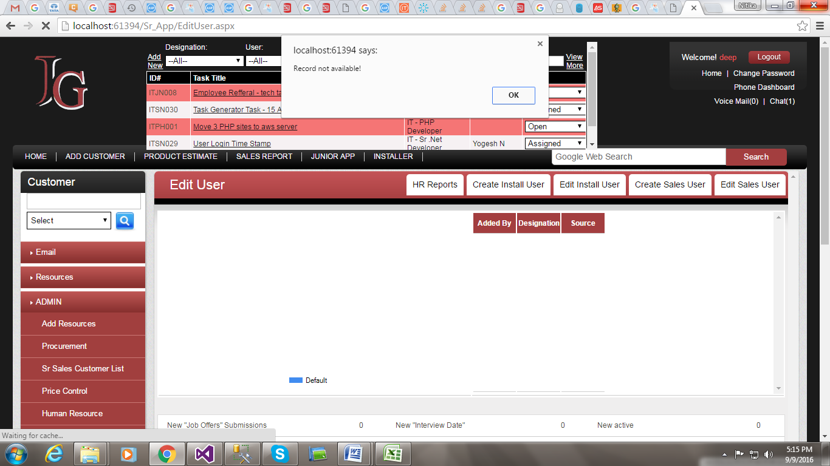

**2)** For the task I have changed the design of popup as you asked , for that the screenshot is as below -

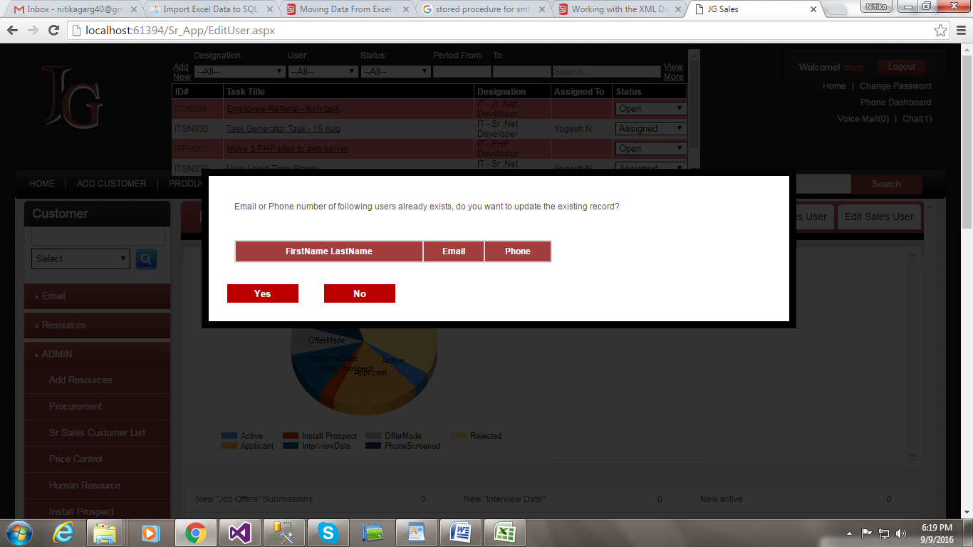

**3)** And After changing of few code the message of "upload successfully" is also displaying but not properly due to the excel to xml conversion as I described in first point , please check the upload successfully display screen below -

