**Critical Thinking**

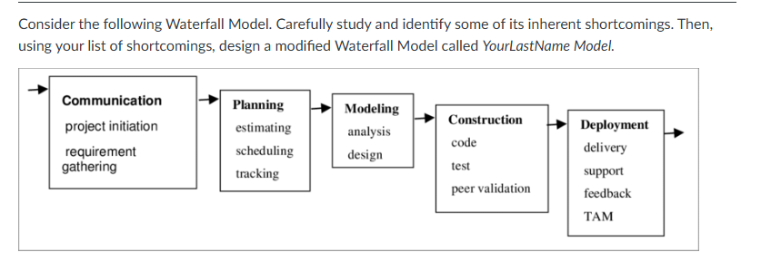

Answer1 –

**Shortcomings of the Waterfall Model:**

1. **Lack of Iterative Feedback**: The model assumes that once a phase is completed, it doesn't need revisiting. This can lead to missed opportunities for improvements or adjustments based on feedback.
2. **Lack of Flexibility**: Once a phase is completed, it's challenging to go back and make changes.
3. **Late Testing**: Testing only occurs after the development is complete, which can lead to a higher number of defects.
4. **Risk Management**: Risks are not addressed continuously but only at the beginning of the project.
5. **Customer Involvement**: Customer feedback is limited to the early and late stages of the process, so the software may not fully meet user expectations once delivered.

Answer 2– There are note attached to the flowchart – shared with you.

<https://lucid.app/lucidchart/fcf8a871-f6ca-46bf-afd9-ce8bf4f039db/edit?viewport_loc=-1136%2C-133%2C7354%2C3566%2C0_0&invitationId=inv_123a67be-e518-438f-9c6e-78042b5f6f6e>

