DATE: 2/15/25

Web-based Pothole Tracking and Repair System

BY: Sadhana Jarag

Contents

Abstract 2

Introduction 2

Non-Functional Requirements 2

Methodology 3

Structured Approach: 3

UML Diagram: 3

Implementation: 5

Code Execution: 5

Conclusion 6

References 7

# Abstract

The Pothole Tracking and Repair System (PHTRS) is a web-based platform designed for reporting, tracking, and repairing potholes. Citizens report issues online, while the Public Works Department (PWD) prioritizes and manages repairs. The system automates work orders, tracks progress, and logs costs, improving urban infrastructure management (Fowler, 2004).

# Introduction

Maintaining road infrastructure is critical for city management. Potholes pose safety hazards and cause vehicle damage (Schneidewind, 1992). PHTRS serves as a centralized platform enabling citizens to report potholes and PWD to handle repairs efficiently. This document presents a UML use case diagram illustrating system interactions. Key actors include citizens, repair crews, and PWD officials. The system logs pothole details, assigns work orders, and manages damage claims (National Research Council, 2004). Using Python, we generate key use cases and actors to visualize system interactions.

# Assumption

1. Citizens can only report potholes and damage claims.
2. PWD employees manage the repair process and generate reports.
3. Repair crews update work orders but cannot assign themselves to potholes.
4. The system administrator handles user management and system configurations.
5. The system is interactive and accessible via a web interface.

# Non-Functional Requirements

1. **Performance:** During busy periods, like rush hours or after a storm, many potholes may be reported. The system should be able to handle these simultaneous reports without slowing down or crashing, ensuring a smooth user experience.
2. **Reliability:** The system should be available at all times, particularly during emergencies like severe weather or accidents when potholes are likely to be reported in large numbers. A failure during such times could lead to delays in repair and increased damage.
3. **Security:** Citizen information, such as personal details and damage reports, must be kept safe from hackers or unauthorized access. For example, if a citizen reports a vehicle damage claim, their contact information and the damage amount should be securely stored and only accessible by authorized personnel.
4. **Usability:** The system must be designed for citizens of all technical backgrounds to easily navigate. A user-friendly interface ensures that even people with limited digital skills can report potholes, track repair status, and view updates without difficulty.

# Methodology

## Structured Approach:

This program models a Pothole and Highway Traffic Repair System (PHTRS) by:

1. **Actors and Use Cases:** It defines actors (e.g., Citizen, PWD Employee) and their actions (use cases) through get_actors() and get_use_cases() functions.
2. **Display Functions:** It uses print_actors() and print_use_cases() to display actors and their actions, as well as the relationships between use cases (includes/extends).
3. **System Overview:** The print_description() function explains how the system works, detailing pothole reporting, repair management, and damage claims.
4. **Execution:** The main() function runs the program by calling the necessary functions in sequence.

This structure showcases how users interact with the system, reporting and tracking potholes and repairs.

## UML Diagram:

Below representation of the UML use case diagram for the PHTRS system. The diagram includes actors, use cases, and their interactions. [fowler,2004]

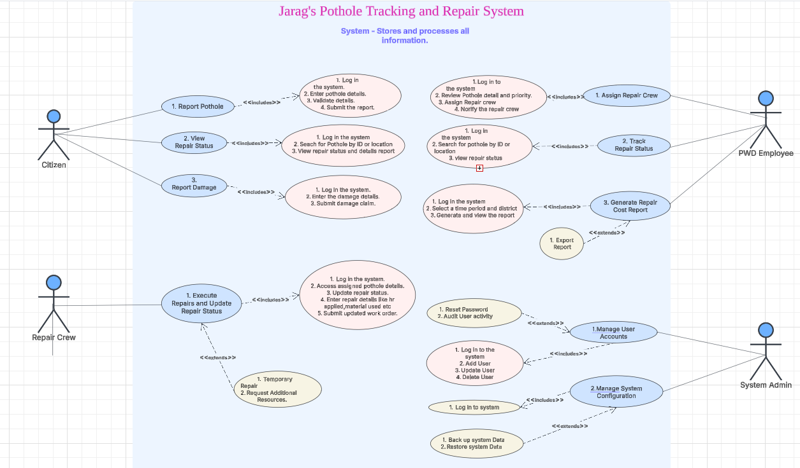

## Implementation:

1. The implementation is done in Python. Below is the code.



1. Git Hub Link – <https://github.com/sadhanajarag/week-4.git>

## Code Execution:

The code is executed, and the output is captured as shown below:

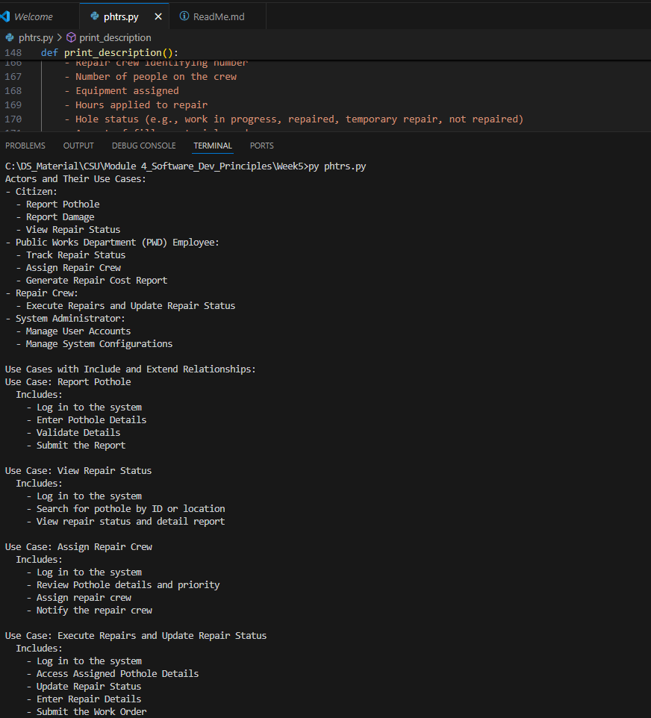

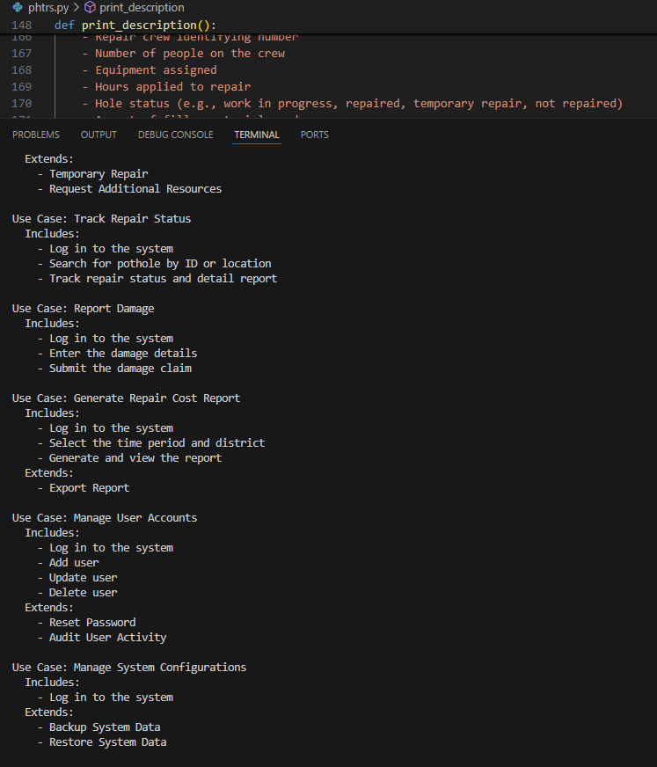

## 

# Conclusion

The PHTRS system streamlines pothole tracking and repair by automating work orders, tracking repairs, and managing costs (National Research Council, 2004). This reduces manual effort and enhances response times. Citizens benefit from a transparent reporting system, while PWD ensures timely road maintenance. Implementing PHTRS improves urban transportation infrastructure, ensuring safer roads.

# References

1. Fowler, M. (2004). *UML Distilled: A Brief Guide to the Standard Object Modeling Language*. Addison-Wesley. *(This book provides a comprehensive guide to UML diagrams and their applications.)*
2. Sommerville, I. (2011). *Software Engineering* (9th ed.). Pearson Education. *(This textbook covers software development processes, including requirements gathering and system design.)*
3. Schneidewind, N. F. (1992). *Software Metrics for Dependable Systems*. IEEE Transactions on Software Engineering, 18(5), 410-423.
4. National Research Council. (2004). *Assessing and Managing the Ecological Impacts of Paved Roads*. National Academies Press.