1. **Addition:**

I = imread('C:\Users\CA161054\Desktop\lab\44.jpg');

J = imread('C:\Users\CA161054\Desktop\lab\55.jpg');

K = imadd(I,J)

Imshow(K)

**Before:**

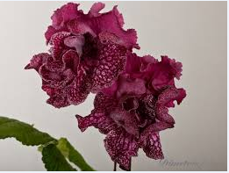 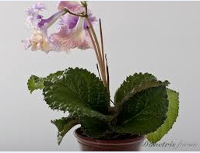

**After:**

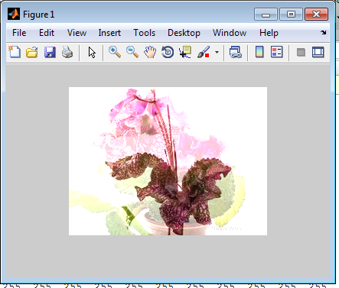

1. **Subtraction:**

I = imread('C:\Users\CA161054\Desktop\lab\2222.jpg');

background = imopen(I,strel('disk',15));

Ip = imsubtract(I,background);

imshow(Ip,[])

**Before :**

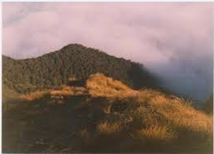

**After:**

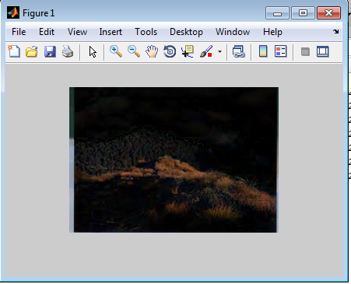

**3)** **Multiplication:**

I = imread(' C:\Users\CA161054\Desktop\lab\2222.jpg');

I16 = uint16(I);

J = immultiply(I16,I16);

imshow(I), figure, imshow(J)

**Before:**



**After :**

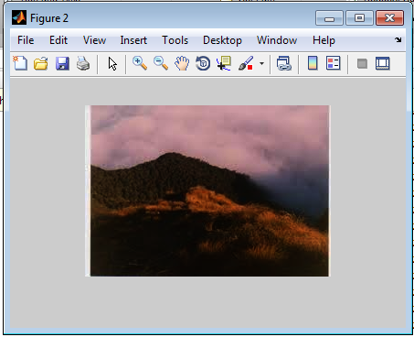

1. **Addition** : GreyScale image.

I = imread('C:\Users\CA161054\Desktop\lab\44.jpg');

J = imread('C:\Users\CA161054\Desktop\lab\55.jpg');

K = imadd(I,J)

Imshow(K)

**Before :**

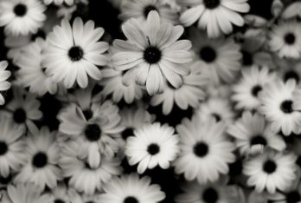

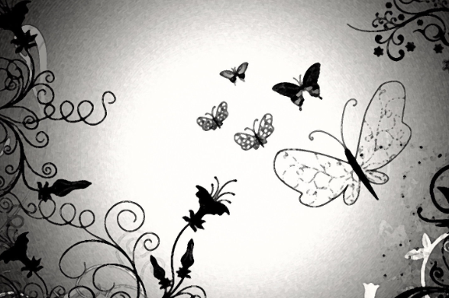

**After:**

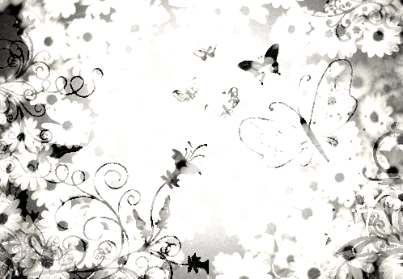

**5) Subtraction**: GreyScale image.

I = imread('C:\Users\CA161054\Desktop\lab\2222.jpg');

background = imopen(I,strel('disk',15));

Ip = imsubtract(I,background);

imshow(Ip,[])

**Before:**

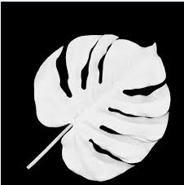

**After:**

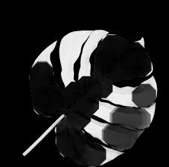

1. **multiplication**: GreyScale image.

I = imread(' C:\Users\CA161054\Desktop\lab\2222.jpg');

I16 = uint16(I);

J = immultiply(I16,I16);

imshow(I), figure, imshow(J)

**Before:**



**After:**

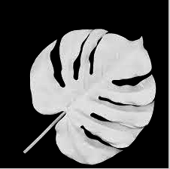

**6)Division:** GreyScale image

I = imread('C:\Users\CA161054\Desktop\lab\3m.jpg');

background = imopen(I,strel('disk',15));

Ip = imdivide(I,background);

imshow(Ip,[])

**Before:**



**After**:



**8) Resize:**

I = imread('C:\Users\CA161054\Desktop\lab\3m.jpg');

J = imresize(I, 0.5);

figure, imshow(I), figure, imshow(J)>> figure, imshow(I), figure, imshow(J)

**Before**:



**After:**

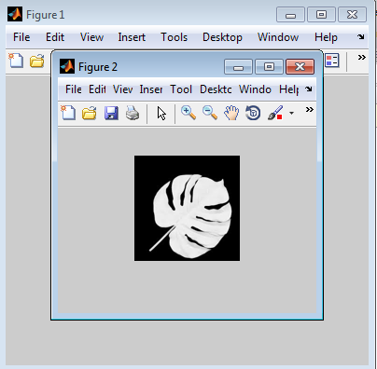

**9**)**Transform**: Horizontal shear:

I = imread('C:\Users\CA161054\Desktop\lab\3m.jpg');

tform = maketform('affine',[1 0 0; .5 1 0; 0 0 1]);

J = imtransform(I,tform);

imshow(I), figure, imshow(J)

**Before**:



**After:**

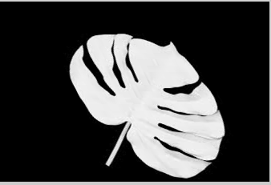

**10) Croping:**

I = imread('C:\Users\CA161054\Desktop\lab\flwr1.jpg');

I2 = imcrop(I,[75 68 130 112]);

imshow(I), figure, imshow(I2)

**Before:**

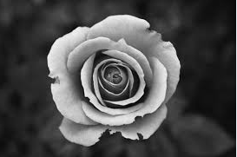

**After:**

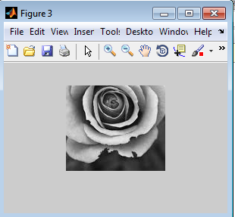

**11) Stretching image:**

I = imread('C:\Users\CA161054\Desktop\5THSEM MCA\lab\2.jpg');

J = imadjust(I,stretchlim(I),[]);

imshow(I), figure, imshow(J)

**Before: After:**

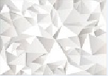 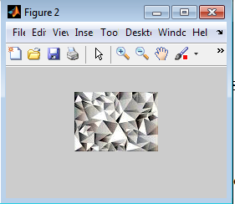

**12)**