CODING CONTEST -1
NAME:SADHANA
REG NO:727721EUAI043
QUESTION NO:1

CODE:
package demo.sanpletesting;

import org.openqa.selenium.By;
import org.openqa.selenium.WebDriver;
import org.openqa.selenium.WebElement;
import org.openqa.selenium.chrome.ChromeDriver;
import org.openqa.selenium.chrome.ChromeOptions;

import io.github.bonigarcia.wdm.WebDriverManager;

public class App{

public static void main(String[] args) {
// TODO Auto-generated method stub
WebDriverManager.chromedriver().setup();
ChromeOptions co=new ChromeOptions();
co.addArguments("--remote-allow-origins=*");
WebDriver driver=new ChromeDriver(co);
driver.get("https://www.saucedemo.com/");
driver.manage().window().maximize();
WebElement user = driver.findElement(By.id("user-name"));
user.sendKeys("standard_user");
WebElement pass = driver.findElement(By.id("password"));
pass.sendKeys("secret_sauce");
WebElement login = driver.findElement(By.id("login-button"));
login.click();
driver.findElement(By.xpath("//*[@id=\"add-to-cart-sauce-labs-backpack\"]")).click();
String cartCount = driver.findElement(By.xpath("/html/body/div/div/div/div[1]/div[1]/div[3]/a/span")).getText();

driver.findElement(By.xpath("/html/body/div/div/div/div[1]/div[1]/div[3]/a")).click();
String product = "Sauce Labs Backpack";

driver.findElement(By.xpath("//*[@id=\"checkout\"]")).click();

driver.findElement(By.xpath("//*[@id=\"first-name\"]")).sendKeys("ABCD");
driver.findElement(By.xpath("//*[@id=\"last-name\"]")).sendKeys("X");
driver.findElement(By.xpath("//*[@id=\"postal-code\"]")).sendKeys("12345");
driver.findElement(By.xpath("//*[@id=\"continue\"]")).click();

System.out.println("Name of the product: " + driver.findElement(By.xpath("/html/body/div/div/div/div[2]/div/div[1]/div[3]/div[2]/a/div")).getText());
System.out.println("Price of the product: " + driver.findElement(By.xpath("/html/body/div/div/div/div[2]/div/div[1]/div[3]/div[2]/div[2]/div")).getText());

}
}

OUTPUT:

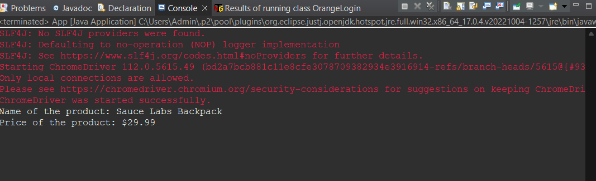

QUESTION 2:

CODE:
package demo.sanpletesting;

import org.openqa.selenium.By;
import org.openqa.selenium.WebDriver;
import org.openqa.selenium.WebElement;
import org.openqa.selenium.chrome.ChromeDriver;
import org.openqa.selenium.chrome.ChromeOptions;

import io.github.bonigarcia.wdm.WebDriverManager;

public class App {

public static void main(String[] args) throws InterruptedException {
// TODO Auto-generated method stub
WebDriverManager.chromedriver().setup();
ChromeOptions co=new ChromeOptions();
co.addArguments("--remote-allow-origins=*");
WebDriver driver=new ChromeDriver(co);
driver.get("https://www.saucedemo.com/");
Thread.sleep(2000);
driver.manage().window().maximize();
WebElement name=driver.findElement(By.xpath("//*[@id=\"user-name\"]"));
name.sendKeys("standard_user");
Thread.sleep(2000);
WebElement pwd=driver.findElement(By.xpath("//*[@id=\"password\"]"));
pwd.sendKeys("secret_sauce");
Thread.sleep(2000);
WebElement btn=driver.findElement(By.xpath("//*[@id=\"login-button\"]"));
btn.click();
Thread.sleep(2000);
WebElement c1=driver.findElement(By.xpath("//*[@id=\"header_container\"]/div[2]/div/span/select"));
c1.click();
Thread.sleep(2000);
WebElement c2=driver.findElement(By.xpath("//*[@id=\"header_container\"]/div[2]/div/span/select/option[1]"));
c2.click();
Thread.sleep(2000);
String e1=driver.findElement(By.xpath("//*[@id=\"item_4_title_link\"]/div")).getText();
System.out.println("A to Z Order's 1st Product Title: "+e1);
WebElement c3=driver.findElement(By.xpath("//*[@id=\"header_container\"]/div[2]/div/span/select/option[2]"));
c3.click();
Thread.sleep(2000);
String e2=driver.findElement(By.xpath("//*[@id=\"item_3_title_link\"]/div")).getText();
System.out.println("Z to A Order's 1st Product Title: "+e2);
Thread.sleep(1000);
WebElement c4=driver.findElement(By.xpath("//*[@id=\"header_container\"]/div[2]/div/span/select/option[3]"));
c4.click();
Thread.sleep(2000);
String e3=driver.findElement(By.xpath("//*[@id=\"item_2_title_link\"]/div")).getText();
System.out.println("Low to High Order's 1st Product Title: "+e3);
WebElement c5=driver.findElement(By.xpath("//*[@id=\"header_container\"]/div[2]/div/span/select/option[4]"));
c5.click();
Thread.sleep(2000);
String e4=driver.findElement(By.xpath("//*[@id=\"item_5_title_link\"]/div")).getText();
System.out.println("High to Low Order's 1st Product Title: "+e4);
Thread.sleep(1000);

}

OUTPUT:
