Digital Forensics Laboratory
EXPERIMENT NO: 01 DATE: August 6, 2026
TITLE: Evidence Acquisition Using AccessData FTK Imager for both volatile and non volatile
AIM:
To acquire digital evidence—both volatile memory (RAM) and non-volatile memory (Hard Disk Image)—using AccessData FTK Imager while maintaining data integrity.
SOFTWARE / TOOLS REQUIRED:
- Operating System: Windows
- Forensics Tool: AccessData FTK Imager (Installed or Portable version)
- Hardware (Optional): Write blocker, USB pen drive/external HDD/virtual harddisk
THEORY Forensic Toolkit (FTK) Imager is a Windows-based commercial software tool (offered as a free version with core capabilities) used by forensic investigators to acquire and analyze digital evidence.
- Evidence Types Acquired:
  - Volatile Memory (RAM): Temporary data lost when powered off, including system execution state, pagefile.sys (Windows pagefile used as extended RAM), and memory structures.
  - Non-Volatile Memory (Disk Image): Persistent storage media such as physical drives, logical partitions, or external drives.
- Acquisition Methods:
  - Live Acquisition: Using a portable FTK Imager version on a USB drive directly attached to an active target system.
  - Static Acquisition: Running FTK Imager on the examiner's laptop with the evidence disk attached via a Write Blocker to grant read-only access and preserve disk integrity.

- Supported Disk Image Formats:
  - Raw (dd): Bit-stream copy without headers or metadata, maintaining spatial integrity.
  - SMART: Compressed bit-stream format intended for Linux file systems.
  - E01 (EnCase): Proprietary compressed format containing case metadata and MD5 checksums.
  - AFF (Advanced Forensic Format): Open-source extensible image format.
PROCEDURE:
Part A: Acquiring Volatile Memory (RAM)
- Launch FTK Imager as an Administrator.
- Click the Capture Memory icon on the top toolbar.
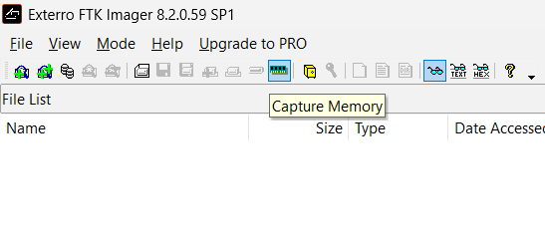
- Click Browse under Destination path to select the output folder and type the output file name (e.g., memdump.mem).
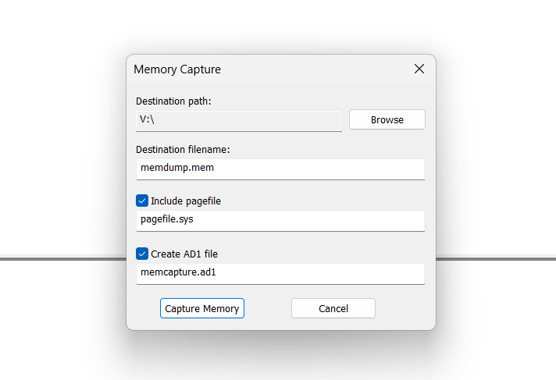
- (Optional) Check Include pagefile (pagefile.sys) and Create AD1 file if required for the investigation.
- Click Capture Memory to begin acquisition.
- Wait until the process finishes; the captured memory will be saved with a .mem extension.
Part B: Acquiring Non-Volatile Memory (Disk Image)
- In FTK Imager, click File > Create Disk Image (or click the toolbar icon).
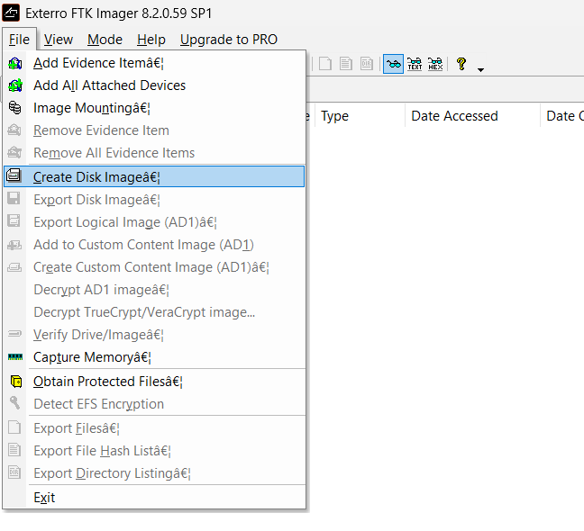
- Select the Source Evidence Type (e.g., Physical Drive or Logical Drive) and click Next.
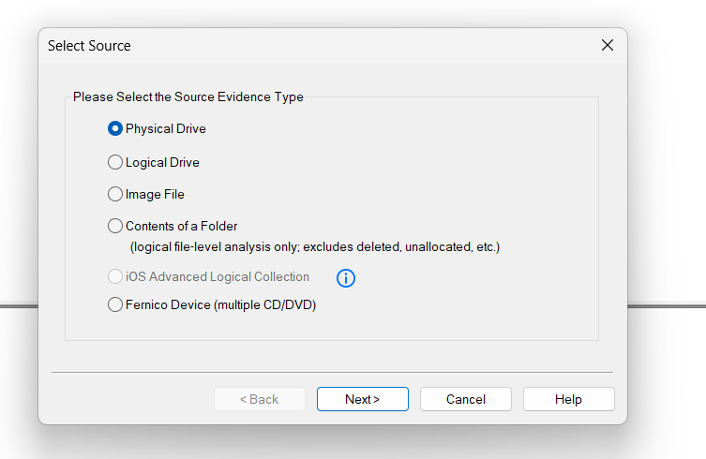
- Select the target drive from the dropdown list and click Finish.
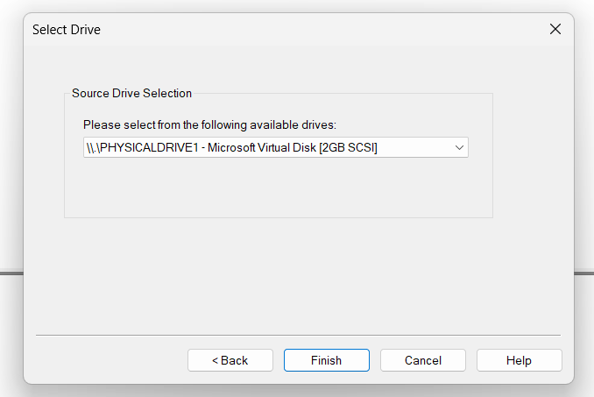
- Click Add... to configure the image destination:
  - Select the Image Type (e.g., Raw (dd), E01, SMART, or AFF) and click Next.
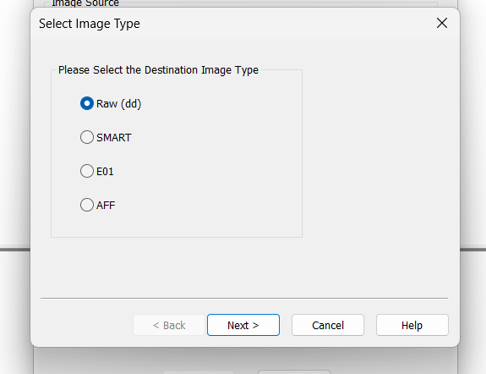
  - Fill in the Evidence Item Information (Case Number, Evidence Number, Examiner Name, Notes) and click Next.
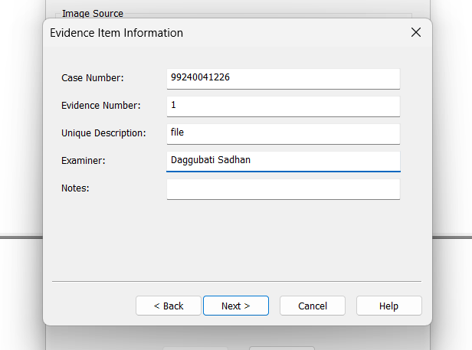
  - Specify the Image Destination Folder and Image Filename.
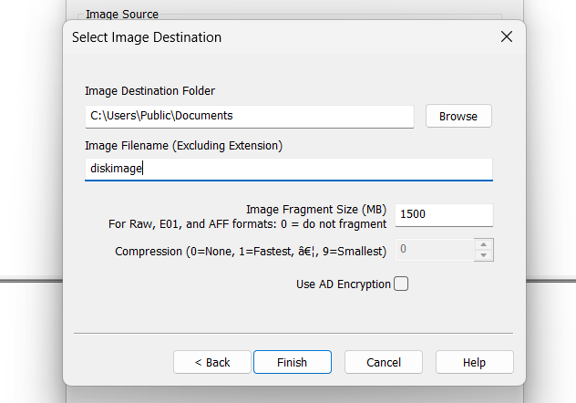
  - Set Image Fragment Size (MB) (set to 0 to keep the file unfragmented as a single image, or leave default values like 1500).
  - Click Finish.
- Check the box Verify images after they are created to ensure hash integrity matching.
- Click Start to begin the disk imaging process.
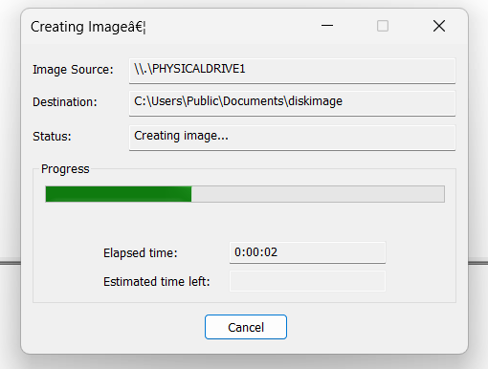
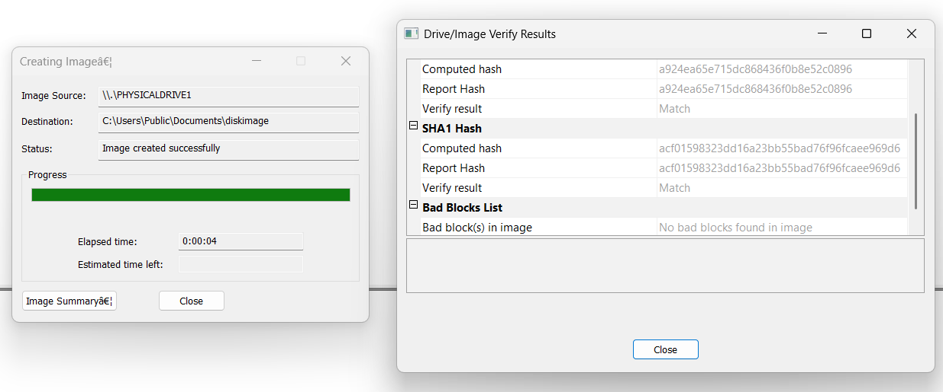
- Once creation finishes, view the Image Summary dialog to confirm that computed MD5 and SHA1 checksums match between the source and created image.

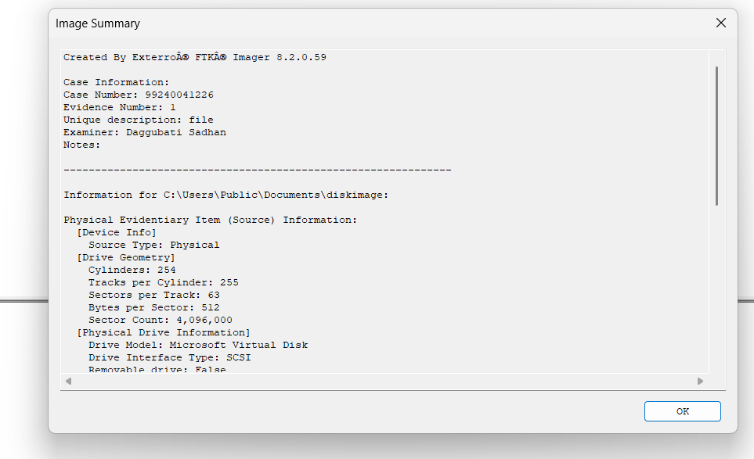
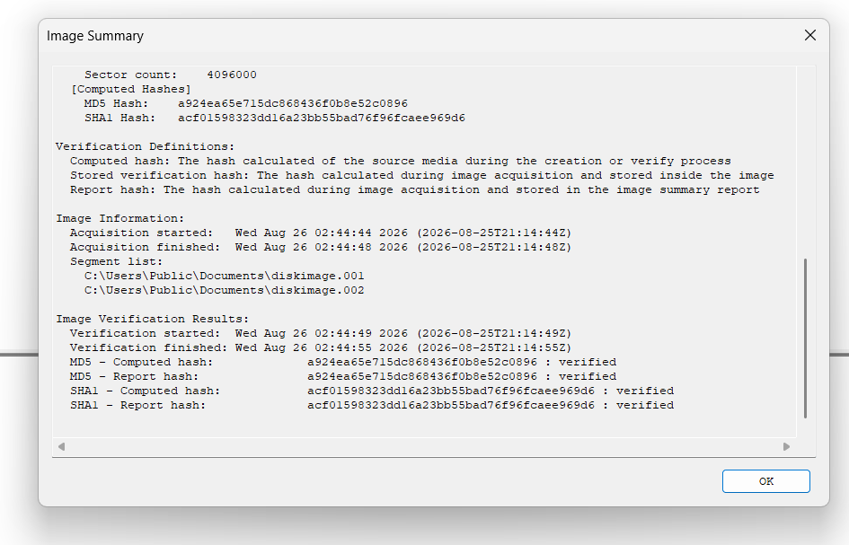
RESULT:
The digital evidence acquisition experiment was completed successfully using AccessData FTK Imager. Both volatile memory (RAM) and non-volatile memory (Hard Disk Image) were acquired into secure raw format files. The calculated MD5 and SHA1 hash checksums of the generated images were verified against the original source data to ensure complete evidence integrity.

