Digital Forensics Laboratory
EXPERIMENT NO: 02 DATE: August 9, 2026

TITLE: Recover deleted or damaged files from a storage device using TestDisk

1. AIM
To recover deleted files and repair a missing or corrupted partition from a storage device using the TestDisk data recovery command-line utility.

2. SOFTWARE / TOOLS REQUIRED

- Operating System: Windows OS
- Forensics Tool: TestDisk (v7.3-WIP Data Recovery Utility)
- Hardware: Target Storage Device (e.g., hp v221w 16GB USB Device).

3. THEORY

TestDisk is a powerful, open-source data recovery software primarily designed to help recover lost partitions and make non-booting disks bootable again when these symptoms are caused by faulty software, certain types of viruses, or human error (such as accidentally deleting a Partition Table). It can also be utilized to undelete files from FAT, exFAT, NTFS, and ext2 file systems. TestDisk queries the BIOS or the OS in order to find the hard drives and their characteristics, performs a quick check of the disk structure, and looks for lost partitions or deleted files.

4. PROCEDURE
Step 1: Log Creation & Disk Selection
- Open the testdisk_win.exe application as an Administrator.
- Log Creation: Choose [Create] to instruct TestDisk to create a log file containing technical information and messages. Press Enter to proceed.
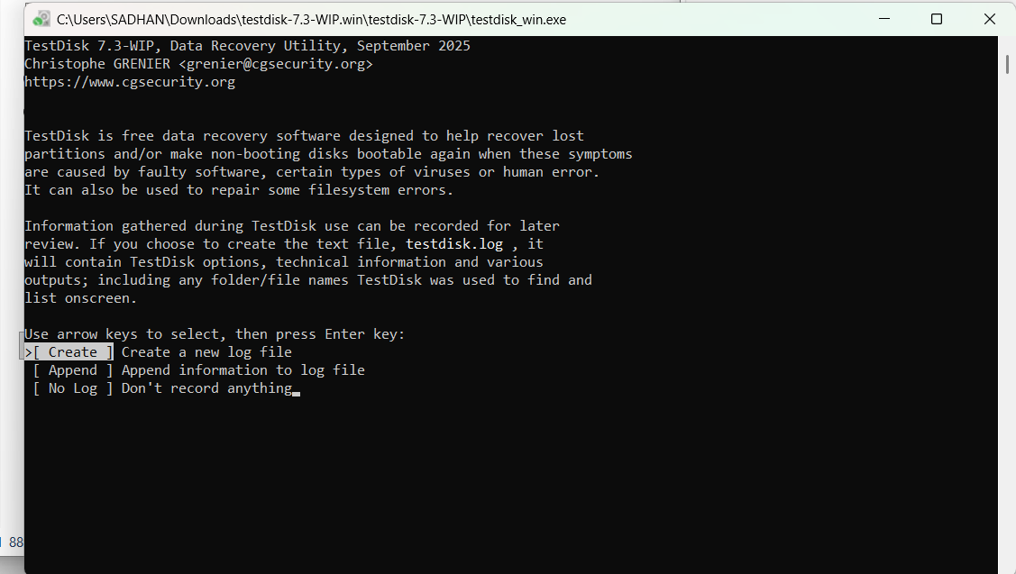Figure 1: Initial TestDisk dashboard prompting for log creation

- Disk Selection: All connected hard drives will be detected and listed. Use the up/down arrow keys to select the target hard drive containing the lost partitions or deleted files (e.g., Disk \\.\PhysicalDrive1 - 16 GB / 15 GiB - hp v221w). Press Enter to Proceed.
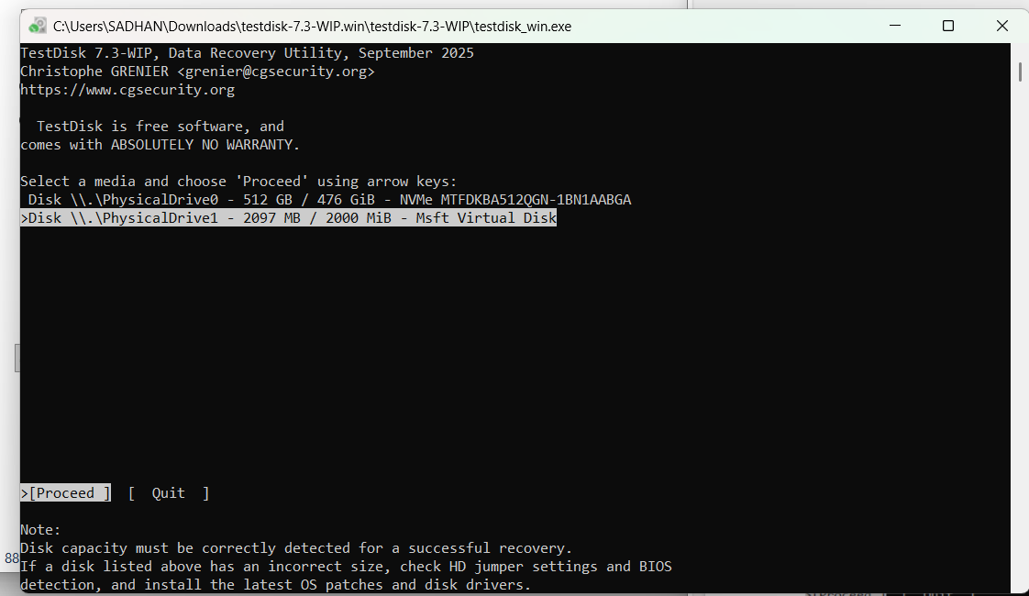Figure 2: Selecting the physical storage drive in TestDisk
Step 2: Partition Table Type Selection
- TestDisk displays the available partition table types.
- Select the partition table type. Usually, the default value is the correct one as TestDisk auto-detects the partition table type (e.g., [Intel] Intel/PC partition). Press Enter to Proceed.
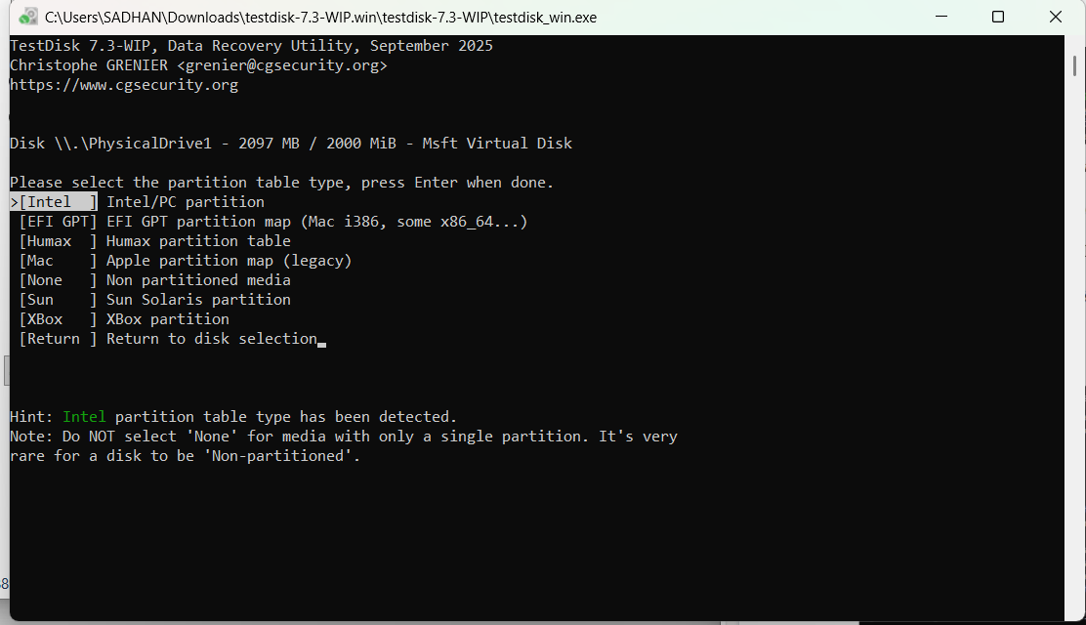
Figure 3: Selecting the Intel/PC partition table type
Step 3: Current Partition Table Status
- TestDisk displays the main menu options. Use the default menu [Analyse] to check your current partition structure and search for lost partitions. Confirm at Analyse with Enter.
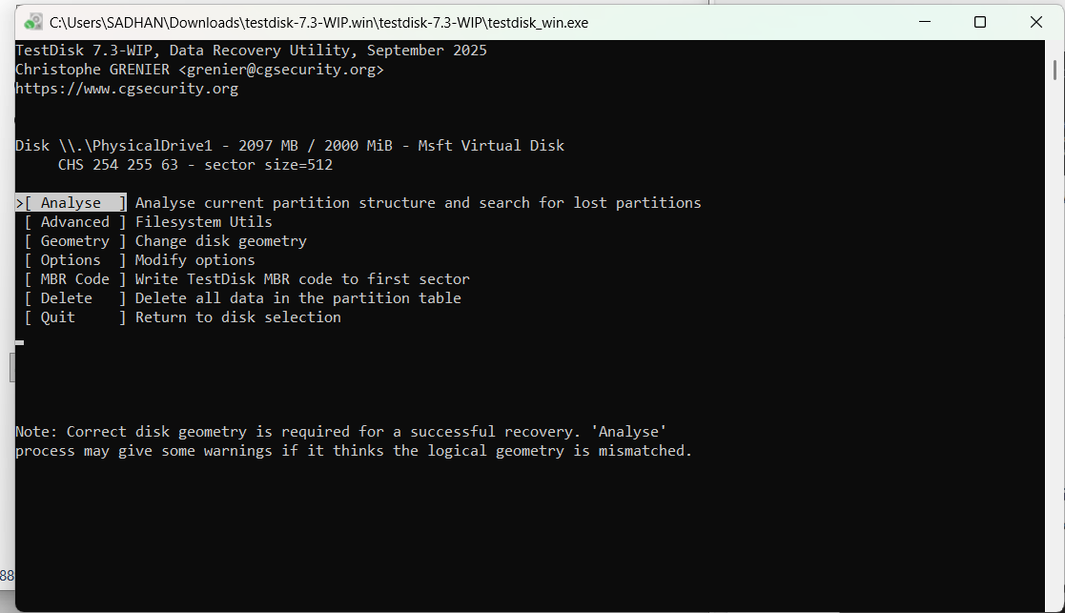Figure 4: Choosing the Analyse option to examine the partition structure

- The current partition structure is listed. Examine the structure for missing partitions and errors (e.g., Invalid NTFS boot, missing logical partitions). Confirm at [Quick Search] to proceed.
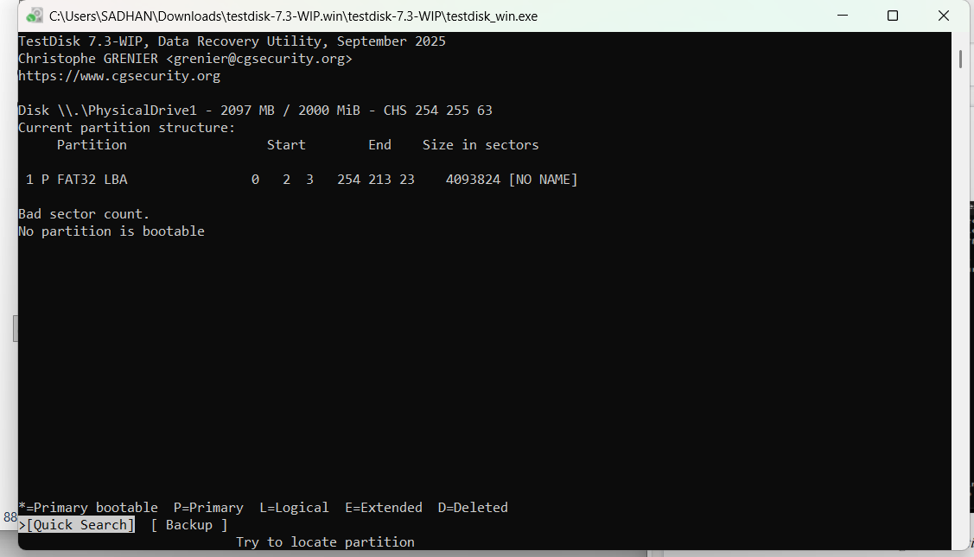
Figure 5: Initiating a Quick Search for lost partitions
Step 4: Deeper Search (If Required)
- If the quick search does not find the required partition or if partitions overlap (status 'D' for deleted), highlight the [Deeper Search] menu and press Enter.
- Deeper Search will scan each cylinder for FAT32 backup boot sectors, NTFS backup boot superblocks, etc., to detect more partitions.
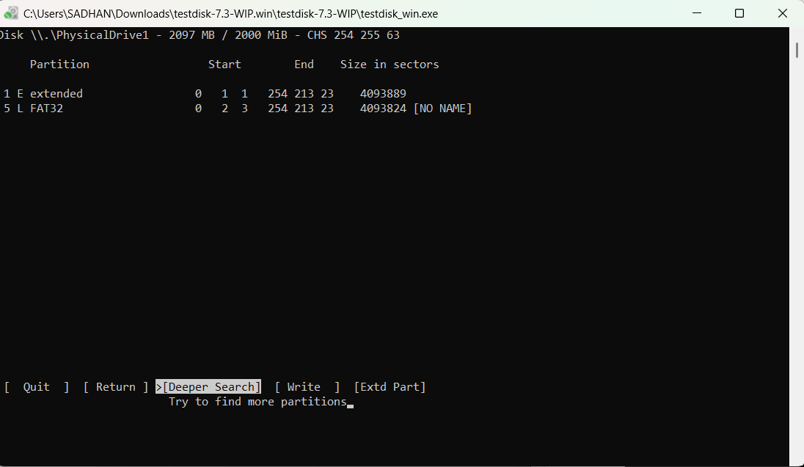Figure 6: Selecting the Deeper Search option

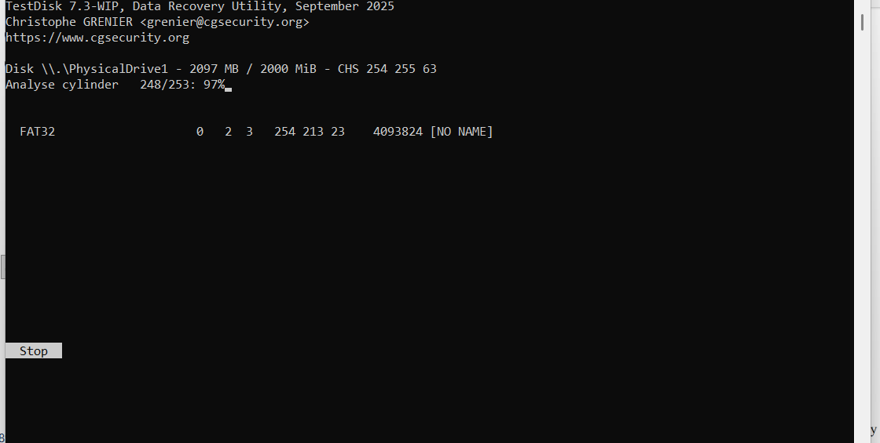Figure 7: Deeper Search actively scanning disk cylinders
Step 5: Identifying and Accessing the Correct Partition
- Once the search is complete, highlight the correct partition you wish to recover or extract files from (e.g., >L FAT32 LBA).
- Press the p key to list the files inside that partition.
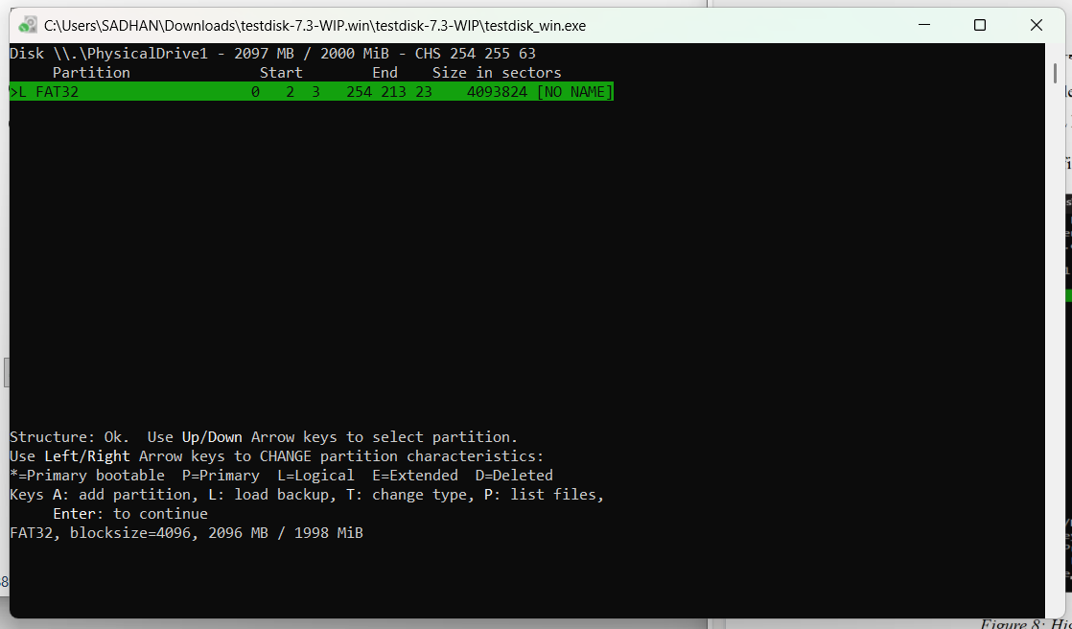
Figure 8: Highlighting the located FAT32 partition
Step 6: Recovering / Copying Deleted Files
- In the file listing, navigate through the folders using arrow keys. Files listed in red indicate deleted entries.
- Highlight the specific deleted file you want to recover (e.g., images (1).jpg).

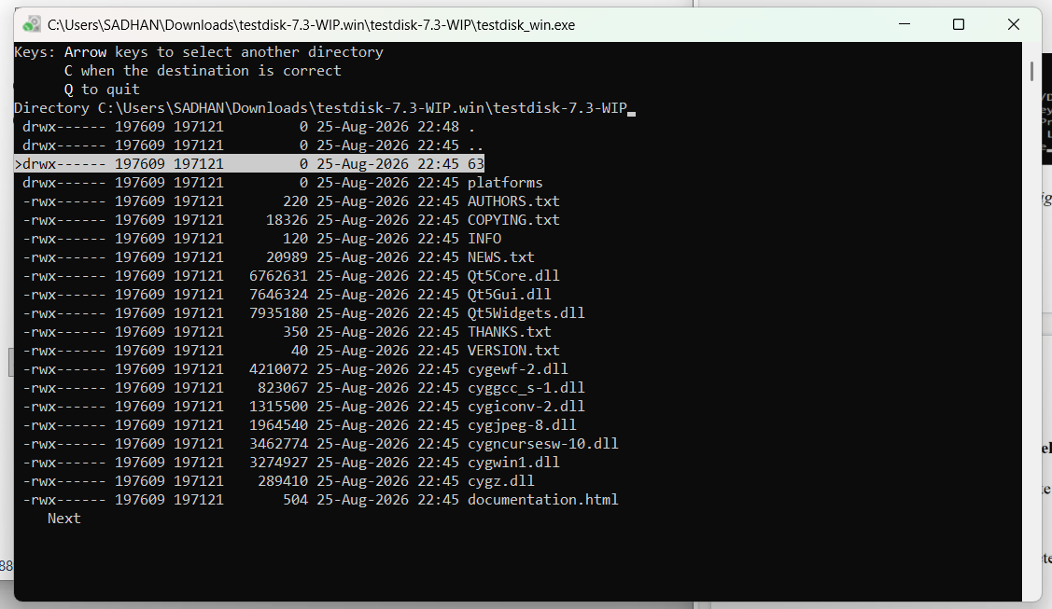Figure 9: Listing the directory contents and selecting a file for recovery

- Press c to copy the current selected file (or C to copy all selected files).
- You will be prompted to select a destination directory to save the recovered file. Navigate to the desired local folder and press C when the destination is correct.
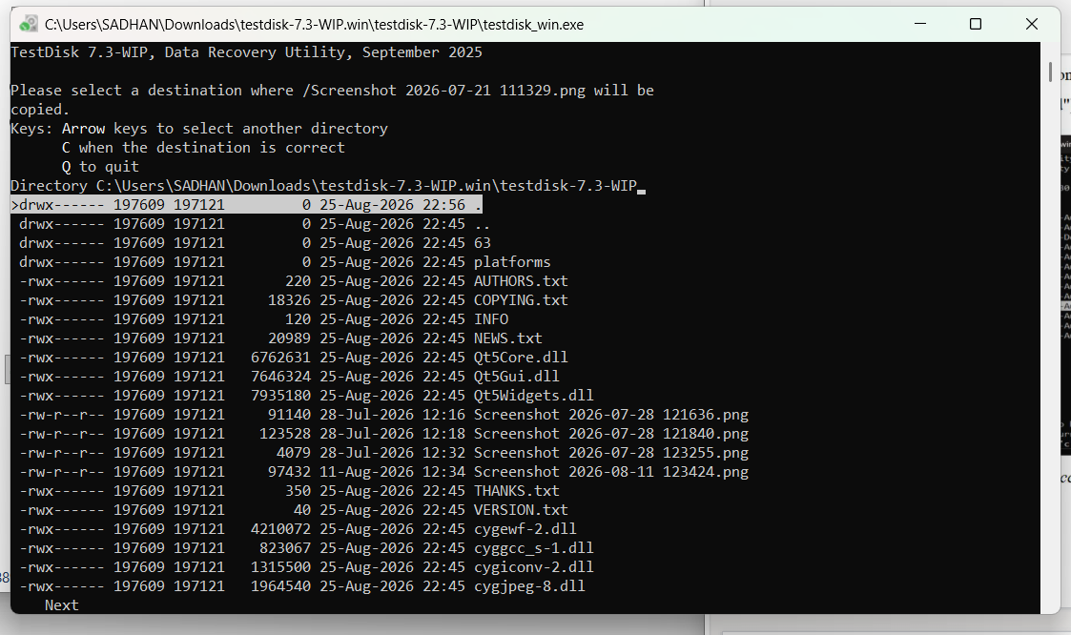
Figure 10: Selecting the destination folder for the recovered file
- TestDisk will display a confirmation message indicating a successful recovery (e.g., "Copy done! 1 ok, 0 failed").
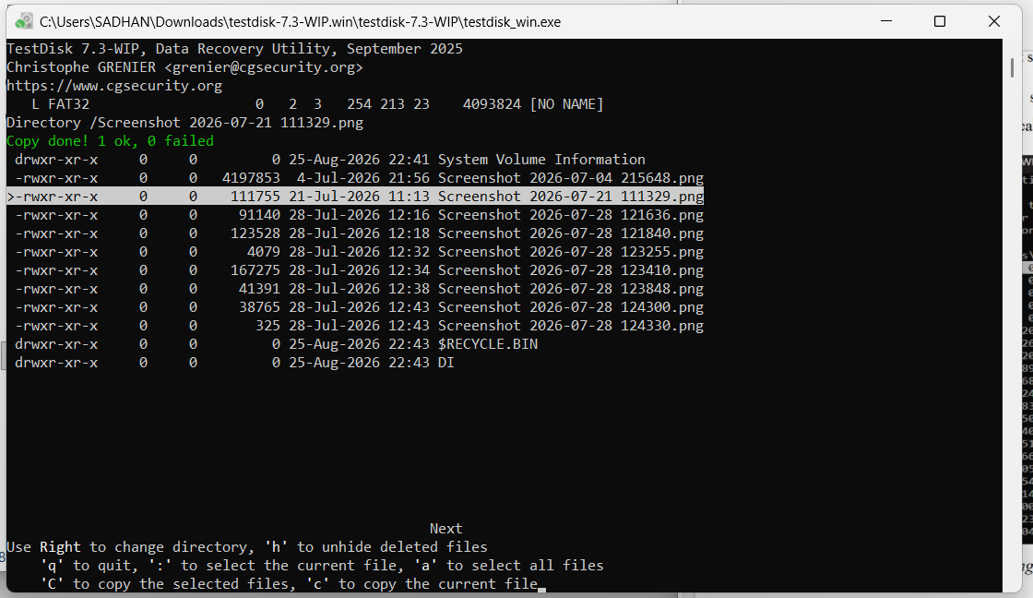
Figure 11: Successful copy/recovery of the deleted file
Step 7: Partition Table and Boot Sector Recovery (Optional)
- Press q to quit the file listing and return to the partition selection.
- Use the left/right arrow keys to change the status of a partition from D (Deleted) to L (Logical) or P (Primary) to recover the partition itself. Press Enter.
- If all partitions are correctly listed, confirm at [Write] with Enter, press y to confirm, and then OK.
- If a boot sector is damaged, use the [Backup BS] option to copy the backup boot sector over the damaged one.
- Exit TestDisk and reboot the computer to access the restored partition data.

5. RESULT
The TestDisk data recovery utility was successfully executed to analyze the physical drive's geometry and partition tables. Lost partitions were successfully identified through deeper searching, and deleted files were effectively navigated, selected, and copied (recovered) to a secure local destination.

