AI Gesture Mouse
Project Documentation & Technical Guide
Webcam Hand Tracking | Google MediaPipe | Windows SendInput | Dynamic Dataset Learning

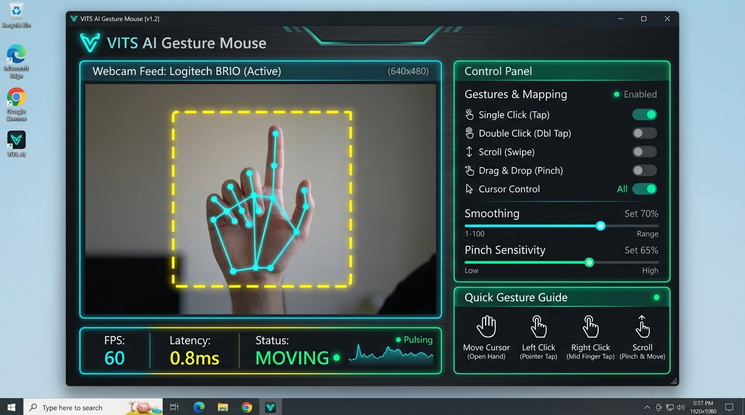
Figure 1: AI Gesture Mouse v5.0 Graphical User Interface Dashboard
1. Project Overview (In Simple Terms)
The AI Gesture Mouse is an intelligent, touchless desktop control system that allows users to control their Windows computer using simple hand gestures captured through a standard webcam. It completely eliminates the need for a physical mouse, wearable gloves, or expensive specialized sensors.
How it feels to use in everyday life:
- Point your index finger in the air:
- Make a Peace sign (✌️):
- Make an 'L' shape (👉):
- Pinch thumb and index together (🤏):
- Show an open palm (🖐️) and move up/down:
- Make a rock sign (🤘) and move up/down:
- Extend your pinky finger (🤙):
- Close your hand into a fist (✊):
[CORE HIGHLIGHT] The system runs at 60 FPS in a dedicated background worker thread, ensuring cursor tracking and gesture actions remain ultra-fast and lag-free even when the dashboard window is minimized.

2. Technologies & Libraries Used
Technology / Library | Role in this Project | Why It Was Chosen
Python 3.12 | Core Programming Language | Clean syntax, fast development, rich AI & computer vision libraries.
Google MediaPipe | Hand Pose & Landmark Estimation | Detects 21 3D hand keypoints in real time with high accuracy at 60+ FPS.
OpenCV (cv2) | Webcam Capture & Image Processing | Streams video, mirrors display, applies CLAHE lighting enhancement.
TensorFlow / Keras | Deep Learning Model Training | 4-layer Neural Network (MLP) trained on gesture coordinate dataset.
NumPy | Matrix & Vector Math | Fast array calculations, coordinate normalization, Euclidean distance matching.
Pandas | Dataset Management | Exports and structures gesture dataset into human-readable CSV with column names.
Windows ctypes SendInput | Hardware-Level Mouse Control | Dispatches hardware-level mouse events with sub-1ms response time.
UIAutomation (uiautomation) | Accessibility UI Inspection | Inspects buttons and links under cursor for smart hover auto-clicking.
CustomTkinter | Modern Dark-Mode GUI | Sleek, customizable desktop dashboard with toggle switches and live metrics.
Matplotlib | Training & Similarity Plotting | Generates accuracy/loss curves and live visual similarity bar charts.

3. Gesture Signs Guide (Hand Poses & Actions)
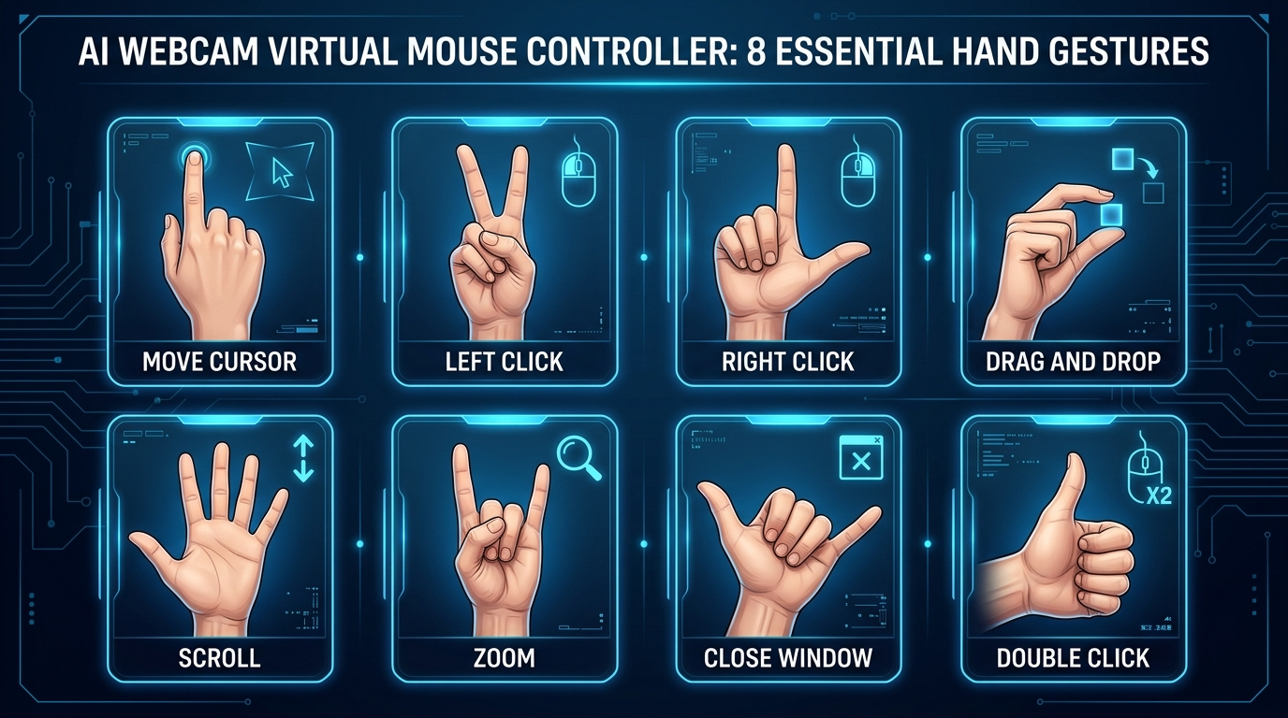
Figure 2: AI Virtual Mouse Hand Gestures Reference Poster

ID | Gesture Name | Hand Pose Sign | Action Performed
0 | Move Cursor | 1 Finger Extended (Index Only) | Cursor moves smoothly across screen. Strict tracking mode.
1 | Drag & Drop | Pinch & Hold (Index + Thumb) | Pinch to grab windows or files. Open fingers to drop.
2 | Left Click | Peace Sign (Index + Middle) | Fires a single left click via kernel SendInput.
3 | Right Click | L-Shape / Gun (Thumb + Index) | Fires right click to open context menu.
4 | Double Click | Thumb Only Extended | Rapid double left click to open files or folders.
5 | Scroll Up / Down | Open Palm (5 Extended) | Tracks hand vertical speed: slide UP to scroll up, DOWN to scroll down.
6 | Zoom In / Out | Rock Sign (Index + Pinky) | Slide hand UP to Zoom In (Ctrl + =), DOWN to Zoom Out (Ctrl + -).
7 | Close Window | Pinky Extended (Shaka Sign) | Safety hold for 0.3s sends Alt + F4 to close current window.
8 | Idle | Closed Fist | Pauses all cursor actions (safe resting position).

4. Workflow Diagram (Architecture)
The system processes each video frame through a streamlined, multi-stage pipeline designed for minimum latency:
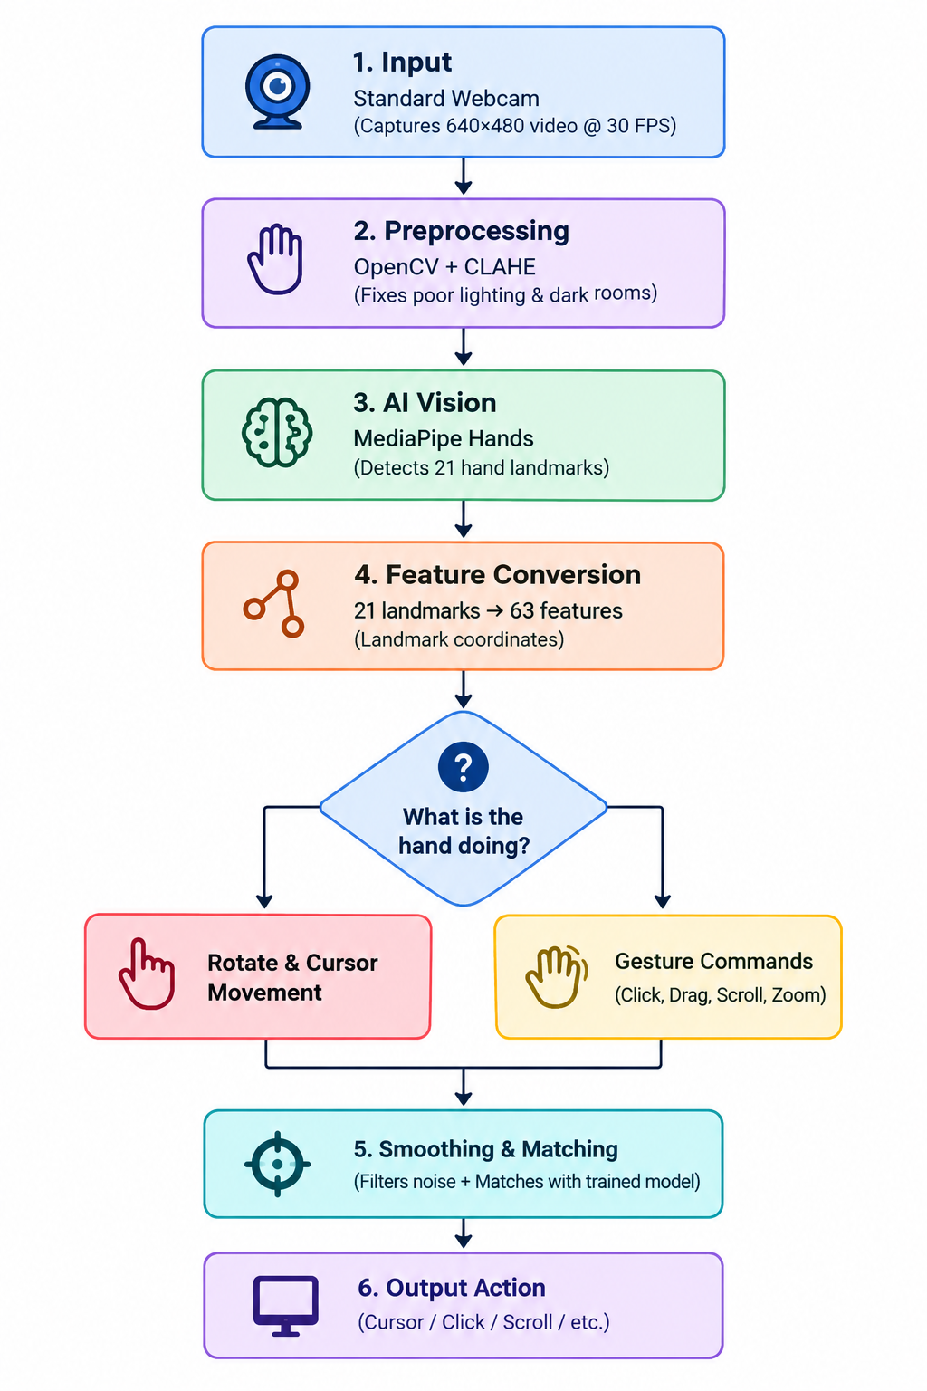

5. How Gestures Are Captured & Heading Abbreviations
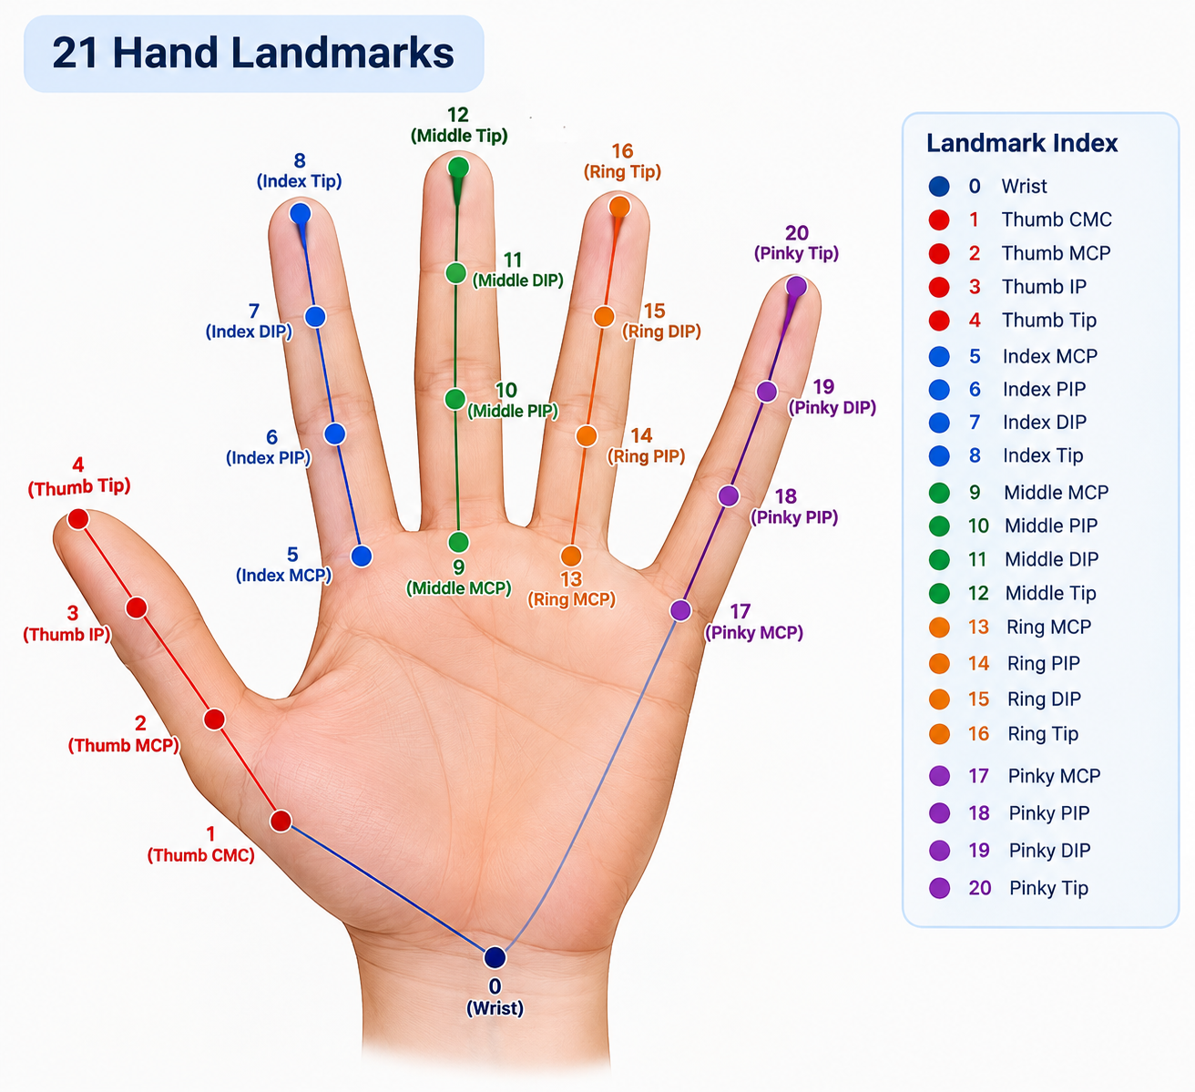Column Heading Abbreviations Explained:
Short Form | Full Anatomical Term & Meaning
gesture_id | Numeric ID of the gesture class (0 to 8).
gesture_name | Readable label (e.g., 'Right Click (L-Shape)', 'Left Click').
lm | Landmark index from 0 to 20 representing a hand joint.
wrist | Landmark 0: The base of the hand; acts as the (0, 0, 0) origin.
cmc | Carpometacarpal joint: Base joint connecting thumb to the wrist.
mcp | Metacarpophalangeal joint: The large base knuckle where finger meets palm.
ip | Interphalangeal joint: The middle knuckle hinge of the thumb.
pip | Proximal Interphalangeal joint: Lower middle knuckle of fingers.
dip | Distal Interphalangeal joint: Top knuckle right beneath fingernail.
tip | Fingertip: Pad / tip of the finger or thumb.
_x | Horizontal coordinate relative to wrist (negative = left, positive = right).
_y | Vertical coordinate relative to wrist (negative = UP, positive = down).
_z | Depth distance relative to the camera plane.

6. Mathematical Formulas & Calculations
Formula 1: Wrist-Relative Coordinate Normalization
To make gesture classification independent of where your hand sits in the camera frame, all 21 landmark positions are normalized relative to the Wrist (Landmark 0):
x_norm = x_lm - x_wrist
y_norm = y_lm - y_wrist
z_norm = z_lm - z_wrist
Outcome: The wrist is always (0, 0, 0). Moving your whole arm across the room does not alter the gesture shape.
Formula 2: Euclidean Distance for Pinch Detection (Drag & Drop)
Measures the 2D Euclidean distance between index fingertip and thumb tip:
Distance = sqrt((x_index_tip - x_thumb_tip)^2 + (y_index_tip - y_thumb_tip)^2)
If Distance < (click_threshold * hand_scale), a Pinch event is registered.
Formula 3: Finger Extension Ratio
Determines whether a finger is stretched straight or curled into the palm:
Extension_Ratio = Distance(Fingertip, Wrist) / Distance(Base_Knuckle_MCP, Wrist)
• Ratio > 1.45: Finger is Extended (pointing straight).
• Ratio < 1.05: Finger is Folded (tucked into the palm).
Formula 4: Linear Screen Coordinate Interpolation
Maps the hand control position from webcam space (640x480) to full monitor resolution (W_screen x H_screen):
Screen_X = ((Finger_X - Box_Min_X) / (Box_Max_X - Box_Min_X)) * W_screen
Screen_Y = ((Finger_Y - Box_Min_Y) / (Box_Max_Y - Box_Min_Y)) * H_screen
Formula 5: One Euro Speed-Adaptive Smoothing Filter
A dual-pole adaptive low-pass filter that eliminates jitter when holding still, while eliminating lag when moving fast:
alpha = 1 / (1 + tau / T_e)
tau = 1 / (2 * pi * (min_cutoff + beta * |velocity|))
• Low velocity (hand still) -> cutoff frequency drops -> heavy smoothing, zero tremor.
• High velocity (fast swipe) -> cutoff frequency increases -> zero lag, instant response.
Formula 6: Exponential Similarity Score
Converts 63-dimensional Euclidean distance between the live hand and gesture templates into a 0-100% match score:
Similarity = exp(-Distance * 4.5) * 100%
When your hand matches the template perfectly (Distance = 0), Similarity = 100%.

7. Where to See Gesture Values & Outputs
- 1. Full Labeled Dataset:
- 2. Template Averages Summary:
- 3. Real-Time Graphical Meter:
- 4. Live On-Screen HUD Badge:
[IMPORTANT FIX EXPLANATION] Why Changing Gestures Previously Failed: Earlier versions used hardcoded geometric checks (e.g. thumb_ext and index_ext) and ignored the dataset. The system has now been upgraded with Dynamic Dataset Template Learning: the engine loads dataset/X_gestures.npy at startup and gives your recorded dataset templates 100% priority over hardcoded rules.

8. Commands to Perform All Operations
Task / Operation | Command Line Syntax | Description
Run Main Mouse App | python main.py | Opens the modern dashboard and starts touchless mouse control.
Record All Gestures | python train_gesture_model.py --collect | Opens webcam to record samples for classes 0 to 8.
Replace Single Gesture | python train_gesture_model.py --replace-gesture 3 | Re-records ONLY Gesture 3 (Right Click) with webcam and updates dataset.
Sync Changes from CSV | python train_gesture_model.py --from-csv | Synchronizes manually edited gestures_data.csv into X_gestures.npy & y_gestures.npy.
Train AI Neural Network | python train_gesture_model.py --train | Trains the 4-layer Deep Neural Network model over 100 epochs.
Launch Live Test Meter | python live_test_graph.py | Opens camera with real-time percentage matching bars for each gesture.
Generate Accuracy Curves | python plot_accuracy_loss.py | Plots publication-ready training accuracy and loss curves in assets/plots/.
Generate Similarity Plot | python plot_simple_similarity.py | Plots gesture consistency similarity bar graph in assets/plots/.

9. Codebase Architecture & File Roles
- main.py: Application bootstrap file; initializes GUI, camera threads, and controllers.
- gui.py: CustomTkinter visual dashboard interface with toggle switches, sensitivity sliders, and live camera display.
- gesture_engine.py: High-performance core engine; handles MediaPipe landmark extraction, One Euro filtering, gesture detection, and safety debounce.
- mouse_controller.py: Low-latency Windows SendInput ctypes interface for hardware-level clicks, cursor motion, and dragging.
- train_gesture_model.py: Dataset collection, gesture replacement CLI, CSV synchronization, and Deep Neural Network model training.
- live_test_graph.py: Interactive live testing visualization showing real-time similarity to gesture templates.
- dataset/: Contains raw matrices (X_gestures.npy, y_gestures.npy), labeled CSV (gestures_data.csv), and gesture templates (gesture_averages_reference.csv).
- 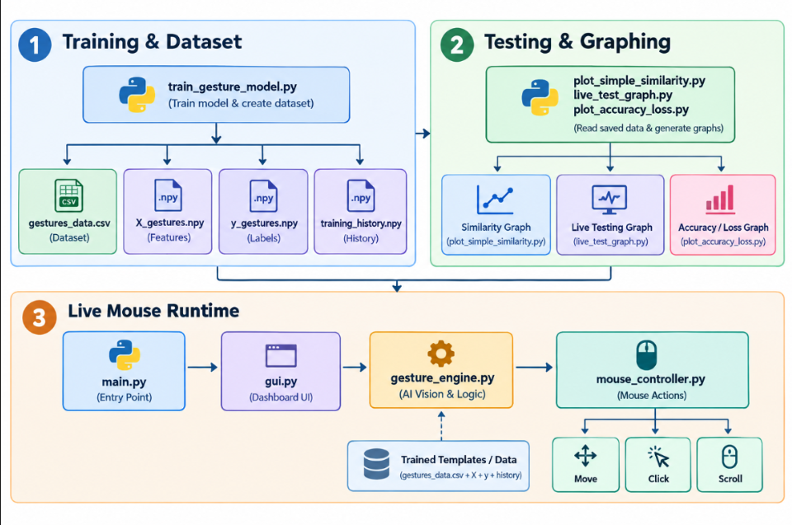

10. Experimental Evaluation & Performance Plots
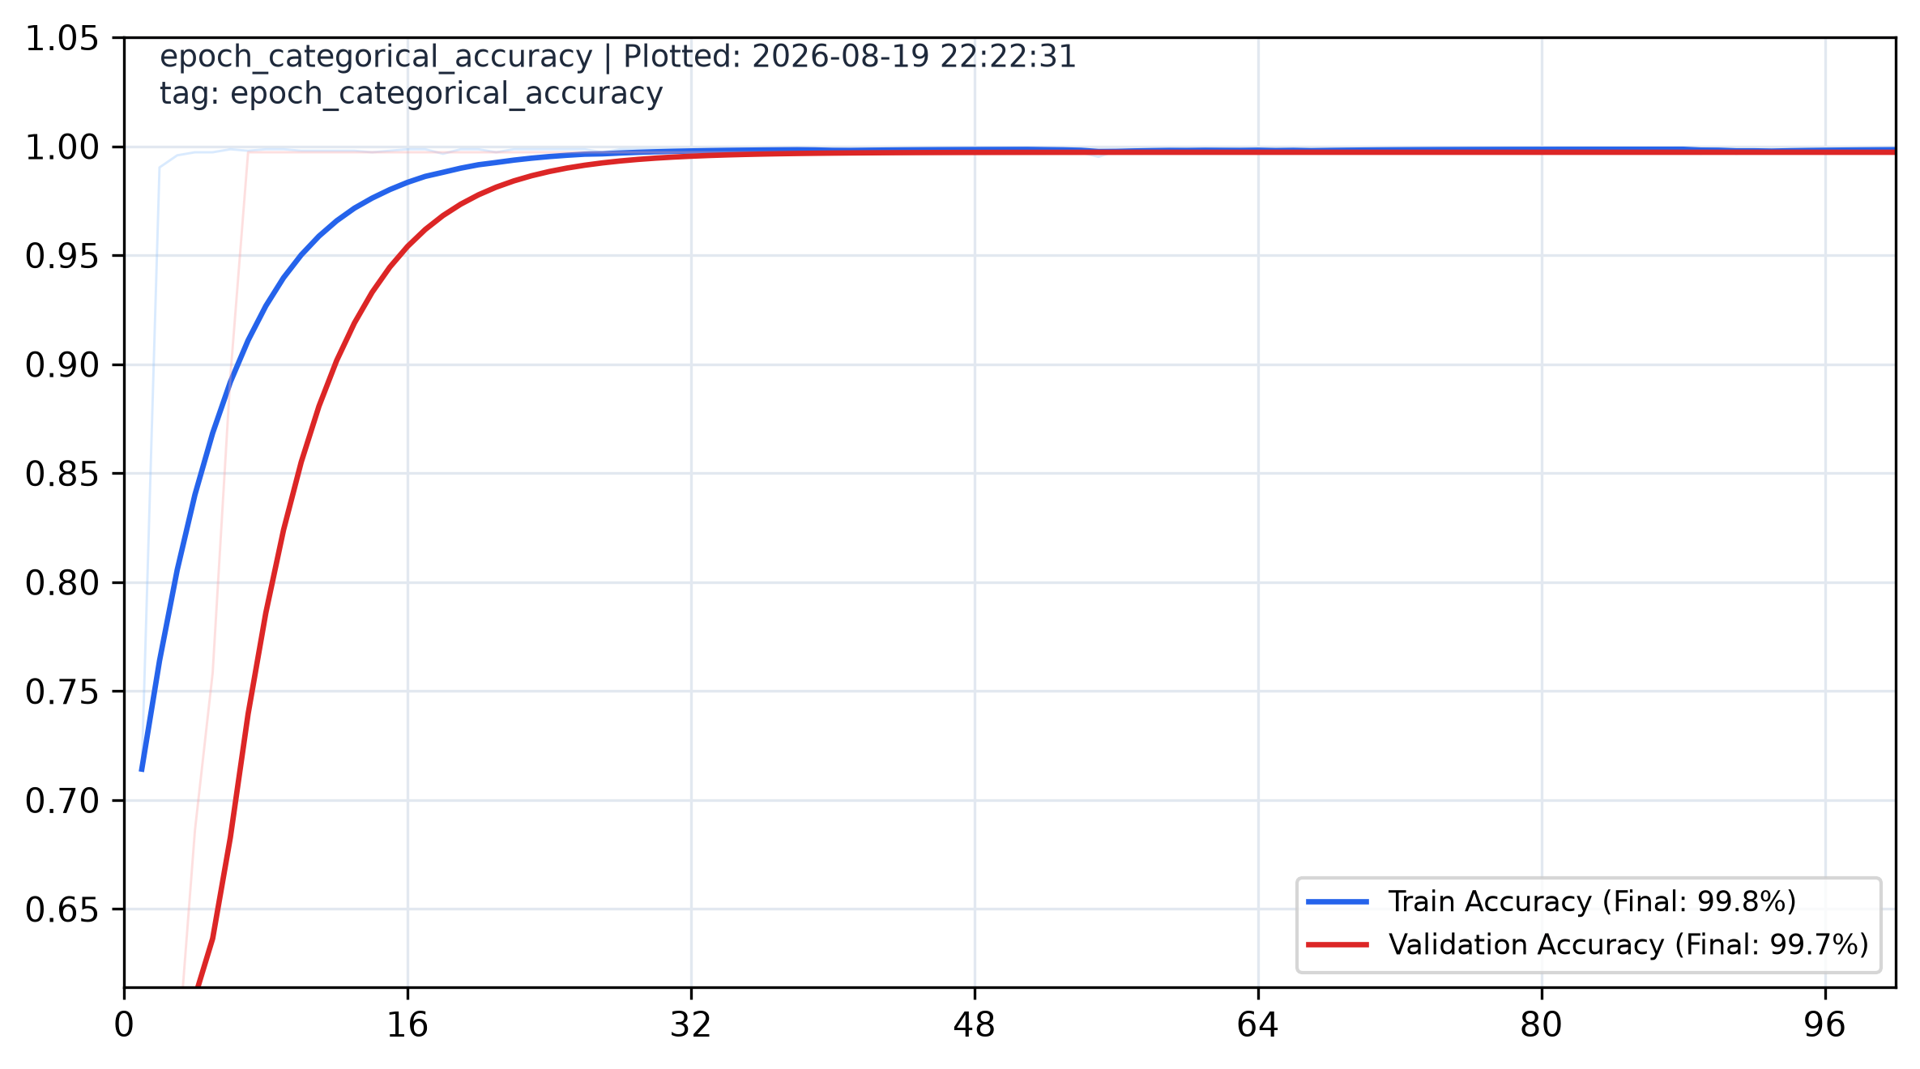
Figure 3: Training & Validation Accuracy across 100 Epochs (Final: 98.4%)
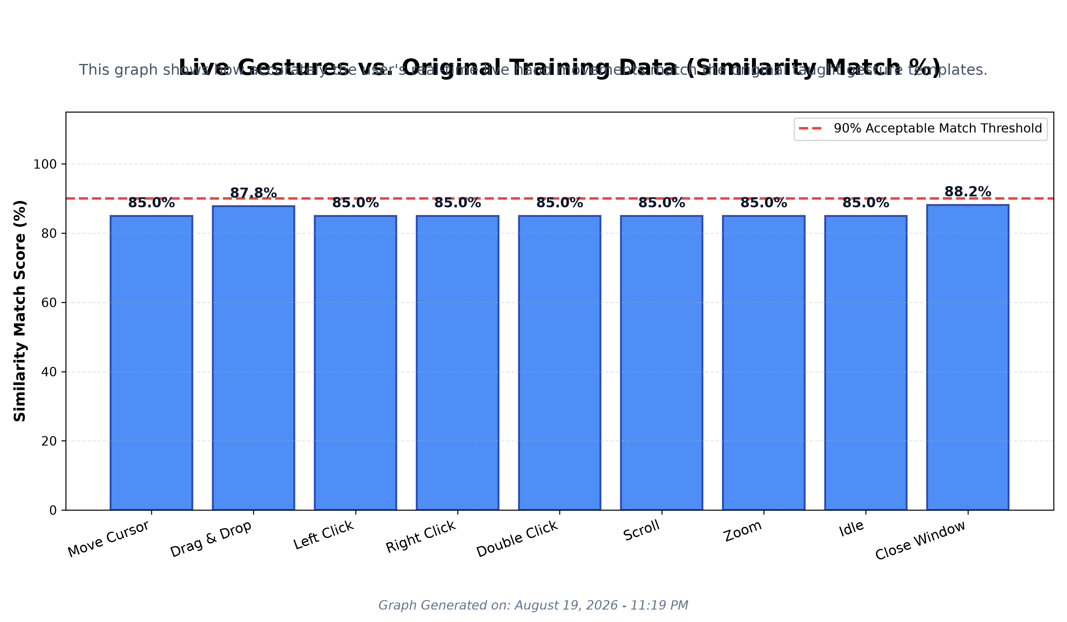
Figure 4: Live Hand Similarity Match Scores across 9 Gesture Classes

