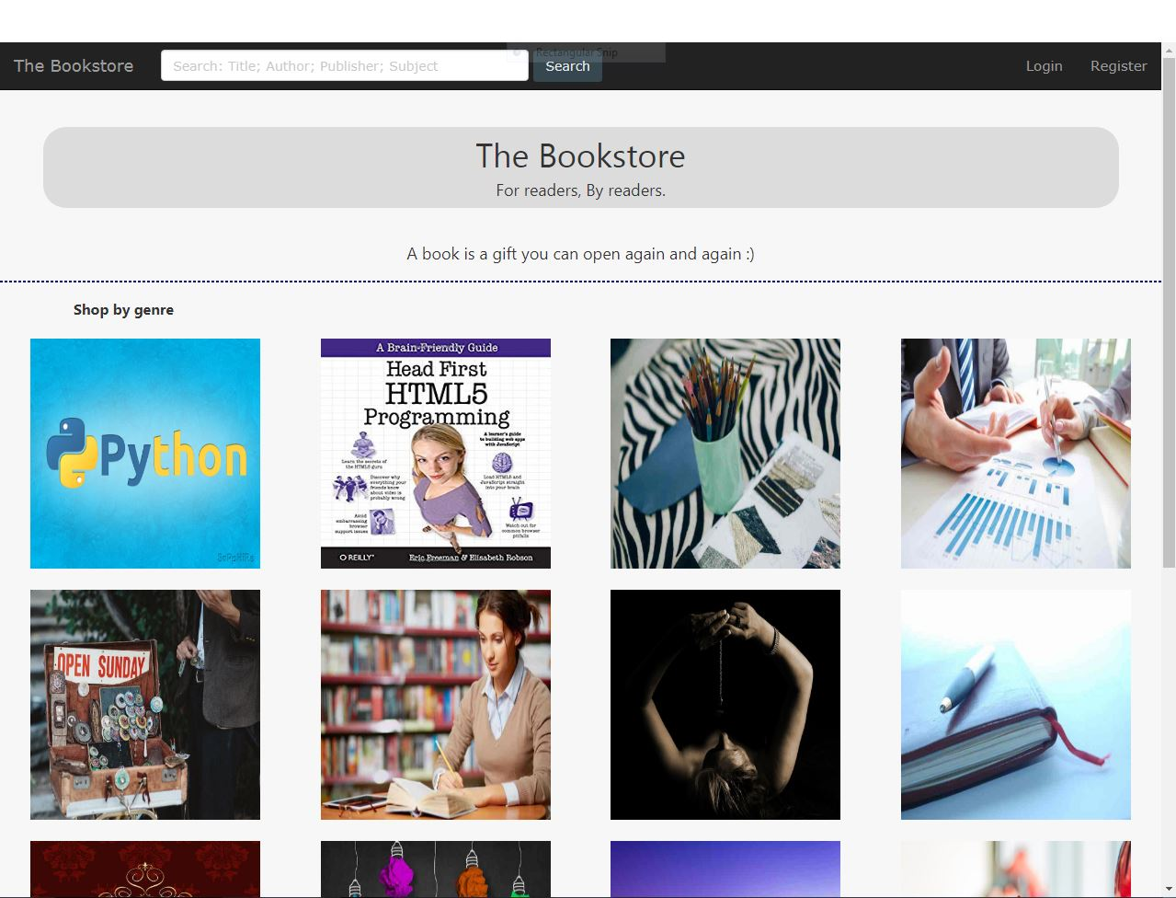

**base.html:-**

<html lang="en">

<title>store</title>

<head>

<meta charset="UTF-8">

<title>

<html>

<head>

<meta charset="utf-8">

<title>The Bookstore | {% block title %}{% endblock %}</title>

{% load static %}

<meta name="viewport" content="width=device-width, initial-scale=1">

<link rel="stylesheet" type="text/css" href="{% static 'bookstore/css/bootstrap.min.css' %}" media="screen">

<link rel="stylesheet" href="http://www.w3schools.com/lib/w3.css">

<link rel="stylesheet" type="text/css" href="{% static 'bookstore/css/style.css' %}" media="screen">

{% block stylesheet %}{% endblock %}

</head>

<body>

<nav class="navbar navbar-inverse navbar-static-top ">

<div class="container-fluid">

<!-- Brand and toggle get grouped for better mobile display -->

<div class="navbar-header">

<button type="button" class="navbar-toggle collapsed" data-toggle="collapse" data-target="#bs-example-navbar-collapse-1" aria-expanded="false">

<span class="sr-only">Toggle navigation</span>

<span class="icon-bar"></span>

<span class="icon-bar"></span>

<span class="icon-bar"></span>

</button>

<a class="navbar-brand" href="{% url 'bookstore:home' %}">The Bookstore</a>

</div>

<!-- Collect the nav links, forms, and other content for toggling -->

<div class="collapse navbar-collapse" id="bs-example-navbar-collapse-1">

<form class="navbar-form navbar-left" method="get" action="{% url 'bookstore:search' %}">

<div class="form-group">

<input type="text" class="form-control" name="search_value" maxlength="150" placeholder="Search: Title; Author; Publisher; Subject">

</div>

<button type="submit" class="btn btn-dark">Search</button>

</form>

<ul class="nav navbar-nav navbar-right">

{% if not user.is_anonymous %}

{% if user.is_staff %}

<li><a href="{% url 'bookstore:stats' %}">Stats</a></li>

<li><a href="{% url 'bookstore:admin' %}">Admin</a></li>

{% endif %}

<li><a href="{% url 'bookstore:cart' %}">Cart</a></li>

<li><a href="{% url 'bookstore:account' %}">Account</a></li>

<li><a href="{% url 'bookstore:logout' %}">Logout</a></li>

{% else %}

<li><a href="{% url 'bookstore:login' %}?next={% firstof request.path '/' %}">Login</a></li>

<li><a href="{% url 'bookstore:register' %}">Register</a></li>

{% endif %}

</ul>

</div><!-- /.navbar-collapse -->

</div><!-- /.container-fluid -->

</nav>

{% block body %}

{% endblock %}

<script type='text/javascript' src="{% static 'bookstore/js/jquery-3.1.1.min.js' %}"></script>

<script type='text/javascript' src="{% static 'bookstore/js/bootstrap.min.js' %}"></script>

</body>

</html>

</title>

</head>

<body>

</body>

</html>