Assignment 5 – Question 2

Part 1

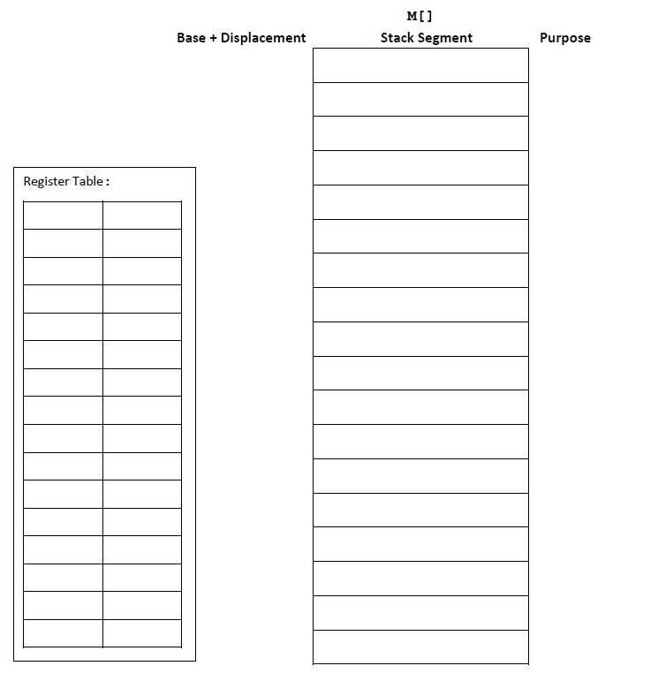

Part 2

What happens to the **canary** value when you reduce the size of buf from 40 down to 24, and x = 6, y = 9?