**PRACTICE:- (01-09-2025)**

***Programs & Output:***

**1.Find the Fibonacci Series up to Nth Term in Python.**

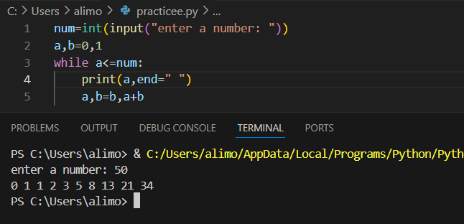

***2.*Find the Fibonacci Series within a range.**

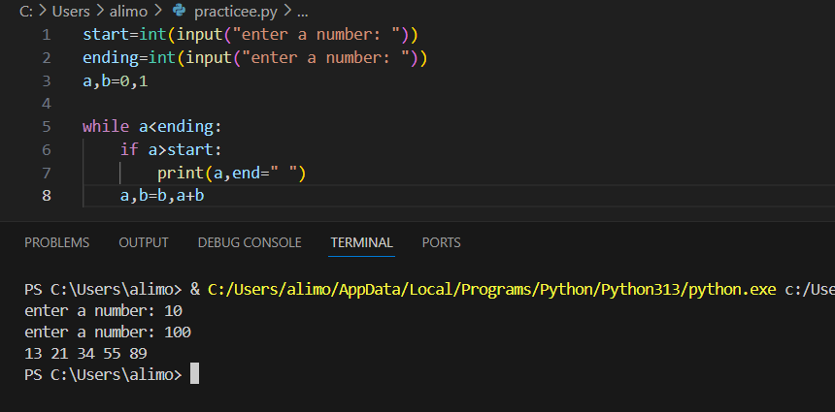

**3. Factorial of a Number in Python.**

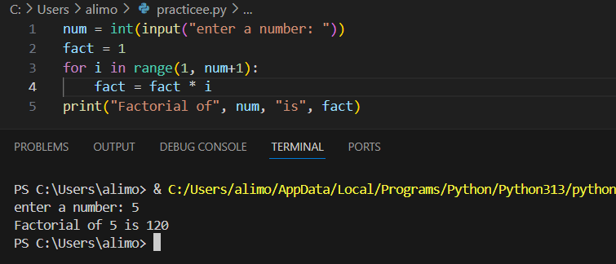

**4. Find the Power of a Number in Python.**

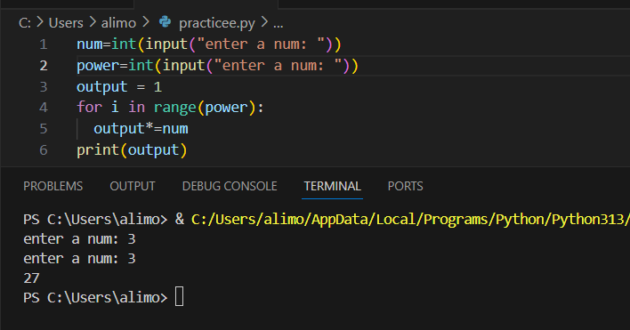

**5. Find the Factors of a Number in Python.**

