**PRACTICE:- (02-09-2025)**

**1.Today’s work is on strings and all types of string functions.**

**A: String(str)**

* **String is a data type**
* **String is a sequence of characters enclosed within single quotes or double quotes.**

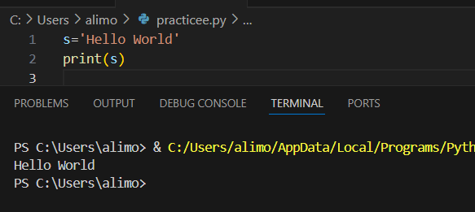

**Slicing: The Python Way to Extract Substrings:-**

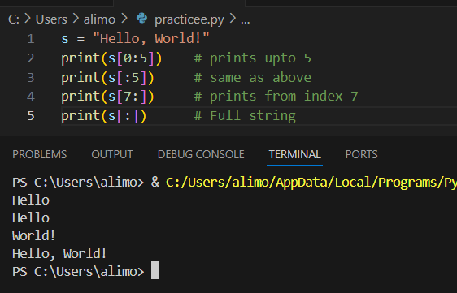

* **Negative slicing:-**

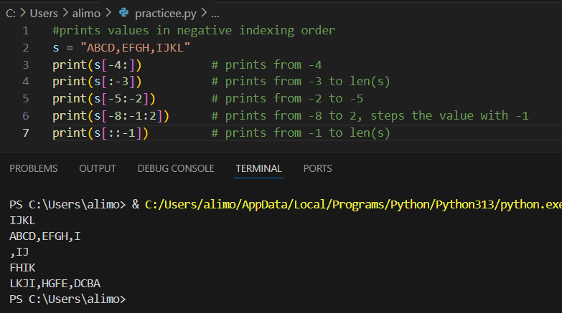

**String Functions and its types:**

***1.Case Conversion:***

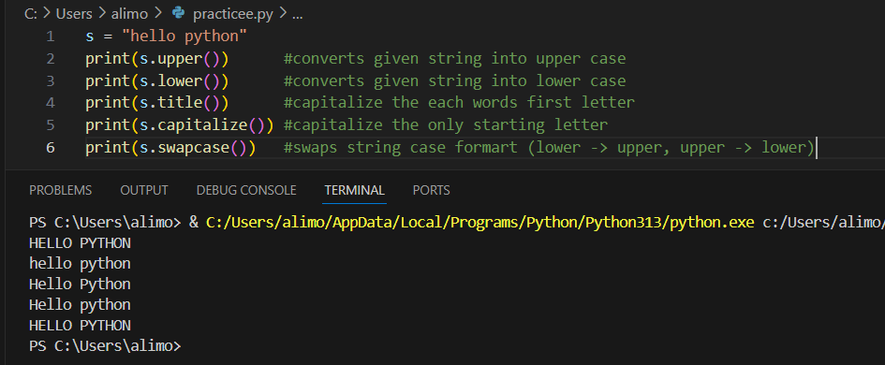

***2.Checking String:-***

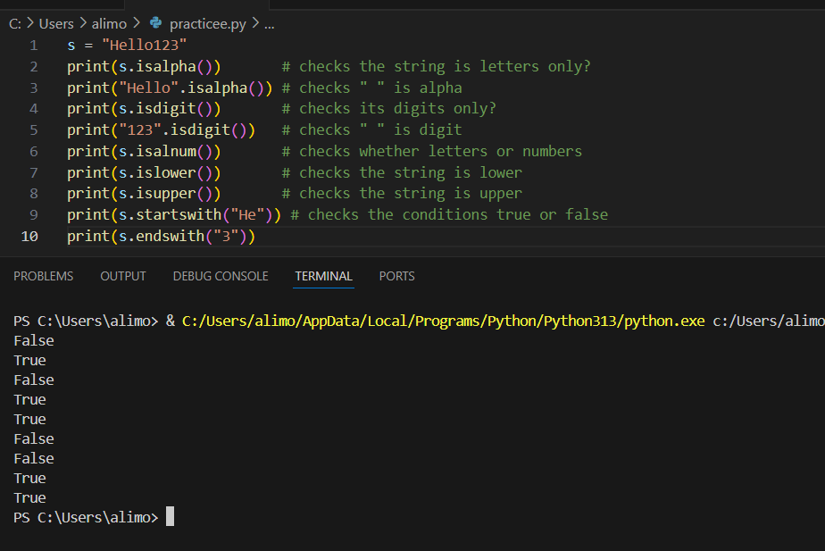

***3.Search and Find:***

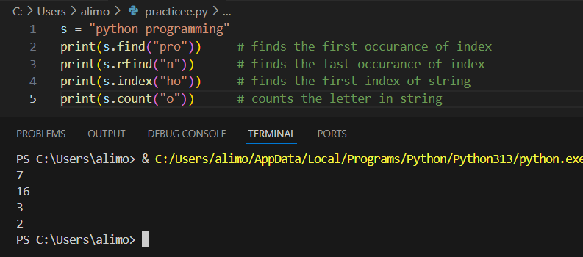

***4.Replace and Modify:-***

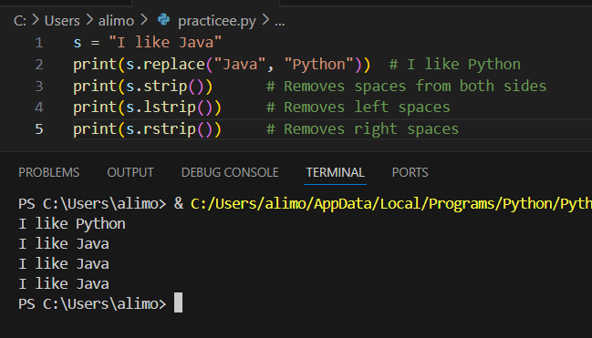

***5.Splitting and Joining:-***

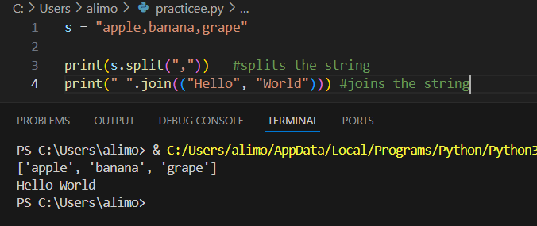

***6.String Formating:-***

