**PRACTICE:- (03-09-2025)**

***Programs & Output:***

**1.Full Pyramid pattern in python.**

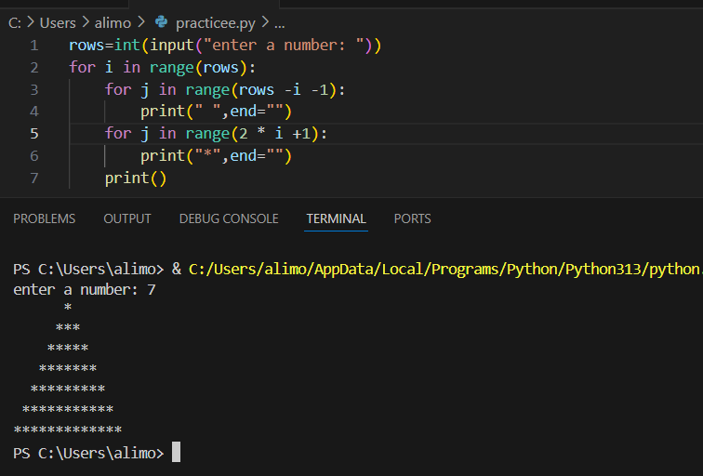

**2. Inverted Full Pyramid pattern in python.**

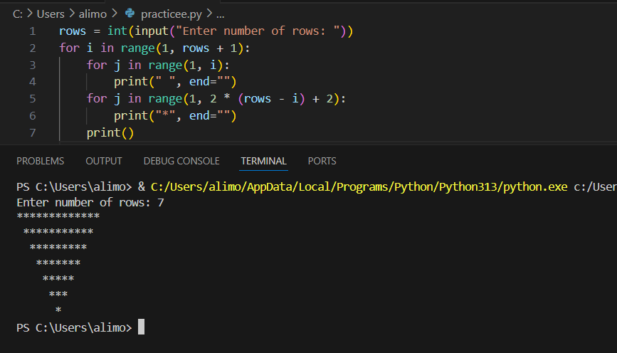

**3. Diamond Shape (Full Pyramid + Inverted Full Pyramid)**

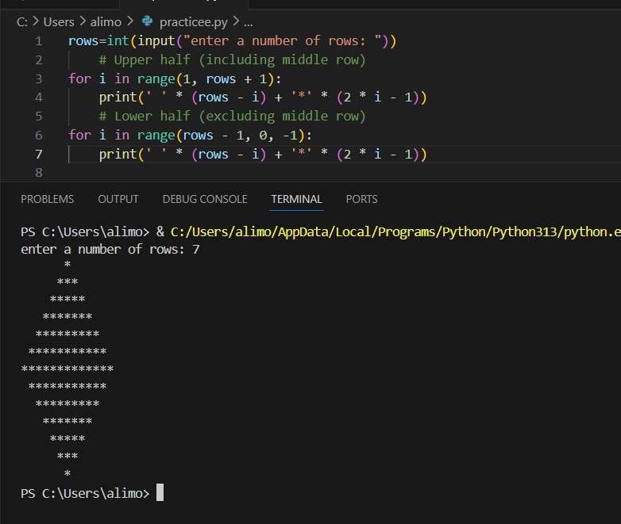

**4.** **Hollow Rhombus pattern in python.**

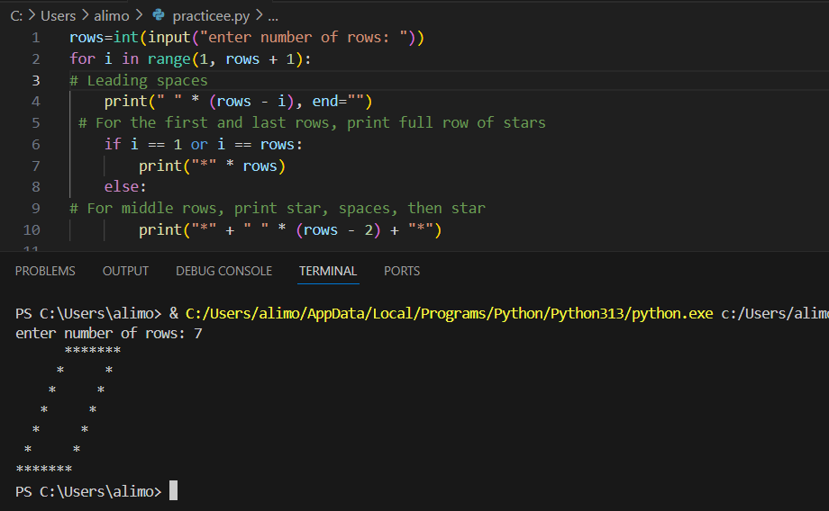

**5.** **Diamond-Style Hollow Rhombus pattern in python.**

