**PRACTICE:- (04-09-2025)**

***Programs & Output:***

1. **Factorial of a Number in python.**

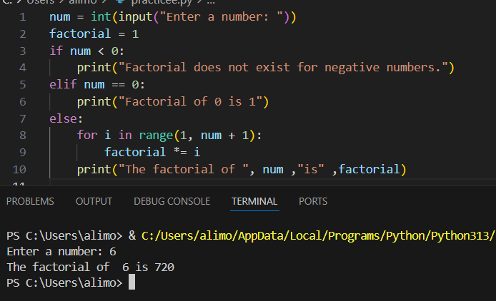

1. **Factors of a Number in python.**

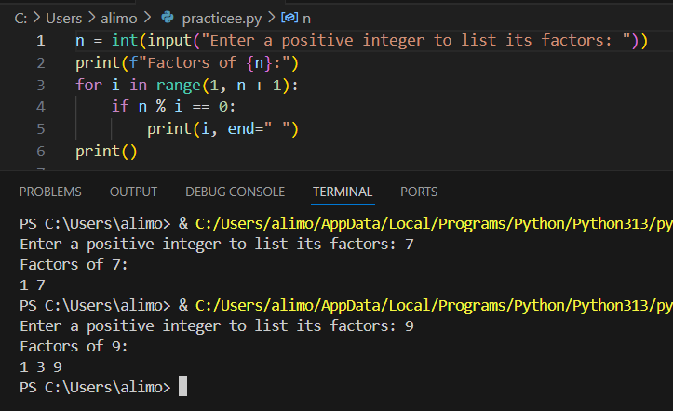

1. **Perfect Number in python.**

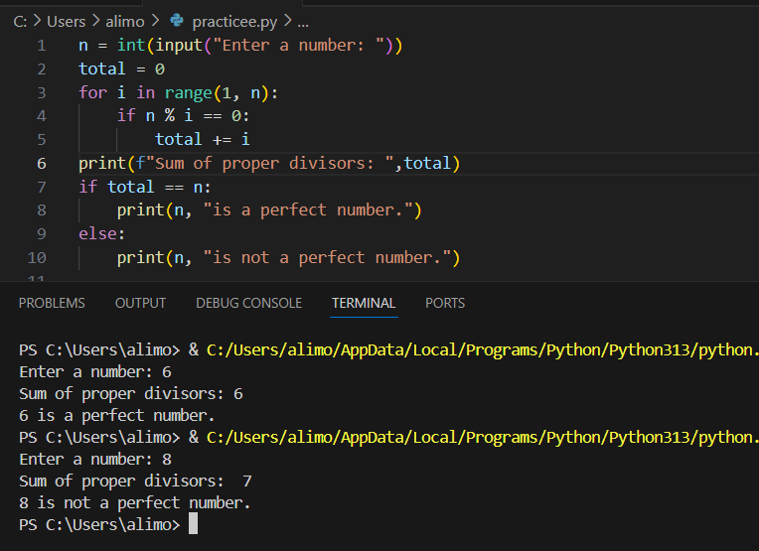

1. **Perfect Square in python.**

