**PRACTICE:- (05-09-2025)**

***Programs & Output:***

1. **Harshad Number in Python.**

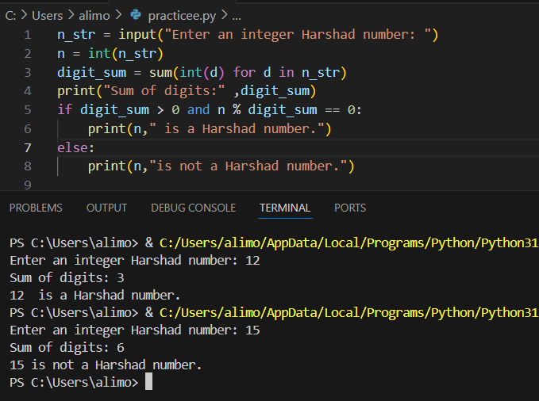

1. **Friendly Pair (Amicable Numbers).**

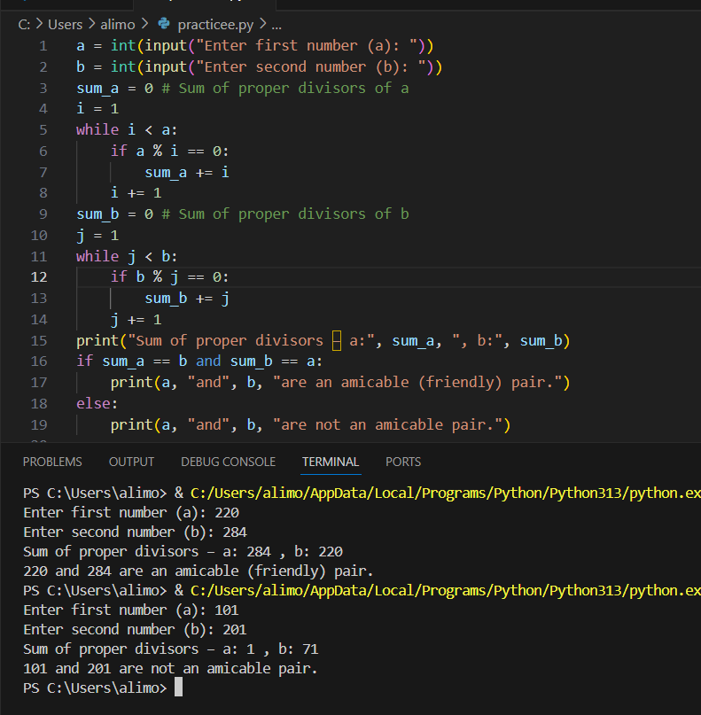

1. **Abundant Number in python.**

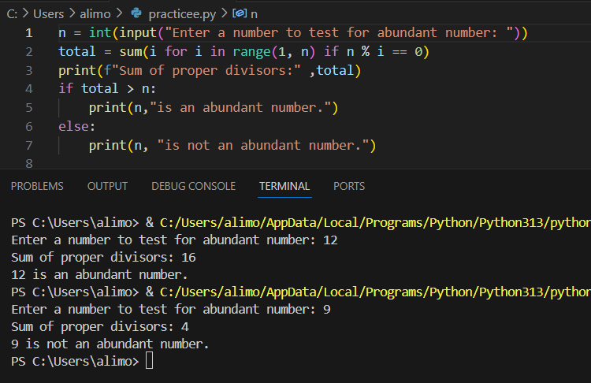

1. **Strong Number (Factorion)**

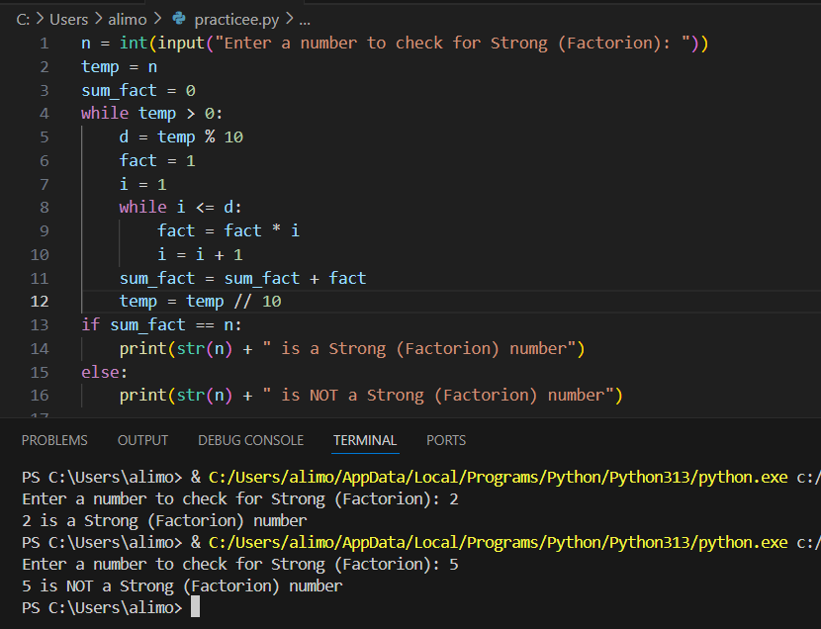

1. **Automorphic Number in python.**

