**PRACTICE :-**

**CREATEING the table:-**

CREATE TABLE employee (emp_id INT PRIMARY KEY, name VARCHAR(50) , department VARCHAR(50),salary INT, joining_date DATE,city VARCHAR(50)

);

**INSERTING THE DATA:-**

INSERT INTO employees (emp_id, name, department, salary, joining_date, city) VALUES

(1, 'Alice Smith', 'HR', 45000, '2020-02-15', 'New York'),

(2, 'Bob Johnson', 'IT', 60000, '2019-08-23', 'Chicago'),

(3, 'Carol White', 'IT', 75000, '2021-01-10', 'New York'),

(4, 'David Brown', 'Finance', 50000, '2020-06-01', 'San Diego'),

(5, 'Eva Adams', 'HR', 47000, '2018-04-12', 'Chicago'),

(6, 'Frank Lee', 'Finance', 65000, '2021-11-05', 'New York'),

(7, 'Grace Kim', 'IT', 80000, '2017-09-18', 'San Diego'),

(8, 'Henry Clark', 'Marketing', 55000, '2019-12-29', 'Chicago'),

(9, 'Irene Scott', 'Marketing', 53000, '2021-03-22', 'New York'),

(10, 'Jack Davis', 'IT', 72000, '2020-08-14', 'Chicago');

DATA:

SELECT * FROM employee;

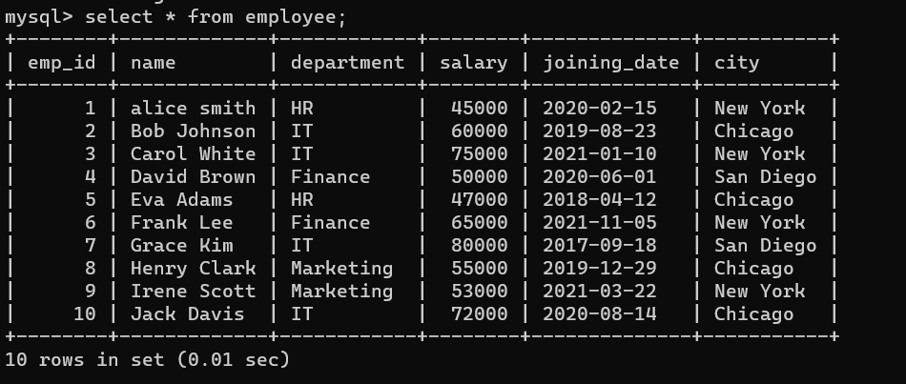

**QUERIES:-**

**-- 1. Show all employees who work in the IT department.**

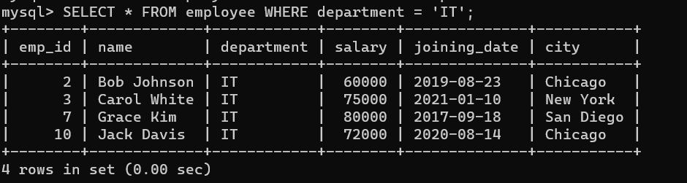

**-- 2. Find employees whose salary is greater than 60,000.**

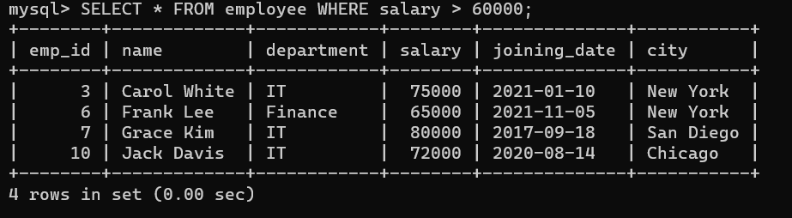

**-- 3. Get all employees who joined after 1st Jan 2020.**

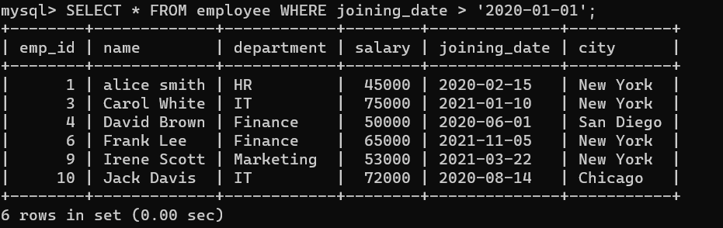

**-- 4. Find the total salary paid to employees in each department.** 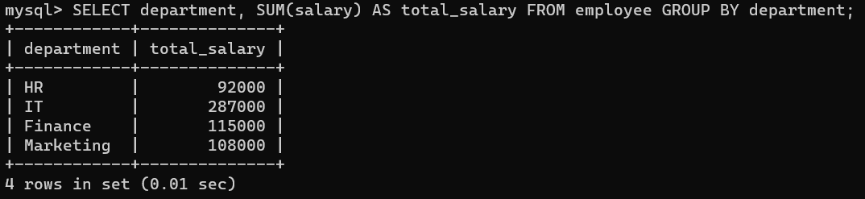

**-- 5. Show the highest paid employee in the Finance department.**

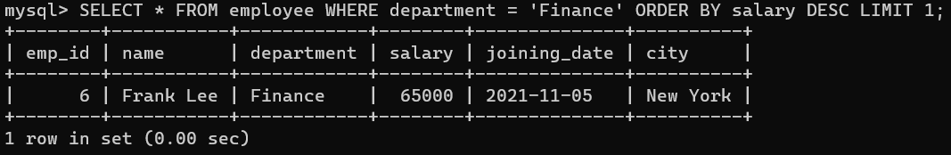

**-- 6. List employees who are from Chicago and earn more than 55,000.**

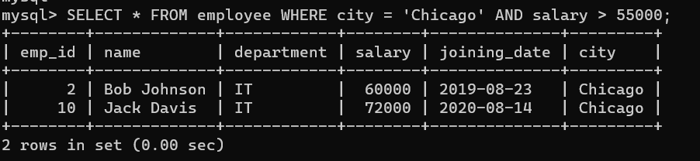

**-- 7. Find the number of employees in each city.**

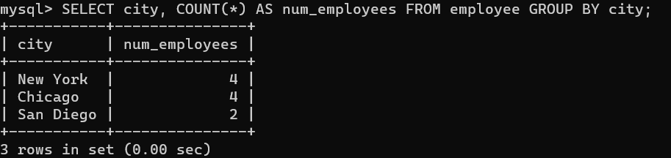

**-- 8. Show employees in the IT department ordered by salary in descending order.**

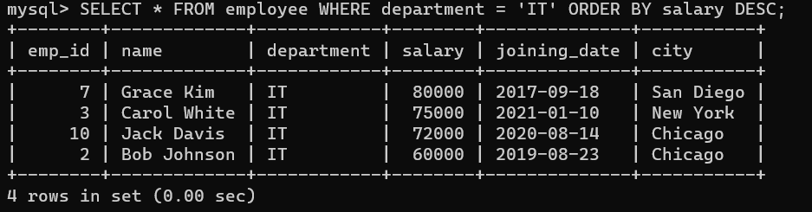

**-- 9. Display the average salary of all employees.**

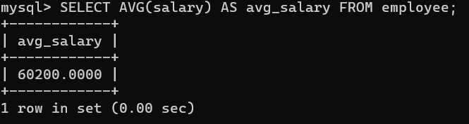

**-- 10. Get the details of the top 3 highest paid employees.**

