**PRACTICE :-**

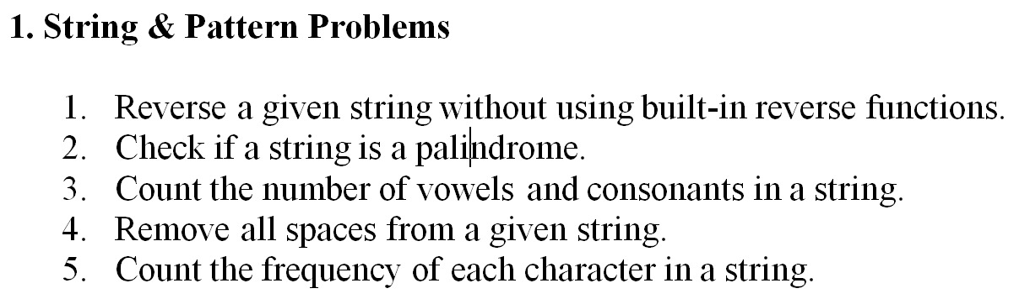

1.Reverse a given string without using built-in reverse functions.

Program & Output:-

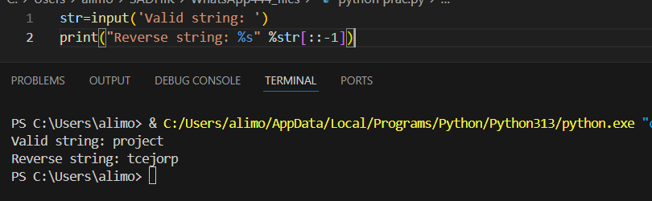

2.Check if a string is a Palindrome.

Program & Output:-

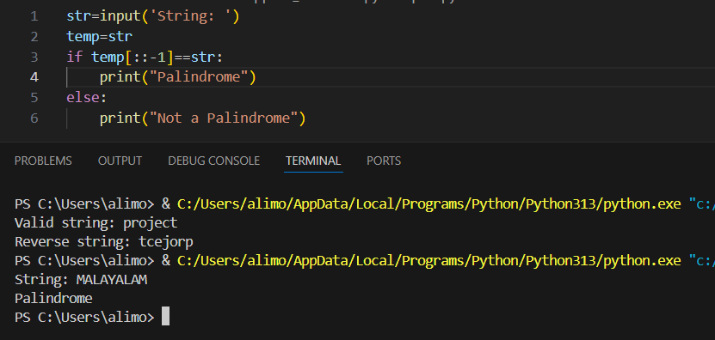

3.Count the number of vowels and consonants in a String.

Program & Output:-

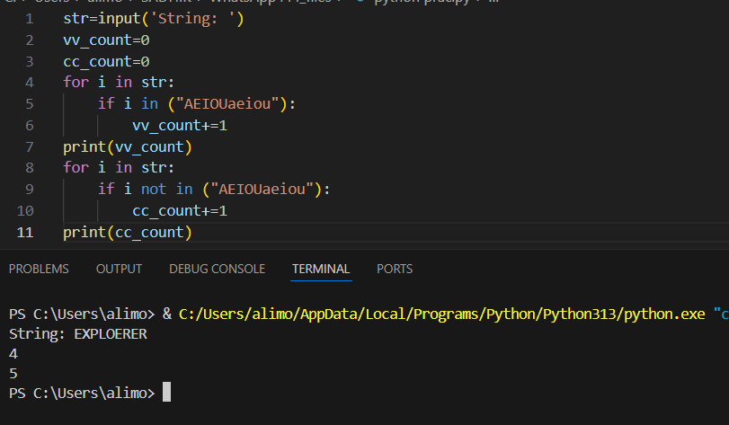

4. Remove all spaces from a given string.

Program & Output:-

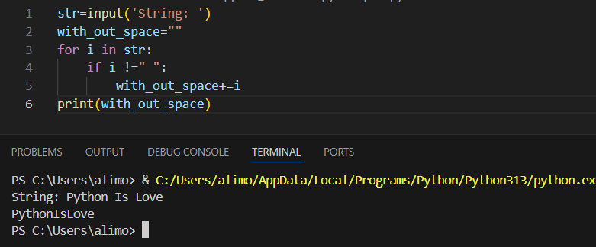

5.Count the frequency of each char in a string.

Program & Output:-

