**PRACTICE:- (18-08-2025)**

***Programs & Output:***

1. **Check if a Number is Positive and Negative in Python.**

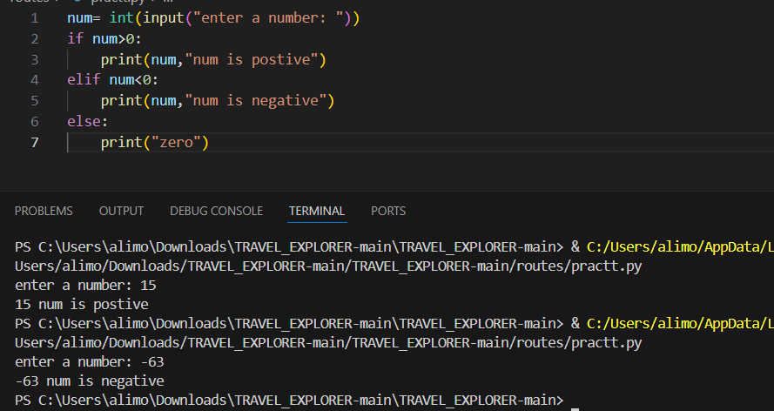

**2.Check Whether a Number is Even or Odd in Python.**

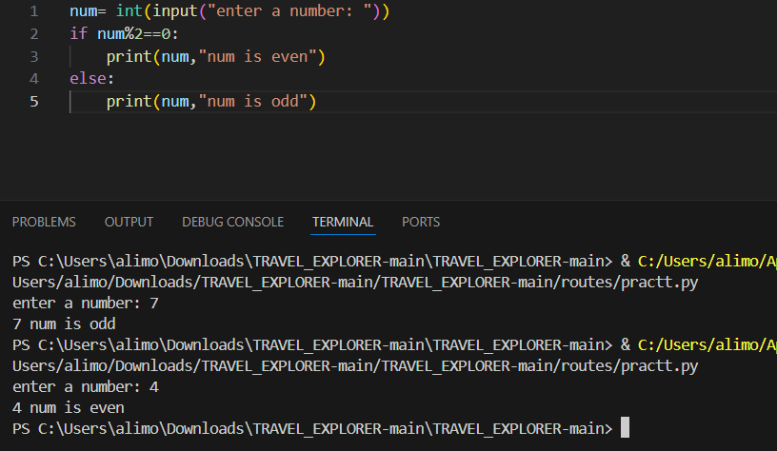

**3.Find the Sum of the First N Natural Numbers in Python.**

